Disease & Parasitism

Parasites are extremely common in natural populations/communities.

Parasitism +/- ecological interaction
Parasite-host systems show evolution of virulence and resistance. History alters the effects of parasites on their hosts.

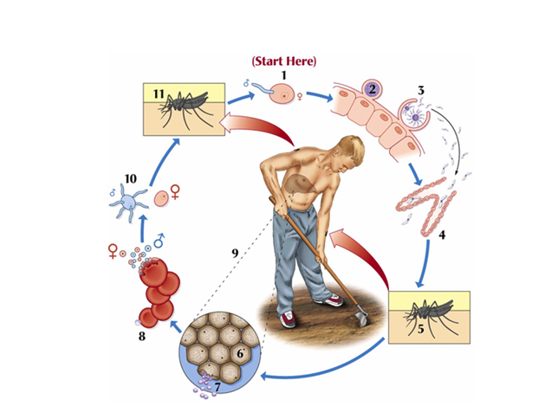
Parasites often have complex life-cycles
requires more than one host to complete life-cycle (each host provides a different ‘environment’)

Definitive host:

Intermediate host(s):

Successful completion of life-cycle requires transmission:

**creates opportunity for strong co-evolution among hosts and parasites

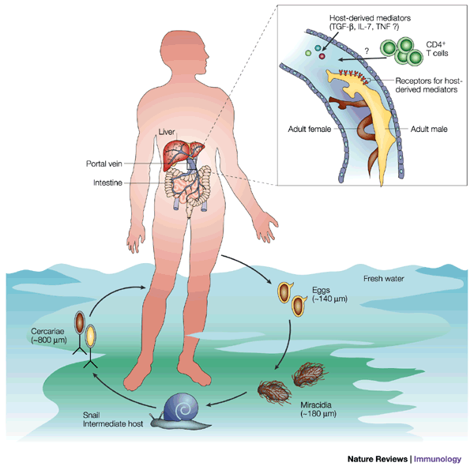
Vertical:

Horizontal:

Direct:

Indirect:

Vectors move pathogens between hosts

Types of Parasites

Microparasites:

Macroparasites:

Ectoparasites:

examples?

Endoparasites:

examples?
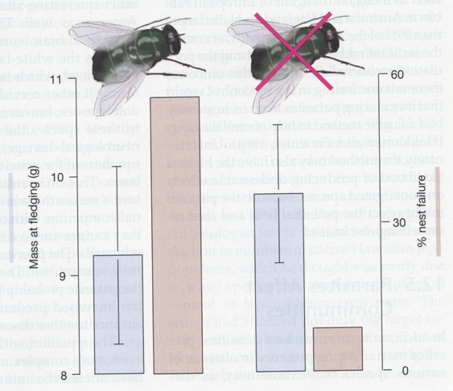

Ecological effects of parasites

Individual-level effects:

types:

examples: Blue tits & blow flies

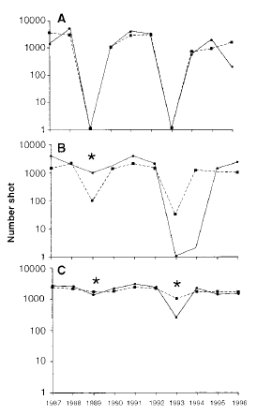

Population-level effects:

types:

Examples: Red Grouse

Community-level effects:

types:

examples:

Disease is often modeled from the perspective of the host as three sub-populations of Susceptible, Infected, and Recovered hosts

(S-I-R models)

Why model the hosts?

Lyme Disease Case Study:

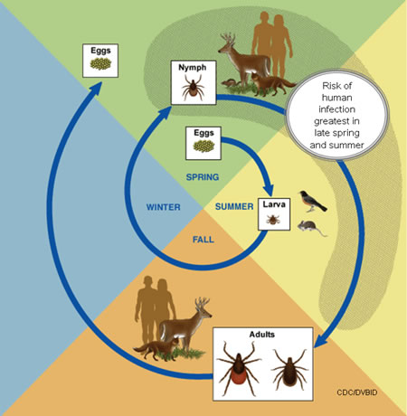
Spirochete bacterium, Borrelia burgdorferi

Hosts?

Why the increase in human prevalence?

What has changed in the system?

