1. One of the major realizations in ecology has been that ecological systems are rarely found in equilibrium (‘steady-state’) conditions. Populations, communities, and ecosystems are nearly always in perpetual change. Many different **disturbances** prevent ecological systems from remaining static over ecologically relevant time periods. Although mathematical models often assume that ecological systems are at equilibrium (for a matter of analytical convenience), it is important to realize that these conditions are more the exception than the norm out there in the real world.
2. Examples of common disturbances to ecosystems
   1. fire (forest, prairies)
   2. flooding
   3. volcanoes
   4. glacial activity
   5. avalanches
   6. drought
   7. windfall
   8. seasonal changes in weather
   9. grazing/browsing
   10. bioturbation
   11. a wide variety of human activities
   12. others?
3. **Succession** is the term describing the predictable sequence of changes in the species composition of communities following disturbance

**Climax community** represents the theoretical ‘end point’ of recovery from disturbance

-assumed to be a stable state

- At least it is stable until the next disturbance shows up!

**But, in many communities, reassembly of the species composition following disturbance is often more random (i.e. less predictable), and the key processes regulating recovery in these types of systems are not as well understood.

* 1. **Primary succession**: community development in newly formed habitats, previously lacked plants or other organisms

-follows exceptionally catastrophic disturbances (volcanic activity, receding glaciers)

* 1. **Secondary succession:** community development following disturbances that move communities away from their climax state

Which proceeds faster?

1. Studying Succession:
   1. Direct Measures
   2. Indirect Measures

“**chronosequences**”

1. The first species to colonize new habitat created by disturbance are referred to as **pioneer species**, and they often have very characteristic life history strategies.



Characteristics of plants that reinvaded Krakatau following the massive volcanic eruption in 1883.



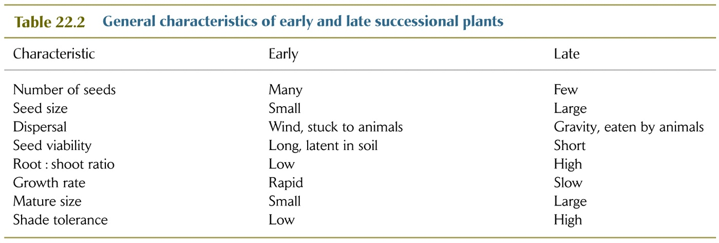

1. Pioneer species usually change the abiotic conditions of the habitat that then **facilitates** the recolonization and success of later successional species.

Examples of **facilitation**: shade, soil development, nutrient enhancement – especially by N-fixers, others?

1. **Inhibition** refers to the fact that many late successional species compete strongly (or eat) early successional species and therefore exclude the pioneers from the late successional or climax community. Examples? Shade tolerance, others?

In some situations, the species that arrives in a new habitat before its competitors takes over and prevents their colonization. In these cases, precedence, the order that species arrive, can determine the composition of the climax community.

Mount St. Helens case study:

1. Examples of some of the more dramatic instances where succession/disturbance have overwhelming effects on community structure and ecosystem processes.
2. Prairie fires
3. Forest fires
4. Beaver dams
5. Sand dunes
6. Alder trees as pioneers in de-glaciated and riparian habitats

Succession concept can be extended beyond plants…

**Examples:**

Succession of intertidal organisms (algae, barnacles, other species)

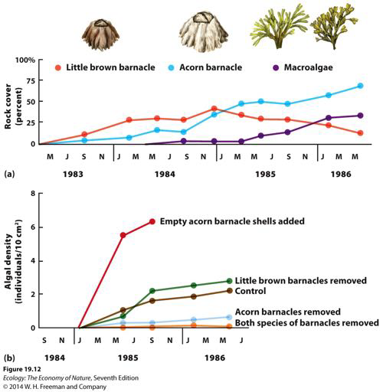

How does disturbance affect succession?

1. Periodic or cyclical disturbances often prevent communities from attaining the climax condition (‘reset the successional clock’). Therefore, these disturbances are often the key structuring forces of certain ecosystems and communities. Human ‘control’ of these natural disturbances often allows these communities to progress towards the climax condition which would rarely be attained in the absence of humans.

Examples:

Forestry (clear-cutting)

Grazing and fire in prairie communities

**Intermediate Disturbance Hypothesis** – as an organizing concept.

-species diversity is often highest at intermediate levels (frequency of recurrence) of disturbance