**Variation in the Physical Environment / Biomes-**

**Motivation**—foundation for understanding broad scale differences among ecosystems. Also serves as the template upon which species adaptation, population dynamics, species interactions, and ecosystem function operates.

Some basic **astronomical features** important for ecological systems:

1. Earth rotates on its axis once every 24 hrs. producing regular day and night cycles
2. The moon revolves around the Earth once every ~28 days producing tidal variation
3. The Earth is tilted on its axis at ~24°
4. The Earth revolves around the Sun once every 365 days, combined with the tilt, produces seasonal variation in solar intensity

**What are some ecological effects of each?**

**CLIMATE**

1. **Major components**

* 1. **Sunlight**
     1. Electromagnetic radiation from the sun serves many purposes—
        1. **Infrared radiation** (~700-15,000 nm) provides main source of heat
        2. **Photosynthetically active radiation** (PAR, 400-700 nm) provides nearly all energy for biological systems—converted to organic molecules by primary producers
        3. **Ultraviolet radiation** (~200-400 nm) damaging to many biological tissues, DNA. Also serves important role in many organisms’ vision
        4. **Human vision** limited to what we commonly call “light”

What wavelengths does this correspond to?

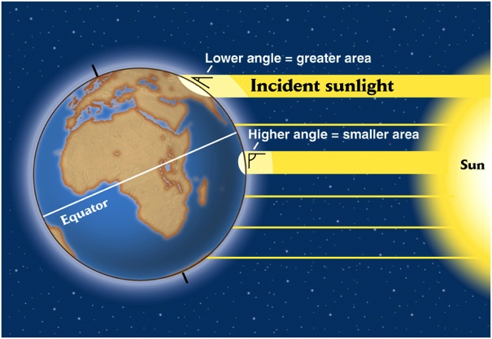

* 1. **Temperature**
     1. Solar heating declines with latitude as incident sunlight is spread across a larger area
     2. Un-even heating due to distribution of land masses in N. Hemisphere
     3. Latitudinal pattern: Lower latitudes are _________
     4. Seasonal pattern: Summer occurs at high latitudes when _______________
  2. **Precipitation**
     1. Solar heating causes air to rise
     2. Rising air cools, and moisture condenses (precipitation)
     3. **Hadley cells** span about 30o latitude: as air descends, it warms and evaporates water
     4. Deserts occur at latitudes of __________
     5. Tropical rainforests occur at latitudes of __________
     6. Air also rises across mountain ranges, casing a dry rainshadow on the leeward side—the **Mountain Rainshadow Effect**
        1. Sequim is in the rainshadow of the Olympic Mtns
        2. Cle Elum is in the rainshadow of the Cascade Mtns

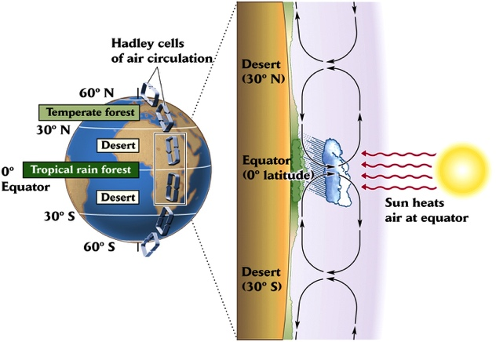

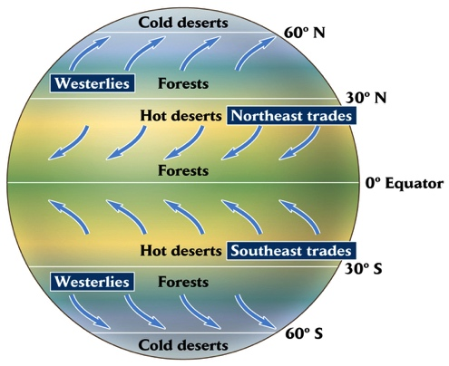

* 1. **Winds**
     1. Air lags behind the rotation of the earth, lagging more where the earth spins faster (low latitudes)
        1. High latitudes have **westerlies** (from the west)
        2. Mid-latitudes have strong **tradewinds** (from NE, SE)
        3. Equator is generally calm, **doldrums**
  2. **Ocean Currents**
     1. Water currents mimic wind patterns—relatively stationary currents
     2. Water moving offshore causes upwelling—can bring deep nutrient rich water to the **photic zone** (enough light to allow photosynthesis)—stimulating primary productivity by phytoplankton
     3. Ocean moderates climate

1. **Climate cycles**
   1. **El Nino Southern Oscillation** (ENSO): abnormal sea surface warming in the eastern equatorial Pacific, also associated with East 🡪 West pressure difference
      1. Warmer water moves east, strong subtropical winds blow east to west (“normal” is cool water and winds blow the other direction)
      2. Low productivity, warm water in Galapagos, Peruvian coast due to reduced upwelling
      3. Vast repercussions for temperature and precipitation over many parts of the globe (drought in some areas, excessive moisture in others)
      4. Frequency = every 2-7 years
      5. Tracked by deviations from long-term average sea surface temps (SST) and a composite “southern oscillation index” (SOI)

*Opposite phenomenon is **La Nina**: abnormally cool sea surface temps

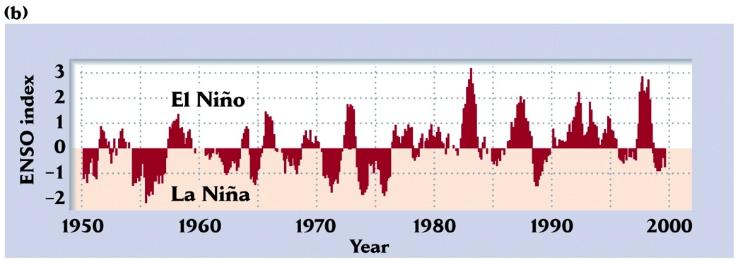

**Examples**:

Galapagos Is. Medium ground finch beak size

* 1. **Pacific Decadal Oscillation** (PDO):
     1. Slow cyclic changes in dominant climate features of the North Pacific (sea surface temps, pressure, circulation, winds)
     2. “warm” and “cool” periods, **regime shift** every 20-30 years
     3. Affects ocean productivity

Example: Alaska vs. Pacific NW salmon returns



**How do we characterize the effect of large-scale patterns in climate?**

1. **Biome concept**: classifies biological systems according to similarity in climate
   1. Since physical characteristics of the environment affect organisms, similar climates tend to have organisms with similar adaptations to that climate (ex. Desert dwelling plants and animals)
   2. Based on the composition of terrestrial plant communities
   3. **Whittaker’s** biome classification: average temperature vs. average precipitation graph
   4. Climate diagrams—plot temperature and precipitation by month on 2 y-axes. Can help identify whether plant growth in a particular location is limited by temperature or precipitation.

