**Study Design**

Ecologists use a variety of different methods to study and learn about ecological systems. Each approach has its own strengths and weaknesses. The major approaches are described below.

1. **Comparative studies**

Comparative studies involve measurements of ecological attributes (e.g., plant biomass, diversity, water temperature, soil nutrients, fecundity, etc.) along a gradient of some variable of interest. Multiple variables can then be compared to determine if relationships occur between these variables. For example, you might be interested in knowing whether rainfall affects plant productivity. One way to evaluate this is to sample a number of sites that vary in rainfall amounts and measure the productivity of plants at each of these sites. A graph of plant productivity and rainfall would then lend insight into whether a correlation exists between these two variables.

Comparative studies can also involve comparisons among individuals of a population, different species, etc.

Examples:

It is important to realize that correlation between variables does not necessarily imply a causative relationship between them!

**2) Retrospective Studies**

These involve the analysis of historical time series as a means for describing the nature of temporal variation in ecological systems and identifying correlations among different variables. Again, correlation does not imply causation!

Examples:

Retrospective studies are sometimes combined with the comparative approach to explore how ecological systems vary in both time and space simultaneously (e.g., **Moran effect**).

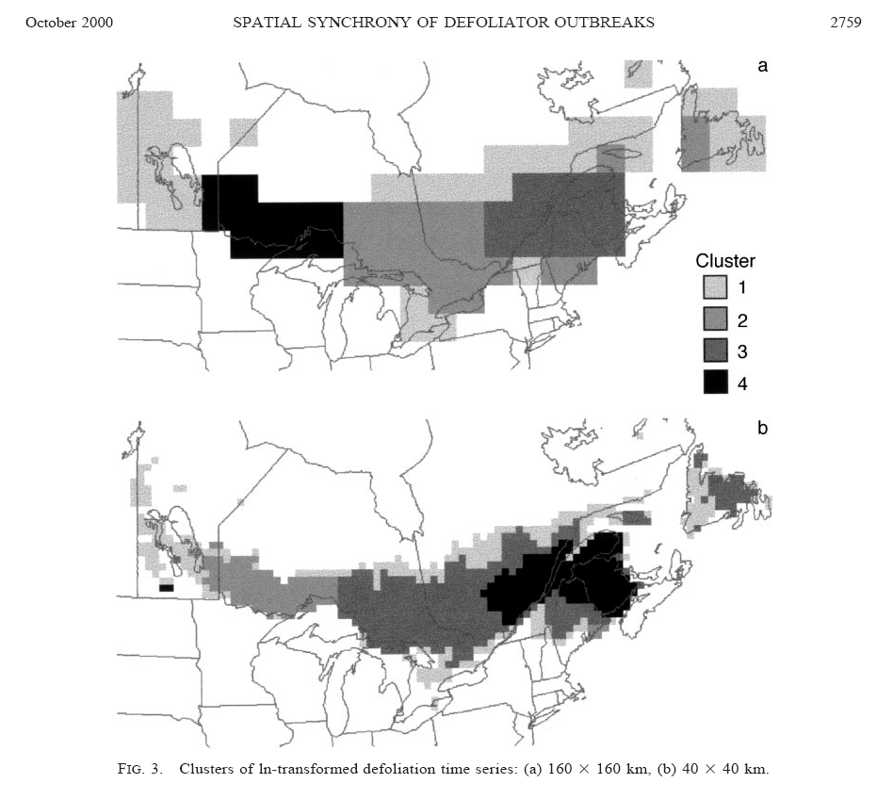

Retrospective studies often use paleo-ecological data to learn about long-term dynamics in ecological systems.

1. **Experimental Studies** are arguably the most powerful way to learn about the structuring features of ecological systems.

Experiments involve:

Treatments

Controls

Replication

Randomization

Unlike the comparative and retrospective approaches, experiments are often designed to specifically reveal the **mechanisms** that determine patterns observed in nature.

Factorial designs are common in setting up experiments because they allow you to estimate whether there are **interactions** between two or more independent variables.

Trade-offs between the size of experimental units and the number of replicates in an experiment are very common. In general, the tradeoff curve looks like:



Why does this tradeoff exist?

What are the implications of this tradeoff?

**Whole ecosystem experiments** are done at a spatial and temporal scale that is most relevant to how real ecological systems operate. However, they are very difficult to replicate. Usually these experiments involve a treatment ecosystem and one or several reference ecosystems that account for variability that is external to the manipulation.

Examples:

1. **Adaptive Management**

These are large-scale experiments that treat management decisions as manipulations. Similar to whole-ecosystem experiments, but they are usually opportunistic and also include humans as part of the response.

Adaptive management is often called “learning by doing”. It involves developing a model describing the way the system works, applying a deliberate manipulation to the system, evaluating the response, and then adapting the management policy. There is no end point! You should expect to continue to learn about the system as additional manipulations are added to older ones.

Example:

**5) Models**

Models are formal representations of ecological systems or processes. They are a common way to explore ecological systems when direct manipulation is not possible or prohibitively difficult. Models can be conceptual, mathematical, simulation-based, or statistical (there are other types too!). All models are challenging to validate, because they are (by definition) abstractions of the natural world. We often use computers to run simulations of models to explore possible responses of ecosystems to perturbations (e.g. what if scenarios).