Life Histories

The “schedule” of an individual’s life, including age at maturity, number of offspring, life span, number of reproductive opportunities (maturity, fecundity, aging, parity)

On average, all individuals have one offspring that reaches reproduction---from dandelions to house finches to humans

Why must this be the case?

Then why so many different “ways” to achieve the same outcome?

1. Basic components of life history:
    - Maturity: age at 1st reproduction
    - Parity: number of reproductive episodes/lifetime
    - Fecundity: number of offspring produced/episode
    - Life span: survival schedule, aging & senescence

a. Terms:
    - Semelparity: reproducing only once before programmed death

Iteroparity: reproducing multiple times

    - For plants specifically, Annual: living one year
Perennial: living >1 year

Examples:
Some species have life histories with high fecundity, short time to maturity, and poor survival (Asian tiger mosquito)

Somewhere in between (Cascades frog)

Some species have life histories with low fecundity, long time to maturity, and high survival (African elephant)

  - Life history diagrams summarize average life history events (usually involve 1-year time steps)

  - Life histories are the result of natural selection. They represent successful ways of allocating limited resources to carry out various functions of living organisms.

- Tradeoffs exist in the allocation of resources.
Goal is to maximize lifetime reproductive success with limited resources.
These are hypotheses that can be tested experimentally.

When to begin breeding? How often to breed? How many offspring per event?

  - Clutch size vs lifetime number of offspring. What is the evidence for the “Lack clutch”?
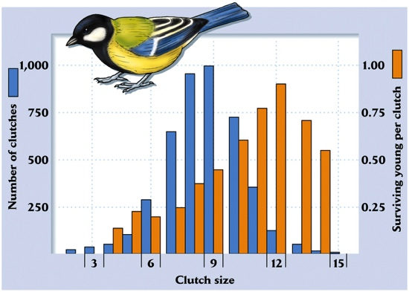
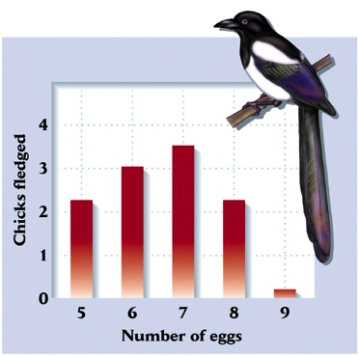

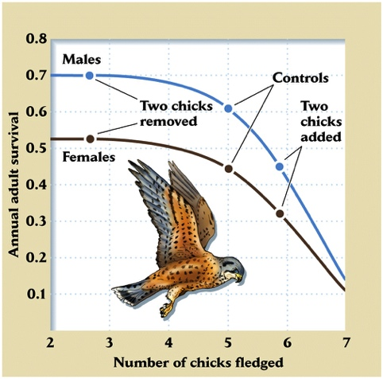
- Fecundity and adult survival

General pattern for birds

European Kestrels

- Age at first reproduction (reproduce now or later): Delayed reproduction in organisms that learn or grow

  - Example with table below

    - Rules: If an organism does not reproduce, then its annual reproductive output increases by 10 offspring

    - This output continues through the lifespan of the individual

TOTAL EGGS PRODUCED
Age at 1st repro | Lifespan: 1 yr | 2 | 3 | 4 | 5
1
2 | --
3 | -- | --
4 | -- | -- | --
5 | -- | -- | -- | --

- Fecundity and growth

  - Determinate vs. Indeterminate growth

b. How does allocation of energy to growth versus reproduction affect lifetime reproductive output?

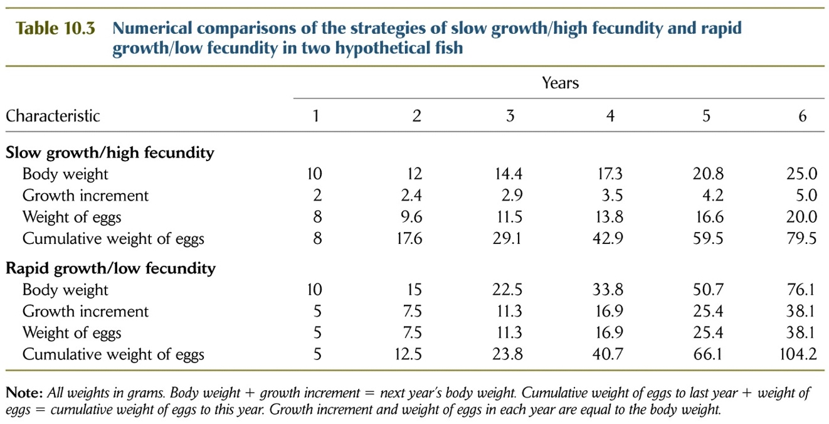

- Environmental conditions affect life-history
  - Most traits under strict genetic control (generally)

  - Some life history traits that respond to environmental cues = phenotypic plasticity

  - Said another way, phenotypic plasticity is change in phenotype due to variation in the environment

  - Reaction norm describes how (if) the phenotype varies with environment

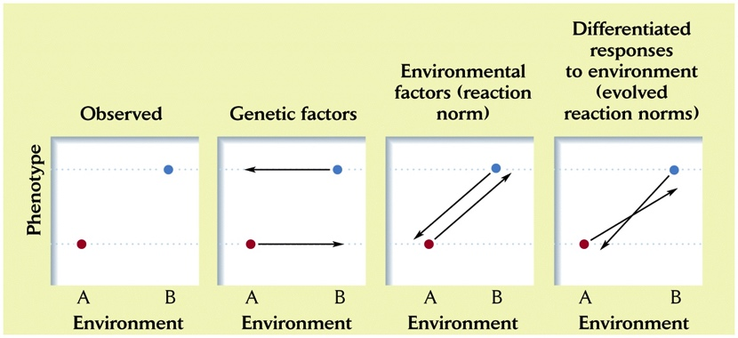

  - Physical (abiotic) environmental variation (temperature, resources---which can affect reproduction, metamorphosis, etc.)
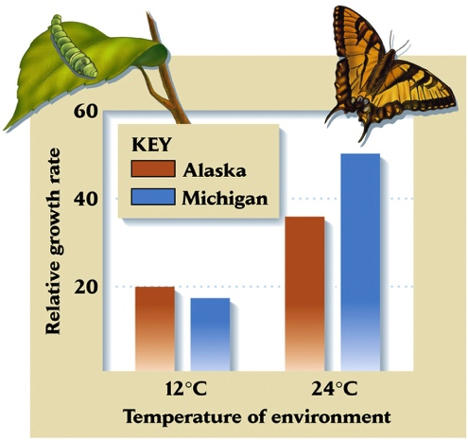

Test for differences between populations of the same species with reciprocal transplant experiment

    - Time to metamorphosis: depends both on food availability and predation risk
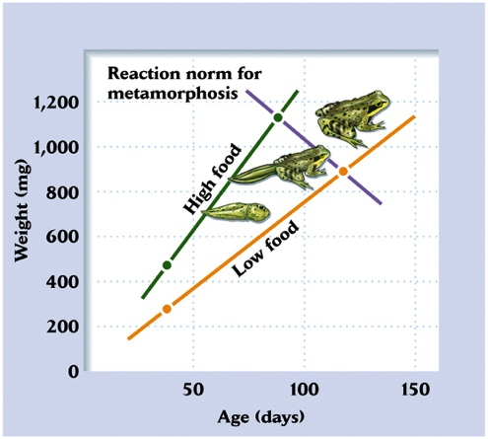

Constant weight threshold

Constant age threshold

Some other combination of cues

  - Genotype x environment interaction: plasticity itself can adapt

Are populations diverging?

