Populations
-Group of regularly interbreeding individuals of a species
-Location-based, somewhat arbitrary distinctions between populations

- Spatial and Temporal arrangement

  - Distribution: Spatial extent of organisms within a species
    - Determined by historical, physical, and biological “filters”
-will discuss biological examples in great detail in later lectures

    - Can classify spatial arrangement (dispersion) along a gradient from:
      - Clumped

      - Random

      - Uniform (evenly spaced)
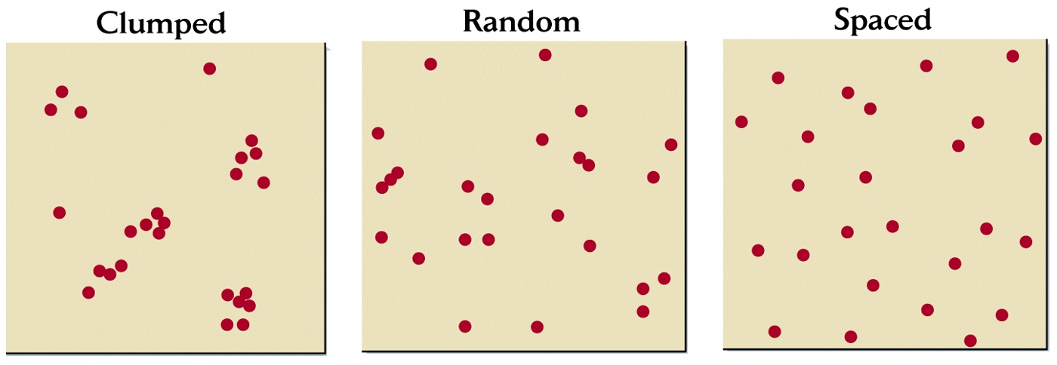

  - Abundance: Number of individuals in a population

Dynamic, changes through time (balance of births, deaths, emigration, immigration)

Often expressed as Density = # individuals/area

- Population dynamics
  - On average every individual produces one successful offspring-- replacement rate results in “steady state” population

  - Balance of births – deaths and immigration – emigration
-see connection to life history features from last time?

Before we talked about how the stability of populations must mean that on average each individual is only replacing itself through reproduction.

Why don’t populations increase dramatically more often?

  - Rapid population growth:

    - Humans (a special case)

Learn something about human population growth (http://www.populationconnection.org/)

    - Formerly exploited species now protected

    - Newly-introduced species
      - Other terms for generally the same thing: Non-indigenous, alien, exotic, introduced, non-native

      - Current rates of invasion are orders of magnitude higher than in the past

      - Invasions can be purposeful (planned releases, imports) or accidental
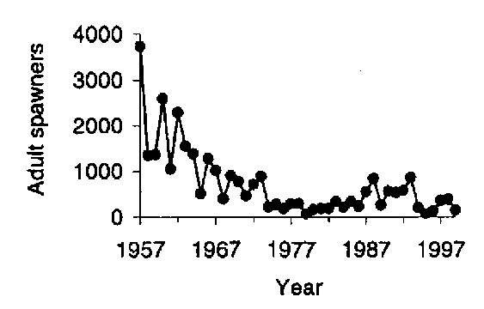
Columbia R. Chinook salmon
  - Rapid population decline
    - Most threatened and endangered species

- Ways to follow and characterize population dynamics

How fast does a population increase/decrease?

What will the population size be next year?

  - Ecologists have developed a simple way of summarizing birth and death schedules.

    - Follow the fate of one cohort through the lifespan-Cohort life table

Limitations?

    - Track the birth and death rates of each stage over several years-Static life table

Limitations?

COHORT life table for frog example

Age (x) | Number alive (N_{x}) | Survivorship (l_{x}) | Survival rate (s_{x}) | Fecundity (b_{x}) | l_{x} b_{x}
0

1

2

3

XXXXX | XXXXXX | XXXXXXX | XXXXXX | R₀ = ∑ l_{x}b_{x}

    - Terms to know
x = age
l_{x} = survivorship to age x (proportion living)
s_{x} = survival rate from age x to age x+1
b_{x} = fecundity (births) at age x

  - Net reproductive rate is the number of offspring produced by the average individual over its lifetime: R₀ = Σl_{x} b_{x}

BUT…Growth of population depends on when reproduction occurs, not simply total offspring produced

  - Generation time = average age at which an individual gives birth to offspring: T = Σ x l_{x}b_{x} / Σ l_{x}b_{x}

  - Approximation for the intrinsic rate of population increase (r_{a}):
r_{a} = ln(R₀) / T

Next time….the mathematical details of geometric, exponential, and logistic population growth.

