Populations III: Review and putting it all together

1. Review of the in-class exercise:

Static versus Cohort life-tables

-understand the differences between static (in-class exercise) and cohort (lecture example) life-table data and how the calculations differ for each.

-ultimately we do these calculations to estimate something about the status of the population of interest (increasing, stable, declining?)

2. Case study: How to save endangered Loggerhead Sea Turtles?

Dramatic declines in last 200 years, breed along SE coast beaches

Local and regional conservation originally focused on protecting nests on beaches

Deborah Crouse (Duke MS student) collected 3 yrs of data for a static life-table

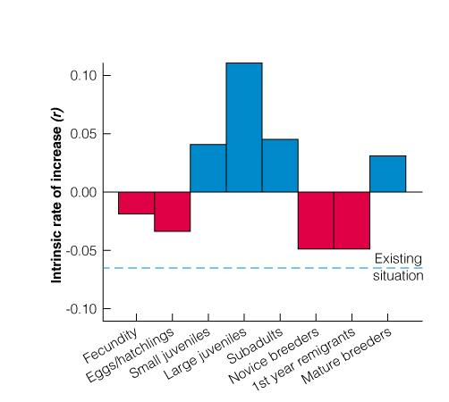

Used life-table to do virtual ‘experiments’ (matrix model)

Evaluated different conservation actions (protecting nesting beaches, juveniles, boost reproduction, adult survival, etc.).

Where would we get the biggest ‘bang’ for our conservation ‘buck’ in terms of reversing the population decline?

3. Special case: dynamics of small populations

Three reasons why populations may fail to increase from low density

- r < 0 , deterministic decline at all densities

- Depensation: individual performance declines at low population size (deterministic decline at low densities)
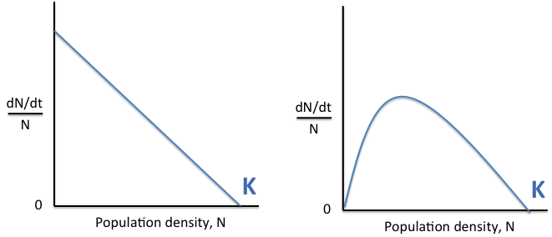

  - Examples of depensation?

-Allee effect:

- Below “Minimum Viable Population” size: susceptible to stochastic decline

Dynamics governed by uncertainty (by chance alone…)

  - Demographic stochasticity: random variation in sex ratio at birth, number of deaths, number reproducing

  - Environmental stochasticity: decline in population numbers due to environmental disasters or more minor events

  - Genetic stochasticity: loss of genetic variation due to small numbers in reproducing population

    - Inbreeding depression
    - Reduction in genetic diversity
    - Genetic drift

**Genetic problems probably occur slower than demographic problems at small population sizes

BUT, reduced genetic variation has big effects for recovering populations (genetic bottlenecks)

Overview of Exam 1
- Non-programmable calculators permitted (no cell phones)
- Closed book
- You will sign an honor pledge “I did not give or receive help on this exam”
- 1 hour 50 minutes time limit
- Mix of questions: short answer, fill in the blank, graphical interpretation, calculations, 1-2 short essays

What to study?
- Lecture notes, in-class assignments (book is for your reference)
- Think!
- At least half of the questions are going to require thinking not just rote memorization

Questions?
- Be specific
- Don’t wait until the last minute
- Use office hours, tutorial, or email for other times
- Email is inefficient and may not get answered

