**Foraging Ecology**

**1.** **All organisms are consumers and victims of consumers**. Consumers can be classified into groups characterized by the ways that each uses resources to obtain energy for their own growth and reproduction.

*Predators*: capture, kill and remove prey from populations

*Cannibalism*:

*Parasites*: consumes part of their hosts, usually don’t kill hosts directly

*Parasitoids*: wasps and flies whose larvae consume the tissues of living hosts – usually ending in death of the host upon pupation

*Herbivores*: eat plants and other primary producers.

Are these predators or parasites?

*Grazers:*

*Browsers*:

*Detritivores* *and scavengers*: consume the tissues of dead organisms. Important for nutrient recycling.

Do they have direct feedbacks to the populations of their resources?

Indirect feedbacks?

**2. Adaptations of consumers for exploiting their prey**

* 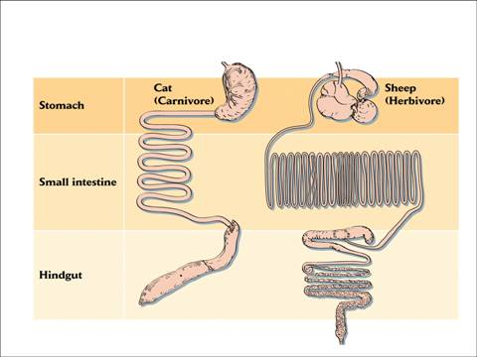Dentition
* Digestion
* Morphology (especially of jaws)
* Behavior

**3. Example of prey body size versus body size of mammalian predators**



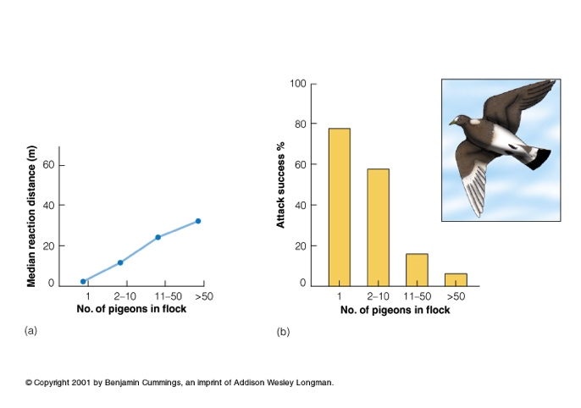**4. Prey have adaptations for escaping their predators**

* Crypsis.
* Chemical defense
* Mimicry of noxious organisms

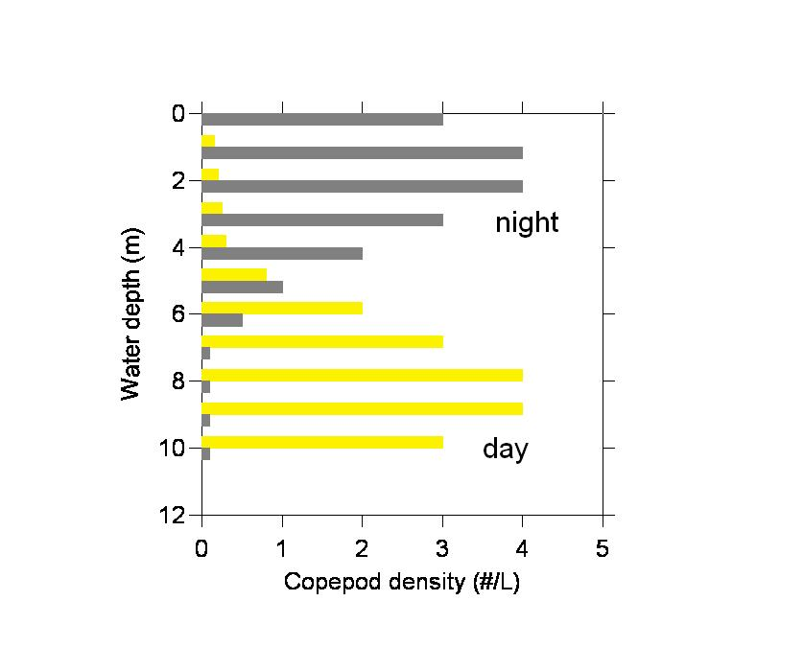-Batesian:

-Mullerian:

* Mechanical and morphological defenses
* Behavior

**5. Plant defenses against herbivory**

* Structural – e.g., thorns, bark, etc.
* Chemical – alter the palatability and digestibility of plants

-Inhibition

-Secondary compounds

*why are chilies hot to humans?

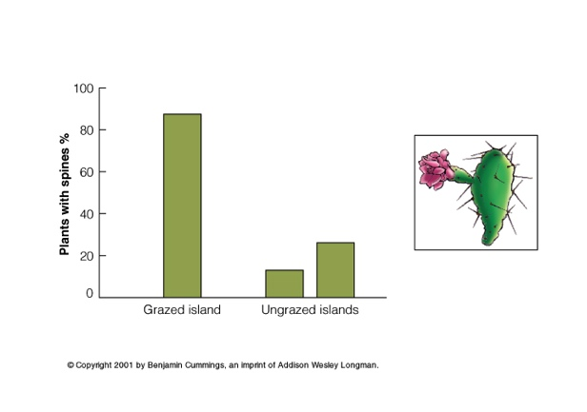Are plant defenses ‘on’ all the time?

Constitutive defenses:

Inducible defenses:

advantages? risks?



**Can herbivores control plant populations?**

Examples:

Can be quantified with exclosure experiments.

**6. Optimal Foraging Theory (OFT)**

* provides a framework for attempting to answer the following types of questions:

1. what prey does a consumer chose to eat?
2. how far will a predator travel to capture prey?
3. how long will a predator search before giving up and moving on to another spot?

With respect to diet selection by consumers, OFT assumes the following:

* consumers have adaptations to feeding on certain prey types
* all prey have certain benefits and costs associated with them. What are they?
* profitability of prey can be ranked in terms of their relative costs and benefits
* others?

OFT makes the following predictions about prey selection by consumers:

* consumer diets are dominated by foods with the highest profitability when these prey are abundant
* less preferred prey are included in consumer diets as most profitable prey become scarce in the environment
* diets are more diverse at low prey densities

Do ‘real’ consumers act optimally or opportunistically in nature?

**7. Risk sensitive foraging**

All consumers are faced with conflicting demands on how they spend their time. Consumers can not spend all of their time searching for food and feeding.

Other demands on consumers include?

looking for mates, hiding from predators, resting

There is now substantial evidence that most consumers will give up the opportunity to feed on high quality prey if the risk of predation is sufficiently high. In many cases, the predictions from OFT have limited use because of the overwhelming importance of avoiding being eaten by a predator.

Example 1: tadpole foraging under the risk of predation from dragonfly larvae and fish

Example 2: minnows choosing food patches depending on the relative food rewards and predator density.



Example 3: How do the feeding rates of consumers in nature compare to the rates that are physiologically attainable? Example from freshwater fishes.

