1. Anti-predator behaviours often come at a **fitness cost** to prey. (e.g. prey that spend more time hiding may have less time to forage or mate).

Example 1: Juvenile rays in Shark Bay, Australia (Vaudo & Heithaus 2013)

* rest in shallow nearshore waters when predators are abundant to reduce predation risk
* warmer temperatures associated with shallower waters mean that rays also incur metabolic (energetic) costs in these refuges

Example 2: Western sandpipers on northward spring migration (Lank et al. 2003)

* reduce predation risks from migrating peregrine falcons
* take a multi-stage migration route, that is longer and more energetically costly than a direct flight

2. Fear effects include:

* prey hiding more
* prey foraging less (which can result in reduced somatic growth rates)
* prey foraging in suboptimal habitat
* prey moving shorter distances from refuges
* prey being less active
* disruption in courtship &/or mating behaviors of prey

*Can you think of any other changes in prey behavior that could result due to the fear of predators?*

3. An example of a simple **trophic cascade** (*we’ll talk about this more in a few lectures*) is shown in A, where predation (by wolves) reduces the population size of prey (deer), and lower numbers of prey in turn allows the plants they eat to increase.

It has been shown that similar chain reactions of predators and prey can occur based on fear, termed a ‘*fear-induced trophic cascade*’ shown in B.

*How might they differ?*

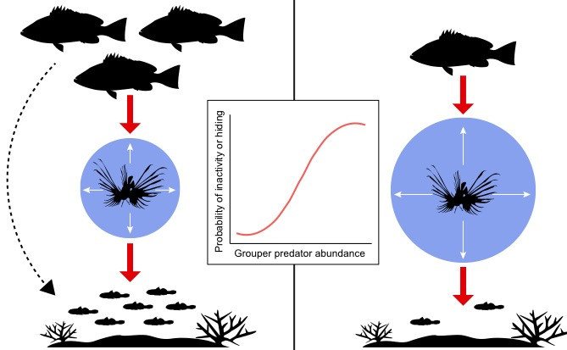A) B)

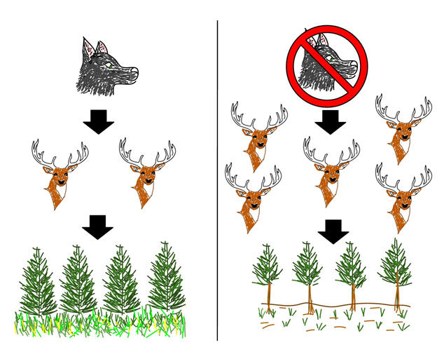

4. Invasive species have to overcome a series of physical and ecological barriers as they progress through the various stages of invasion shown below.



A species that arrives in a new environment typically starts off at a low population density.

*Remember that small populations are more likely to go extinct than large populations due random changes in birth and death rates (i.e., demographic stochasticity).*

Can you think of potential ecological or physical barriers to a species establishing a self-sustaining population in a new environment?

(Hint: What else is present in an environment? Do species automatically end up in the most ideal habitat?)

5) **Biotic Resistance**

The ability of native species to prevent the establishment, or limit the success,

of non-native species

Factors thought to provide biotic resistance:

* Native predators
* Parasites & pathogens
* Higher local diversity (e.g., genetic, species, functional)
  + More diverse communities can be more resistant to invasions

Example:

Biotic resistance through fear of predators on Caribbean coral reefs

Indo-pacific lionfish – invading Caribbean

Predator on many small reef fishes, crustaceans

*Where did they come from?*

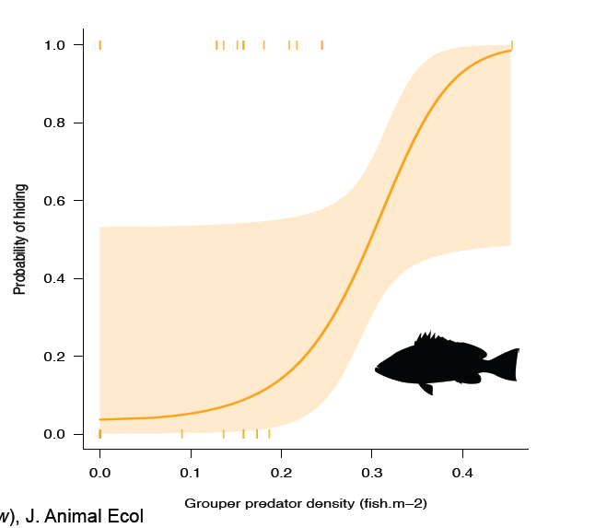 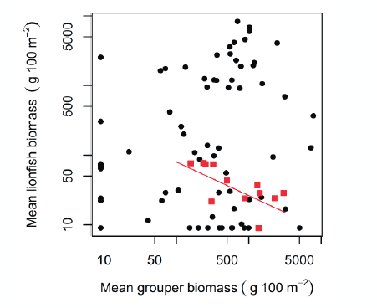

*What kind of study did Nicola and colleagues use to evaluate their hypothesis?*

How did lionfish respond to higher grouper (predator) biomass?

Did they find support for a ‘fear-induced trophic cascade’?

What are some key lessons learned from this study?