Guest Lecture #3 – Human alteration of nutrient inputs and subsidies
Presented by Nicolas Muñoz

Ecosystem Nutrient Limitation
Ecosystems are often nutrient limited in that the productivity of primary producers is limited by the availability of nutrients such as nitrogen and phosphorus.
Where do these nutrients come from?
Within ecosystems nutrient recycling
  - Question: Describe the principal process by which nutrients are recycled in aquatic ecosystems. What environmental variable can impede this process?
Adjacent ecosystems nutrient subsidies
Human activities eutrophication, exotic species

Nutrient Subsidies
Nutrients from adjacent ecosystems can be delivered into recipient ecosystems, often through the migration of animals. The nutrients that migratory animals bring can increase the productivity of recipient ecosystems beyond that which can be supported by in situ (i.e. within) productivity alone.
Examples: Rocky islands via seabird guano, temperature rainforests via spawning salmon

Eutrophication
Excessive inputs of nutrients in aquatic ecosystems lead to algal blooms, which deplete waters of oxygen (i.e. hypoxic water) and, subsequently, result in fish die-offs. Humans cause eutrophication through intensive livestock production as well as the widespread use of nitrogen- and phosphorus-based fertilizers, which enter aquatic ecosystems through runoff.
Question: Where would you expect eutrophication to principally occur? That is, in which bodies of water?
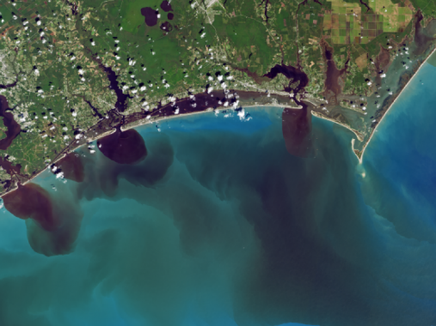
Example: Eutrophication from pig farms in North Carolina, spurred by hurricanes.
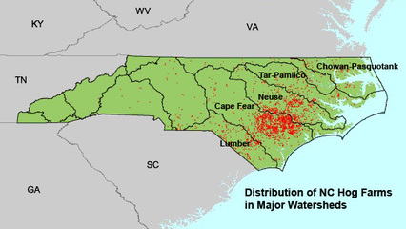

Exotic Species
Human activities have led to the establishment of exotic, non-native species in ecosystems around the world. One of impacts that exotic species can have is the disruption or creation of nutrient subsidies.
Example: Seabirds enhance coral reef productivity in the absence of invasive rats.
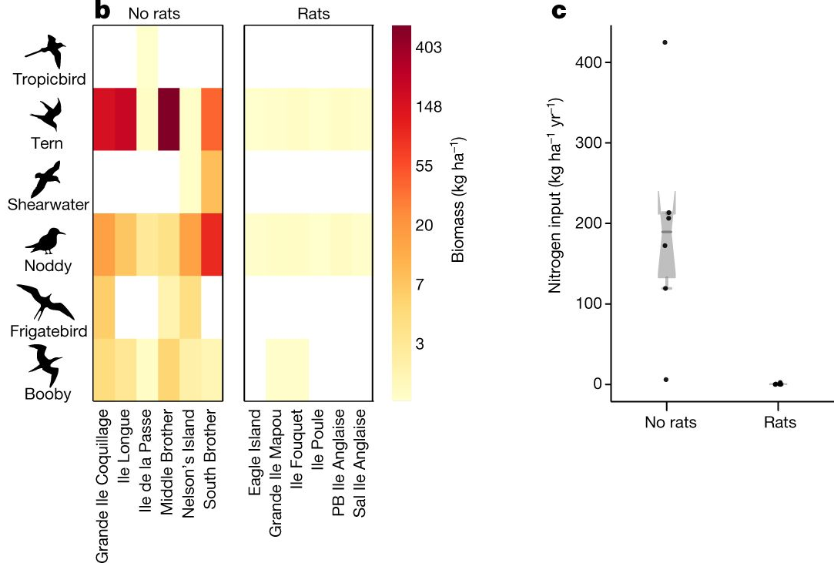

Case Study: Exotic salmon in Patagonia, southern South America
Chinook salmon were introduced to a few streams in southern Chile in the 1970s and 80s, and have since colonized seemingly all inhabitable watersheds in southern Chile and Argentina.
In addition to subsidizing forest ecosystems, salmon can subsidize the streams in which they spawn. Nutrients from their carcasses dissolve in the water column and are subsequently incorporated into the microbial communities comprising benthic biofilms. Biofilms are the ‘mat’ on the streambed and are composed of a diverse assemblage of microbes including algae, bacteria, fungi and protozoa. The algae in biofilms are often the principal primary producers in stream ecosystems. In nutrient-limited streams, salmon-derived nutrients can increase the abundance of algae, which can increase the abundance of heterotrophic organisms.
Question: If subsidized algae increase the abundance of heterotrophic organisms, what type of food web effect would this be? Which trophic level should be affected the most?

Hypothesis
Salmon-derived nutrients subsidize stream biofilms in Patagonia.

Study Design
- Four streams: three with spawning salmon, one “reference” stream with no salmon
- Each stream has a waterfall, which acts as a natural barrier to salmon migration. Below the waterfalls are the “Impact” sites, where salmon are present. Above the waterfalls are the “Control” sites, where salmon are absent.

Question: what variables could confound this type of upstream vs. downstream comparison?

- Response variables:
  - Isotopic ratios of carbon (δ¹³C) and nitrogen (δ¹⁵N)
  - Biomass of algae (chlorophyll a)
Stable Isotope Analysis
Tool to assess the source and movement of nutrients within food webs. Isotopes are atoms of the same element that have an unequal number of neutrons, giving them different weights (e.g. ¹²C and ¹³C). Isotopes are ubiquitous in the world, being in the food we eat and the air we breathe. When consumed, organisms incorporate isotopes into their tissues. Analysis of stable isotopes has become a powerful tool in food web studies because the ratios in which isotopes occur (e.g. the relative amount of ¹²C versus ¹³C) vary in predictable ways across ecosystems and trophic levels.
Marine ecosystems are generally enriched in ¹³C and ¹⁵N relative to stream ecosystems. Because salmon spend most of their lives feeding in the ocean, their bodies are enriched in these heavy isotopes. As such, the nutrients that they deliver to streams when they spawn are enriched in ¹³C and ¹⁵N. We can therefore detect the incorporation of salmon-derived nutrients in aquatic organisms by testing if their tissue is enriched in ¹³C and ¹⁵N.
Results
- Biofilm at the Impact sites of salmon streams were significant more enriched in ¹³C and ¹⁵N than their corresponding Control sites, whereas there was no difference between sites in the reference stream.
- Algal biomass was significant higher at the Impact sites of two salmon streams relative to their Control sites, but was not different between sites in one of the salmon streams (nor in the reference stream).

Question: The biofilm in one of the study streams (Nirehuao) had increased ¹³C and ¹⁵N at the Impact site but did not have increased algal abundance (chl a) there. How would you interpret this result in the context of nutrient limitation?

Question: If salmon subsidize biofilms in Patagonia, what kind of ecological impacts would you expect? How could these impacts be ‘positive’ or ‘negative’ in terms of native species abundance?

ns
*
*
***
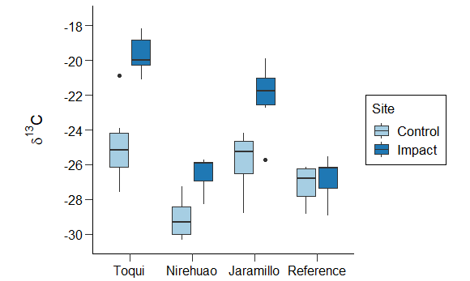

ns
***
***
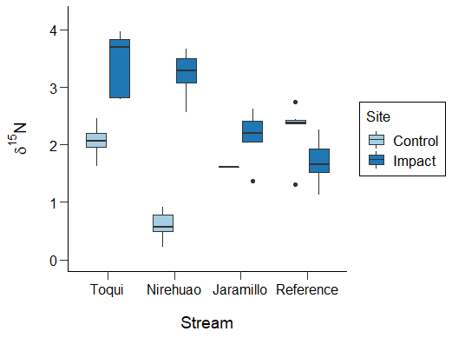

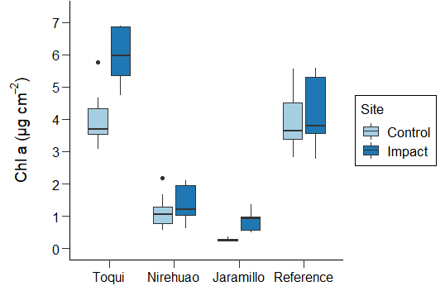
*
ns
ns
***
Stream

