Island Biogeography:

Why study islands?
- Small, simple
- Have discrete boundaries that are easy to understand
- Natural replication
- Many unique characteristics – variations in size, shape, degree of isolation
What might this mean for species?
____________________________________________________________

Early theories
Buffon’s Law:
- “Environmentally ___________ but geographically ___________ regions are comprised of distinct biotas.”
What do you call a species that is unique to a specific geographical location?
____________________
Johann Reinhold Forster:
- Islands generally less diverse than mainland
- Diversity of plants increases with island area, availability of resources, habitat, and heat.

Island Biogeography Theory
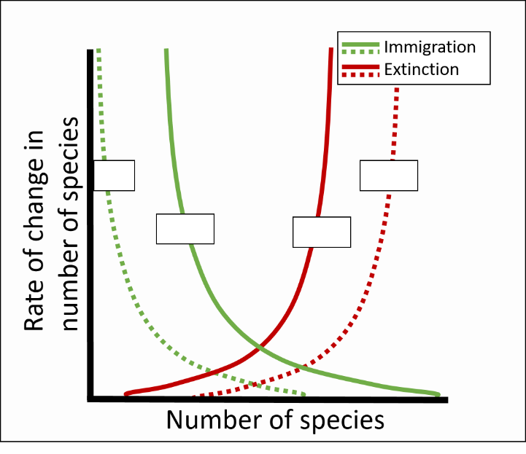
Immigration rate is determined by:

Extinction rate is determined by:

The intersection between the lines for immigration rate and extinction rate tells you:

Figure 2 Rates of immigration and extinction help predict number of species found on an island.

What is meant by dynamic equilibrium in the context of island biogeography?
Equilibrium species richness is reached between rate of immigration of new species, and rate of extinction of established species. Before MacArthur and Wilson, it was thought that species composition on islands was “static”, or “fixed”. It was thought that as time went on, islands would accumulate species, and once all niches were filled, the island’s species composition would remain constant. According to MacArthur and Wilson’s revolutionary theory, even though an island’s species richness remains in equilibrium, the actual species that make up the island’s composition are constantly changing.

Additions to Island Biogeography Theory

Habitat Heterogeneity:
Also known as habitat diversity, habitat heterogeneity is the number of different habitats that are available for species to occupy.
More habitat heterogeneity should mean a greater variety of niche spaces. It’s been proposed that larger islands may have more species on them because they have more different types of habitats on them (not just because they are larger areas).
Example: Ricklefs and Lovette (1999) conducted a study in the Lesser Antilles to distinguish the effects of habitat heterogeneity from island area. They found a set of islands where habitat heterogeneity and area were not correlated. They found that for certain taxa, like plants, with high degrees of specialization, and for those with really large populations (ones where they don’t have to worry about demographic stochasticity), habitat heterogeneity was important, and area was not. They found that for other taxa, like birds, which were found in lower densities and are generalists, area was more important.

Primary Productivity:
- Rate of energy (biomass) produced per area per unit time
- Measure of the amount of energy in an ecosystem
Species-energy theory (Wright 1983): Instead of area, ______________________________ is most important in determining species richness on islands. This can be taxon-specific. For example, in the original study, they used ________________________________ for plants and _______________________________ for birds.

Wind & wave action:
Wind and waves affect the __________________ of an island. If prevailing winds and currents direct organisms towards an island, it is effectively less _______________________.

Climate:
A study by Kalmar and Currie (2006) found that 85 – 90% of global variation in species richness on islands can be explained by:
- Area
- Average annual temperature
- Distance to nearest continent

Ecosystem subsidies
A resource that is passed from one ecosystem to another, increasing ____________ of the recipient ecosystem.
Types of subsidies:
- Organisms
- Materials (detritus)
- Nutrients
Examples of ecosystem subsidies:
In temperate rainforests:

On rocky islands via seabird guano:

On desert islands via kelp wrack:

Subsidized Island Biogeography:
Theory:
At first, as productivity increases, diversity increases.
Beyond a certain point, some species will outcompete others and become dominant, leading to a decrease in species richness.
Effect stronger on small islands because ocean subsidies have a higher per-unit-area effect on productivity.

Diversity

Productivity

Deb’s thesis work:
- Surveyed 91 islands on the Central Coast of BC
- Quantified terrestrial breeding bird communities
- Collaborators flew drones over all islands to assess habitat heterogeneity, shoreline substrate
- Another collaborated weighed wrack (beach-cast seaweeds) on every island
- Collected soil samples to calculate amount of marine-derived nitrogen in soils (represents river otter activity)
Hypothesis:
- Subsidies from the sea (river otter activity & wrack), in addition to classical island biogeography predictors, drive patterns in bird species richness and densities on islands.
- Depending on how productive an ecosystem already is, we might expect an input of subsidies to either increase or decrease species richness.
- Since islands are usually nutrient-poor, we expected higher species richness on islands receiving more subsidies.
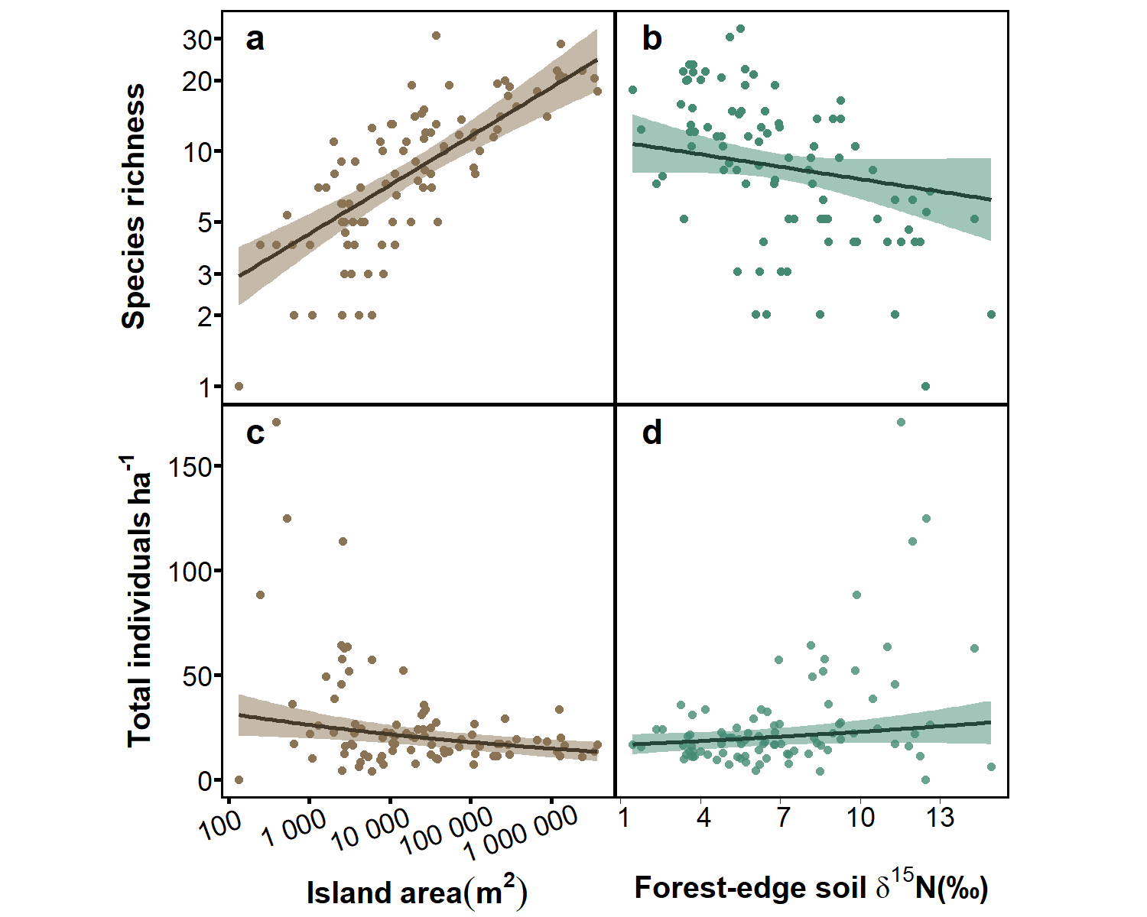
What we found:
Species richness best predicted by area and subsidy
- Larger islands more bird species
- Subsidized islands fewer bird species (possibly due to otters: avoiding predation and/or disturbance)
Total density also best predicted by area and subsidy
- Larger islands bird communities less dense
- Subsidized islands bird communities more dense
No effect of habitat heterogeneity, isolation, shoreline substrate, or wrack
- Species not dispersal limited

How would you expect subsidies to affect immigration rates?
Extinction rates?
What did I find?

