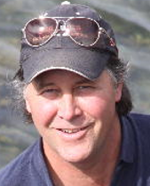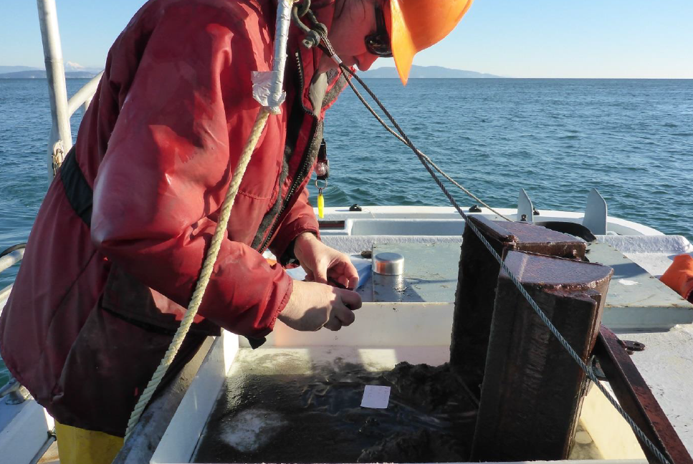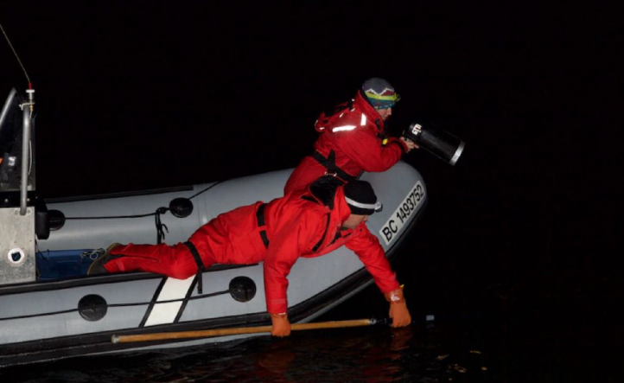
Dr. Doug Bertram: Research Scientist, Pacific Marine Birds and Ecosystems
Wildlife Research Division - West, Science and Technology Branch
Institute of Ocean Sciences, Sidney, BC, Environment and Climate Change Canada

Historically (1996-2001), I was the Seabird Research Director for the CWE focussed on the establishment of long-term funding for the Triangle Island Seabird Research and Monitoring Station, as well as coordination of the large-scale Marbled Murrelet Tracking Programs in Desolation Sound and Clayoquot Sound. As an Adjunct Professor I co-supervised MSc candidates Cecilia Lougheed, Louise Blight, and Carina Gjerdrum.
I took an indeterminate BI 3 position with CWS in 2001 to be Chair of the MAMU Recovery Team, based at the Institute of Ocean Sciences in Sidney, BC. The team met frequently while writing the three part Conservation Assessment (http://www.sfu.ca/biology/wildberg/bertram/mamurt/links.htm) which layed the groundwork for the Recovery Strategy and Action Plan required under the Species at Risk Act.
In 2011, I was transferred to the Science and Technology Branch, Wildlife Research Division, and attained the capacity of Research Scientist. My research focusses on causes of population trends and habitat needs for marine birds with recent emphasis on anthropogenic threats from gillnet entanglement and oiling. I support long-term ecological monitoring and research to develop robust time series. My lab is also devoted to rescuing historic data to make it publically available, such as we have recently done with the CWE MAMU tracking datasets (Pastran et al. 2022, Cooke et al. 2022a,b)
I haven’t supervised grad students directly for a while but continue to play a supportive and advisory role to assist CWE projects, new and old.
Selected publications related to CWE
Pastran, S., D.B. Lank, P.D. O’Hara, R.W. Bradley, C. Lougheed, L.W. Lougheed, N.R. Parker, L. McFarlane Tranquilla, , E.A. Krebs, F. Cooke, D.F. Bertram. 2022. The influence of breeding status and nest site location on marine habitat use by Marbled Murrelets. Marine Ornithology Final Acceptance 18 August 2022.
Hipfner, J.M., Galbraith, M., Bertram, D.F., and D.J. Green. 2020. Multi-decadal ocean climate variability and basin-scale oceanographic processes impact zooplankton community structure, and diet and reproductive performance of a sentinel North Pacific seabird. Progress in Oceanography. 182: https://doi.org/10.1016/j.pocean.2020.102290

McFarlane-Tranquilla, L., J.L. Ryder., L.K. Blight, P.D. O’Hara, and D.F. Bertram. 2020. Nightly attendance patterns of provisioning Cassin’s Auklet Ptychoramphus aleuticus are consistent and synchronous. Marine Ornithology 48: 263-272. Published with dataset and R script. http://www.marineornithology.org/content/get.cgi?rn=1380
Hipfner, J.M., Shervill, D., Domalik, A.D., Bertram, D.F., Lemon, M.F.J., Rodway, M.S., Smith, C. and Hudson (Trefry), S.A 2019. Longevity in the Rhinoceros Auklet Cerorhinca monocerata.and a comparison with other species of Alcidae. Marine Ornithology 47: 223–225.
Bertram, D.F. 2019. Oil spill settlement funds directed to seabird conservation. Marine Policy 108 (103622) https://www.sciencedirect.com/science/article/pii/S0308597X19302490
Bertram, D.F., A. Harfenist, L.L.E Cowen, D. Koch, M.C. Drever, J.M. Hipfner & M.J.F. Lemon. 2017. Latitudinal temperature-dependent variation in timing of prey availability can impact Pacific seabird populations in Canada. Canadian Journal of Zoology 95 (3): 161-167, 10.1139/cjz-2016-0197.
Bertram, D.F., D. L. Mackas, D.W. Welch, W. S. Boyd, J. L. Ryder, M. Galbraith, A. Hedd, K. Morgan, and P.D. O’Hara. 2017. Variation in zooplankton prey distribution determines marine foraging distributions of breeding Cassin’s Auklet. Deep Sea Research Part I: Oceanographic Research Papers 129: 32-40. https://www.sciencedirect.com/science/article/pii/S0967063717300778?via%3Dihub
Bertram, D.F., MacDonald, C.A., O'Hara, P.D., Cragg, J.L., Janssen, M.H., McAdie, M. & Boyd, W.S. 2016. Marbled Murrelet Brachyramphus marmoratus movements and marine habitat use near proposed tanker routes to Kitimat, B.C., Canada. Marine Ornithology 44: 3-9.
Data Publications
Bertram, D.F., M. Jannsen, J.L. Cragg, C.A MacDonald, M. McAdie, A. Wilson, K. Woo, E. Gross, M. Maftei, P.D. O’Hara, S. Davis, R. Green, and P. Vincent. 2022. Data from: Study “Marbled Murrelet satellite tracking data from British Columbia, Canada 2014-2016”. Movebank Data Repository. DOI forthcoming.
Cooke F, Lank DB, Bradley RW, Parker NR, Lougheed C, Lougheed LW, McFarlane Tranquila LA, Pastran SA, Greene R, Vincent P, Bertram DF. 2022a. Data from: Study "Marbled Murrelets at Clayoquot Sound, British Columbia, Canada (2000-2002)". Movebank Data Repository. https://doi.org/10.5441/001/1.kg210889
Cooke F, Lank DB, Bradley RW, Parker NR, Lougheed C, Lougheed LW, McFarlane Tranquila LA, Pastran SA, Greene R, Vincent P, Bertram DF. 2022b. Data from: Study: "Marbled Murrelets at Desolation Sound, British Columbia, Canada (1998-2001)". Movebank Data Repository. https://doi.org/10.5441/001/1.hr82ph6n

