Working Alone or in Isolation Supervisor Guidance Document
* It is recommended that GP 39 and its appendices be reviewed prior to reading this document *

Policy requirements at a glance
Step 1: Identify activities in the department where employees may be required to work alone or in isolation
Step 2: Determine the level of risk (low, moderate or high) of those activities
Step 3: Implement controls to eliminate or reduce the risk
Step 4: Develop site-specific protocols (including check-in procedures for each activity) and train employees
Step 5: Follow check-in procedures when working alone or in isolation activity occurs

Understanding working alone and working in isolation
Working alone or in isolation is defined as working in circumstances where assistance would not be readily available to the worker in case of an emergency or in case the worker is injured or in ill health. Review the below scenarios to further understand what is and what is not working alone or in isolation:

Not working alone or in isolation | Completing work in an area where other employees can see and/or hear you
Working alone | - An office employee completing photocopying alone outside of their department’s office hours  - A researcher testing hazardous substances alone in a laboratory outside of their department’s office hours
Working in isolation | - A Facilities Services employee working in a mechanical room  - An IT employee upgrading equipment in a network closet  - A researcher or team of researchers in a remote location collecting samples by themselves

Things to consider re: “Readily available”
- Presence of others: Are other people in the vicinity?
- Awareness: Will others capable of providing assistance be aware of the worker’s need?
- Willingness: Is it reasonable to expect assistance will be provided?
- Timeliness: Will assistance be provided within a reasonable period of time?

Understanding risk assessment
A risk assessment is an examination of the aspects of a task that may expose workers to an increased risk of injury - a thorough look at a workplace to identify hazards such as potential damage, harm or adverse health effects that may cause harm, particularly to people. Working alone or in isolation adds another layer of risk. The purpose of a risk assessment is to determine whether enough controls are in place or further controls measures are needed to ensure the safety of the worker.

Depending upon department size and the complexity of the potential hazards, the assessment process may be as simple as a short discussion held with workers who are given an opportunity for input or as complex as using an assessment team. Assessment teams should include those workers and employer representatives with the knowledge and experience to provide the best input into the process.

Risk assessment steps:
- Identify hazards
  - What hazards are associated with the activity?
    - Consider: biological, chemical, ergonomics, physical, psychosocial and safety hazards
  - What hazards are associated with working alone or in isolation?
- Evaluate the risk associated with that hazard
  - What is the likelihood of an injury/incident?
  - What is the severity of the injury/incident?
- Determine risk level of the activity
  - Assess all hazards and determine an overall risk level – low, moderate, or high risk
    - See GP 39’s Risk Assessment Procedure for examples of SFU work activities for each risk level
Risk Level | Definition | Requirement
Low | There is minimal hazard with respect to the activity and the work environment. | Low risk protocol development  - List activities  - List check-in procedures
Moderate | Some minor hazard(s) exist in the activity and/or the work environment, but the risk is decreased by the control measures in place. | Moderate/authorized high risk protocol development:  - List positions  - List activities by risk level (including prohibited activities) along with hazards and controls  - List check-in procedures  - List emergency procedures  - List emergency phone #s  - List location of resources  Record check-in
High Risk | There is considerable hazard in the activity and/or the work environment, but the risk is minimized by multiple effective control measures.  High risk activities may only proceed if they have been authorized by the Dean, Director, or Chair. It is highly recommended that a buddy system is utilized.

- Determine appropriate ways to eliminate or control the hazard
  - Mitigate risk associated with the activity using the hierarch of controls
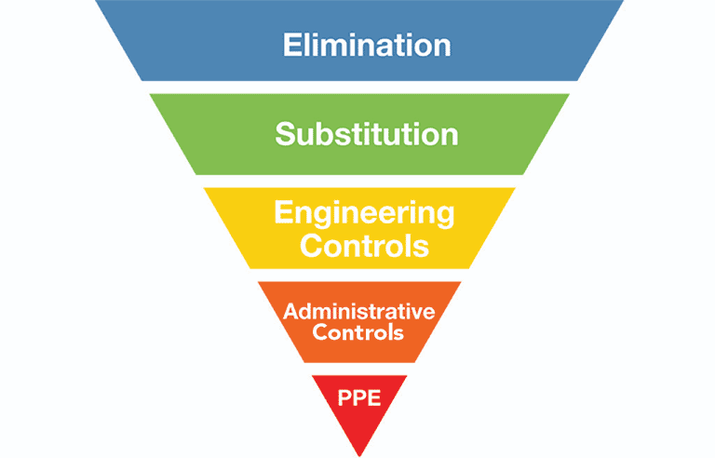

  - Mitigate risk associated with working alone or in isolation
Engineering Controls | Administrative Controls
- communication systems (cell phones, radios, intercoms  - location systems (closed-circuit cameras)  - alarms or personal emergency call devices  - redesigning the work area to improve line-of-sight and/or access | - check-in procedures  - rescheduling work to when other Employees are present  - implementing a buddy system  - restricting new or young employees from certain tasks  - increasing the amount of direct supervision

Site-specific working alone or in isolation protocols
Following the risk assessment, Working Alone or in Isolation Protocols must be developed. The purpose of the protocol is to document the activity’s hazards and controls, list procedures for checking on workers who are working alone or in isolation, and steps to follow if check-in does not occur (including emergency procedures). These documents are “site-specific” meaning they must include details of work activities completed alone or in isolation in the department or can be further focused on activities within a lab.

From the risk assessment, the work activities will be classified as low, moderate, or high risk. High risk work needs to be approved by the department’s Dean, Director or Chair before proceeding. Two template documents have been developed for moderate/authorized high-risk work and low-risk work. The templates are customizable and Supervisors only need to fill in the department-specific activities, controls, and check-in procedures.

Note: It is possible for work activities of all levels of risk to be present in a department. Supervisors can combine the two documents or keep them separate.

Once the protocol is finalized, all employees who work alone or in isolation must be trained on the protocol. If it is found that the protocol is inadequate (missing information) or check-in procedures are ineffective, they should be reviewed. EHS is able to assist supervisors with risk assessments and documentation.

Check-in procedures
Check-in procedures are documented in the site-specific protocols. The procedures should include the following details for each working alone or in isolation activity, however, similar activities can have the same procedures.
The check-in procedures will include:
- Frequency of check-in
  - Approved high risk and moderate risk activities require more frequent check-in.
  - Low risk activities may require check-in only at the beginning and end of the activity.
- Check-in method
  - Visual confirmation of the worker’s well-being is the ideal check-in method; however, two-way voice contact is a suitable alternative. Use of email or instant messaging is acceptable for low-risk activities.
  - In remote locations, in-person check-in is not always possible. Other methods include:
    - Wireless satellite hand-held alerting and tracking devices
    - Satellite phones
    - Radio transmitters
- Contact person
  - Supervisors can delegate the check-in responsibility to a designate. This check-in designate must be trained on the site-specific protocol to understand the risk level and controls associated with the task and able to follow the check-in procedures.
  - Prior to commencement of the activity, the lone worker and contact person should establish who will be making contact.
- Steps to follow if the employee can’t be reached (including steps to take in an emergency)
  - In the event that the lone worker does not check-in, Supervisors or the check-in designate must be prepared to take further steps to ensure their well-being.
    - For example, if the primary check-in method is via telephone, the next step would be to attend the work location for visual confirmation.
- A check at the end of the shift.

Check-in should be documented. A template has been developed to for check-in documentation.

Additional support
For general inquiries about working alone or in isolation or specific questions about documentation, please contact vanessa_christner@sfu.ca.

