Speaking Notes and Powerpoint Slides.

“All the work women do:
Imagining household and group provisioning”

Marge Reitsma-Street
Stephanie Baker Collins
Judy Cerny
Sheila Neysmith
Elaine Porter
Sandra Tam

“Imagining Public Policy to Meet Women’s Economic Security Needs” Conference hosted by Simon Fraser University Women’s Studies and the Economic Security Project
October 14, 2005, Vancouver, B.C

Introduction

This conference is about gathering strands of imaginative ideas. It is about creating ideas through our papers, conversations, and by being together here and now. The aim is to engage with ideas that propel us forward into new directions and reconfigured arenas.

This paper introduces one such imaginative idea–provisioning–that we argue can help propel us to innovative policy and practice. The subsequent three papers go deeper into this concept and its implications, drawing upon original research from interviews with over 100 women in marginal social positions, as well as focus groups, field conversations, observations in six different women’s groups and organizations in British Columbia and Ontario associated with the Wedge Provisioning Research Project.

Patti Lather and other feminist scholars and activists speak of ideas with catalytic validity. Catalytic validity means ideas are not just empirically sound and well argued but they are also inspirational, catapulting persons into activity. The inspiration is about strong ideas for specific actions, to be used in the here and now, and ideas that spark theoretical possibilities for other futures. Therefore, those committed to the notion that ‘another world is possible’ -- whether as policy makers, community workers, activist scholars, or participatory researchers-- seek to engage with ideas that do not paralyse, but activate energy for change, individually and collectively.

There are various types of strong, catalytic ideas that need to be pursued. We decided to choose an idea, a concept--provisioning--because it is catalytic and also productive. By this we mean an idea or concept “does” something active to us and others. Provisioning seems to produce more information, more fruitful questions, more complex yet parsimonious ways of understanding the world of women’s work, than other concepts that we had worked with but rejected, such as poverty, social exclusion, or unpaid labour. Productive ideas produce interest and attention–by many people-- to the range of what is problematic and important about everyday living. Unpaid or caring labour is important. But that concept now seemed too limited to us, missing the range of complex realities of what women say is important to their lives and struggles.

A productive idea produces something. A productive idea adds substantial value to understanding everyday issues and intellectual directions for solving of ordinary, complex, important problems. It captures a more complete range of what women and men do in their lives, and how they do it, and what policies would support how they do provisioning well. That is the substantive contribution we hope to make in our four papers today. The next slide is our current definition of provisioning, and I will return a little later to what it means, and how we reached this definition.

Slide: Definition of Provisioning
Provisioning is the daily work performed to acquire material and intangible resources for meeting responsibilities that ensure survival and well-being of self and others. These activities involve relationships with others. Both work activities and relationships may be voluntary or prescribed.

Finally, catalytic and productive ideas, such as provisioning, produce ways to create solidarity, connections, and foundations—or maybe at first only rafts or webs--that serve as means for women and men to think and work together, collectively, for another world. Marxist thought is replete with productive ideas such as ‘capitalism expropriates the surplus value of people’s work’ that open up a rationale for developing solidarity among workers and initiate unions and campaigns to reclaim that surplus value. In feminist thinking, the notion ‘the personal is political’ provided a powerful rationale that women used to engage collectively in debates, campaigns and experiments to create women’s centres, some public funding for daycare, and anti-harassment and equity pay laws. Productive ideas are thus not just strong catalytic ones; they also give us in Marilyn Waring’s phrase ‘a place to stand’ together.

The Wedge Provisioning Research Project

The six members of the Wedge Provisioning Project cross site team is looking at “how do women and groups ‘provision’ for themselves and others for whom they have responsibility” and what supports and constrains their provisioning work. The four co-investigators are here today presenting papers and there are two doctoral students. Each of the six is responsible for a particular site, presented in the next slide.

Slide: Six Sites of Provisioning

- members of a food coop in a small city in southern Ontario,
- members of a community resource centre working-class multilingual neighbourhood in northern Ontario;
- members of an employment preparation program for abused women in a western Canadian city
- young immigrant women in programs for education, employment and housing in a large Ontario city
- members of an older women’s network centered in a large Ontario city
- members of an emerging tenants group in a large public housing in an urban centre in southern Ontario

Each of us is engaged in research that contributes to policy and community in the areas of women’s work, alternative organizations, poverty, and marginalization. We came together a few years ago, wanting to assist in some way to stall, to witness, to document, and to resist the avalanche of destructive policies for women. In particular we were concerned about the gutting of services to women on low or insecure incomes, the destruction of local, non profit, women centered women’s groups and organizations, and the shrinking of spaces where women collected to talk and imagine other ways to survive and prosper.

One way we decided to contribute is to document and theorize how women–individually and collectively--talk about, create, and value “all the work they do everyday” in the new economy restructured by neoliberal governance and market globalization. Hence the two part title of this paper: “all the work women do” and “imagining household and collective provisioning.” “All the work women do” is a phrase that speaks to the many activities that women do that they see as work–i.e. necessary and productive tasks. The word “imagining” points to the work that women and groups think they could do if the conditions were right.

The work of this WEDGE provisioning research project is guided by advisory groups of women in each of the sites. The purpose of these site groups is to ensure the research activities make sense to the sites and that community members have opportunities to provide input into how the research activities are designed and interpreted, and how the research can be useful.

Concepts about Women’s Work

How did we come to provisioning as a concept? How does it help us understand more of what women and women’s groups do, and could do? We started the research examining concepts that contribute to conceptualizing the work women do in the household, the market, and the community.

Think of pie sliced into six wedges. Each of these wedges represents one concept or way of thinking about women’s work.

Wedge one is paid employment and acquisition of funds to purchase necessities. This aspect of work is essential, but only one avenue for achieving the goal of procuring the necessities for a household or agency. Moreover, as restructuring, downsizing, and demands for performance and flexibility increase, women face precarious, insecure “flexible” jobs with inadequate pay or benefits while organizations scramble to write another proposal for short-term contracts that do not cover costs of services. Neither the jobs nor the funds adequately provide for the necessities of life.

Wedge two is the underground economy and informal work. Women in households and in their women’s groups engage in diverse but invisible ways–whether through bartering, exchanges, secondments, and accommodations and so on–to obtain resources necessary to ensure the survival of those for whom they feel responsible.

Wedge three is domestic work of cleaning and cooking, shopping and mending, whether paid or unpaid. The janitorial, cooking, domestic work to feed people, clean places, and keep households and agency toilets in order! Time and skills devoted to these necessary activities are enormous. Their contributions to GDP are no longer questioned, but they remain undervalued and ignored. Anti-racist critiques peal away the problematic implications of policies that push households and agencies to hire poor women and Majority World women to do these tasks cheaply.

Wedge four is caring labour–whether paid or unpaid–performed inside households or in agencies, groups, communities, and residential settings. This type of work is finally recognized as real work–purposeful, essential, planful activity. Caring labour includes both the emotional caring about persons and the attentive caring for specific concrete bodily needs of persons, particularly of vulnerable, sick, young, or older persons. This wedge of women’s work brings into the spotlight that caring labour is embedded in social relationships that are integral to the work, and cannot be fragmented, divided or out sourced. Also that humane time is required to care about and for people do this work, that cannot be squeezed into clock time and market efficiencies of 20 minutes for a bath.

Wedge five is the volunteer and community work that women do individually and together. Looking at this aspect of work makes visible not just the two spheres of household and market as places where women work, but the third sphere of community. Research documents some of this type of work activity while organizations rely more and more on the volunteering of individuals to fulfill their mission statements. But, much of this work goes beyond volunteering in associations, and thus is underestimated. So too individuals and women’s groups perform invisible community work that is invaluable, but ignored. Neither is it theorized or supported. Volunteering doesn’t fit or adequately represent what women, especially those in low income households and communities actually do to provide for others.

So, we come to wedge six. This is the huge category of miscellaneous, the third shift, all the residual ‘other’ work that needs to be done to provide the necessities of survival and well-being. This miscellaneous category includes for example the health work of getting kids to the doctors. There’s the filling out of welfare forms, and waiting for hours by the phone for the welfare worker to call. It is the work of negotiating the boundaries, emotions and conflicts between paid, domestic, caring, voluntary, and informal work. Our research is filled with examples of many types of miscellaneous work in organizations and households that ensure the survival and well-being of households and communities.

Provisioning as ‘All the Work that Women Do’

Provisioning thus contains these six wedges of work–employment, informal, caring labour, domestic, volunteering, and miscellaneous other. Provisioning is a concept that also brings into the spotlight the relationships and implications of how all these types of work activities interact, compete, and collaborate with one another. Thus, in our interviews and focus groups, we do not ask about paid work, caring labour, or their voluntary work. Instead, we ask individual women, many of them on very low income, and groups associated with women’s organizations, about who they are responsible for, what they provide, and how.

The next slide is a picture of how we in the Wedge Provisioning Research Project are imagining the coming together of these separate wedges of work into the one concept of provisioning. As we with our arms in wedges move together into a circle we are conveying the coming together and the creating of another concept-- provisioning. The circle of provisioning is, we argue, a more accurate, comprehensive concept that captures and values the complexity, the relatedness, the imbrication, the entanglement of all the work that women do—individually, in households, and in community groups.

Slide: Provisioning includes all the wedges of women’s work
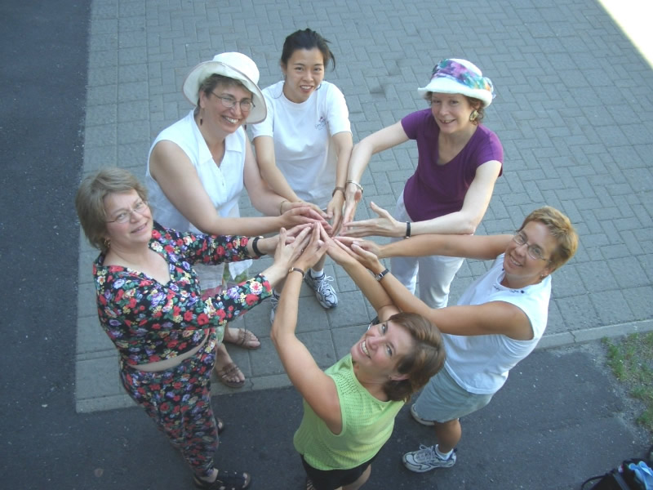

In brief, we argue that the six wedges are not to be traded off one against the other. Each is important. Provisioning, however, is a larger and different type of concept in which these wedges or categories of work come together in new and fulsome ways. We also argue that using provisioning as a concept helps to faithfully examine what and how women work, and wish to work. Thus we are rejecting the current ways of “splitting” women’s work into paid work, caring labour, volunteering etc. Rather we have decided to “lump” all work women do into the larger concept of provisioning and are now proceeding to investigate what provisioning does to seeing what is and could be. This means we will split open this provisioning concept not into the old ways of seeing women’s work, but into new ways of understanding the varieties and patterns of the work women really do and wish to do–in the context of their complete lives. With this new understanding, we aim to see more thoroughly what supports and constrains providing for the lives of those for whom women are responsible.

Provisioning is not a new concept, nor one we created. Julie Nelson and other feminist economists have coined it to speak more completely about what women do and how, and they focus on the material context in which women work and the purposes for which they work. The term “social provisioning” is currently appearing in the feminist academic and professional international literature (Powers etc.). Elaine will comment on some of this literature in the introduction to her paper on collective provisioning about the work that women groups and organizations do as they move from the “I to the we.”

We adopted this concept of provisioning and are now developing and theorizing it through empirical work in information from multiple sources the six sites, in order to see more accurately what women do and how and what implications it has for theory and policy. The next slide revisits our provisional definition of provisioning.

Slide: Provisioning Revisited

Provisioning refers to the human time, the multiple tasks, and the relational dimensions of women’s work in the context of the purposes for which the work is produced.

The next two slides provides a glimpse of the emerging new ways we are naming all the work women do when women and groups of women are asked about what they do to provide for those they feel responsible for. Stephanie and Elaine will expand and debates these emerging names and patterns and hence I move on to last part of this paper.

Slide: Patterns of Household Provisioning Activities

- producing publicly recognized work e.g. job, domestic work, education
- doing caring labour, e.g. emotional work
- attending to personal needs e.g. health work
- performing daily survival strategies, e.g. doing 3 jobs; making claims; managing resources; prioritize safety
- engaging in community work, e.g. creating networks, volunteering
- envisioning a future e.g. making plans; imagining other possibilities; resisting erasure; negotiating boundaries

Slide: Patterns of Group Provisioning
- Providing material support
- Fostering foundations & inspiration
- Creating culture that counters dominant discourses
- Striving to survive amid narrowing spaces
- Minding the margins

Concluding Comments

The first question of the Wedge Provisioning Project is to examine the patterns of how women and groups provide, and to explore how they imagine it could be different.

The second question is what constrains and supports provisioning work. The next slide illustrates this research question: what happens for instance to provisioning if policies and discourses force disproportionate attention to paid work and funding proposals? As jobs and money are pushed into a privileged status, sculptured by one of the researchers standing upright while the others are bowed down, then jobs monopolize time and attention while other work required to ensure people and communities flourish gets scrunched, paralyzed, and distorted.

Slide: Disproportionate attention to finding a job and funding negatively impacts other aspects of provisioning

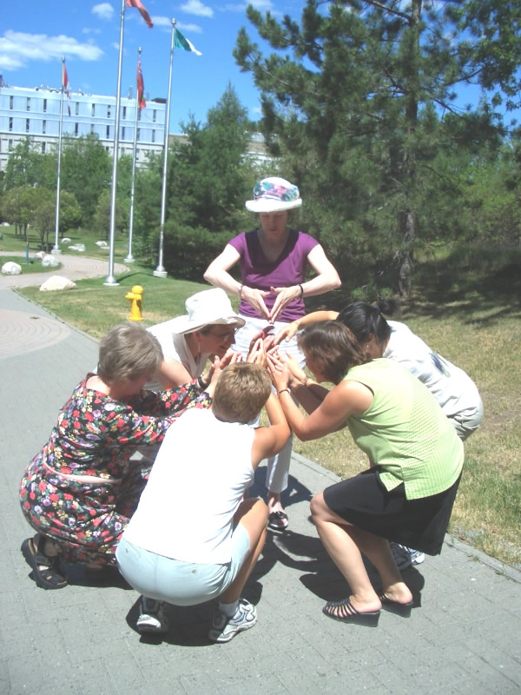

Given the focus of this conference is on imagining new possibilities for policies, we are not reporting at this time findings on the impact of policies such as performance based funding or workfare on provisioning in households and groups. Rather, we leave you with a final photo that sculptures an imaginative way to weave together the many dimensions of provisioning into a stronger whole, with none privileged. The linking of arms suggests the many aspects of provisioning activities are inextricably part of each other. The braiding of women’s arms also captures the relational nature of provisioning. Provisioning is about women doing work with, for, and in the midst of relationships: work is not separated from the work nor is provisioning separate from the provider. Finally, the sculpture of braided arms points to how we in the Wedge Provisioning Research Project imagine the active, relational nature of provisioning is nourished and strengthened in a group or community of other people.

Slide: Weaving activity and relational aspects of provisioning into a stronger whole

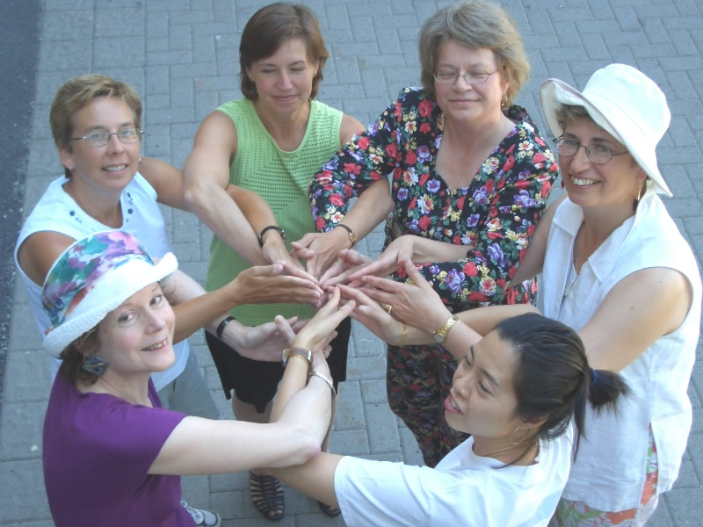

To end, I will speak about two assumptions in the research that challenge our imagination. One is the pursuit of imagining ideas and strategies takes place through conversations with others, in our research and in this conference. Hence, a key part of our analysis is looking at what women talk about when they come together in the food cooperative, in the employment centre for women leaving abuse, and how do they together address the harsh pressures and contradictions of trying to “survive and change at the same time” as one woman said about her organization that had its funding contract terminated.

The other assumption is these conversations are embedded consciously or unconsciously in theories of political economy, that attempt to account for how the world economies and governance are seen to operate, and how they could do so differently. Briefly, as sketched in the last slide , we draw upon a framework of three types of economics–a market economy, a welfare economy, and a provisioning economy and three types of governance-- a market or capitalist state, a welfare state, and what we propose to name the provident state (see writings of I. Bakker) These frameworks of economics and governance assist in clarifying how people see, name, and argue what are the important forces and logics that push, regulate, constrain, and support all the work women do in their everyday lives. Sheila will be picking up in her paper some points from these frameworks, to sketch what policies of a provident state could look like.

Slide and Table:
Provisioning Research Theorized with Frameworks of Economics and Governance

 | The Political Economy of the Market | The Political Economy of Welfare | The Political Economy of Provisioning
Key Concepts | Trade  Supply & Demand  Money (credit, income, wealth)  Work  Productivity  Efficiency  Independence | Rights & Needs  Relationships  Capital (Economic, Surplus, and Social)  Labour  Distribution  Justice  Interdependence | Provisioning  Relatedness  Resources (Time, Natural, & Human)  Provisioning  Differences  Capabilities  Livelihood
Nature of Persons | Worker  Consumer | Citizen  Claimant | Provider  Member
Spheres of Activities | Two Sphere  Market & Household | Three Sphere  Market, Household, & State | Four Sphere  Community, Household, Market & State
Nature of State | Capitalist State | Welfare State | Provident State
Logic of Change | Logic of accumulating profit from surplus value of labour and natural resources | Logic of claiming rights, distributing wealth fairly, and responding to needs | Logic of provisioning for rich life of current and
Issues and Critical Tensions | Restrictions on trade & money;  Inefficiencies;  Need for consumption;  Discipline undeserving poor & aid to deserving  Starvation & oppression;  Invisibility of caring work and destruction of earth;  Monopolies of money, ideas, creativity, power | Inadequate access to education & employment opportunities;  Balance of people s rights, claims, needs with resources and market requirements  Paternalistic surveillance and technologies of conformity;  Near Monopolies of money, ideas, creativity, power | Negotiating implications of multiple differences;  Sustaining connections among persons and spheres of activities over time and space  Contradictions between limits on growth while enhancing diversity

Selected References
Nelson, J. A. (1993). The study of choice or the study of provisioning? Gender and the definition of economics. In M.A. Ferber and J.A. Nelson (Eds). Beyond economic man: Feminist theory and economics, 23-36. Chicago: University of Chicago Press.
Isabella Bakker (2003) “Neo liberal governance and the reprivatization of social reproduction: Social provisioning and shifting gender orders. Pp. 66-82. in Power, production and social reproduction. Edited by Isabella Bakker and Stephen Gill Houndmills, Basingstoke, Hampshire and New York: Palgrave Macmillan
Nelson, J. (1998). Labour, gender and the economic/social divide. International Labour Review 137(1), 33-46.
Neysmith, S, M. Reitsma-Street, S. Baker Collins & E. Porter. “Provisioning: Thinking about all of women’s work” Canadian Woman Studies 2004 Vol 23(3/4): 192-198
Neysmith S. & M. Reitsma-Street. “Provisioning”: Conceptualizing the work of women for 21st century social policy” Women’s Studies International Forum, 2005, Vol 28(5): 381-391.
Power, Marilyn. (2004). Social provisioning as a starting point for feminist economics. Feminist Economics vol. 10 no. 3, 3-19.

File=home/WEDGE/papers/overviewprovisioningESPwebdec2005

Dr. Marge Reitsma-Street is Professor in Studies in Policy and Practice, Faculty of Human and Social Development, University of Victoria, and Principal Investigator of the Wedge Provisioning Research Project. mreitsma@uvic.ca For more information on the project contact Donna Barker at dbarker@uvic.ca Special thanks to Oxana Mian for excellent photos and to Heather Keenan for preparing presentation. The funding of SSHRC is appreciated, Standard Research Grant No. #31833. See Appendix 1 for Update on Wedge Research Project and recent publications.
2 See initial publications including: “Provisioning: Thinking about all of women’s work” by S. Neysmith, M. Reitsma-Street, S. Baker Collins & E. Porter. Canadian Woman Studies 2004 Vol 23(3/4): 192-198; “Provisioning”: Conceptualizing the work of women for 21st century social policy” by S. Neysmith & M. Reitsma-Street. Women’s Studies International Forum, 2005, Vol 28(5): 381-391.

