Dynasty
IAT 410 – Testing Report

October 16th, 2007
Section E104

Team:
Denesa Yip (PM)
Jessica Kwan
Catherine Poon
Ivan Yuen
Michael Leung
Calvin Li

Setup

We conducted three playtesting sessions in total with one user for each session. Since we were unable to find a time where all our team members and users were available to reserve the observation room at school, we chose to use a study room at one of our houses that had a glass door. However, users’ voices did not carry very far past the doors, so we connected voice conversations on two laptops through MSN accounts and placed one laptop on a side table to the left of the game setup, which allowed us to observe their playtesting from a distance. To make more use of this connection, we incorporated interactive games on MSN and on the web into the prototype of our game.

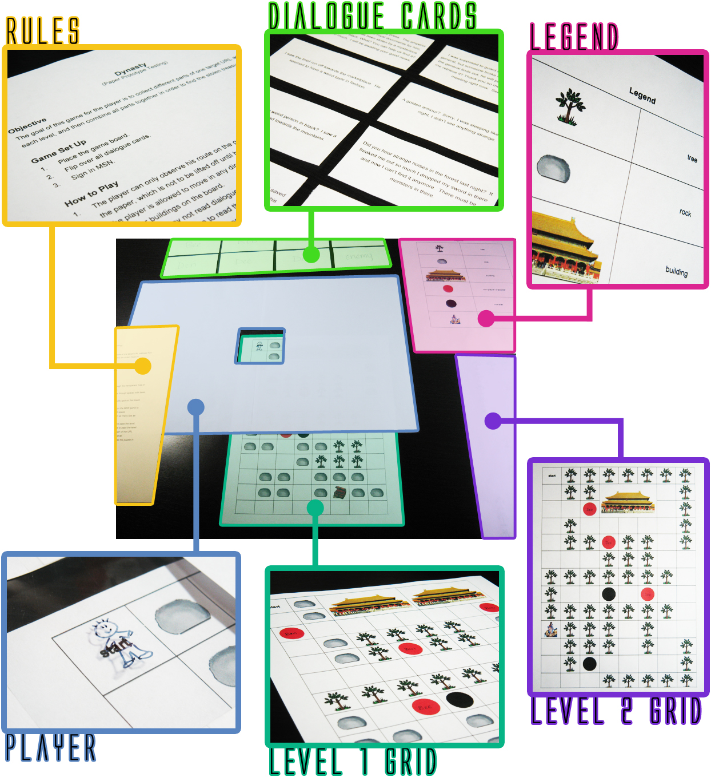

This setup places everything at arm’s length and also gives a sense of which items should be viewed first. The instructions sheet lying on top of the player piece to make sure the user will read it first. The player’s walker piece is already centered on the start space of the level-one grid so that the game may begin right away. To the right is the level-two grid lying face down so users will not see and memorize the layout before they pass level one, but at the same time is close enough so the switch can be made quickly afterwards. As for the legend and dialogue cards, they are placed farther away yet at a handy distance that can be easily reached when needed.
Users

Since the graphics of Dynasty will be geared towards cute animations, we chose gamers whose usual preference is role-playing games (RPG) with a similar level of design.

Name | Ben | Dexter | Teresa
Age | 15 | 16 | 20
Socio-economic Status | Average | Average | Average
Occupation | Student | Student | Student
Level of Game Experience | Average | High | Above Average
Genre Preference | RPG | RPG | RPG
Favourite Games | Eternal Sonata, Children of Mana | FF Tactics (GBA), Pokemon | Animal Crossing, Pokemon

Procedure

Before leaving the users to start the game on their own, we took some time to explain the basic storyline of the game, because to simplify and shorten things up, the prototype only covers two levels of the game and then skips directly to the end level boss. We said:

“This is the first prototype of our game Dynasty, so none of the graphics have been developed yet, but we have decided to take on a cute animation style comparable to graphics you may find in Pokemon, Eternal Sonata, and other similar RPG games. Now here’s the storyline. A sudden warp in time brings you a thousand years back in ancient China, where you discover that history has been shuffled around. Items in the last five dynasties of China have gone missing, which means there will be five levels in the game plus a boss stage. As you restore the items (one for each dynasty), you will gain pieces of a puzzle that you will have to put together in the end and realize who is behind all these robberies. Each item is actually stolen by people in black outfits who serve the Dark Master, and you will have to battle him in the end. However, for this paper prototype, you will only get to play through two simplified levels and then skip to the boss stage. Also, battle modes have currently been replaced with puzzle games on MSN and the web for now to represent the strategy that will be needed in the final product, so when you reach situations in the game where you need MSN, use this laptop. We will leave you to test the game now. Please think out loud, and we will be observing from outside. You might want to read the rules first. Have fun.”

At this point, we left the users alone so they may begin their playtesting sessions. We took notes on the other side of the glass door that allowed us to monitor our users on a side profile, and listened to their thinking with the microphone linked through MSN on a laptop. When each player finished the game, two team members took individuals into another room where they asked them a set of questions prepared beforehand, which aided us afterwards in the reflection and improvement of our game design.
Observation

In-game Observations

Ben
- Read the rules and went through the game without much pausing and difficulty.
- Interesting comments during gameplay:
  - Ooo…a printing press. (reading the first dialogue card)
  - Ahh! A monster.
  - I got a key! To what? Oh! I get half a URL.
  - Yay, I found the treasure.
  - This is like Dungeons and Dragons.
  - Yes! A puzzle. I love puzzles.

Dexter
- Read the rules and went through the game without much pausing and difficulty.
- Interesting comments during gameplay:
  - These graphics make it look like Neopets.
  - So I have to find a block.
  - There are no mountains.
  - There are no royal scrolls.
  - Oh that’s evil. (walked into a dead end with a monster)
  - What? Another dead end?

Teresa
- Read the rules and went through the game without much pausing and difficulty.
- Interesting comments during gameplay:
  - Oh ok, I need to find a printing block.
  - I got the key I got the key. So this is the first half of the URL?
  - I’m stuck…I’m stuck again. (referring to dead ends)
  - Hey I don’t want to fight this monster.
  - Hi NPC (non-player character).
  - No! Another monster!
  - Yay I got the complete URL now.
  - Ooo…a puzzle.

Post-game Questions

General Questions

What was your first impression?
Ben | I didn’t know where to go.
Dexter | It’s one of those limited visibility games with dead ends everywhere.
Teresa | It looked complicated.

How did that impression change as you played?
Ben | It wasn’t that difficult when you start playing with it.
Dexter | It involves some aspects of strategic playing.
Teresa | It’s actually very simple and easy.
Was there anything you found frustrating?
Ben | No.
Dexter | The monster that led to a dead end.
Teresa | Dead ends that I couldn’t see.

Did the game drag at any point?
Ben | Not really.
Dexter | Only the replacement battle modes online, but hey it’s a prototype.
Teresa | Not really.

Were there particular aspects that you found satisfying?
Ben | Meeting non-player characters and getting information.
Dexter | The dialogue.
Teresa | Interesting dialogue.

What was the most exciting thing about the game?
Ben | Collecting the missing pieces that lead to the puzzle.
Dexter | The boss.
Teresa | Finding the item in each stage.

Formal Elements

Describe the objective of the game.
Ben | Find missing pieces and restore history to its original place.
Dexter | To find items, collect the five pieces, and defeat the Dark Master and his minions.
Teresa | To find all the missing pieces that lead to the boss and defeat him.

Was the objective clear at all times?
Ben | Yes.
Dexter | Yes.
Teresa | Yes.

What elements do you think could be improved?
Ben | Extra clues that can speed up the process of recovering items.
Dexter | Interaction with the environment, like random items that serve as bonus help.
Teresa | Optional side quests could be added.
Dramatic Elements

Was the game’s premise exciting?
Ben | Yes, because Chinese history is new to me.
Dexter | It seems cliché in that there is a Dark Master, minions, and you save the world, except the fact that it is based on Chinese history and time travelling.
Teresa | Yes, because I’ve never seen Chinese RPG games with a cute style before; the graphics are usually more realistic.

Did the story enhance or detract from the game?
Ben | Enhanced.
Dexter | Enhanced.
Teresa | Enhanced.

Is this game appropriate for the average RPG fan?
Ben | I suppose so.
Dexter | The basic things like equipments and spells would be nice to be incorporated.
Teresa | Considering that this is a prototype, I think the final product will be.

Describe your emotional involvement over the course of the game.
Ben | I feared getting lost and running into monsters, but was happy when I found clues.
Dexter | It rose when intriguing dialogue appeared but dropped when I came across monsters.
Teresa | I liked talking to people and reading the story, but fighting monsters annoyed me.

How would you make the story and game work better as a whole?
Ben | More information on Chinese history can be included.
Dexter | It would be more realistic if it was some guy trying to master time travel and take over the world, but he somehow messed up in his tests and now since you are in a different era and have nothing to do, you might as well save the world. This will add a taste of comedy and/or romance.
Teresa | More details and funny elements could be added.

Procedures, Rules, Interface, and Controls

Were the procedures and rules easy to understand?
Ben | Yes, simple and straightforward.
Dexter | Yes.
Teresa | Yes.

Was the screen size alright?
Ben | It was acceptable in proportion to the map size.
Dexter | Yes for that small of a map.
Teresa | It seemed fine.

How did the exploration and navigation feel?
Ben | Average.
Dexter | Normal.
Teresa | Followed common sense thinking.

End of Session

Overall, how would you describe this game’s appeal?
Ben | Fairly interesting.
Dexter | A cheap production, like one of those games based on movies that are never good.
Teresa | Fresh.

Would you purchase this game?
Ben | Yes.
Dexter | Depends on the game art.
Teresa | No, because I don’t buy a lot of games.

What elements of the game attracted you?
Ben | A foreign subject/theme.
Dexter | The time travelling and Chinese thing. It’s weird so it’s new.
Teresa | If it really is going to have cute graphics, and the Chinese theme.

Who do you think is the target audience for this game?
Ben | People interested in history.
Dexter | RPG fans.
Teresa | People who like RPG games and are interested in Chinese history.

Reflection

From our three prototype playtesting sessions, we have learned that the basic objective of our game is not difficult to comprehend, and our navigation follows typical RPG games, so users should not struggle over these areas. The reason that the start of the game brought confusion was probably due to the fact that it is still a prototype and players did not receive a well-rounded introduction to the story, which means our introduction story and animation must be storyboarded and planned out carefully. Dead ends in the game were found slightly annoying, so we should take care not to map dead ends unless for special purposes. Suggestions were made to add small features and additional side quests to spice up the game, and we find this as a hint that if our game is based only on the main storyline, it may grow boring as the game progresses. The elements that appealed most to the players were the dialogues of NPCs and the collecting of missing items, which concludes that aspects and details related to the story of the game are the areas where we must concentrate and put most effort into designing and developing, because these will be the factors that will keep players addicted.

References

Fullerton, T., & Swain, C. (2004). Game Design Workshop. San Francisco: CMP Books

