

Paper Prototype User Testing Report.

Team Stick Ninja.

Cody Sawatsky
Erica Wong
Suen Ting
Simon Lee
Leon Tang
Kenson Wang
Ruby Chang

1. Setup: number of sessions and number of people for session. Lab location and setup. A picture of the prototype setup in the room.

Our testing area was the observation lab in room 3950 of SFU’s Surrey Campus. We had three game testing sessions, each with only one user. Our test setup was quite Spartan so as to eliminate any extraneous factors and focus the users on the essence of our gameplay mechanic. We set up our prototype on the one table in the middle of the room. We then provided a set of game rules for the users to follow. The game rules are included in the asset file. We have included one picture of the setup, but many more and a video are available in the asset file as well.

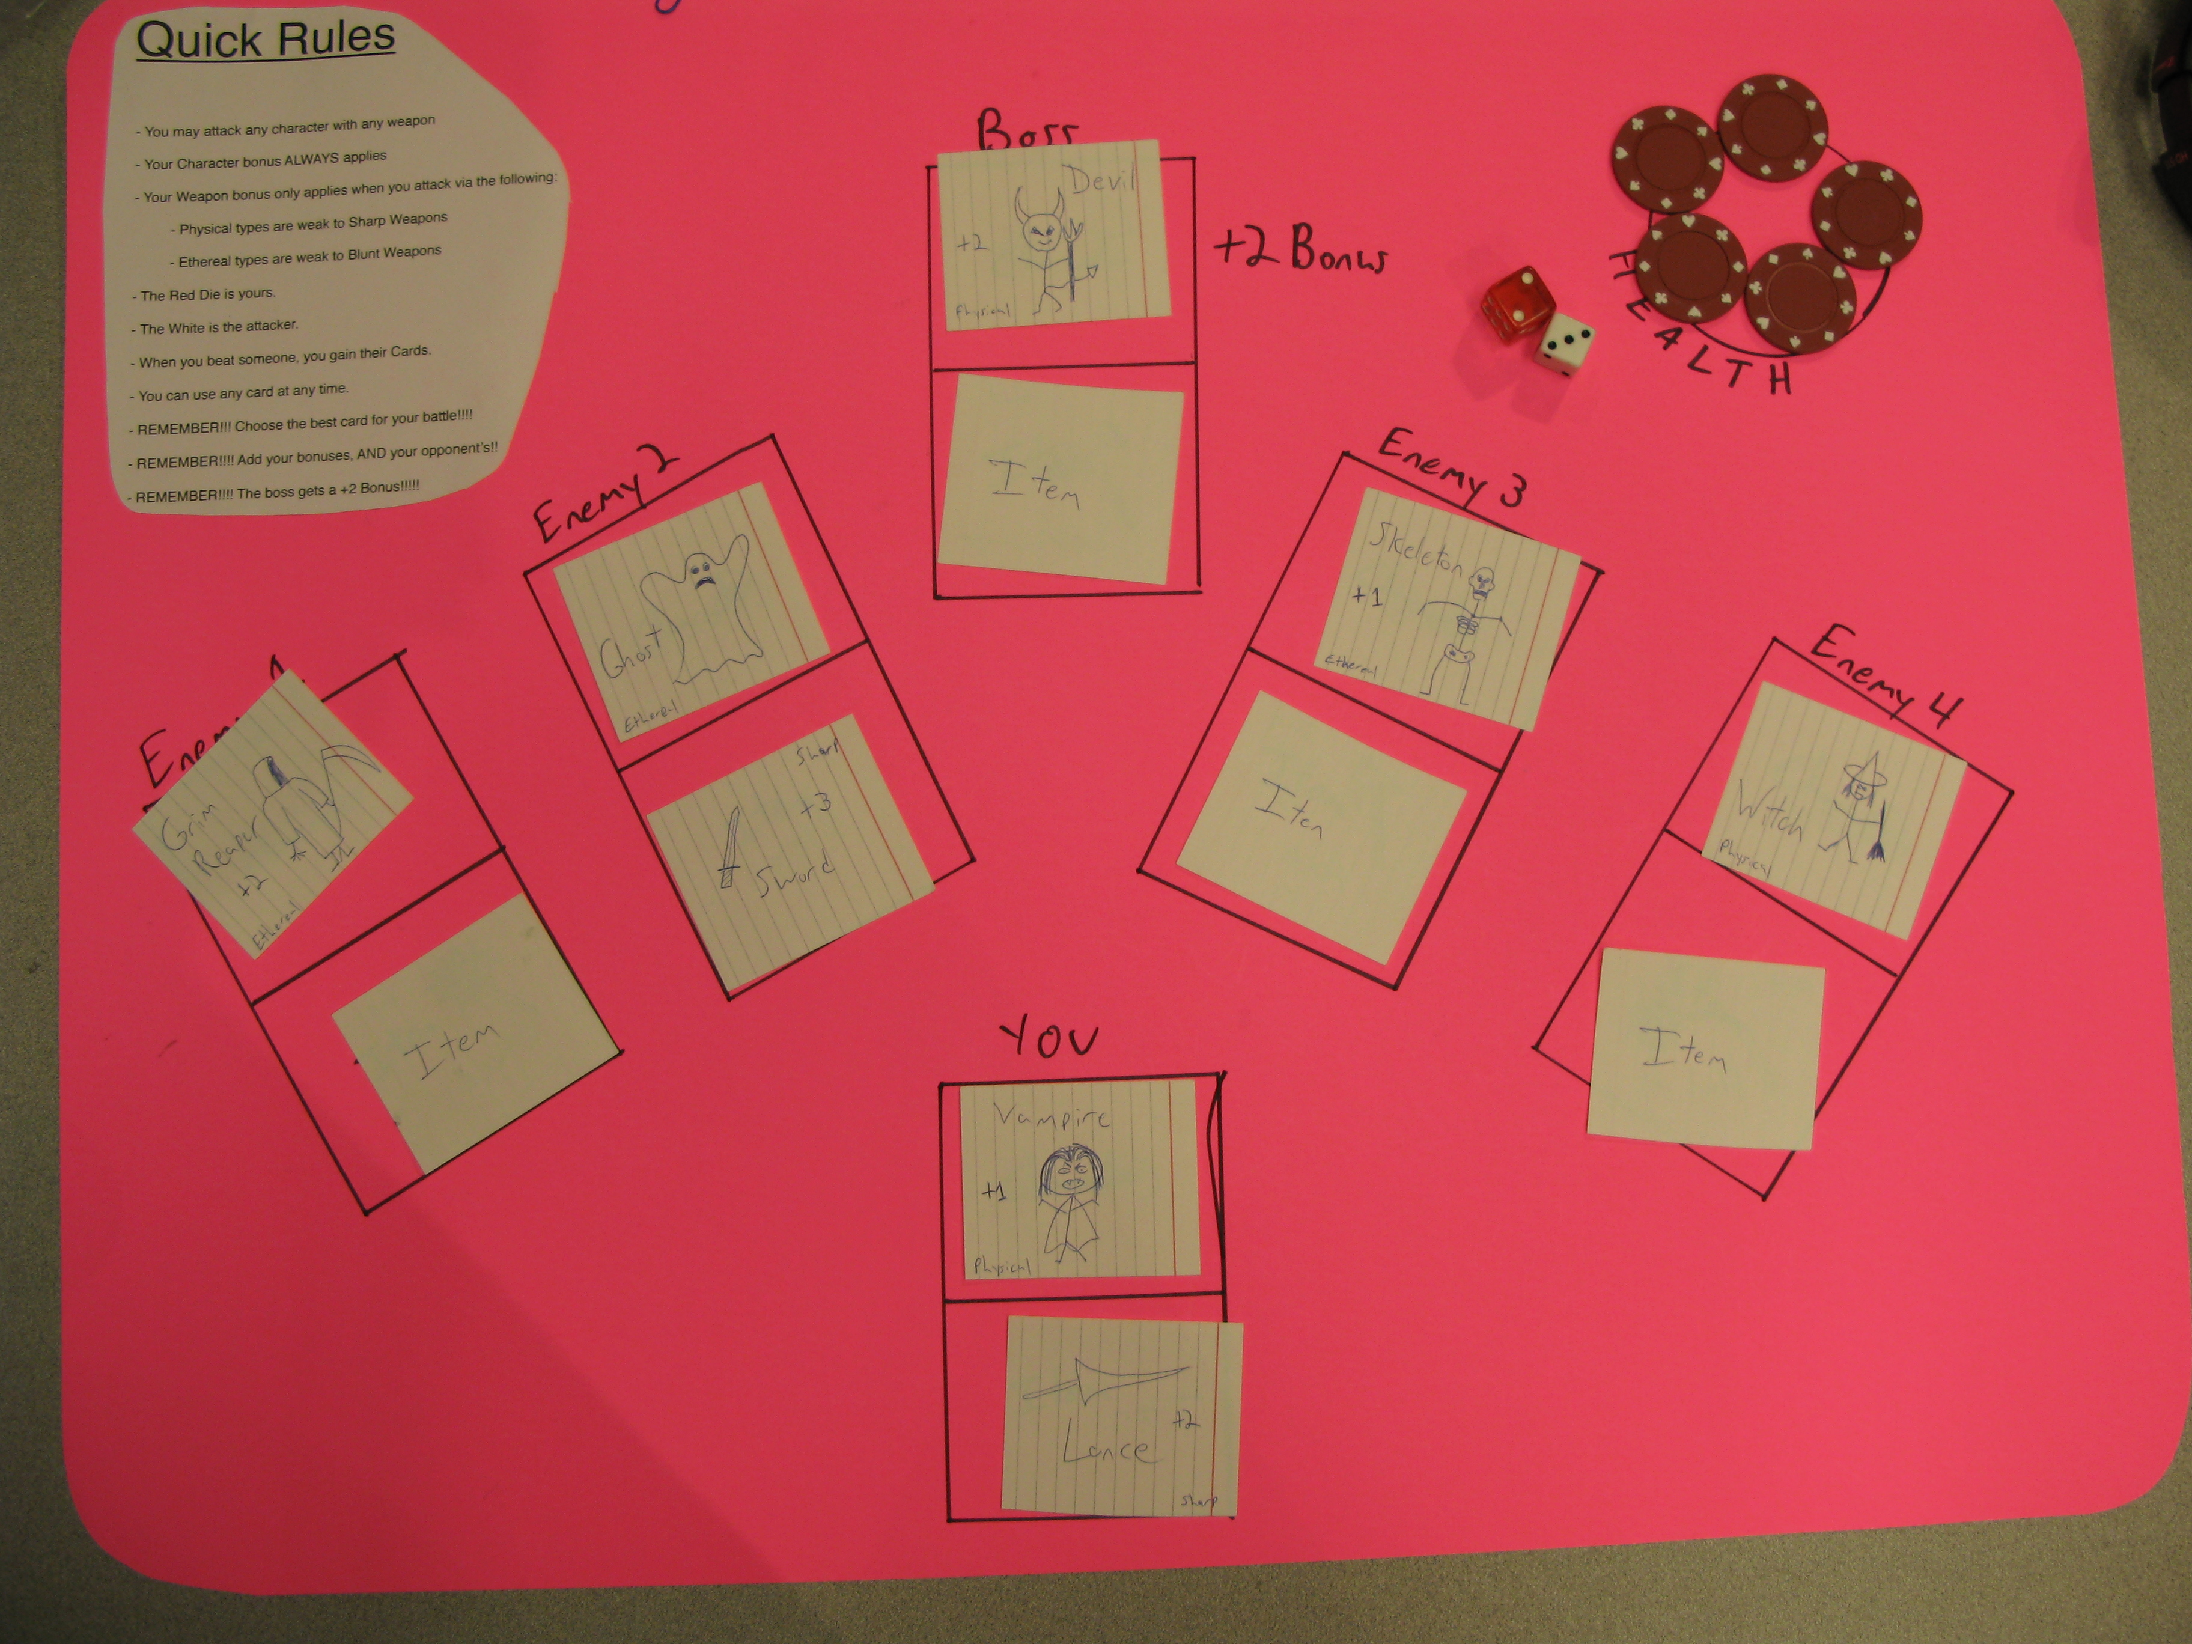

2. Users: who are they? Age? Socio-economic status? Occupation?
Jiyoung, 21, Student
Brain, 23, Student
William, 22, Student

All our participants are from relatively middle to upper class families, residing in the greater Vancouver area.

3. Procedure: describe what you did, what did you tell the users? How did you introduce the game, if you did?
We had the users read the game rules document and asked them to follow the instructions laid out therein. We did not tell the users what to do or give any special instructions above asking them to read the game rules document. However, we did tell them how to add up the attack points correctly. Also, when asked we would deliver yes or no answers to question the participants directed towards us. We in no way influenced or guided the process.

4. Observation notes: what did they say? Try to be objective and write everything with no bias.
Throughout the game testing session, the users seem to be confused about the attack points. The users did not seem to know how to add up the attack points correctly due to the different attributes that the weapons on different characters. However, as they continued on, they were able to better understand and fully grasp the idea. In addition, they began to know when to change the characters and weapons to increase their attack points and maximize their defense when facing different enemies. In essence, as they played, the rules became sensible to them, and fit within the context of the gameplay.

5. Reflection: what did you learn through this session? What conclusions can you make?
From our feedback, we learned that we have a very successful combat model that will be simplified greatly when it is finally digitized and less apparent to the user.

We also learned that the complexity is enough to make the combat non-trivial, but simple enough to learn in a few minutes.

From the results of our prototyping session, we can see that we have a solid combat/gameplay model that we can progress forward with confidently into the next stages of our game development.

