Testing Document
Drive-thru Tycoon

IAT 410
Section E104

Team members
PM - Ching Chun Kao (Kevin) – student number: 200122176
Jack Yeh – student number: 200124143
Micky Tang – student number: 200119501
Simon Jim – student number: 200052348
Eroca Hongs

- 1. Setup: number of sessions and number of people for session. Lab location and setup.
- A picture of the prototype setup in the room.

Lab location: Room #3950
Observing equipments: PC laptop, microphone, still camera, video camera

Prototype setup
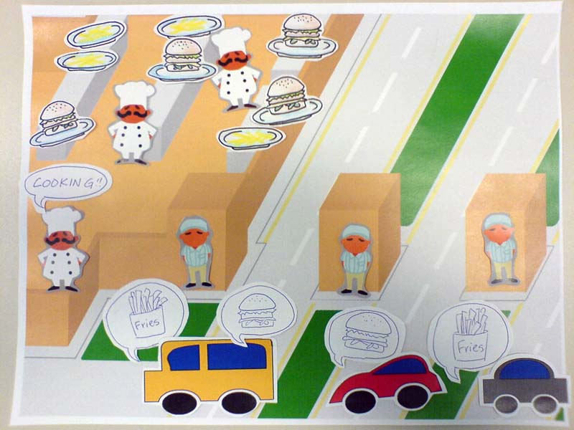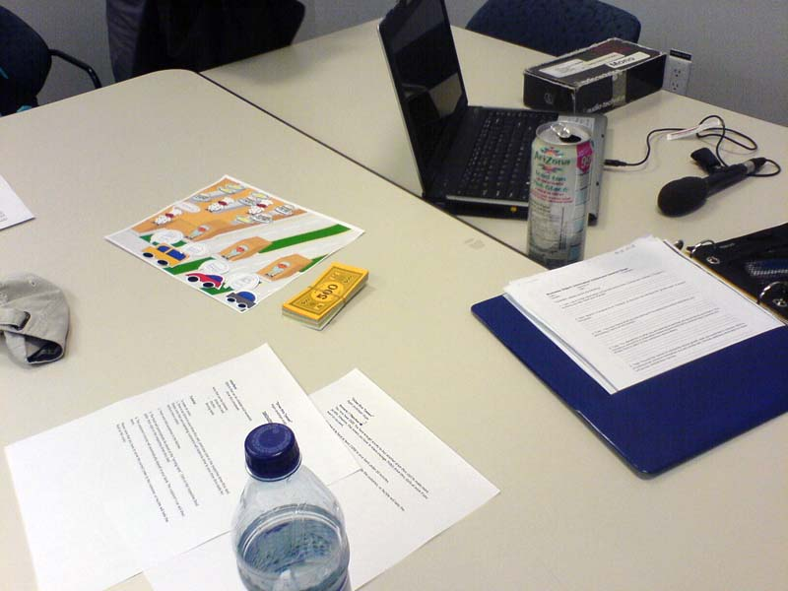

Picture of the prototype setup in the room
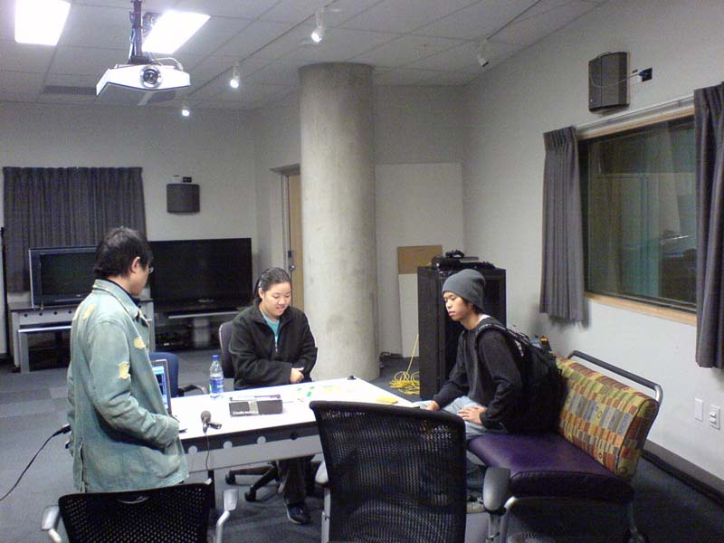

There are three sessions in total, and each session has one subject, one “computer”, and four observers.

- 2. Users: who are they? Age? Socio-economic status? Occupation?

Name | Age | Socio-economic status | Occupation
Daryl Weo  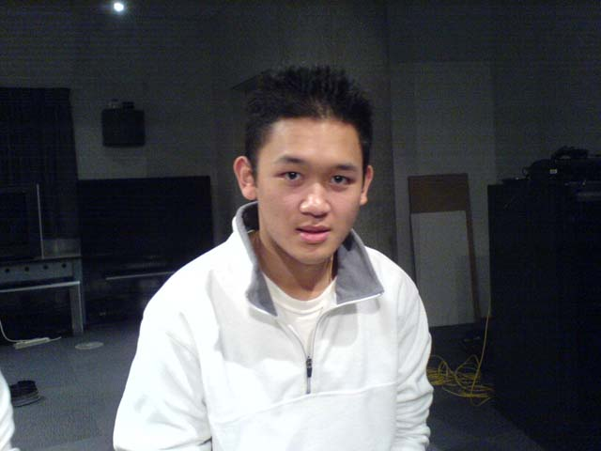 | 20 | Less than $2500 a month | Student
Kenson Wang  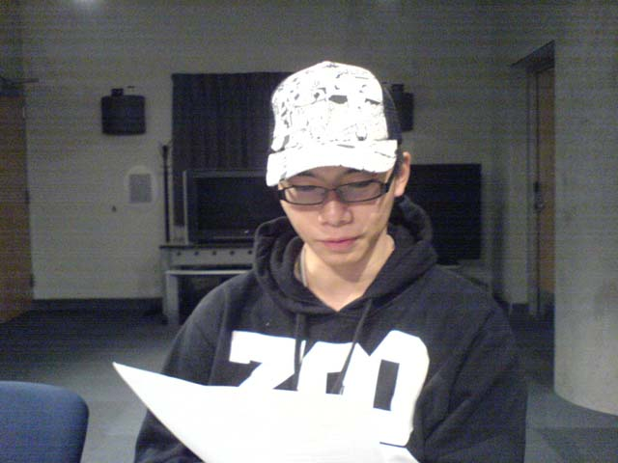 | 23 | Less than $2500 a month | Student
Joseph Yu  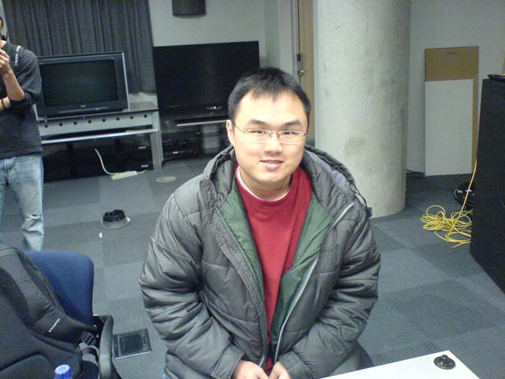 | 21 | Less than $2500 a month | Student

- 3. Procedure: describe what you did, what did you tell the users? How did you introduce the game, if you did?

First of all, we give the user an introduction sheet. The sheet explains how the game works and teaches user how to play the game. After the user read through the introduction sheet and have an idea of the game, we start the testing with the user.

We have three scenarios that the users must get through for each session. Upon successfully finishing a scenario, the user will advance through a more complicated scenario set before them. This is to test and rank the difficulty/learning curve of our game.

Below is a picture of our instructions / scenario sheets that was provided to all of our subjects:
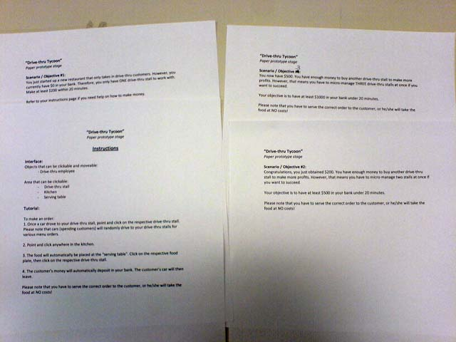

One of our team members also recorded video during the paper prototype session. This is done so that our team can observe how the subject reacts to each of the “computer” actions, as well as how they respond to the “computer”.

Below is the link to our play-test session videos:
http://www.youtube.com/profile?user=SiatSjim

- 4. Observation notes: what did they say? Try to be objective and write everything with no bias.

- The game needs more different kind of food.
- The introduction is not clear enough.
  - The subject does not know the employee will move automatically.
  - The subject does not expect he/she is required to remember the order of food.
- Every employee should have different appearance.
- The food icon does not show when the customer go to the station (stall).
- Daryl Weo (subject) ranked game play/mechanic 8.5/10
- Kenson Wang (subject) ranked game play/mechanic 8/10
- Joseph Yu (subject) ranked game play/mechanic 9/10

- 5. Reflection: what did you learn through this session? What conclusions can you make?

After our team finished all sessions of user testing, we learn many things for our game. The introduction was not clear enough, and therefore, we have to revise it. We need to explain more about the features and controls in the game. Some part of the game mechanic has to be improved such as the types of food and appearances of the drive-thru employees. Our team also noticed that we can add on more feature such as time limit for each action that the user inputted (such as moving the drive-thru employee). We are thankful that we did a paper prototype of our game, since it provided immediate feedback with minimal effort.

