Zodiac War
Paper Prototype Test Report

- Setup: number of sessions and number of people for the session. Lab location and setup.

Our group has performed one united test session with a total of 3 testers. The test site’s location was in Room3950. For our prototype testing, our group used one set of paper prototype that was made out to simulate our game’s environment as closely as possible. Basically, our paper prototype consist of the following parts: 1 paper game board, 4 character movement cards per side, 3 normal attack and 1 special attack cards, 10 health points, 3 special power points, 4 pages of story narration and 2 game results.

At the start of our testing, our subjects (players) will receive a brief explanation regarding the mechanic of the game (in the prototype format). Once completed, the subject will begin the game by going through the 4 pages of narration (very short background explanation) and step into the actual game – the battle. In that part, one of our team member will act as the A.I. to control one character while the subject control the other. The subject will then battle against the A.I. (our member) and the fight will end once one side loses the fight.

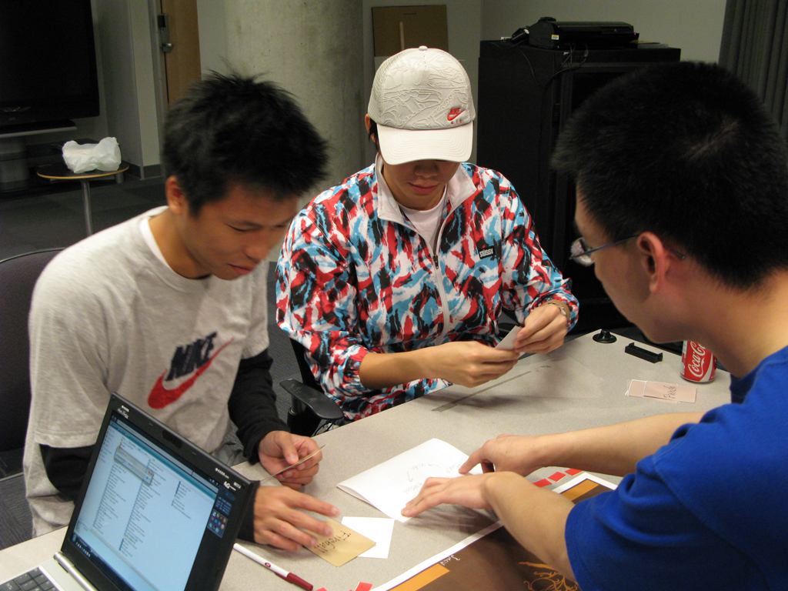
Here is Leon and Kenson getting an explanation of our game

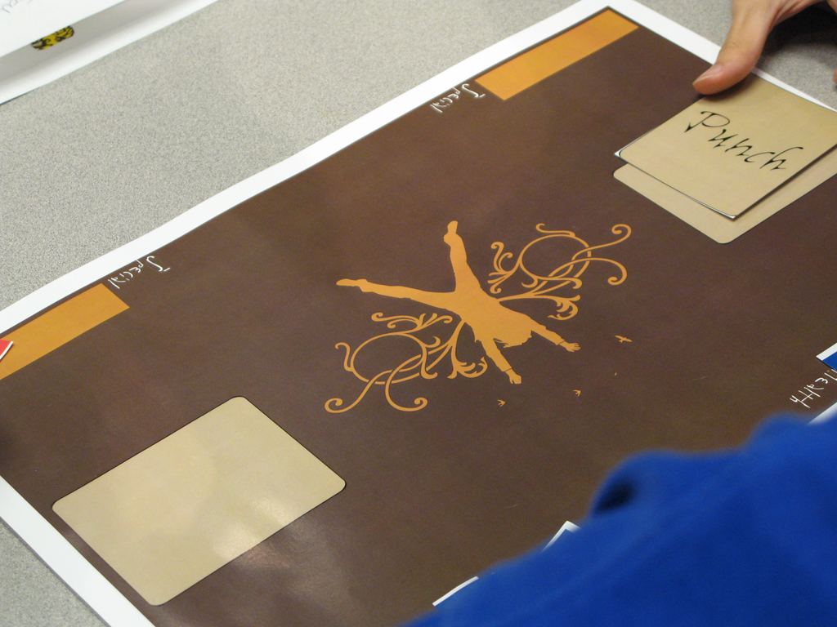
Here is a Basic Setup of Our Game

- Users: who are they? Age? Socio-economic status? Occupation?

Here are the descriptions of our subjects:
Tester 1: Leon Tang,
Age: 25
Occupation: Student
Socio-economic Status: Average
Tester 2: Kenson Wang
Age 23
Occupation: Student
Socio-economic Status: Self-proclaim poor, but really not
Tester 3: Cody Sawataky
Age 23
Occupation: Student
Socio-economic Status: Average

- Procedure: describe what you did, what did you tell the users? How did you introduce the game, if you did?

Upon the arrival of our testers, we began by introducing the genre of our game and the mechanic of our prototype. Once the explanation regarding the mechanical side of the game was completed, we invited the tester to sit down and began “playing” the prototype. We intentionally avoided to explain about the background story of the game during our verbal explanation and placed the story explanation directly into the game.
Along the way of the battling (the actual game part), we reminded the testers regarding the battle mechanics in order to prepare them for the game.

- Observation notes: what did they say? Try to be objective and write everything with no bias.

- Our first tester (Leon) had problem with remembering which attack (punch, kick and minor special) can override which attack. The second tester also experienced similar problem but soon caught on.
- All 3 testers really liked the background story and would like to see of the story in the future.
- All three testers expressed that our prototype took too long to play because the 3 main attacks cancel out each other too easily. They all would like to see more variation in the basic attacks to reduce the “cancelling” rate
- Both Leon and Cody expressed that the prototype has achieved to allow the players to feel the urge to beat the “A.I.” as quickly as possible. They would like to see a 2player function to be added to the final game.

- Reflection: what did you learn through this session? What conclusions can you make?

Overall, our group has done quite a successful job in creating a short and simple simulation of our final game. One major flaw we had with the prototype was that we did not produce enough basic attacks for the players to use, which of course, caused each session of our prototype to be longer than we had expected.
Another thing we have learned is that it might be easier, if not better, to create a 2 player game first for our actual game and then add the 1 player mode. That is simply because it would be much easier to create actions for the players to select to use than actually creating an A.I. to decide of what attack to use.
From the result of the prototype testing, we concluded that there are 3 things which we must have in the actual game to ensure the success of our project:
- More attack variation
- Controls should be as clear as possible
- Ensure the pace of the game is not too fast or too slow for the player’s comfort.

