Four particles of equal mass M are fixed at the corners of a square with sides of length a. A fifth particle has mass m and moves under the gravitational forces of the other four.
Consider the gravitational potential energy U of the mass m as a function of its position (x,y). This potential energy map U(x,y) is an extremely useful way of representing the effect of the gravitational force on the mass m:
- If m is held at rest at some point (x₁,y₁) and you let it go, it will always move toward a point of lower potential energy. You can therefore think of the function U(x,y) as a topographical map: the particle m will always “roll downhill”.
- If the mass m moves from point (x₁,y₁) to point (x₂,y₂), the potential energy difference U(x₁,y₁) – U(x₂,y₂) tells you exactly how much work was done by gravity, and exactly how much kinetic energy the particle gained as a result.
Let’s visualize all this. The figures below show the potential energy map U(x,y) for the square configuration of four masses M illustrated above. The height of the surfaces indicates the magnitude of U at each point. Which one is correct?
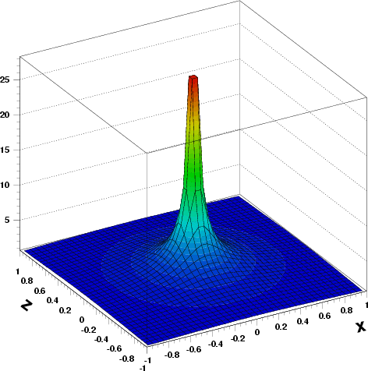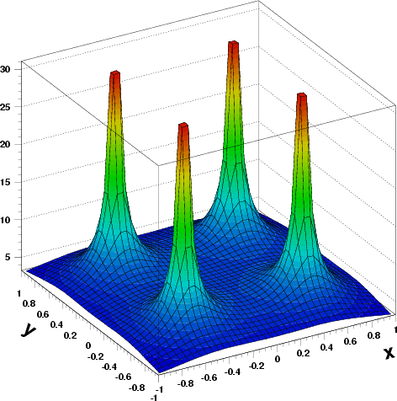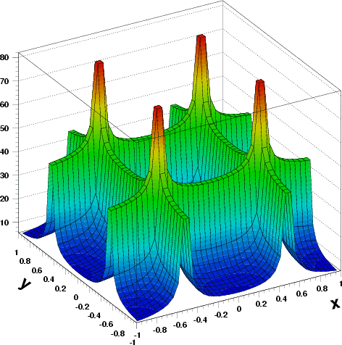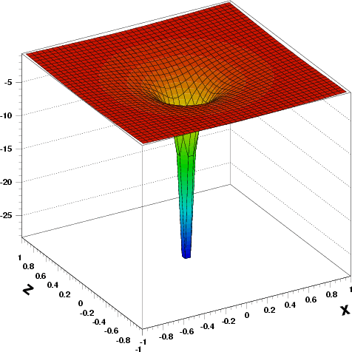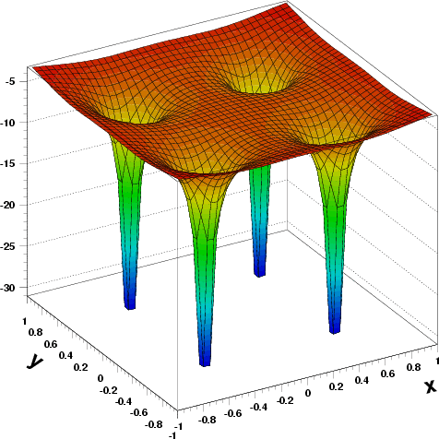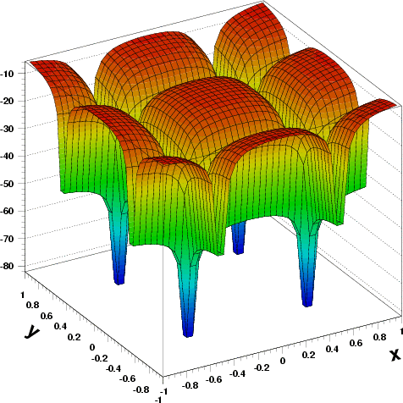
Now let’s perform some calculations using potential energy. Here’s the master formula for the gravitational potential energy between two masses m₁ and m₂ separated by a distance r₁₂:
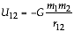
y
m
M
M
M
M
a
a
x
(a) Show that the net gravitational potential energy of particle m when at the origin is .
Hint: The equation above gives the gravitational potential energy of mass m₁ in the presence of mass m₂, or vice versa. Use it and superposition to find the net potential energy of mass m in the presence of the four fixed masses M. As long as the masses M remained fixed, it is not necessary to consider their mutual potential energies.

(b) If the particle m is released at rest from infinity and passes through the origin, calculate the magnitude of its velocity there.

(c) Calculate the net potential energy of m when it is at the mid-point of the right-hand side of the square.
y
m
M
M
M
M
a
a
x

(d) If the particle m is released at rest from the mid-point of the right-hand side of the square, does it reach the origin? Support your answers with physical arguments.

x
y
x
M
M
a
a
M
M
(e) In Discussion Question B, you calculated the force on the mass m when it is at the mid-point of the right-hand side of the square. If all went well, you found that this force points in the –x direction, i.e. towards the origin. Given this fact, plus your answer to part (d), can you make a rough sketch of the potential energy function U(x) for points along the x-axis? Give it a try!
U

x
–a/2
a/2

