Four particles of equal mass M are fixed at the corners of a square with sides of length a. A fifth particle has mass m and moves under the gravitational forces of the other four.
Consider the gravitational potential energy U of the mass m as a function of its position (x,y). This potential energy map U(x,y) is an extremely useful way of representing the effect of the gravitational force on the mass m:
- If m is held at rest at some point (x₁,y₁) and you let it go, it will always move toward a point of lower potential energy. You can therefore think of the function U(x,y) as a topographical map: the particle m will always “roll downhill”.
- If the mass m moves from point (x₁,y₁) to point (x₂,y₂), the potential energy difference U(x₁,y₁) – U(x₂,y₂) tells you exactly how much work was done by gravity, and exactly how much kinetic energy the particle gained as a result.
Let’s visualize all this. The figures below show the potential energy map U(x,y) for the square configuration of four masses M illustrated above. The height of the surfaces indicates the magnitude of U at each point. Which one is correct?
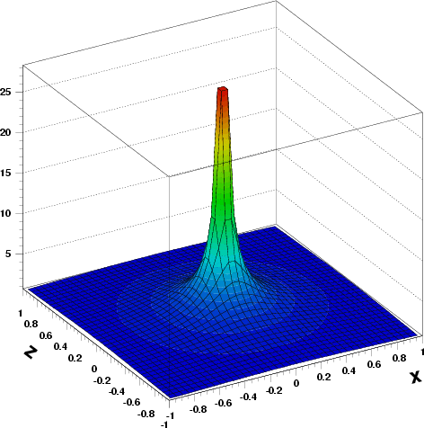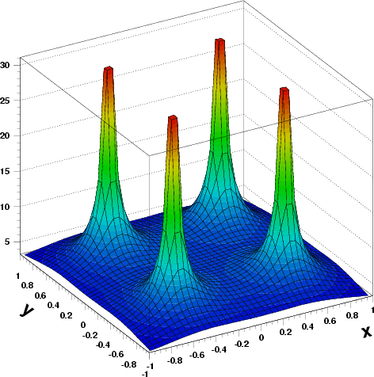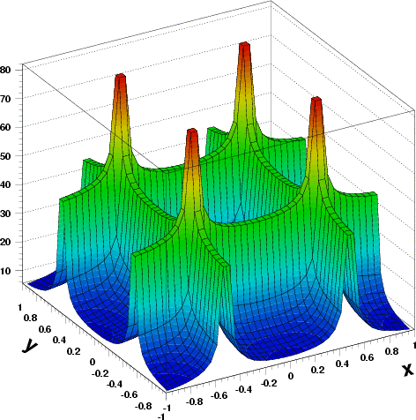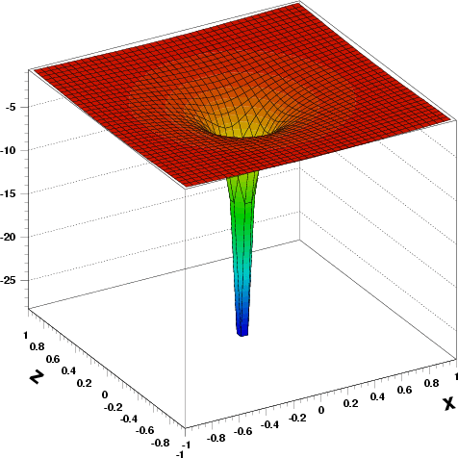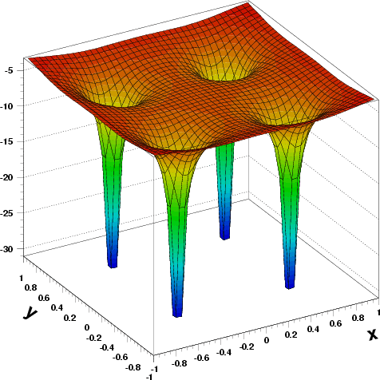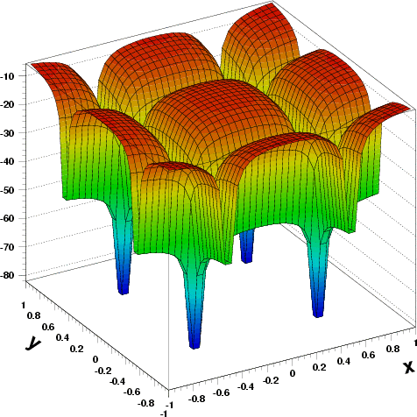
The correct map is the bottom middle one. The top three can be eliminated since they indicate higher potential energy near the masses M. That can’t be: the gravitational force attracts masses toward each other, so the potential energy must be lower closer to the masses. The bottom left figure corresponds to the potential around a single point mass M, not four of them. Finally, we can see that the bottom middle figure is the correct one by considering superposition: the potential energy map for the four masses is just the superposition (sum) of four maps for a single mass, like the bottom-left figure. The bottom right figure shows additional features (ridges) in the map that would not be caused by our simple collection of 4 masses.
Now let’s perform some calculations using potential energy. Here’s the master formula for the gravitational potential energy between two masses m₁ and m₂ separated by a distance r₁₂:
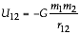
y
m
M
M
M
M
a
a
x
(a) Show that the net gravitational potential energy of particle m when at the origin is .
Hint: The equation above gives the gravitational potential energy of mass m₁ in the presence of mass m₂, or vice versa. Use it and superposition to find the net potential energy of mass m in the presence of the four fixed masses M. As long as the masses M remained fixed, it is not necessary to consider their mutual potential energies.

By superposition, the potential energy of m in the presence of the four masses (which we’ll call M₁ through M₄) is just the sum of the potential energy due to each individual mass. In symbols, U = U₁ + U₂ + U₃ + U₄. We used superposition of forces in problem 1 … notice how much easier it is with potential energy since that quantity is a scalar (just a number), not a vector, and so does not involve any components. From the left-hand diagram, we see that the distance r between m and each of the M’s is the same: r² = (a/2)² + (a/2)² = a²/2, and so r = a / √2. From the potential energy formula, we get U = 4.U₁ = -4 G M m √2 / a.

(b) If the particle m is released at rest from infinity and passes through the origin, calculate the magnitude of its velocity there.

If the particle “falls” from infinity to the origin, it loses potential energy in the amount U that you calculated above. This energy has to go somewhere → it is converted to kinetic energy = m v² / 2. Rearranging the terms in -U = m v² / 2 we can find the particle’s final velocity:

(c) Calculate the net potential energy of m when it is at the mid-point of the right-hand side of the square.
y
m
M
M
M
M
a
a
x

Again by superposition, U = U₁ + U₂ + U₃ + U₄. Since all the masses are the same, the only difference between the U_{i}’s is the distance from the mass M_{i} to the test mass m. For the two right-hand masses, r₁ = a/2. For the two left-hand masses, r₂² = (a/2)² + a² = 5a²/4, and so r₂ = √5a/2.
⇒ U = –2 G M m / r₁ – 2 G M m / r₂ = -4 G M m / a (1 + 1/√5)

(d) If the particle m is released at rest from the mid-point of the right-hand side of the square, does it reach the origin? Support your answers with physical arguments.

From part (a), U at origin = -4 √2 G M m / a = -5.657 G M m / a.
From part (b), U on right-hand side = -4 ( 1 + 1/√5) G M m / a = -5.789 G M m / a.
The potential energy is thus lower on the right-hand side than at the origin. That means that the mass m prefersto be on the right-hand side than at the origin. Further, it cannot reach the origin unless it starts with enough kinetic energy to overcome the potential difference between the two positions. Since our particle is starting from rest, no it will not reach the origin.

x
y
x
M
M
a
a
M
M
(e) In Discussion Question B, you calculated the force on the mass m when it is at the mid-point of the right-hand side of the square. If all went well, you found that this force points in the –x direction, i.e. towards the origin. Given this fact, plus your answer to part (d), can you make a rough sketch of the potential energy function U(x) for points along the x-axis? Give it a try!
U

x
–a/2
a/2

