Discussion Question 7A

P212, Week 7
RC Circuits

The circuit shown initially has the capacitor uncharged, and the switch connected to neither terminal. At time t = 0, the switch is thrown to position a.

 | C
 | a
 | b |  | E = 12 V
E | b | R₂ | C = 5 µF
E | R1 | R₂ | R₁ | = 3 Ω
 |  |  | R₂ | = 6 Ω
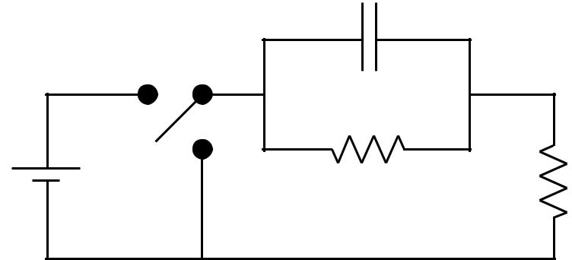

- At t = 0+, immediately after the switch is thrown to position a, what are the currents I₁ and I₂ across the two resistors?
What does the uncharged capacitor look like to the rest of the circuit at time 0? Does it offer any resistance to the flow of charge? (Why or why not?)

At t = 0, the capacitor acts like wire w/ no resistance to current flow. Hence the battery is effectively hooked to R₂ = 6Ω ⇒ I = E/ R₂ = 12V / 6Ω = 2 A

- After a very long time, what is the instantaneous power P dissipated in the circuit? After a very long time, what will have happened to the capacitor? Now what will it look like to the rest of the circuit?

After a long time the capacitor acts like an open circuit and the battery current flows through R₁ + R₂ . Hence I = E /(R₁ + R₂ .) = 12/9 =4/3 A and the power is

- = E I = (12V ) × ( 4/3A) = 16 W

- After a very long time, what is the Q charge on the capacitor? To detemine Q, you need the voltage across the capacitor ...
From part (b), we know after a long time I=4/3 A. The voltage drop across the capacitor is the same as the voltage drop across R₁ → ∆V_{cap} =IR₁ =4/3 A × 3Ω = 4V .

- = C ∆V_{cap} = ( 5µ F )( 4V )=20µC

Next, after a very long time T, the switch is thrown to position b.

C
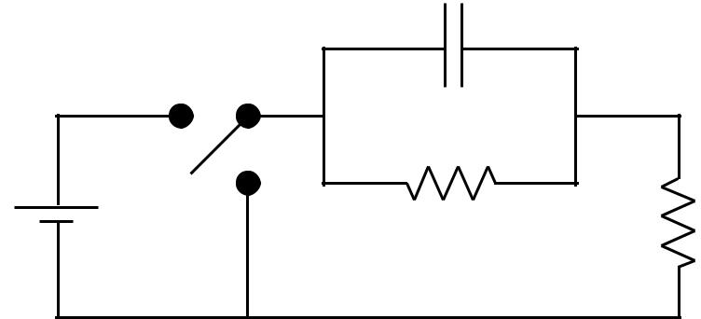

a

E | b | R₂
 |  | R₁

(d) What is the time constant τ that describes the discharging of the capacitor?

We have a nice formula available for time constants: τ = RC. But the R in the formula refers to the total resistance through which the capacitor discharges. Redrawing your circuit might help you to determine this R .

When the switch is thrown to b, the capacitor discharges through R₁ and R ₂ in parallel. R_{equiv} = R₁ R₂ / ( R₁ + R₂ ) = 3(6) /(3 + 6) = 2Ω ; τ = CR_{equiv} = ( 5µ F )( 2Ω ) = 10µs

- Write down an equation for the time dependence of the charge on the capacitor, for times t > T. Your answer for Q(t) should depend only on the known quantities E, R₁, R₂, C,
and T.

You know the general form for the time dependence of a discharging capacitor. All you have to do is fix the constants in this expression to match the charge at t = T and at t = ∞.

We know that Q will involve a exp(-t/τ ) factor added to a possible constant. The boundary conditions are at t = T ⁺ ,Q = 20 µC and fades to zero at infinity.

The form that does this is Q = 20µC exp − ^{t} ⁻ ^{T} 10µs

(f) What is the charge Q₂₀ on the capacitor 20 µsec after time T?

Q = 20µC exp − | t − T | = 20µC exp − | 20µs | = 20e⁻² = 2.71 µC
Q = 20µC exp − |  | = 20µC exp − | 10µs | = 20e⁻² = 2.71 µC
10µs |  |  | 10µs

(g) What is the current through R₂ 20 µsec after time T ?

The voltage across R₂ is the ∆V_{cap} = Q₂₀ / C = 2.71µ C / 5µF = 0.542 V ∆V_{cap} = I ₂ R₂ → I ₂ = ( 0.542 V ) / ( 6Ω ) = 0.0903 A
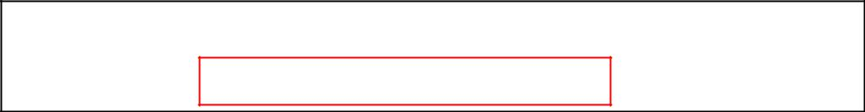

2

