The figure below depicts a region of space (shaded) where there is a constant magnetic field, B = 1.2 T, directed along the negative z axis (into the page). The magnetic field region extends infinitely far in the positive and negative y directions, but is constrained to the region between x = 0 and x = 1 m. A proton travels along the x axis toward this region, with initial speed v0.
x

y

B = 1.2 T

1 m

q, m

proton:m = 1.67 x 10-27 kgq = e = 1.6 x 10-19 Cv0 = 2 x 108 m/s

(a) What is the radius of curvature of the proton's path after it enters the magnetic field region?
To describe the particle's circular path, match the Lorentz force exerted by the B field to the centripetal force.
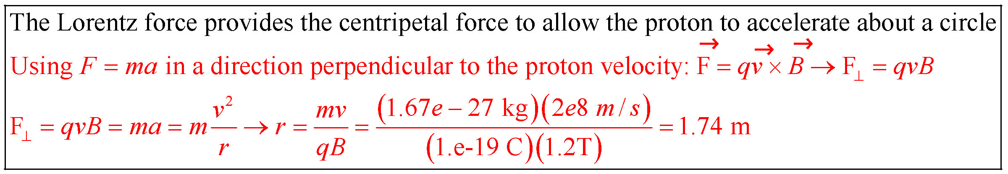

(b) At what x and y positions will the proton leave the magnetic field region?
Sketch the proton's path on the figure, and use your knowledge of the radius of curvature.
❑

1 m

R cos

R=1.74 m

x

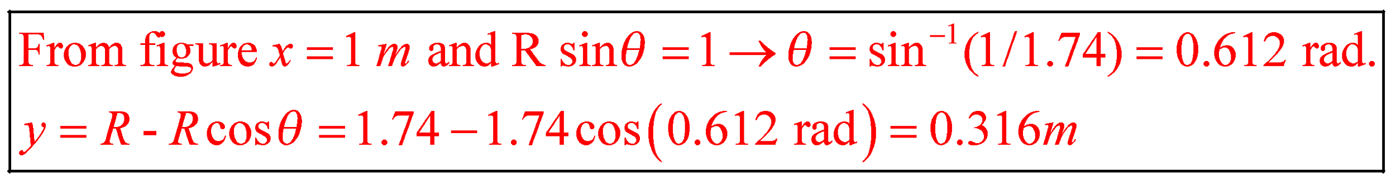
(c) What is the magnitude v of the proton’s speed as it exits the magnetic field?
x

y

B = 1.2 T

1 m

q, m

proton:m = 1.67 x 10-27 kgq = e = 1.6 x 10-19 Cv0 = 2 x 108 m/s

If the speed of the proton has changed, what has happened to its kinetic energy? Can the Lorentz force cause such an effect?



(d) Suppose the proton had an initial component of velocity in the +z direction of
vz = 1 x 108 m/s, and the same initial speed v0 as before in the xy plane. What then would be its final velocity v as it exits the magnetic field? This time, express your answer as a vector with three components.
Analyze this situation by components. What effect does the Lorentz force have on the particle's motion in the z direction? What about in the xy-plane?
❑

1 m

R cos

R=1.74 m

x

❑

vy

vx

v0

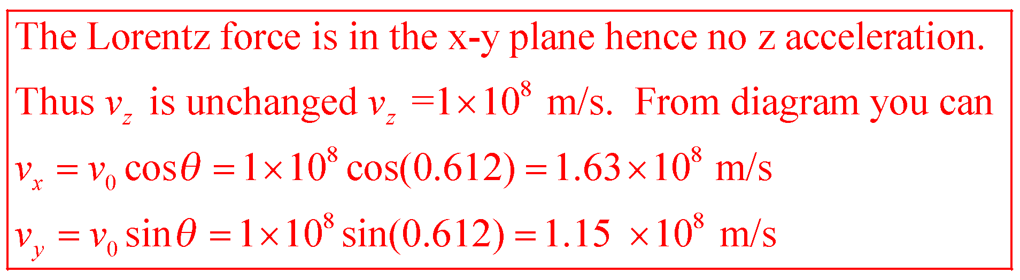

(e) Finally, a constant electric field E is added in the shaded region. The effect of this field is that all charged particles launched with initial velocity v₀ in the x direction travel straight through the field region without being deflected at all! What is the magnitude and direction of the field E?


