High Frequency Trading: Positive Advancement or Barrier to Entry?
Ryan Hildebrandt
301265087
Simon Fraser University
Dr. Kasa
ECON446

In this paper we will discuss a few topics relating to high frequency trading (HFT) such as: What is HFT, when did HFT begin, how does HFT work, what are popular types of usages for HFTs, and is HFT considered good or bad for market health. We will be primarily focusing on HFTs in general compared to being restrictive to the foreign exchange market due to the rapid growth and expansion of HFTs into other markets since the early 2010s. This growth and expansion will be very crucial when determining if this new form of trading is considered healthy or simply another barrier to entry for individuals and firms.
What is HFT?
Firstly, what is HFT? High Frequency Trading is a type of algorithm code that allows individuals or firms to trade at extreme speeds in market settings. HFTs have two main components: execution algorithms, and decision-making algorithms. Execution Algorithms (EAs) are the most commonly used type of HFT in the current markets (2020-2021) simply because EAs can grab a large order of buy or sell commands and cut the orders up into multiple smaller orders which can then be put onto the market. The idea behind cutting up one large order into many smaller orders is that the market is more easily able to interpret and digest the information being provided over a couple second interval compared to forcing the market to fully adapt to one large order instantaneously. The EAs are also specifically programmed by humans and fully support human interaction in emergency cases but are mostly fully automated by code with specific restrictions and instructions. Decision-Making Algorithms (DMAs) are not used as much as its counterpart, but it can still play a minor role in the new everyday trading. DMAs were the original and the go-to for high frequency trading in 2007 up until the early 2010s before EAs were introduced onto the market. DMAs are basic HFTs that do not cut up large orders into smaller orders but simply determine when a good time to buy and sell is and executes the order independently of most human interaction. Therefore, DMAs are simply rapid calculating humans that scan a market for potential profit opportunities and EAs are more advanced DMAs which allow automated trading with restrictions and instructions.
When did HFT start:
Modern day HFT began in 2007 with the introduction of DMAs into the market as a type of aid for firms and individuals to make proper trading decisions with errors, improper trading, and human bias being set to a minimum per transaction. This particular aid and error minimization became very popular with central banks due to the high level of risk aversion being provided to the individuals using them (Markets Committee, 2020). Furthermore, with the addition of EAs almost entirely replacing DMAs in the early 2010s, it allowed firms to make effortless trading possible with minimal human interaction and with none of the innate human bias or errors being involved.
How does HFT work:
Continually, how does HFT work? This is also surprisingly simple on the surface level to understand. It is an algorithm generated by a series of code meant to scan multiple markets with predictive information to calculate good opportunities to buy and sell to make miniscule profits at the milli- or micro-second interval (Markets Committee, 2020). Considering that HFTs are fully computerized and essentially fully automated, this allows the EAs to find minute differences between any two options (even on the same index) and create a small arbitrage condition that creates profit out of nothing. Since computerized thought processes are significantly quicker than human interactions can measure, these powerful algorithms are able to scan multiple markets simultaneously and are able to create buy and sell orders in the thousands before humans can blink, therefore providing a large advantage for the users of these HFT algorithms (Seth, 2020). Figures 1 and 2 provided show a good example of creating an arbitrage condition along the same index to create miniscule profits in the milli-second.
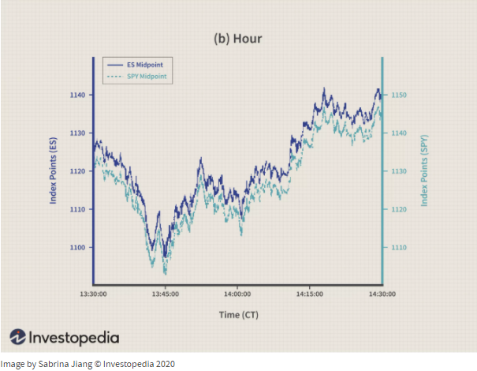
Figure 1. Graph depicting changes of S&P500 Futures (Blue) and S&P500 ETF (Teal) showing minimal chance of profitable trading along two options of the same index.
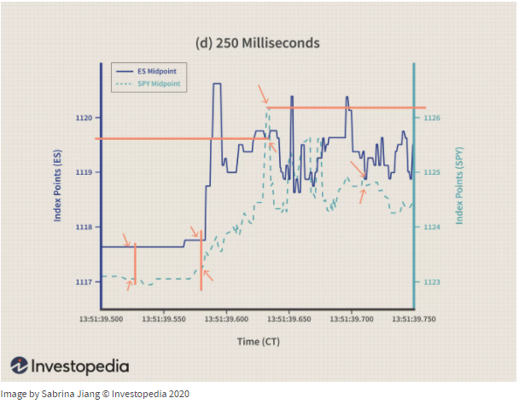
Figure 2. Chart showing the same two indexes from Figure 1 but zoomed into the millisecond intervals to show where EAs can create arbitrage conditions to make miniscule profits.
Popular usages of HFTs:
According to Shobhit Seth (2020) and Markets Committee (2020), the list below are some examples of popular usages of HFTs and the definition of each one:
Trend-Following Strategies:
Simplest form of usage, the algorithm follows trends in moving averages, channel breakouts, price level movements, and other indicators to determine a simple trade transaction. Usually follows a 50-day and 200-day moving average for trend following.
Index Fund Rebalancing:
Index Funds have specific periods where they decide to rebalance their holdings to match their current levels of investments or to reevaluate certain levels of holdings. Therefore, the algorithms can be set to monitor expected trades just before the index fund rebalancing which can create timely executions and the best pricing.
Mathematical Model-Based Strategies:
Proven mathematical trading such as delta-neutral trading can be performed by HFTs in automated formats. Delta-Neutral Trading is a strategy that allows traders to not be overexposed by allowing to bring the derivative values of a certain asset down to zero to minimize losses, however, this also happens in reverse and can take huge profits out of the hands of traders.
Trading Range (Mean Reversion):
Mean Reversion is a strategy that states high or low-price fluctuations are temporary and assets prices tend to revert back to their mean average price over time, meaning the HFTs can scan the range of price indices and the mean average price to make small trades when the price is low or high to buy or sell, respectively.
Volume-Weighted Average Price (VWAP):
Volume-Weighted Average Price is a strategy that breaks up a large order into smaller orders to help firms and individuals move in or out of a certain asset safely without a huge price fluctuation in the market.
Time Weighted Average Price (TWAP):
Time Weighted Average Price is a strategy that breaks up a large order into smaller orders to help firms and individuals move in or out of a certain asset safely with specific given intervals of time as well as market average price to minimize market impact.
Percentage of Volume (POV):
After the initial order is complete, the algorithm will continue to send partial orders according to the set participation ratio in the market and will automatically adjust when stock prices reach the user-defined levels.
Implementation Shortfall:
Implementation Shortfall’s aim is to minimize execution costs of an order which benefits from the opportunity cost of delayed execution and will automatically increase or decrease target participation determined by the level of favorability in the price.
Arbitrage Opportunities:
Purchasing an asset that suddenly drops then simultaneously selling it at a higher price in a different market before both markets are fully able to coordinate and adjust.
Triangular Currency Trading:
Three different currencies are traded in a triangular fashion to make small arbitrage conditions which create minute profits in the currency of origin. (Trading currency #1 for currency #2, then for currency #2 to currency #3, then from currency #3 to currency #1.)
Do HFTs create a safe and healthy market or are they simply a burden:
Negatives:
As of 2020, HFTs are quite a controversial topic due to the seemingly unfair advantage towards rich firms that have the capital to gain the highest speed HFTs and the lowest time lag internet connections on the market while other firms with less overall capital to burn must settle with slightly slower HFTs and internet connectivity. These two points are crucial since EAs specifically work in milli- or micro-seconds and can create and reevaluate thousands of trades in one normal second, therefore, if one EA can capitalize on another EA that is one second slower, the second EA will hardly ever make a big profit whilst the first EA reaps all the benefits. This type of “latency trading” can have a huge market impact and can deter many classical forms of trading due to the hostility of the market or create a pseudo-arms race for many larger players to fight for these miniscule profits (Seth, 2020).
Building on the previous point of latency trading and the arms racing being created by larger firms, this will incentivize additional hostile reaction from smaller firms and individuals that do not have the excess capital to fight larger, more established, corporations. Therefore, the alternative to fighting a capital-on-capital race, would be to create fake or temporary market shifts that would attempt to trick HFTs/EAs into buying and selling at unfavorable prices (Seth, 2020). This method is simply called “Spoofing” and the entire intention of spoofing is to sow chaos among computerized programs which creates adverse selection issues in market settings (Foucault & Biais, 2014). A good example of Spoofing is the Knight Capital Case: Knight Capital decided to purchase and install brand new software to give them a competitive edge in daily trading, however, the news of this new addition became publicly known and allowed individuals to fake shift market values to trick the HFT into buying and selling $7 billion worth of NYSE stocks at unfavorable pricing in milliseconds, forcing the firm to liquidate 40% of its total value to cover the costs of the newly installed HFT software (McDermid, 2012).
Another potential downside to EA integration is that it is creating new liquidity dynamics in all of the market settings. EAs create a large volume of orders from a singular large order which allows the market to understand, digest, and adapt more efficiently than having a singular large order pushed into the market without any time to truly adapt (Markets Committee, 2020). However, this method of trading creates a shift in liquidity dynamics in the sense that overall market depth decreases but market liquidity increases at a faster rate, which simply means that assets are more quickly able to trade hands without having large bid-ask spreads and significantly smaller wait times in between trades (Markets Committee, 2020). Continually, because of this new, and quicker dynamic, it will force individuals or firms to also purchase and use EAs and HFTs in their daily trading lives in order to remain competitive in the market, which also forces younger, and smaller firms to play the larger firms’ game.
Finally, HFTs are extremely costly to maintain and if they are not maintained properly, then the outcome could be even more extreme (See Figure 3, the Flash Crash of 2010.) and since technology is improving more rapidly each year, the costs of replacing previous iterations of HFTs for bleeding edge HFTs will be extremely expensive to purchase, install, and maintain. Assuming that the brand new HFTs are fully completed, and thoroughly tested for any form of bugs, potential program crashes, and flawless security, the entire cost is mostly put into the purchase, install, and maintain categories, however, nothing is ever truly perfect on the first iteration which leaves potential for security breaches or program bugs.
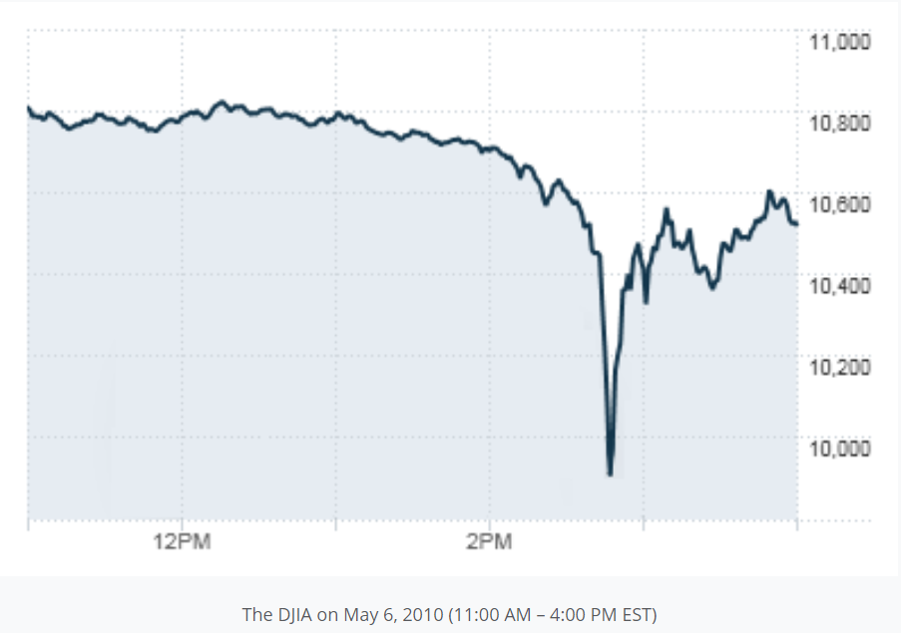
Figure 3. Graph showing the Flash Crash of March 6th, 2010. DJIA losing 1000 points over 10 minutes due to HFTs malfunction but quickly recovering 600 points over the next 30 minutes.
Positives:
Positives from HFTs and EAs are mostly simple and straight forward to understand but provide safety and reassurance to wary market agents throughout all trading channels. Firstly, bid-ask spreads have been reduced significantly after the integration of EAs into the foreign exchange market and the securities market (Seth, 2020). In addition to the previous statement, HFT integration does not include human error, emotional & psychological factors, and improper timing of transactions which cause large market inefficiencies (Seth, 2020). EAs allow firms and individuals to trade at higher frequencies with a lessened market impact or market footprint, assuming that the EAs are well maintained, with this lessened market impact or footprint, the total volume of trading can be positivity ignited with minimal concern for risk (Market Committee, 2020). The reduced trading costs and lessened market impact is a large reason why many central banks are participating in HFTs, according to The Bank for International Settlements, Market Committee 2020 (See figure 4). Under the study of the Market Committee, 15 central banks were asked if they used HFTs (All of which do) and if they did use HFTs, what percentage of their daily transaction volumes were being put through HFTs to which they, on average, replied around 50-70% of all transaction volumes. In addition to the previous statement, Foucault & Biais, 2014 state:
“HFTs can affect market quality if they account for a large fraction of trading activity. Preliminary evidence from empirical analyses using data on HFTs indicates that this is the case. For instance, Brogaard (2011a) finds that the 26 HFTs in the Nasdaq sample participate in 68.5% of the dollar volume traded on average and account for a larger fraction of the trading volume in large capitalization stocks than in small capitalization stocks. Hirschey (2011) also finds that HFTs in his sample are more active in large than in small stocks (41% vs. 15%). HFTs in Kirilenko et al. (2010)’s sample account for 34.22% of the daily trading volume in the S&P500 index (for 4 days in May 2010). The high frequency market-maker studied by Menkveld (2010) participates in about 16% of all trades in large stocks and 7% in small stocks. Finally, Hagströmer and Nordén (2012) finds that HFTs in their sample account for about 26% to 52% of all trades for the 30 stocks in their sample. Overall, empirical studies suggest that HFTs account for a significant fraction of trading volume (ranging from 1/3 to 2/3) and that HFTs’ activity might systematically vary according to securities’ characteristics (e.g., small vs. large stocks).”
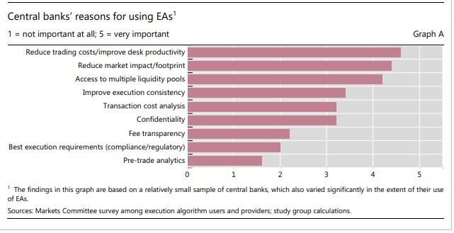
Figure 4. A graph showing the reason for using HFTs by Central Banks, provided by Markets Committee, 2020.
Figure 4 brings us to the final few points of positives of HFTs in markets: providing adequate access and matching, allowing for proper price discovery, and creating new liquidity dynamics. Adequate matching simply states that EAs can scan through multiple trading channels simultaneously (10 minimum) and provide the user with useful information almost instantaneously with potential profit margins. As previously stated, EAs breakdown larger orders into many smaller orders which allows proper price discovery without the volatile fluctuations of sudden high demand or high supply. Finally, even though market depth has overall decreased, the market liquidity refreshment rate has increased significantly, which means that assets can be traded more frequently, at a more accurate, and fast paced rate. The benefits behind a higher liquid market are that they will attract many buyers and sellers, it will reduce dramatic price fluctuations, and increase overall smoothness of transactions as well as efficient transactions.
Conclusion:
In conclusion, high frequency trading algorithms are a net positive for the markets even though they may create adverse selection issues. Under proper management and maintenance, HFTs will reduce human errors, and human psychological bias’s that cause severe market inefficiencies, as well as reduce market stagnation. In addition to these reductions, the increased liquidity safely ignites the markets and creates rapid transactions to occur without the severe price fluctuations from human interactions. Despite all the severe negatives previously mentioned, the incentive to make more transactions, more rapidly, and more consistently than most other market participants is enough to create a sense of normalcy for HFTs and they will not be leaving any time soon.

References
Bajpai, P. (Oct. 2, 2020). Strategies and Secrets of High Frequency Trading (HFT) Firms. Investopedia. https://www.investopedia.com/articles/active-trading/092114/strategies-and-secrets-high-frequency-trading-hft-firms.asp
Foucault & Biais. (2014). HFT and Market Quality. Bankers, Markets & Investors. http://www.revue-banque.fr/medias/content/users/christine/1389193141609.pdf
Market Committee. (2020). FX execution algorithms and market functioning. Bank of International Settlements, Market Committee. Retrieved from: http://www.bis.org/.
McDermid, B. (2012). Knight Capital lost about US$10M a minute as a result of trading disaster. Reuters. https://financialpost.com/investing/knight-capital-losing-about-us10m-a-minute-after-trading-disaster
Seth, S. (Mar. 7, 2020). Basics of Algorithmic Trading: Concepts and Examples. Investopedia. https://www.investopedia.com/articles/active-trading/101014/basics-algorithmic-trading-concepts-and-examples.asp
Seth, S. (Apr 30, 2020). The World of High-Frequency Algorithmic Trading. Investopedia. https://www.investopedia.com/articles/investing/091615/world-high-frequency-algorithmic-trading.asp

