“Belief, Knowledge, and Language”
The Cambridge History of the World, vol. 1: Historiography

Luke Clossey

version 1.2
July 2010

“How do I know that what I call knowing is not ignorance? How do I know that what I call ignorance is not knowing?” 庸詎知吾所謂知之非不知邪？庸詎知吾所謂不知之非知邪？
--Zhuangzi 莊子 (4th century BC)

“We ought not to be ashamed of appreciating the truth and of acquiring it wherever it comes from, even if it comes from races distant and nations different from us. For the seeker of the truth nothing takes precedence over the truth…” و ينبغي لنا…[write out Arabic]
--al-Kindī الكندي, On First Philosophy (9th century)

"Where is the wisdom we have lost in knowledge? Where is the knowledge we have lost in information?"
-- T. S. Eliot, The Rock (1934)

[al-Kindi quote is I think perfect, the others less so and I worry they distract from al-Kindi]

1.0 Preliminaries
2.0 Two pseudo-scientific experiments
2.1 Space
2.2 Time
3.0 A closer look at key moments
3.1 Secularization
3.2 Scientific Revolution
3.3 Axial Age
3.4 Hominization
4.0 Conclusion
4.1 Current limitations
4.2 Future possibilities

1.0 Preliminaries

An ambitious seeker of knowledge might hesitate in choosing between two books with epic titles: quiz-show shark and Encyclopaedia Britannica editor Charles van Doren's A History of Knowledge: Past, Present, and Future (1992) and Cambridge research associate Peter Watson's Ideas: A History of Thought and Invention, from Fire to Freud (2005). Arguably the most important change in the writing of history over the last fifty years has been the rise of world history as a respectable and influential subdiscipline, and despite their similarly generic titles and the mere thirteen years separating their publication dates each of the two books represent different moments in the new globalizing trajectory. The van Doren volume's first chapter dispatches in fifteen pages with Egypt, India, China, Mesopotamia, the Aztecs and Incas, Buddhism, and human sacrifice; the next chapter celebrates a turning point in the “Greek Explosion” and the rest of the book never looks beyond the west. Watson's book gives Asians about a third of the pages on ancient history (though none of the chapter on the origins of philosophy and science), pushes the climax up from the Greeks to “The Great Hinge of History: European Acceleration” around the time of Thomas Aquinas, and smuggles some unexpected names (al-Afghani, Muhammad Abduh, Rashid Rida) into the penultimate chapter. A truly global history of knowledge has not yet been written. The publication of this Cambridge History of the World signals that the new world history has reached a certain maturity, and this essay takes advantage of this moment to take stock of the vast scholarship on the history of ideas by responding to a single question: What role has the wider world played in how we write and understand the history of belief, knowledge, and language?
Historians have approached language, belief, and knowledge in many ways, and these differences are reflected in large measure by the confidence we have in various aspects of language, belief, and knowledge, and by the extent we consider language, belief, and knowledge to be universal. Generally speaking, a pound of doubt added to knowledge creates belief; add a pound of confidence to belief and you have knowledge. Picturing the likely author and likely audience of an academic essay written today, we might associate science with confidence and religion with doubt; “scientific knowledge” and “religious belief” roll off the tongue, while “scientific belief” hesitates, and “religious knowledge” feels qualified, or patronizing. In the plural, “beliefs” sounds natural, but “knowledges” awkward, for how can there be multiples of a universal? This sense of difference between belief and knowledge is confirmed in the sarcasm of Seamus Deane's Jesuit mathematics teacher, who promises his students, “If every sum is answered correctly, the sun will stand still in the heavens and I will take up the teaching of a secure and sure subject, like religion.”
Because this essay describes historiography rather than history, we will decline to define terms that historians themselves rarely and inconsistently define. As with “belief” and “knowledge” above, we mainly describe how these terms are used, their behaviours in the historiographical wild. “Europe” refers to the continent, itself with fuzzy boundaries, but when appearing in the world history of knowledge “European” usually refers also to the places most colonized by Europeans in the last two centuries, and to those places' peoples and their ideas. For practical purposes, we'll refer to the “West”; for its complement, we'll use the name “Rest” or “Wider World.” Each term has its silliness: A round rotating world can have an absolute north and south, but not an absolute “west,” and referring to the larger part of the planet in terms of its not being the smaller part is certainly backwards. Travelling peoples and travelling ideas burst through such divisions in both direction, and historians are increasingly aware of and interested in these trespassers, even as the fundamental geographical division endures in most minds. I am writing now in Vancouver General Hospital, a continent and an ocean away from Europe, seeing mostly practioners with Asian faces, in a medical zone full of medicines western and sometimes eastern, and my compass needle has not stopped spinning. Each term, “West” and “Wider World,” though tentative and problematic, remains ubiquitous and useful.
With both “West” and “science” amorphous, we have exactly twice as much wiggle room as we actually need to slyly define one in terms of the other, and historians often do this. Science is the knowledge developed in the West, which consists of those places with science, which is the knowledge developed in the West. . . Even those who deny the monopoly of the west on science usually admit that western science is unique in its connection to a raw kind of power to blow things up, like atomic bombs. The German poet Heinrich Heine once wrote that “people in those old times had convictions; we moderns only have opinions. And it needs more than a mere opinion to erect a Gothic cathedral.” Today, however, it may take something more than convictions or opinions to split the atom. This sense of science being an objective thing that we have achieved may, of course, be illusory. The medicine of comedian Steve Martin's medieval Theodoric of York is modern in its confidence if not in its explanations: “Why, just fifty years ago, they thought a disease like your daughter's was caused by demonic possession or witchcraft. But nowadays we know that Isabelle is suffering from an imbalance of bodily humors, perhaps caused by a toad or a small dwarf living in her stomach.” In the eyes of the academy, religion may do things, too, but if it once resurrected the dead its focus has shifted to moral subtleties and obscure miracles sometimes involving images in tortillas. Frustrated in his prayers for a bicycle, Emo Phlips stole a bike and prayed for forgiveness, something modern religion can still dispense.
This sense that European science won in some crude way may be a reality, perhaps because we (and anyone who touches a Cambridge History joins this “we” to some degree) are ourselves in a European tradition and must stretch to value what's outside it, and perhaps because European empires once claimed dominance over the world. Most of our books about knowledge are in fact about euro-knowledge, rather than about the wider world's ethno-knowledges. We so implicitly understand knowledge to be the stuff of Kant and Newton that we forget to qualify it implicitly with a “euro-” prefix, and often we forget that it needs to be qualified at all.
The division between euro-knowledge and ethno-knowledges works differently, depending on the kind of knowledge under discussion, its perceived universality, and the confidence with which we might know it. At one end of the continuum is mathematics. Most of us know that 2 + 2 = 4, in Cambridge as well as in Timbuktu, and we have deductions (surprisingly complex) from axioms (surprisingly arbitrary) to give us tremendous confidence in this our universal knowledge. Outside of this euro-mathematics we have several traditions of ethno-mathematics, most of which care little for deductions and axioms; their knowledges typically consist of different methods, and different objectives, but the results are compatible with euro-mathematics and indeed can be legitimized by euro-mathematicians using their own methods. Consider the process of the Tamil mathematician Ramanujan ராமானுஜன (1887-1920): After the goddess Namagiri had put the ideas' seeds in his head, Ramanujan worked them out on his writing slate, and recorded his results on paper for posterity, but the path he took to them (along with any hint of proofs) vanished as he wiped clean his slate. In Asian mathematics, the articulation of convincing explanations was traditionally, on pedagogical grounds, the responsibility of the mathematician's students; in Ramanujan's case distinguished euro-mathematicians have since his death played this role, with these efforts teaching them as much as the Ramanujan's results themselves. The distinction between euro- and ethno- works much the same ways in many of the natural sciences. We think universal laws of physics are no less universal in Timbuktu, and the odd term “ethno-physics” exists mostly as a heuristic foil, as it does here.
As we move along our continuum of knowledge, our sciences soften into fields without pretension to one universal truth; these sciences involve many truths (like the many languages under the microscope of linguistics) or no widely agreed-upon truth at all (as in psychology). Psychology's wars between Freudianists and Gestaltists and cognitivists and functionalists and behaviouralists have no parallel in chemistry; linguistics does not distinguish between the euro-linguistic study of French and the ethno-linguistic study of Swahili. In these cases, the ethno- prefix turns a science not into a multicultural analogue of a euro-science but rather into a subfield of study that looks at the relation between the objects of knowledge and the culture of the peoples that produce them. Ethnolinguistics explores how peoples' enculturation affects language, and ethnopsychology explores how peoples' enculturation affects psychology. The case of philosophy is still in flux, with the mainstream academy perhaps seeing in Europe a logical, systematic philosophy made by individuals, while Africa has an ethnophilosophy or folk philosophy, more intuitive than logical, more communal than built by individual genius.
Extending the euro-/ethno- distinction into religion requires great care. It may be tempting to equate ethno-religions with the primitive or primal religions, or with religions that are not Christian. Some scholars use “ethno-religion,” or “ethnic religion,” to denote a religion closely associated with an ethnic group, such as the Ahmadis or the Amish or the Assyrians. For our purposes, however, we can continue the thrust of the previous paragraphs by describing all religions as ethno-religions, and leaving the category of euro-religion as empty, though we might perhaps mention the temptation to include there euro-science itself. Such is the secularism of the contemporary academy that no religion enjoys the same confidence we have in chemistry, and religion only survive under the protection of the same willful suspension of disbelief we might apply to ethnomathematics--although in this case without a real euro-religion, there are no reliable euro-religionists to check Muhammad's math, so to speak, after the fact, as euro-mathematicians had done for Ramanujan.
The upshot is that the ethno- prefix allows non-european knowledges to be included and excluded simultaneously, to be included but only conditionally, as at the children's table of a wedding dinner. This “xkcd” cartoon (FIGURE ONE) points at the key issues: whether science works, and the effects of cultural circumstances (“you're so cute when you get into something”) on that science. If the second figure's hat were a Buddhist monk's robes (some Buddhist adepts have been known to levitate and to zap things), we would have an image that works out the tension between scientific knowledge and religion belief, in favour of the latter--yet this cartoon is humorous only because science does seem to “work.”
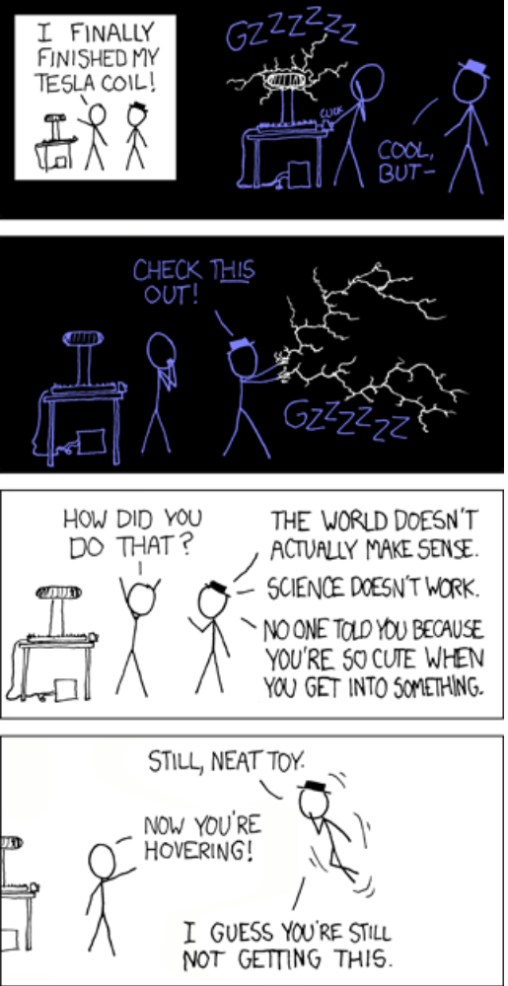
FIGURE ONE

2.0 Two non-scientific experiments

Historians have written a good deal about language, belief, and knowledge. To get a manageable panorama of the field, I did two small experiments, neither reliable by euro-scientific standards nor multicultural by ethno-scientific standards. Both, I hope, help us see the underlying structural patterns in how historians have approached belief and knowledge.

2.1 Space

For the first experiment, I surfed through dozens of Cambridge University websites with a net trawling for the proper names, names of the key producers of knowledge. Because Cambridge does not aggregate course descriptions in the style of the North American academic catalogue, and because not all webpages are open to the external eyes, I ended up working through a diversity of tripos descriptions, lecture titles, undergraduate prospectuses, and staff research interests. Ignoring textbook authors, my trawl caught the names of people whose selves or thoughts or schools had been deemed worthy of study. Putting aside the Faculty of Divinity, to which we turn below, I looked at all the faculties and departments of the university, although only about half gave up names of the sort I sought. Much depends on the vicissitudes of webpage design, or indeed on the more explicit interest a sociologist professes for Weber than a scientist for Newton, but I believe the resulting lists are telling, and give us a sense of the Cambridge pantheon of knowledge makers.
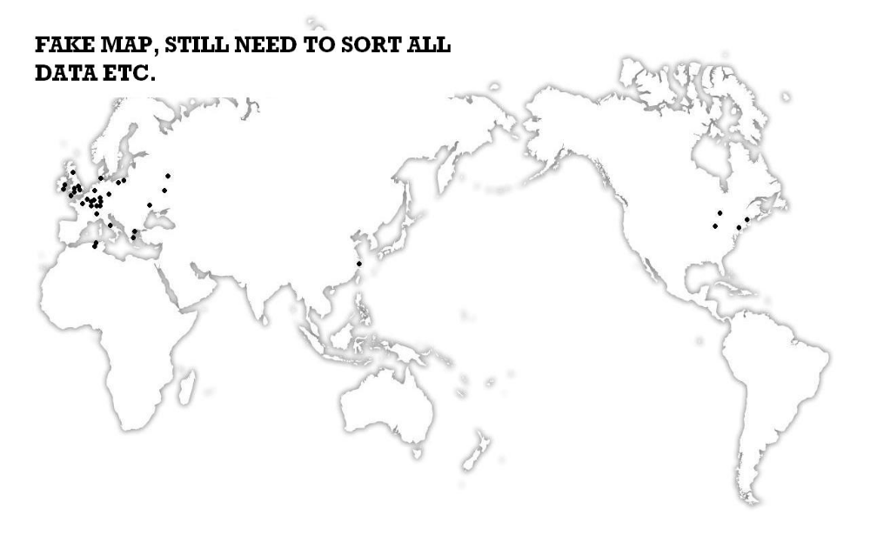
FIGURE TWO

Putting a dot on each knowledge maker's birthplace gives us a visual representation of the geography of knowledge at Cambridge [FIGURE TWO]. The vast majority are Europeans, with Plato, Kant, and Wittgenstein in the first row, as most frequently appearing. There is a small contingent of Americans: Nozick and Rawls, Quine, the trumpeter Miles Davis, and T. S. Eliot--who would become legally British and intellectually very British. The entire rest of the world is represented by a single dot, for the English novelist J. G. Ballard, by virtue of his birth in the Shanghai International Settlement. x (y%) of these men (and the z women) are born within w kilometres of Versaille [or somewhere]*. These results--the peoples with knowledge and those without--visually echo the century-old map (FIGURE THREE) distinguishing between the colourful places of the “people with history” and the inky blackness of the land of the people merely with tradition.
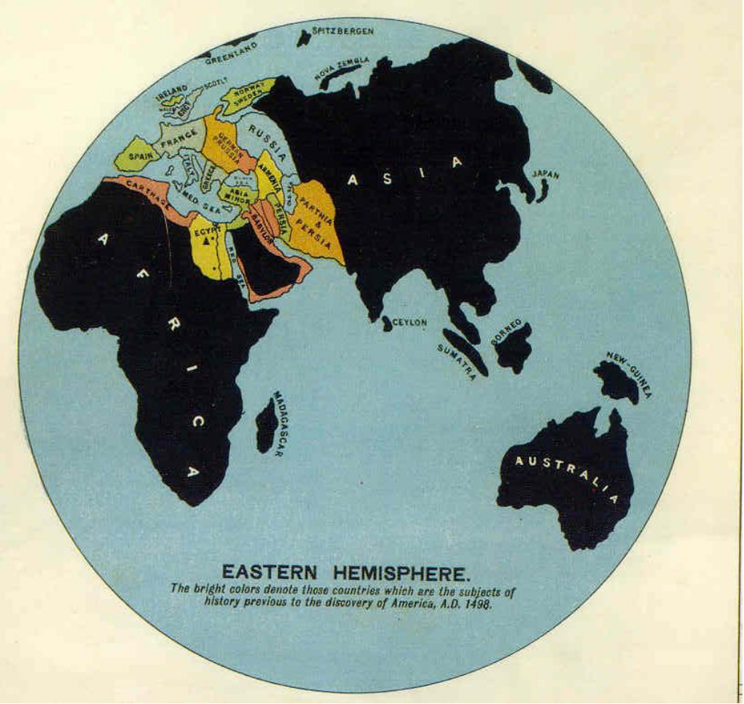
FIGURE THREE

Names from the Divinity Faculty's website were treated separately, in part because of our sense of difference between religious belief and scientific knowledge, and in part because they ran opposite to the grain of the overall pattern. Here, if we deny Jesus and Augustine honorary status as Europeans, we are left with only three Europeans names: Maimonides (1137/8-1204) and Ibn Juzay (1357-1321) بن جزي , both of Andalusia, and the Sicilian Thomas Aquinas (1225-1274)--one Jew, one Muslim, and one Christian. The list is dominated by non-European Muslims and Jews, and bucks the overall trend yet again by being populated mostly by medievals. Here religion saves the non-European intellectual world from complete obscurity. Because of the relative decline in theology's prestige as it has been crowded out in modern times by new academic units, these names make only a small dent in the overall picture.
My point is not to pick on Cambridge University, but to suggest its excellence is as a regional university, and that it avoid the dangers of parochialism by reaching out to the wider world, or at least by being cognizant of the narrow geographical basis of the knowledge it teaches. The situation is not better elsewhere. The best universities in non-western countries have a similar curriculum, slightly supplemented by regional knowledge; an African university looks to the West and Africa, while an Asian university looks to the West and Asia, or its part of Asia. There is no knowledge of universal authorship. In our universities, knowledge was created by Europeans.

2.1 Time

Our second experiment shifts its focus from space to time. Here I have chosen three popular and reliable world history textbooks (Worlds Together Worlds Apart, Bentley and Ziegler's Traditions and Encounters, and Fernández-Armesto's The World: A Global History), worked through their over 1500 subsections and 3000 pages, and noted when knowledge and belief show up in the narrative. Of course, knowledge and belief appear well integrated throughout these texts, so to bring some precision to an impossible task, I counted subsections in which most paragraphs were mostly about science or about religion. I found some two hundred such subsections, and classified these into western vs. wider-world and religion vs. science categories. The division was crude and bloody. Science became defined as the sort of thing that would be found in a history of science book. Religion became everything else, including “bad science,” fields that might have been science except for our disbelief in them today, such as divination. Religion also included religious beliefs no one holds anymore; those classified as science held up better over time.
For most of human history, neither science nor religion were distinctive categories, so this search is historically anachronistic, but historiographically revealing. Because the number of atheists--despite their greater propensity than, say, Australian aboriginals to advertise their views on the sides of buses--has been so small, we might think the amount of religion in the world has been constant. If the coverage in textbooks is not constant, we have here an opportunity to understand how belief and knowledge fit into our artifices of world-history periodization. This reflects not only the historiography as a whole (reflecting the current 'further reading' bibliographies), but also the story we tell our university students, the story that those students--including most future world historians--are told in their formative years.
The results appear in (FIGURE FOUR). Religion dominates, with a great peak during an extended, and slightly delayed, Axial Age before beginning a long decline that gains speed in the wake of the scientific revolution. Less dramatic in its movements, science has a lower baseline it deviates from twice, once to partake modestly in the Axial Age, and then for the Scientific Revolution (a peak no greater than that for the Axial Age)--after which it dips and begins a slower rise. Only for the twentieth century do our textbooks pay more attention to science than to religion.

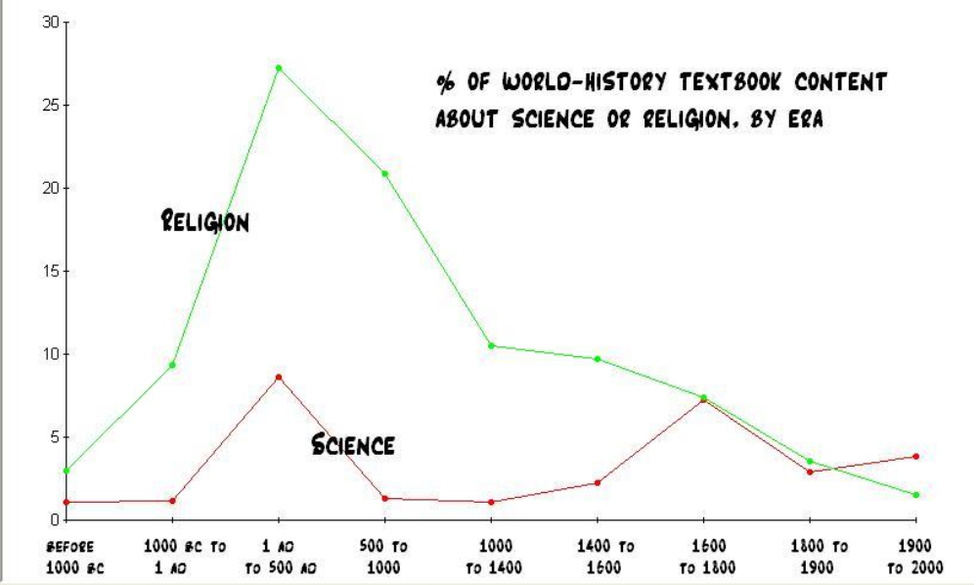
FIGURE FOUR

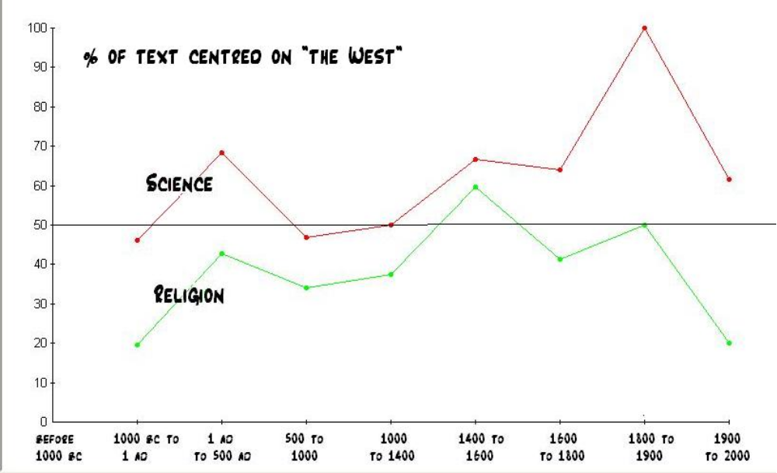
FIGURE FIVE

When we look at the geography of this data, we get a sense of how the west-vs.-wider-world question resolves itself in our textbooks. FIGURE FIVE plots, for each era but the first, the percentage of discussion that focuses on the West, for both science and for religion. (I offer no data for the earliest period, as what little coherence the western/wider-world division has in later centuries completely collapses here.) For every era, the science line is higher than the religion line; that is, discussions of science are more focused on the west than are discussions of religion. For the most part, science stays above the 50% boundary, and religion below it; that is, discussions of science are almost always more western while discussions of religion are almost always more wider world. Religion trespasses only once, is only once more western than eastern, from 1400 to 1600, during the Christian reformations. These are also the early years of the scientific revolution, and so even here science moves ever further west as if to accommodate religion's fling with Europe. Science trespasses twice, is only twice more eastern than western: the first millennium BC, when so little science is discussed that even brief consideration of the Mayan calendar drags it outside of the west, and the five centuries from 500 to 1000 AD, the so-called European “dark ages.”

3.0 Closer look at key moments

A somewhat crude analysis of textbooks and webpages confirms and adds precision to what we may already know: Scinece is western, religion eastern, and knowledge was built by Europeans.
At this point I'd like to look at the scholarship beyond the level of the textbook, and look at how historians and others have treated four key moments in the history of knowledge and belief, and specifically at what role the wider world plays in their scholarship. The four points are selected on the basis of the previous study: hominization (the prehistoric process of becoming human), the Axial Age that so dramatically directed textbooks' attention towards both science and religion, the European scientific revolution, and recent and continuing secularization (when our textbooks first favour science over religion). Because we are using our language, knowledge, and beliefs to study language, knowledge, and belief, we are in a bit of a self-referential intellectual swamp, and so will work in reverse chronological order, much as a nurse secures a fracture by working from the point of maximum relative stability. As we look back a century, a half millennium, two millennia, and tens of thousands of years, we see these four joints bearing the greatest explanatory burden.

3.1 Secularization

The most recent of the four moments is secularization, and this is particularly important as it motivates what was described in the opening paragraphs of this essay as the distinction reigning in the academy between knowledge and belief. The Latin “saeculum” originally meant “era” but extended to include “world,” not in in terms of global geography but in the sense of the world beyond the monastery walls, as for example “secular clergy.” Formulations vary, but the general sense of the secularization thesis is that as modernity (or wealth or science or rationalism) increases, religiosity declines. Scholars have imagined such a decline in religion would find expression in fewer people identifying as religious, less frequent participation in religious activities such as churchgoing, less influence in public or government or academic life, in an increased neutrality towards religion in those same spheres, and in religion becoming compartmentalized, declawed, and domesticated. When Christian Scientist parents refuse medical treatment for their children, on the grounds that “material medicine” secondguesses God and thus dilutes the efficacy of prayer, the state makes clear the place of religion in modern western society, and that it can not be realized or appealed to exclusively.
The timing of secularization is even more varied than its likely expressions--in the eighteenth, nineteenth (Spengler, Durkheim, Weber, Marx, Freud), twentieth, and twenty-first centuries it has been predicted to happen “very soon.” It has been “very soon” for a very long time, always the heaven or hell--depending on your perspective--lurking just around the corner. Consistency over so many centuries creates an unavoidable vagueness and uncertainty. As scholars actually look for data, in vain, there is increasingly a consensus that the thesis itself is false.
What role has the wider world played in the construction and destruction of the secularization thesis? The thesis was of course formed in a European scholarly milieu, based on ideas about contemporary and past Christianity, and only then subsequently expanded to the wider world. Indeed, Charles Taylor finds one root of secularism anchored in Christianity itself: “What is peculiar to Latin Christendom is a growing concern for Reform, a drive to make over the whole society of higher standards.” Subtle eurocentric assumptions remain in some versions of the secularization thesis. For example, the idea that contradictory religions brought together by pluralizing globalization are a recipe for secularism depends on a concept of religion with enough coherence and hard boundaries to cause crashes rather than syncretisms, a concept of religion particularly western before recent times.
Sometimes the wider world is used to confirm the secularization thesis. The expansion of the thesis beyond Europe moved rather smoothly; at first glance the wider world confirms it (especially when scholars considered the new evidence no more closely than they had their western data), for the wider world in our imagination and in reality remains relatively unmodern and relatively religious. For sociologist Talcott Parsons, the wider world fills in for history: Contemporary Australian aboriginals (or Durkheim's presentations of them) plays the role of an early stage of his (development of Durkheim's semi-explicit) evolutionary scheme. A 2008 study by the Pew Institute does indeed show an inverse correlation between religiosity (measuring belief in the necessity of God for morality, respondents' claimed importance of religion, and daily prayer--admittedly western criteria) and GDP per capita. (Only a handful of odd places contradict the secularization thesis: Kuwait and the United States, each astonishingly religious given its wealth, and some ex-Communist countries surprisingly irreligious given their poverty.) In most cases most wider-world countries prove the obversion of the thesis by being poor and religious, while Israel, Canada, and Japan all confirm the rich-and-irreligious correlation--and indeed values for Japan more precisely match the western Europe average scores than any of the countries' in western Europe. Sometimes secularization has been implicitly defined as the decline of Christianity (rather than religion in general), and so upticks in Islam and other religions become by definition evidence of increased secularization.
In other cases, however, the wider world works against the thesis. In recent years, years presumed to be more modern, powerful examples of religiousity flare up, counter to the thesis: Islamic enthusiasm (especially when government limits the “free market” of religious ideas), Christianity in Africa, Evangelicism in Latin America, and the religious underpinnings of the terror wars. Indeed, modernization has been seen as a cause of Islamism. Norris and Inglehart use the demography of the wider world to qualify their version of the secularization thesis that links greater security (rather than modernity per se) to greater secularism: that the more religious wider world has avoided the secular collapse of birth rates means that their populations grow more rapidly, and so the world as a whole is moving towards more religion. Although the wider world thus plays a limited role in the fight against the thesis, it is more the situation in Europe, the religion enduring modernity, that drives the thesis's decline, just as it was once the situation in Europe--modernity seemingly eroding religion--that motivated the thesis in the first place.

3.2 Scientific Revolution

In 1543 Nicholas Copernicus's De Revolutionibus put the sun in the centre of the universe; in subsequent centuries historians put Europe in the centre of science. Copernicus and the historians together share motivations sometimes rational, sometimes arbitrary, and came up with results in part rooted in reality and in part distortions of that reality. As an icon, the mere fact of moving the sun to the centre may herald the dawn of modernity, but a scientist today would find little to embrace in De Revolutionibus except for the results, and perhaps the impressive trigonometry and the use of zero, the only two features distinguishing it from ancient Greek science. Without modern methods motivating it, Copernicus's breakthrough could have just as well come from luck, and the European exceptionalism might then reduce to a genius for guessing. In fact, De Revolutionibus was both “the cradle and the coffin” for Copernicus's system, but it caused problems whose solutions by later proto-scientists developed fundamental components of the scientific revolution: empiricism, the mathematicization of nature, the mechanical universe, institutional supports for science, among others.
This emergent science is a complex of technological, methodological, and social changes, so lacking an agreed-upon core that Steven Shapin can write “there was no such thing as the Scientific Revolution, and this is a book about it.” When the debates' dust dies down, however, most undisputed is that science is European. Indeed, the early-modern volume of the Cambridge History of Science only pretends to step outside of Europe in its final chapter, “European Expansion and Self-definition,” but even here remains eurocentric and introverted in its formulation. McClellan and Doris's Science and Technology in World History fulfills the obligations of its title by devoting seventy-seven pages to the “world's people,” but after Ulugh Beg has shown his observatory, Montezuma I his zoo, Akbar his canal department, and the Ming their 1609 encyclopedia, the book surrenders to Europe, and science shines only on Europe and its colonial extensions.
Despite and because of historians' focus on Europe, historians of science in the wider world have found themselves drawn to it. In the last century, the world has entered the historiography of science primarily through the “grand question” of Joseph Needham (and earlier, of Max Weber): Why did China, despite an apparent early advantage in technology, not develop modern science? Replace technology with theory, and the same question could be asked for the medieval Islamicate world. Some scholars have denied the usefulness of the question; others have contributed to a growing list of answers and explanations for European exceptionalism: the handiness of an alphabet, the concept of the corporation, the end of feudalism, greater curiosity, the shock of Chinese technologies arriving in rapid succession, Islamic iconoclasm, the discovery of the Americas, neutral spaces of free inquiry, a moderate amount of skepticism, strong nation-states, and more. The range of these answers is indicative of a lack on consensus that reflects the complexity of the definition of modern science. Toby Huff's Rise of Early Modern Science: Islam, China and the West has offered the most geographically comprehensive explanations, and has attracted criticism in proportion to its ambition.
Recently historians have paid increasing attention to the global roots and branches of European science. The roots of the scientific revolution run via Arabic-language texts that intermediate between Europe and south Asia even while introducing their own innovations. The zero and trigonometry that makes Copernicus something more than ancient Greek science have these extra-European origins, and Copernicus's aversion to the equant may also be inherited from Nasir al-Din al-Tusi. Bala offers a recent synthesis of research on the extra-european roots of western science, as does Joseph's Crest of the Peacock for mathematics. Many such assertions of influence entail only compounded possibilities: Some minority view in China may have traveled to Europe where it may have been inhaled by some proto-scientist who may have incorporated it into some writing or device that may have played a role in the scientific revolution, a role that may have been crucial. Joseph includes a chart, FIGURE SIX, that shows possible and known lines of transmission of mathematical ideas. Scientific ideas followed similar paths. The design of a similar diagram for cross-cultural religious influences would be more difficult and subtle, but perhaps not impossible. Proponents of the wider-world roots of western science tend to yell shrilly into the eurocentricists' deaf ears, and the shrillness and deafness encourage each other. The reverse story can be told of science's branches, how modern science moved out of Europe into the wider world. The classic case is astronomy in China, but scholars are increasingly drawn to the European science using wider-world data as well as propagating globally, often in imbalanced power situations associated with colonialism and imperialism.

NEED TO SCAN IN FIGURE SIX***

3.3 Axial Age
In his 1949 Vom Ursprung und Ziel der Geschichte [The Origin and Goal of History] philosopher Karl Jaspers popularized the Axial Age, the three centuries before and after 500 BC, in which regions across Eurasia witnessed revolutionary developments, parallel but independent, in religion and science. In part motivated by the Holocaust, he pointedly avoided a focus on Europe alone. These were the centuries of Confucius, the Buddha, Socrates and other Greek philosophers, Daoism's shadowy Laozi, and a dozen Hebrew prophets. As any concept so grand and vast might, the Axial Age underwent sharp criticisms, especially charges of a lack of specificity or empiricism, or that it secularized salvation.
As we have seen, the Axial Age appears to be to religion what the Scientific Revolution is to science, and through the Greeks science enters the Age too. Its historiographical effects, however, tend to work in the opposite direction as the Scientific Revolution. While the Scientific Revolution is important for creating and privileging one tradition, the Axial Age dazzles precisely for the plurality of traditions it produces. The sociologically inclined might see in this plurality only a superficial cover over an essential unity, but G. K. Chesterton held rather that the only common ground between religions, fundamentally different, was exactly that sort of superficial cover. It is very difficult to compare religions without constructing a highly artificial common ground that could almost be described as secular, and a neo-othodox theologian like Karl Barth might object even to desecrating what he considers truth by calling it “religion” at all. Cross-cultural connections tend to be less relevant in the Axial Age than in the Scientific Revolution, in part because there were fewer, and in part because this is a plurality not about to become the single, universal euro-religion. In many ways the Axial Age is less important for what happened in it than for the story we tell about it. Few of these figures probably intended to found a religious tradition in our modern sense; it is subsequent generations in a line from them to us who look back and award these thinkers special status.
Scholars of the Axial Age revel in the wider world; at its very soul the concept has a wider world significance. Some scholars, it would appear, see in this this geographical universalism a truth somewhat analogous to that of modern science. Karen Armstrong, for example, imagines a real religious truth--compassion--that humanity essentially discovered in this period (“we have never surpassed the insights of the Axial Age”). In her writings, the sense of this objective religious truth is clear enough to her that she can spot flaws in earlier manifestations of religion: “The Axial Age was not perfect,” she writes, “a major failing was its indifference to women.” By implication, Jesus's “Do not think that I came to bring peace on the earth; I did not come to bring peace, but a sword” (Matthew 10:34) would simply show that he never really “got” Christianity. Although this bias is not explicitly eurocentric, it is teleological in that “our” modern religious sensibility is the yardstick by which others could be judged.
Rodney Stark's Discovering God attempts to get around eurocentrism, and indeed around the eurocentric de-privledging of religion. Here BC becomes BCE, but Christ becoming “Common Era” turns a particular birthday that happens to be in common use into a “common” chronological marker normative for the planet. The usual “God” becomes “Gods,” an attempt to get around the monotheism of the west, but notice the capital letter: He has created a pantheon stocked by multiples (almost in a Warholian sense) of the monotheistic Judeo-Christian-Islamic God, a pantheon alien to any eyes that do not see it as heretical . The Buddha, for example, is said to have received a revelation from God, an assertion likely to surprise both of them. At places Stark appeals to God's revelations as explanations, but as his overall narrative seems so normal, the revelations of God appear to be mere grace notes. His brave sortie out of eurocentrism fails.

3.4 Hominization

The obstacles inherent in the study of language, knowledge and belief are compounded by a daunting paucity of evidence--and total lack of written sources--to make the study of their birth tremendously difficult. Anthropologists' interpretations are often conjectural, based on presuppositions supplemented by “backstreaming,” where their data on prehistorical humans is extrapolated from observable hunter-gatherer peoples today, a procedure reliable exactly to the extent that hunter-gatherers “have no history,” have not changed over the centuries. If alien anthropologists came to a post-apocalyptic earth, they could use our own anthropologists' methods to find in a precious artifact such as the “Girls With Guns Calendar 2009” a magical device for promoting fertility (note the enlarged breasts), success in the hunt (note the high-calibre firearms), and measuring time (not so bad a conjecture, but surely missing the calendar's primary appeal) (FIGURE SEVEN).


FIGURE SEVEN

Many criteria have been proposed as what distinguishes humans from their primate ancestors, most frequently the use of tools and bipedalism, with language and “superior mental faculties” both also appearing frequently. For each of these ideas, the suggestion that it was the distinctive feature of humanity was first made by the ancient Greeks, no later than the fourth century BC.. Religion or morality are very rarely considered important factors. The scholarly consensus is that the first humans were too hungry to speak or think; our ancestors lived uncommunicative and unreflective lives dedicated to the acquisition of food, where neither language nor thought had a point. To help them in their quest for food, humans invented tools, and only then was language necessary and possible. Only with language, the consensus holds, does reason--our belief and knowledge--become possible. Religion is born as humans without science dream up explanations for natural phenomena, and was motivated by fear of those natural phenomena. Cave art--the best evidence of religious belief system--is done for material aims, for a successful hunt. It is not a result of thinking, as for the most part humans were too hungry, too busy hunting, to think. Like reason and language, religion is utilitarian, a consequence of material conditions, and oriented towards survival. In keeping with the usual valorization of science, religion here serves a function not only material but one merely psychological.
Wiktor Stockowski has demonstrated that almost every scholar's “recipe for making a human being” can be reduced to one of two variations, depending on assumptions about human nature: “Take an ape who could be incited to act only by necessity, remove it from the protective shell of environment A and put it on the grill of a hostile nature for a few million years (environment of period B). If your ape is more orientated toward optimization of profit, surround it with a host of savory ingredients of Period A in order to obtain the same end result.” Despite apparent advances in anthropology and biology, the story scholars tell of our species' origins is a rehashing of ideas--assumptions, really--from the ancient Greeks. (Leroi-Gourhan has pointed out the neurological prerequisites of language, but this only shifts it from a consequence of the material to a fruit of the physiological.) Although archaeological findings precludes some possible interpretations, we have mostly a free reign in constructing interpretations. Unfortunately, our collective scholarly imaginations have not proved very imaginative, and we are more confident in our conclusions than we have any right to be.
A possible consolation is that we have gone back chronologically so far before any meaningful concept of a Europe that we have necessarily outflanked eurocentrism. In fact, as our focus moves beyond and before Europe, scholars' eurocentric narrowmindedness broadens into an anthropocentric narrowmindedness. Much depends on this idea that thinking cannot occur without language, which leads us to take other species' lack of verbal communication as a lack of reason. There is no reason for this, any more than for the stereotypical American tourist who screams in English--certainly loudly enough to be understood--at the perplexed and mute citizens of Rome to conclude that they are rather stupid. More subtle ways of marking human exceptionalism have been suggested. Grammatical language has been proposed, but even their people can tell when some animals' vocalizations are irregular, though of course we might not know if these are bad grammar, cursings, or beat poetry, perhaps a canine version of Ginsburg's “Howl.” Another criterion measures degrees of intentionality, whereby "I suspect that she knows that I'm watching her talking to him" would have four degrees of intentionality. It has been suggested that this exceeds a chimpanzee's two-degree limit, while remaining just under a human's limit at five. Perhaps a clever mathematician could imagine an arbitrarily high degree of intentionality by imagining a recursive queue of people each suspecting the next person's suspicions (of the next person's suspicions of...); this reveals the alarming conclusion that as a species humans stand closer to chimpanzees than to mathematicians. I gave a draft of this essay to a six-year-old dog for comment, in vain. It is tempting to say she lacked the language-belief-and-knowledge capabilities, but why assume a lack of capacity before a lack of collegiality or interest?

4.0 Conclusions

4.1 Current limitations

In our cursory survey of historians' treatment of knowledge and belief, we have seen a quite consistent eurocentrism, but a great diversity in what that means, in what it consequences are. The wider world mostly reinforces the secularization thesis, begs questions of the scientific revolution, and delights in the level playing field of the Axial Age. In every case that involves a “Europe,” eurocentrism plays important roles.
Is this eurocentrism a problem? On the one hand, we--in this essay and in the academy more broadly--have spent so much time looking at it that other issues get short shrift. Many of these may be more interesting than the west-vs.-rest problem, which after all is not much more than a question of organizing knowledge. Some of issues are related to the eurocentrism: For example, Edward Said's much criticized Orientalism is surely not completely wrong in linking western scholarship on the wider world to western imperial dominance over the wider world. It is, moreover, not easy to avoid carrying one's cultural presuppositions into studies of other cultures: So, because Nagarjuna's writings became accessible to the West during or after the ascendancy of Wittgenstein, there was a tendency to see Nagarjuna as a Wittgensteinian, seventeen centuries in advance. Cultural incommensurability is one of the more fashionable of a long list of reasons why comparative study is impossible, though much of the list had been anticipated by the ancient wise. If you had told Zhuangzi that he couldn't know what a Hindu thought, he would have asked how you could then know what he could or could not know--intercultural incommensurability reduces to interpersonal incommensurability, which ends our scholarly conversations. Foregrounding these geographical divisions in our knowledge may also reinforce an unwanted gap between west and rest that is at least partly historiographical.
The greatest obstacle is western scholars' relative disinterest in the histories of belief and knowledge in the wider world. From that disinterest follows not only a relative ignorance, but also some sense that wider-world peoples, their beliefs, and their knowledges are less deserving of our notice. The geographical interests of historians in the top history departments of the United Kingdom, Canada, and the United States are proportionate not to population numbers, but to gross domestic product; our professional specialization is the history of the very wealthy. History departments in the west are dominated by historians of western history. Some wider-world historians are somewhat hidden from view in the various area-studies academic units, but this does nothing to ameliorate the reality that half of history departments skip Africa entirely.
We are furthermore relatively uninterested in the wider world's languages. In the United States' universities, only some one seventh of foreign-language enrollments are in non-western languages, a proportion steadily growing over the last five decades, a growth fueled before the 1990s slowdown by enthusiasm for Japanese, and now mostly by jumps in Chinese and Arabic enrollments. This should not make us optimistic, as the total number of students studying language has largely remained steady in the last half century, despite the undergraduate population in the United States more than doubling. In the United Kingdom, about a tenth of undergraduate students whose subjects of study are language are working in non-European languages. (Typically in the United Kingdom language students are twice as likely to be female, but this gender imbalance disappears when only students of non-western languages are considered.) Note that three quarters of the earth's population are native speakers of a non-western language. Even looking at the rates of change based on the more encouraging America data, we do not expect enrollments to reach this level until sometime in the twenty-third century.
Problems with language compounds problems with sources. Key treatises from Muslim scientists working before the European Scientific Revolution have not yet been translated into a western language. Sometimes even whole collections of the originals of non-western sources are endangered. Soon some thirty thousand of the historical manuscripts in Timbuktu will have been evacuated into the the Ahmed Baba Institute's new building. The fate of the hundreds of thousands that remain precarious in private institutions is an open question. If we ignore these sources, their histories will go away.

4.2 Future possibilities

Of course we can not discount the possibility that there will be a future historiography of language, belief, and knowledge that introduces wholly new issues and changes the variables that seem most meaningful. In this digital age we record per person each year some 800 megabytes of information, which may prove intellectually overwhelming even if it is not in media physical enough to physically suffocate us. Perhaps a Silencepeace movement will arise to save us from information pollution, or monasteries of apophatic monks will prune bonzai libraries. David Macaulay's masterful Motel of the Mysteries (1979)--perhaps the greatest meditation on historians' ability to know past knowledge and understand past belief-- deals with the junk-mail tsunami of 1985. Perhaps future attention will swivel from language, belief, and knowledge to silence, doubt, and ignorance.
It may be helpful to consider, through the magic of imagination and extrapolation, the next century's Beijing History of the World (Beijing UP: forthcoming, 2114). Historians of the future will have remembered the early-twenty-second-century shift of the core of the academy from west to east, following not long after the Asian dominance of the world economy. Chinese and Indian scientists accumulated Nobel prizes for finding the Higgs particle (had it been hiding in Urumchi all along?), resolving the proton-spin crisis, equating P and NP, and much else. If you turn to the History's chapters on the history of science, you will see a great many Chinese names, even from much earlier centuries. The section on physics, for example, traces modern (i.e. twenty-second-century) physics back to its roots in the atomism of the ancient school of Mozi 墨子. A special boxed text section on ethno-science, inserted at the eleventh hour by an editor keen on multiculturalism, mentions the probable additional influence of 笛卡儿 and 波义耳. Their names are helpfully romanized in the index (volume 14) as Descartes and Boyle, although Chinese has become the academy's default language, and even scholars primarily anglophone might drop in a classical allusion with no translation and with minimal pretension; after all, 人不知而不愠、不亦君子乎 (论语 1).
Although the Beijing History helps us see our own blind spots, it does little more than replace one centrism with another. Perhaps our imaginations have not drifted quite far enough into the future. Looking down the bookshelf, we can just make out the cover of the twenty-fifth-century Lunar History of the Earth. This may promise the objectivity born of great distance, but we notice the publisher is Copernicus Crater University Press, the name reminding us of the iconic yet ironic place of Copernicus in all of these discussions. Who knows what perspectives the lunar colonists will have? A great deal depends on what beliefs and knowledges the CCU history department's colonist forefathers will have brought with them--and whether they are packed in boxes labeled “religon” or “science”--and a great deal depends on whether they will have been lifted to the moon by nuclear thermal rockets, or by devas and angels.

Bibliography
Bala, Arun. The Dialogue of Civilizations in the Birth of Modern Science. New York: Palgrave Macmillan, 2006.
Hall, David L., and Roger T. Ames. Thinking Through Confucius. Albany: SUNY Press, 1987.
Huff, Toby. The Rise of Early Modern Science: Islam, China and the West. New York: Cambridge UP, 1993. [second edition 2003]
Joseph, George Gheverghese. The Crest of the Peacock: Non-European Roots of Mathematics. 2nd. ed. London: Penguin Books, 2000.
Macaulay, David. Motel of the Mysteries. Boston[?]: Graphia, 1979.
Needham, Joseph. The Grand Titration: Science and Society East and West. London: Allen & Unwin, 1969.
Odera Oruka, H., ed., Sage Philosophy: Indigenous Thinkers and the Modern Debate on African Philosophy. Leiden: E. J. Brill, 1990.
Scharfstein, Ben-Ami. A Comparative History of World Philosophy: From the Upanishads to Kant. Albany: SUNY Press, 1998.
Stoczkowski, Wiktor. Explaining Human Origins: Myth, Imagination, and Conjecture. Cambridge: Cambridge UP, 2002.
Tuck, Andrew P. Comparative Philosophy and the Philosophy of Scholarship: On the Western
Interpretation of Nagarjuna. Oxford: Oxford UP, 1990.

Seamus Deane, “Maths Class,” The New Yorker (year?) 100-103 at 101. [maybe anthologized so I don't have to cite the evil TNY?]
Französische Bühne (The French Stage), ch. 9 (1837) [page???]
« Theodoric of York, » Saturday Night Live, Season 3 Episode 18. April 22, 1978
need to find
Kanigel, Robert. The Man Who Knew Infinity: a Life of the Genius Ramanujan. New York: Charles Scribner's Sons, 1991, p.36 [doublecheck]
A more positive reassessment of Africans' cognitive abilities coincided with World War II, and by 1945 Placide Tempels could write of a Philosophie Bantoue, available in English translation as Bantu Philosophy (Paris, Présence africaine, 1969). Today the question of an African “philosophy” looms large in African philosophy departments, where Tempels is now largely considered very conservative. For the debate, see Paulin J. Hountondji, African Philosophy: Myth and Reality, trans. H. Evans (London: Hutchinson University Library for Africa, 1983) and H. Odera Oruka, ed., Sage Philosophy: Indigenous Thinkers and the Modern Debate on African Philosophy (Leiden: Brill, 1990). See also David L. Hall and Roger T. Ames' Thinking Through Confucius (SUNY, 1987), which seeks to clear away Euronormative assumptions about ancient Chinese philosophy before putting it to work sorting out current issues.
Randall Munroe, “Tesla Coil,” http://xkcd.com/298/ (August 3, 2007)
See Thomas Albert Howard, Religion and the Rise of Historicism: W. M. L. de Wette, Jacoob Burckhardt, and the Theological Origins of the Nineteenth-Century Historical Consciousness (Cambridge: Cambridge UP, 2000), 18-19 [track down note 80 on p.18]
Charles Taylor, A Secular Age, p. 63. [NTS]
[See Parsons 1977 The Evolution of Societies, which turns out not to be so explicitly based on Durkheim and a combined edited version of _Societies: Evolutionary and Comparative Perspectives_ and _The System of Modern Societies_.
Pew Global Attitudes Project (chart on p.41). Find URL
p3 Book title=Sacred and secular: religion and politics worldwide?
Joseph T. Clark, “'Something Old, Something New, Something Borrowed, Something Blue' in Copernicus, Galileo, and Newton,” in Transformation and Tradition in the Sciences, 67-79 (Place: Pub, Year), 70.
Steven Shapin, The Scientific Revolution (Chicago: University of Chicago Press, 1996), 1.
The most accessible treatment is in Needham, The Great Titration (...)
Safier suggests Green Imperialism and Lissa Roberts, “Situating Science in Global History: Local Exchanges and Networks of Criculation,” Itinerario 33 (2009): 9-30.
Karl Jaspers, Vom Ursprung und Ziel der Geschichte (Munich: Piper Verlag, 1949). Translated into English by M. Bullock as The Origin and Goal of History (London: Routledge and Keegan Paul, 1953).
Karl Jaspers, The Question of German Guilt, trans. E. B. Ashton (New York: Fordham University Press, 2000), 17 NTC*
I think this is in Orthodoxy, but need to find it.*
need to find.
Both quotes from Karen Armstrong, The Great Transformation: The Beginning of Our Religious Traditions (Toronto: Random House, 2007), xvii and xxi. Similar sentiments in her book on Jerusalem, &c.
Rodney Stark, Discovering God: The Origins of the Great Religions and the Evolution of Belief () need to find pages.*
TABLE 6 of Stockowski. NTC**
Stockowski p. 67 (or 69??)
1964. Page number? Title of book? Hello?
Corballis, From Hand to Mouth, p. 61
Steven Mithen, The Prehistory of the Mind, p. 108
See Andrew P. Tuck, Comparative Philosophy and the Philosophy of Scholarship: On the Western Interpretation of Nagarjuna (Oxford: 1990).
See Guyatt/Clossey study in preparation now, which might allow more detail in this paragraph.
That AHA Perspectives study a few years ago that NG sent me.
I base my calculations on data from Nelly Furman, David Goldberg, and Natalia Lusin, “Enrollments in Languages Other Than English in United States Institutions of Higher Learning, Fall 2006,” Modern Language Association, tables 4, 5, 6, and 8.
I base my calculations on data from the Higher Education Statistics Agency, http://www.hesa.ac.uk/index.php/component/option,com_datatables/Itemid,121/task,show_category/catdex,3/#subject
Linear extrapolation. Could get a better answer using polynomials but that would take an afternoon...
True?
Peter Lyman and Hal R. Varian, “How Much Information? 2003,” http://www2.sims.berkeley.edu/research/projects/how-much-info-2003/.

