Fluid Statics
When the fluid velocity is zero, called the hydrostatic condition, the pressure variation is due only to the weight of the fluid.
Consider a small wedge of fluid at rest of size Δx, Δz, Δs and depth b into the paper. There is no shear stress by definition, and pressure is assumed to be identical on each face (small element).

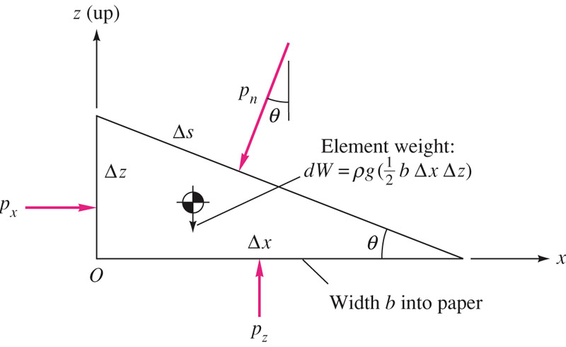
g
Fig. 1: Equilibrium of a small Fluid element at rest.
Since the element is at rest, summation of all forces must equal zero.
$$\sum{F_{x}=0=p_{x}}b ∆z-p_{n}b ∆s sinθ$$
$$\sum{F_{z}=0=p_{z}}b ∆x-p_{n}b ∆s cosθ-\frac{1}{2}ρg b ∆x ∆z$$
From geometry, $∆s sinθ=∆z ∆s cosθ=∆x$. After substitution in above equations, one finds:
$$p_{x}=p_{n} p_{z}=p_{n}+\frac{1}{2}ρg ∆z$$
This means:
- There is no pressure change in the horizontal direction.
- There is a vertical change in pressure proportional to the density, gravity and depth change in the fluid (i.e. the weight of the column of the fluid above the point).
Note: in the limit as the fluid wedge shrinks to a point, Δz goes to zero, we have: $p_{x}=p_{z}=p_{n}=p$. Thus, pressure in a static fluid is a point property.

Pressure force on a fluid element
Assume the pressure vary arbitrarily in a fluid, p=p(x,y,z,t). Consider a fluid element of size Δx, Δy, Δz as shown in Fig. 2. The net force in the x-direction is given by:
$$dF_{x}=pdydz-\left(p+\frac{∂p}{∂x}dx\right)dydz=-\frac{∂p}{∂x}dx dy dz$$
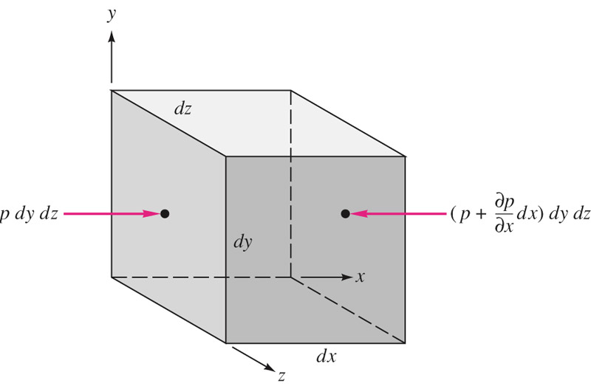
Fig. 2: Net force in the x-direction due to pressure variation.
In a similar manner, net forces acting in y- and z-directions can be calculated. The total net force vector, due to pressure, is:
$$dF_{press}=-\left(\frac{∂p}{∂x}i+\frac{∂p}{∂y}j+\frac{∂p}{∂z}k\right)dx dy dz$$
Notice that the term in the parentheses is the negative vector gradient of pressure and the term dx dy dz =dV, is the volume of the element. Therefore, one can write:
$$f_{press}=-∇p$$
where f_{press} is the net force per volume. Notice that the pressure gradient (not pressure) causing a net force that must be balanced by gravity or acceleration and/or other effects in the fluid.
Note: the pressure gradient is a surface force that acts on the sides of the element. That must be balanced by gravity force, or weight of the element, in the fluid at rest.
In addition to gravity, a fluid in motion will have surface forces due to viscous stresses. Viscous forces, however, for a fluid at rest are zero.
The gravity force is a body force, acting on the entire mass of the element:
$dF_{gravity}=ρgdx dy dz f_{gravity}=ρg$

Gage pressure and vacuum pressure
The actual pressure at a given position is called the absolute pressure, and it is measured relative to absolute vacuum.
The measure pressure may be either lower (called vacuum pressure) or higher (gage pressure) than the local atmosphere.
$$p>p_{a} Gage pressure p_{gage}=p-p_{a}$$
$$p<p_{a} Vacuum pressure p_{vacuum}=p_{a}-p$$
P_{atm}
P_{gage}
P_{abs}
Absolute (vacuum) = 0
P
P_{vac}
Fig. 3: Absolute, gage, and vacuum pressures.

Hydrostatic pressure distribution
For a fluid at rest, the summation of forces acting on the element must be balanced by the gravity force.
$$\vec{∇p}=ρ\vec{g}$$
This is a hydrostatic distribution and is correct for all fluids at rest, regardless of viscosity.
Recall that the vector operator $∇$ expresses the magnitude and direction of the maximum spatial rate of increase of the scalar property (in this case pressure).
Note: $∇p$ is perpendicular everywhere to surface of constant pressure p. In other words, in a fluid at rest will align its constant-pressure surfaces everywhere normal to the local-gravity vector. Or, the pressure increase will be in the direction of gravity (downward). However, in our customary coordinate z is “upward” and the gravity vector is:
$$\vec{g}=-gk$$
where g=9.807 m/s². For this coordinate, the pressure gradient vector becomes:
$$\frac{∂p}{∂x}=0 \frac{∂p}{∂y}=0 \frac{∂p}{∂z}=-ρg=-γ$$
Since pressure is only a function of z (independent of x and y), we can write:
$$\frac{dp}{dz}=-γ p_{2}-p_{1}=-\int_{1}^{2}{γdz}$$
As a result, we can conclude: pressure in a continuously distributed uniform static fluid varies only with vertical distance and is independent of the shape of the container. The pressure is the same at all points on a given horizontal plane in a fluid.
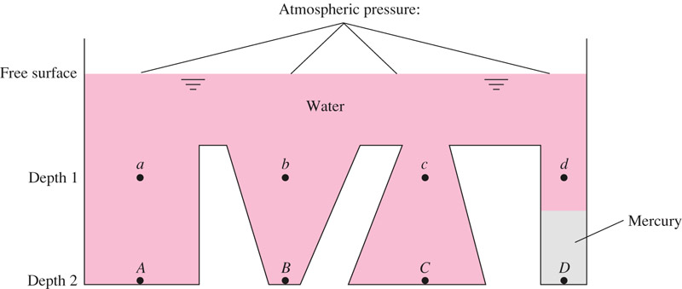
Fig. 4: Hydrostatic pressure is only a function of the depth of the fluid, $p_{a} = p_{b} = p_{c}$. However, $p_{A}=p_{B}=p_{C}≠p_{D}$. Because point D, although at the same level, lies beneath a different fluid, mercury. The free surface of the container is atmospheric and forms a horizontal line.
Note: In most engineering applications, the variation in acceleration of gravity (g) due to different heights is less than 0.6% and can be neglected.
For liquids, which are incompressible, we have:
$$p_{2}-p_{1}=-γ\left(z_{2}-z_{1}\right) or z_{1}-z_{2}=\frac{p_{2}}{γ}-\frac{p_{1}}{γ}$$
The quantity, $p/γ$ is a length called the pressure head of the fluid.

The mercury barometer
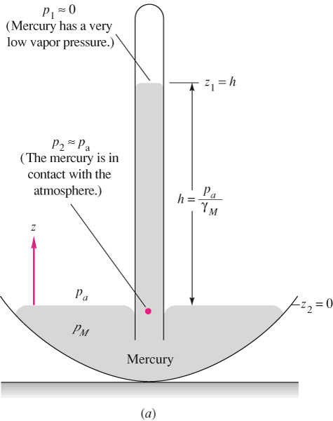
Mercury has an extremely small vapor pressure at room temperature (almost vacuum), thus p₁ = 0. One can write:
$$p_{a}-0=-γ_{mercury}\left(0-h\right) or h=\frac{p_{a}}{γ_{mercury}}$$
At the sea-level, the atmospheric pressure reads, 761 mmHg.

Hydrostatic pressure in gases
Gases are compressible with density nearly proportional to pressure, thus the variation in density must be considered in hydrostatic calculations. Using the ideal gas equation of state, $p=ρRT$:
$$\frac{dp}{dz}=-ρg=-\frac{p}{RT}g$$
After integration between points 1 and 2 and also assuming a constant temperature at both points T₁ =T₂=T₀ (isothermal atmosphere), we find:
$$p_{2}=p_{1}exp\left[-\frac{g\left(z_{2}-z_{1}\right)}{RT_{0}}\right]$$
The isothermal assumption is a fair assumption for earth. However, for higher altitudes the atmospheric temperature drops off nearly linearly with z, i.e. $T≈T_{0}-Bz$, where T₀ is the sea-level temperature (in Kelvin) and B=0.00650 K/m, we find:
$$p=p_{a}{\left(1-\frac{Bz}{T_{0}}\right)}^{g/{RB}} for air \frac{g}{RB}=5.26$$
Note that the atmospheric pressure is nearly zero (vacuum condition) at z = 30 km.

Manometry
It is shown that a change in elevation of a liquid is equivalent to a change in pressure, $∆h=∆p/γ$. Thus a static column of one or multiple fluids can be used to measure pressure difference between 2 points. Such a device is called manometer.
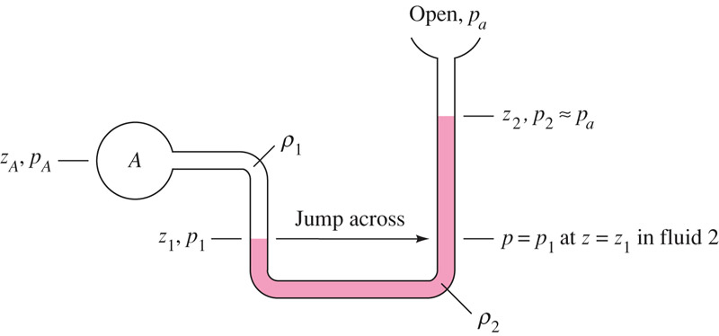
Fig. 5: Simple open manometer.
$$p_{A}+γ_{1}\left|z_{A}-z_{1}\right|-γ_{2}\left|z_{1}-z_{2}\right|=p_{2}=p_{atm}$$
Two roles for manometer analysis:
- Adding/ subtracting $γ∆z$ as moving down/up in a fluid column.
- Jumping across U-tubes: any two points at the same elevation in a continuous mass of the same static fluid will be at the same pressure, thus we can jump across U-tubes filled with the same fluid.

Hydrostatic forces on plane surface
Consider a plane panel of arbitrary shape completely submerged in a liquid.
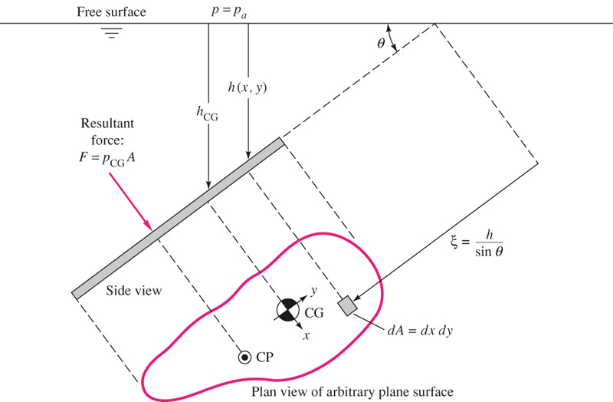
Fig. 6: hydrostatic force and center of pressure on a plane submerged in a liquid at an angle θ.
If h is the depth to any element area dA, the local pressure is:
$$p=p_{a}+γh$$
The total hydrostatic force on one side of the plane is given by:
$$F=\int{pdA=\int{\left(p_{a}+γh\right)}}dA=p_{a}A+γ\int{hdA}$$
We also have: $h=ξsinθ$. After substitution, we get:
$$F=p_{a}A+γ sinθ\int{ξdA}=p_{a}A+γ sinθ ξ_{CG}A$$
Since, $h_{CG}=sinθ ξ_{CG}$,
$$F=p_{a}A+γh_{CG}A=\left(p_{a}+γh_{CG}\right)A=p_{CG}A$$
It means, the force on one side of any plane submerged surface in a uniform fluid equals the pressure at the plate centroid times the plate area, independent of the shape of the plate or angle θ.
To balance the bending-moment portion of the stress, the resultant force F acts not through the centroid but below it toward the high pressure side. Its line of action passes through the centre of pressure CP of the plate (x_{CP}, y_{CP}).
To find the center of pressure, we sum moments of the elemental force pdA about the centroid and equate to the moment of the resultant force, F:
$$Fy_{CP}=\int{ypdA}=\int{y\left(p_{a}+γξsinθ\right)}dA=γsinθ\int{yξdA}$$
The term $\int{ydA=0}$, by definition of centroidal axes. Using the definition of the area moment of inertia about centroidal x axis, $I_{xx}=\int{y^{2}dA}$, after some simplifications:
$$y_{CP}=-γsinθ\frac{I_{xx}}{p_{CG}A}$$
The negative sign shows that y_{CP} is below the centroid at a deeper level and depends on angle θ and the shape of the plate (I_{xx}).
Following the same procedure, we find:
$$x_{CP}=-γsinθ\frac{I_{xy}}{p_{CG}A}$$
Note: for symmetrical plates, I_{xy} = 0 and thus x_{CP} = 0. As a result, the center of pressure lies directly below the centroid on the y axis.
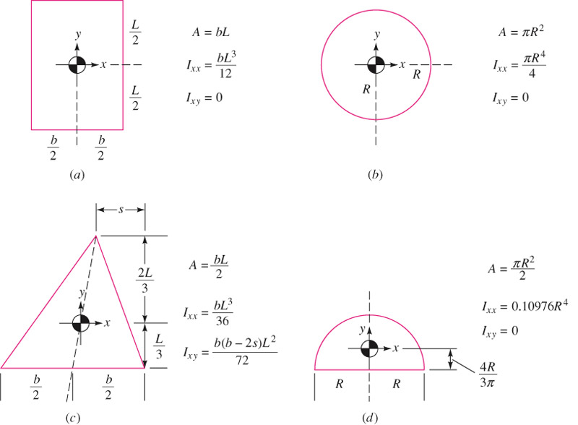
Fig. 7: Centroidal moments of inertia for various cross-sections.

Hydrostatic forces on curved surfaces
The easiest way to calculate the pressure forces on a curved surface is to compute the horizontal and vertical forces separately.
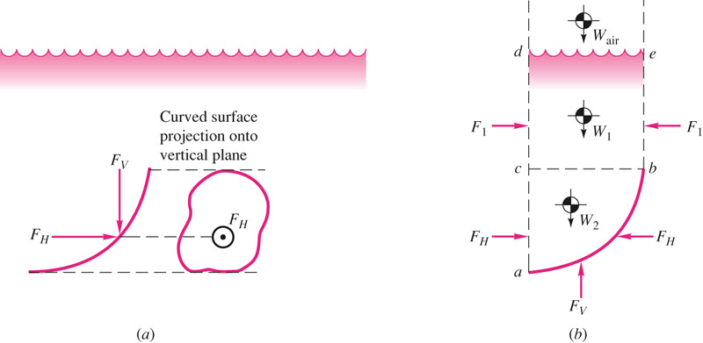
Fig. 8: Calculating horizontal and vertical pressure forces on an immersed curved surface.
Using the free-body diagram shown in Fig. 8b, one can find:
The horizontal force, F_{H} equals the force on the plane area formed by the projection of the curved surface onto a vertical plane normal to the component.
The vertical component equals to the weight of the entire column of fluid, both liquid and atmospheric above the curved surface. For the surface shown in Fig. 8:
F_{V}= W₂ + W₁ + W_{air}

Buoyancy
Archimedes’s 1st laws of buoyancy: A body immersed in a fluid experiences a vertical buoyant force equal to the weight of the fluid it displaces, see Fig. 9 and 10.
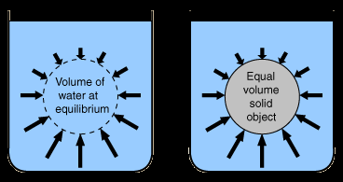
Fig. 9: an immersed body in a fluid, experiences a force equal to the weight of the fluid it displaces.
The line of action of the buoyant force passes through the center of volume of the displaced body; i.e., the center of mass is computed as if it had uniform density. The point which F_{B} acts is called the center of buoyancy.
Both liquids and gases exert buoyancy force on immersed bodies.
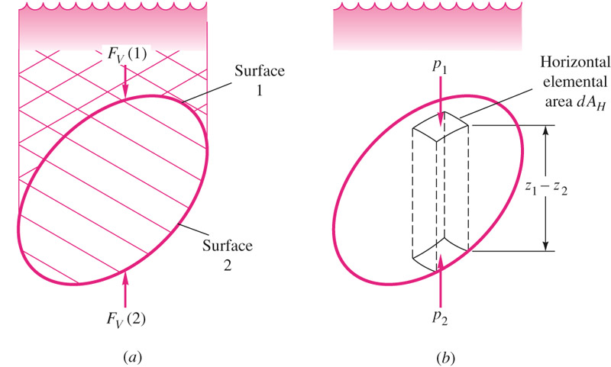
Fig.10: Archimedes first law of buoyancy.
$$F_{B}=\int_{body}{\left(p_{2}-p_{1}\right)}dA_{H}=-γ\int{\left(z_{2}-z_{1}\right)}dA_{H}=γ\left(body volume\right)$$
This equation assumes that the body has a uniform specific weight.
A floating body displaces its own weight in the fluid in which it floats.
In the case of a floating body, only a portion of the body is submerged, thus:
$$F_{B}=γ\left(displaced volume\right)=weight of the hfloating body$$
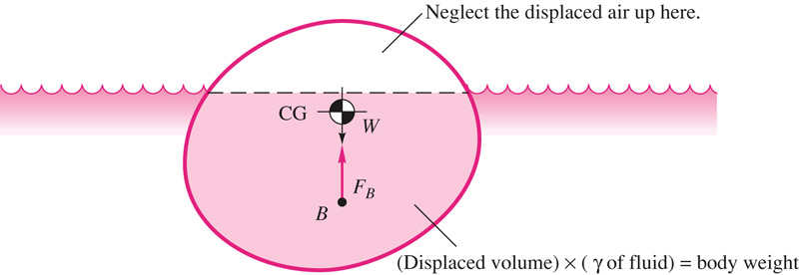
Fig. 11: Archimedes second law of buoyancy.
Example: Buoyancy force on a submerged object
A spherical body has a diameter of 1.5 m, weighs 8.5 kN, and is anchored to the sea floor with a cable as is shown in the figure. Calculate the tension of the cable when the body is completely immersed, assume $γ_{sea-water}=10.1 kN/m^{3}$.
Solution:
The buoyancy force F_{B} is shown in the free-body-diagram where W is the weight of the body and T is the cable tension. For equilibrium, we have:
$$T=F_{B}-W$$
The buoyancy force is; $F_{B}=γV$. And the volume of the body is:
$$V=\frac{πd^{3}}{6}$$
The cable tension then becomes:
$$T=10.1×{10}^{3}\left(N/{m^{3}}\right)\frac{π{\left[1.5\left(m\right)\right]}^{3}}{6}-8.50×{10}^{3}\left(N\right)=9.35kN$$
d
Seawater
Cable
T
W
F_{B}

Pressure distribution in rigid-body motion
Fluids move in rigid-body motion only when restrained by confining walls. In rigid-body motion, all particles are in combined translation and rotation, and there is no relative motion between particles. The force balance equation becomes:
$$∇p=ρ(\vec{g}-\vec{a})$$
where a is the acceleration. The pressure gradient acts in the direction of g – a and lines of constant pressure (including the free surface, if any) are perpendicular to this direction and thus tilted at a downward angle θ (see Fig. 11) such that:
$$θ=\tan^{-1}\frac{a_{x}}{g+a_{z}}$$
The rate of increase of pressure in the direction g – a is greater than in ordinary hydrostatics:
$$\frac{dp}{ds}=ρG where G={\left[a_{x}^{2}+{\left(g+a_{z}\right)}^{2}\right]}^{1/2}$$
Note: the results are independent of the size or shape of the container as long as the fluid is continuously connected throughout the container.
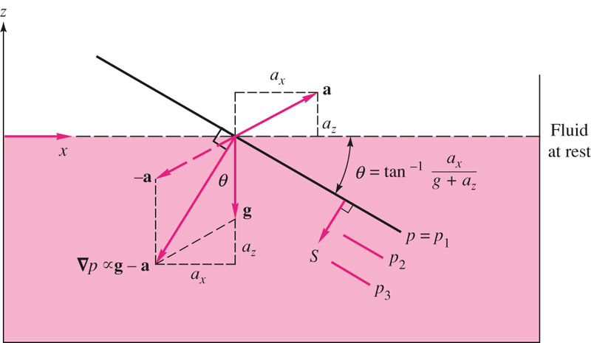
Fig.11: Rigid-body motion of a fluid contained in a tank.

Rigid-body rotation
Consider rotation of the fluid about the z-axis without any translation, Fig. 12. The container is assumed to be rotating at a constant angular velocity $Ω$ for a long time.
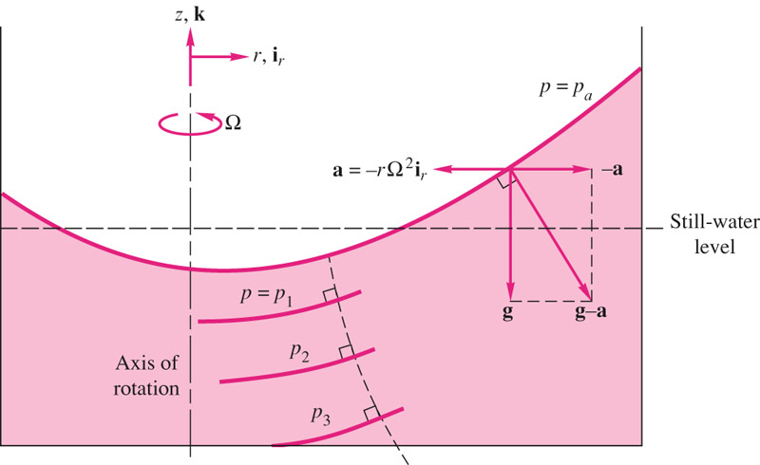
Fig. 12: Paraboloid constant-pressure surfaces in a fluid in rigid-body rotation.
The angular velocity and position vectors are given by:
$$\vec{Ω}=Ωk \vec{r}=ri_{r}$$
The acceleration id given by:
$$Ω×\left(Ω×\vec{r}\right)=-rΩ^{2}i_{r}$$
The forced balance becomes:
$$∇p=\frac{∂p}{∂r}i_{r}+\frac{∂p}{∂z}k=ρ\left(g-a\right)=ρ\left(-gk+rΩ^{2}i_{r}\right)$$
The pressure field can be found by equating like components:
$$\frac{∂p}{∂r}= ρrΩ^{2} \frac{∂p}{∂z}=-γ$$
After integration with respect to r and z, and applying boundary condition, p=p₀ at (r,z) = (0,0):
$$p=p_{0}-γz+\frac{1}{2}ρr^{2}Ω^{2}$$
The pressure is linear in z and parabolic in r. The constant pressure surfaces can be calculated using:
$$z=\frac{p_{0}{-p}_{1}}{γ}+\frac{r^{2}Ω^{2}}{2g}=a+br^{2}$$
The position of the free surface is found by conserving the volume of fluid. Since the volume of a paraboloid is one-half the base area times its height, the still water level is exactly halfway between the high and low points of the free surface.
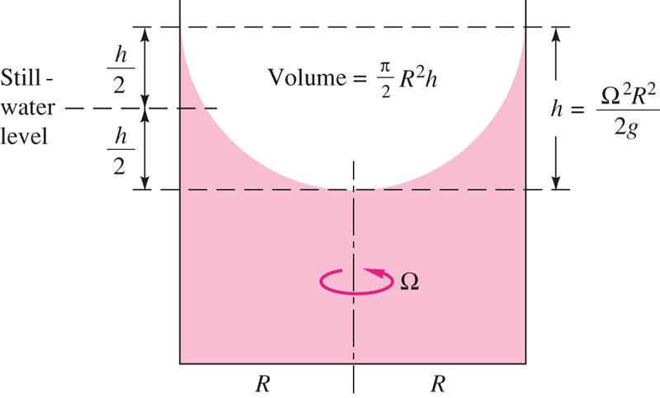
Fig. 13: Determining the free-surface position for rotation of a cylinder of fluid about its axis. The center of the fluid drops an amount $h/2=Ω^{2}R^{2}/4g$, and edges rise an equal amount.

Pressure measurement
Pressure is the force per unit area and can be imagined as the effects related to fluid molecular bombardment of a surface. There are many devices for both a static fluid and moving fluid pressure measurements. Manometer, barometer, Bourdon gage, McLeod gage, Knudsen gage are only a few examples.
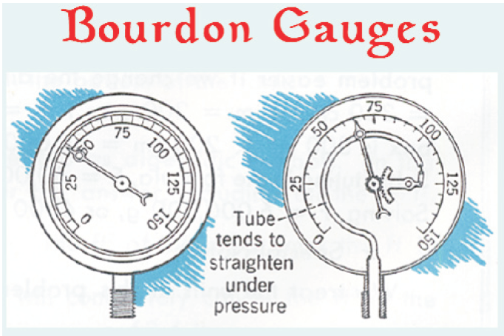
Fig. 14: Bourdon gage.

