

ENSC 283
Introduction and Properties of Fluids

Spring 2009

Prepared by:
M. Bahrami
Mechatronics System Engineering, School of Engineering and Sciences, SFU

Introduction
A fluid cannot resist a shear stress by a static deflection and it moves and deforms continuously as long as the shear stress is applied.
Fluid mechanics is the study of fluids either in motion (fluid dynamics) or at rest (fluid statics). Both liquids and gases are classified as fluids.
There is a theory available for fluid flow problems, but in all cases it should be backed up by experiment. It is a highly visual subject with good instrumentation.
Since the earth is 75% covered with water and 100% with air, the scope of fluid mechanics is vast and has numerous applications in engineering and human activities. Examples are medical studies of breathing and blood flow, oceanography, hydrology, energy generation. Other engineering applications include: fans, turbines, pumps, missiles, airplanes to name a few.
The basic equations of fluid motion are too difficult to apply to arbitrary geometric configurations. Thus most textbooks concentrate on flat plates, circular pipes, and other simple geometries. It is possible to apply numerical techniques to complex geometries, this branch of fluid mechanics is called computational fluid mechanics (CFD). Our focus, however, will be on theoretical approach in this course.
Viscosity is an internal property of a fluid that offers resistance to flow. Viscosity increases the difficulty of the basic equations. It also has a destabilizing effect and gives rise to disorderly, random phenomena called turbulence.
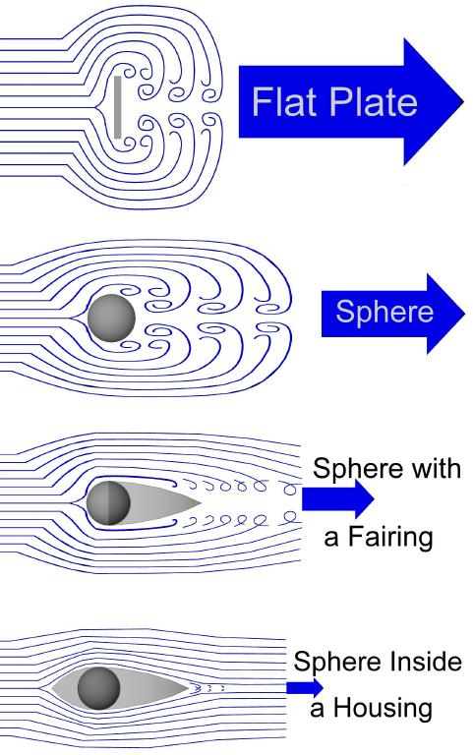
Fig.1: effects of viscosity and shape on the fluid flow.

History of fluid mechanics
Ancient civilization had enough knowledge to solve certain flow problems, e.g. sailing ships with oars, irrigation systems.
Archimedes (285 – 212 B.C.) postulated the parallelogram law for addition of vectors and the laws of buoyancy and applied them to floating and submerged objects.
Leonardo da Vinci (1452 – 1519) stated the equation of conservation of mass in one-dimensional steady-state flow. He experimented with waves, jets, hydraulic jumps, eddy formation, etc.
Edme Mariotte (1620 – 1684) built the first wind tunnel and tested models in it.
Isaac Newton (1642 – 1727) postulated his laws of motion and the law of viscosity of linear fluids, now called newtonian. The theory first yield the frictionless assumption which led to several beautiful mathematical solutions.
Leonhard Euler (1707 – 1783) developed both the differential equations of motion and their integral form, now called Bernoulli equation.
William Froude (1810 – 1879) and his son developed laws of model testing and Lord Rayleigh (1842 – 1919) proposed dimensional analysis.
Osborne Reynolds (1842 – 1912) published the classic pipe experiment and showed the importance of the dimensionless Reynolds number, named after him.
Navier (1785 – 1836) and Stokes (1819 – 1903) added newtonian viscous term to the equation of motion, the fluid motion governing equation, i.e., Navier-Stokes equation is named after them.
Ludwig Prandtl (1875 – 1953) pointed out that fluid flows with small viscosity, such as water flows and airflows, can be divided into a thin viscous layer (or boundary layer) near solid surfaces and interfaces, patched onto a nearly inviscid outer layer, where the Euler and Bernoulli equations apply.
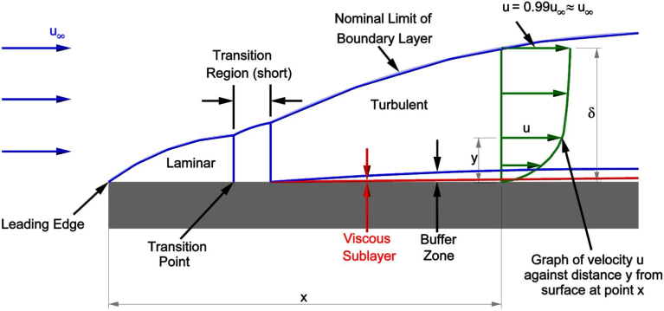
Fig. 2: The concept of boundary layer.

The concept of fluid
There are two classes of fluids:
Liquids: are composed of relatively close-packed molecules with strong cohesive forces. Liquids have constant volume (almost incompressible) and will form a free surface in a gravitational field if unconfined from above.
Gases: molecules are widely spaced with negligible cohesive forces. A gas is free to expand until it encounters confining walls. A gas has no definite volume, and it forms an atmosphere when it is not confined. Gravitational effects are rarely concerned.
Liquids and gases can coexist in two-phase mixtures such as steam-water mixtures.
We can define fluid properties and parameters, as continuous point functions, ONLY if the continuum approximation is made. This requires that the physical dimensions are large compared to the fluid molecules.
The fluid density is defined as:
$$ρ=\lim_{δV→δV^{*}}{\frac{δm}{δV}}$$
where the $δV^{*}$ is a limiting volume above which molecular variations are not important, this volume for all liquids and gases is about 10⁻⁹ mm³.

Dimensions and units
Any physical quantity can be characterized by dimensions. The arbitrary magnitudes assigned to the dimensions are called units. There are two types of dimensions, primary or fundamental and secondary or derived dimensions. Some primary dimensions are: mass, m; length, L; time, t; temperature, T. Secondary dimensions are the ones that can be derived from primary dimensions such as: velocity (m/s), pressure (Pa = kg/m.s²).
There are two unit systems currently available SI (International System) and USCS (United States Customary System) or English system. We, however, will use SI units exclusively in this course. The SI system is based on 7 fundamental units: length, meter (m); mass, kilogram (kg); time, second (s); electric current, ampere (A); amount of light, candela (cd); amount of matter, mole (mol).
The SI units are based on decimal relationship between units. The prefixes used to express the multiples of the various units are listed in Table 1.
Table 1: Standard prefixes in SI units.
MULTIPLE | 10¹² | 10⁹ | 10⁶ | 10³ | 10⁻² | 10⁻³ | 10⁻⁶ | 10⁻⁹ | 10⁻¹²
PREFIX | tetra, T | giga, G | mega, M | kilo, k | centi, c | mili, m | micro, μ | nano, n | pico, p
Important note: in engineering all equations must be dimensionally homogenous. This means that every term in an equation must have the same units. It can be used as a sanity check for your solution.
Example 1: Unit Conversion
The heat dissipation rate density of an electronic device is reported as 10.72 mW/mm² by the manufacturer. Convert this to W/m².

Eulerian and Lagrangian Point of View
There are two different points of view in analyzing problems in mechanics.
In the Eulerian point of view, the dynamic behavior of the fluid is studied from a fixed point in space. Therefore, fluid properties and parameters are computed as filed functions, e.g. p(x,y,z,t). Most measurement devices work based on Eulerian method.
The system concept represents a Lagrangian point of view where the dynamic behavior of a fluid particle is considered. To stimulate a Lagrangian measurement, the probe would have to move downstream at the fluid particle speed.

Fluid velocity field
Velocity: the rate of change of fluid position at a point in a flow field. Velocity in general is a vector function of position and time, thus has three components u, v, and w, each a scalar field in itself:
$$V\left(x,y,z,t\right)= u\left(x,y,z,t\right)i+v\left(x,y,z,t\right)j+w(x,y,z,t)k$$
Velocity is used to specify flow filed characteristics, flow rate, momentum, and viscous effects for a fluid in motion. Furthermore, velocity field must be known to solve heat and mass transfer problems.

Thermodynamic properties of a fluid
Any characteristic of a system is called a property. In this course, the fluid is assumed to be a continuum, homogenous matter with no microscopic holes. This assumption holds as long as the volumes, and length scales are large with respect to the intermolecular spacing.
Thermodynamic properties describe the state of a system.
System is defined as a collection of matter of fixed identity that interacts with its surroundings.
For a single-phase substance such as water or oxygen, two basic (independent) properties such as pressure and temperature can identify the state of a system; and thus the value of all other properties.
Note: In this course, important non-equilibrium effects such as chemical, nuclear, and magnetic effects are neglected.

Temperature
Temperature is a measure of the internal energy, it is also a pointer for the direction of energy transfer as heat.
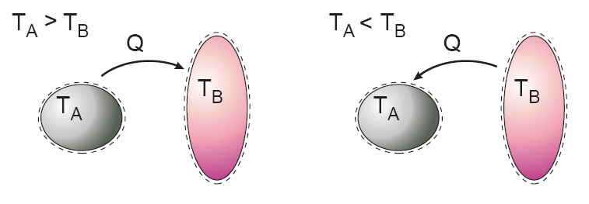
Fig. 3: Heat transfer occurs in the direction of higher-to-lower-temperature.
When the temperatures of two bodies are the same, thermal equilibrium is reached. The equality of temperature is the only requirement for thermal equilibrium.
Experimentally obtained Temperature Scales, the Celsius and Fahrenheit scales, are based on the melting and boiling points of water. They are also called two-point scales.
Conventional thermometry depends on material properties e.g. mercury expands with temperature in a repeatable and predictable way.
Thermodynamic Temperature Scales (independent of the material), the Kelvin and Rankine scales, are determined using a constant volume gas thermometer. The relationships between these scales are:
$$T\left(K\right)=T\left(°C\right)+273.15$$
$$T\left(R\right)=T\left(°F\right)+459.67$$
$$T\left(R\right)=1.8T\left(K\right)$$
$$T\left(°F\right)=1.8T\left(°C\right)+32$$

Pressure
Pressure is the (compression) force exerted by a fluid per unit area.
$$Pressure=\frac{Force}{Area} \left(\frac{N}{m^{2}}\right)≡Pa$$
In fluids, gases and liquids, we speak of pressure; in solids this is normal stress. For a fluid at rest, the pressure at a given point is the same in all directions.
Differences or gradients in pressure drive a fluid flow, especially in ducts and pipes.

Density
The density of a fluid is its mass per unit volume:
$$ρ=\frac{m}{V} \left(\frac{kg}{m^{3}}\right)$$
Liquids are essentially incompressible, whereas density is highly variable in gases nearly proportional to the pressure. In general, liquids are approximately 3 orders of magnitude denser than gases at atmospheric pressure.
@20˚C, 1 atm | Air | Water | Hydrogen | Mercury
$$ρ \left({kg}/{m^{3}}\right)$$ | 1.20 | 998 | 0.0838 | 13,580
Note: specific volume is defined as:
$$v=\frac{V\left(m^{3}\right)}{m\left(kg\right)}=\frac{1}{ρ}$$

Specific weight
The specific weight of a fluid is its weight, $W=mg$, per unit volume. Density and specific weight are related by gravity:
$$γ=ρg \left(\frac{N}{m^{3}}\right)$$

Specific gravity
Specific gravity is the ratio of a fluid density to a standard reference fluid, typically water at 4˚C (for liquids) and air (for gases):
$${SG}_{gas}=\frac{ρ_{gas}}{ρ_{air}}=\frac{ρ_{gas}}{1.205 \left(kg/m^{3}\right)}$$
$${SG}_{liquid}=\frac{ρ_{liquid}}{ρ_{water}}=\frac{ρ_{liquid}}{1000 \left(kg/m^{3}\right)}$$
For example, the specific gravity of mercury is SG_{Hg} = 13,580/1000 ≅ 13.6.

Energy and specific heats
Potential energy is the work required to move the system of mass m from the origin to a position against a gravity field g:
$$PE = mgz$$
Kinetic energy is the work required to change the speed of the mass from zero to velocity V.
$$KE=\frac{1}{2}mV^{2}$$
The total energy, E, of a substance is the sum of the internal, kinetic, and potential energies at a given state point:
$$e\left(kJ/kg\right)=\frac{E\left(kJ\right)}{m\left(kg\right)}=u+gz+\frac{V^{2}}{2}$$
Note: the molecular internal energy u is a function of temperature and pressure for the single-phase substance, whereas KE and PE are kinematic quantities.
Specific heat capacity, also known simply as specific heat, is the measure of the heat energy required to increase the temperature of a unit mass of a substance by one degree temperature. There are two types of specific heats, constant volume c_{v} and constant pressure c_{p}.

The ideal gas equation of state
Any equation that relates the pressure, temperature, and specific volume of a substance is called an equation of state. The simplest and best known equation of state for substances in the gas phase is the ideal-gas equation of state.
It is experimentally observed that at a low pressure the volume of a gas is proportional to its temperature:
$$\left\{\begin{matrix}p∝T \\ p∝\frac{1}{v}\end{matrix}\right. →P∝\frac{T}{v}$$
or
$$p=R_{u}ρT$$
where R_{u} is the gas universal constant, R_{u} = 8.314 (kJ/kmol.K). The ideal gas equation can be written as follows:
$$p=ρRT$$
The constant R is different for each gas; for air, R_{air} = 0.287 kJ/kg.K. The molecular weight of air M=28.97 kg/kmol.
$R=c_{p}-c_{v}$ is the gas constant and c_{p} and c_{v} are specific heat constants.
For an ideal gas, the internal energy is only a function of temperature; $u=u\left(T\right)$; thus constant volume specific heat is only a function of temperature:
$$c_{v}={\left.\left(\frac{∂u}{∂T}\right)\right|}_{v}=\frac{du}{dT}=c_{v}\left(T\right)$$
or,
$$du=c_{v}\left(T\right)dT$$
Enthalpy, another thermodynamic property, is related to internal energy:
$$h=u+\frac{p}{ρ}=u+RT=h\left(T\right)$$
The constant pressure specific heat can be defined as:
$$c_{p}={\left.\left(\frac{∂h}{∂T}\right)\right|}_{p}=\frac{dh}{dT}=c_{p}\left(T\right)$$
or,
$$dh=c_{p}\left(T\right)dT$$
The ratio of specific heats of a perfect gas is an important dimensionless parameter in compressible flow analysis:
$$k=\frac{c_{p}}{c_{v}}=k\left(T\right)≥1$$
For air, k_{air} = 1.4 at atmospheric conditions.

Incompressible fluid
Liquids are (almost) incompressible and thus have a single constant specific heat:
$$c_{p}=c_{v}=c dh=cdT$$

Viscosity
Viscosity is a measure of a fluid’s resistance to flow. It determines the fluid strain rate that is generated by a given applied shear stress.
u(y)
y
No-slip at wall
Velocity profile
Fig.4: Velocity profile and shear stress.
A Newtonian fluid has a linear relationship between shear stress and velocity gradient:
$$τ=μ\frac{du}{dy}$$
The shear stress is proportional to the slope of the velocity profile and is greatest at the wall.
The no-slip condition: at the wall velocity is zero relative to the wall. This is a characteristic of all viscous fluid.
The linearity coefficient in the equation is the coefficient of viscosity, $μ \left(N.s/m^{2}\right)$. We can also use the kinematic viscosity ${ν\left({m^{2}}/s\right)=μ}/ρ .$ Some examples:
$μ_{hydrogen}=9.0E-6 \left(\frac{kg}{m.s}\right)$, $μ_{air}=1.8E-5 \left(\frac{kg}{m.s}\right)$, $μ_{water}=1.0E-3 \left(\frac{kg}{m.s}\right)$ $μ_{engine oil, SAE30}=0.20 \left(\frac{kg}{m.s}\right)$
Temperature has a strong and pressure has a moderate effect on viscosity. The viscosity of gases and most liquids increases slowly with pressure.
Gas viscosity increases with temperature. Two common approximations are the power law and the Sutherland law:
$$\frac{μ}{μ_{0}}=\left\{\begin{matrix}{\left(\frac{T}{T_{0}}\right)}^{n} & power law \\ \frac{{\left(T/{T_{0}}\right)}^{3/2}\left(T_{0}+S\right)}{T+S} & Sutherland law\end{matrix}\right.$$
where $μ_{0}$ is a known viscosity at a known absolute temperature usually 273K (note that Kelvin temperature scale must be used in the formula). The constant n and S are fit to the data. For air n=0.7 and S=110K.
Liquid viscosity decreases with temperature and is roughly exponential, $μ≈ae^{-bT}$. A better fit is the following empirical relationship:
$$ln\frac{μ}{μ_{0}}≈a+b\left(\frac{T_{0}}{T}\right)+c{\left(\frac{T_{0}}{T}\right)}^{2}$$
where for water $T_{0}=273.16K, μ_{0}=0.001792\frac{kg}{m.s}, a=-1.94, b=-4.80, and c=6.74$ with accuracy about 1%.

The Reynolds number
The Reynolds number, Re:
$$Re=\frac{ρVL}{μ}=\frac{VL}{ν}$$
is a dimensionless number that gives a measure of the ratio of inertial forces $\left(ρV\right)$ to viscous forces$\left(μ/L\right)$ and, consequently, it quantifies the relative importance of these two types of forces for given flow conditions.

Very low Reynolds number | Viscous creeping motion, i.e. inertia effects are negligible
Moderate Reynolds number | Smoothly varying laminar flow, both inertia and viscous forces important
High Reynolds number | Turbulent flow, with strongly random high-frequency fluctuations

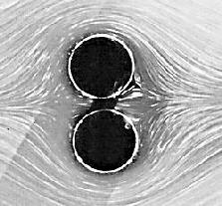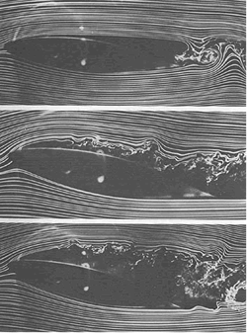
Fig. 5: LHS, very low Re number, creeping flow around two cylindrical bodies. RHS: air flow around an air-foil, from moderate Re number, laminar flow (top photo) to high Re number, turbulent flow regime (bottom photo).
Explicit numerical value of Re numbers depend on flow geometry.

Thermal conductivity
It can be observed that the rate of heat conduction through a material layer is proportional to the temperature difference across the layer and the heat transfer area, but it is inversely proportional to the thickness of the layer, as shown in Fig. 6.
$$Rate of heat transfer∝\frac{\left(surface area\right)\left(temperature difference\right)}{wall thickness}$$
To make this equality, k $\left(W/{m.K}\right)$the thermal conductivity of the material, is introduced. This is called the Fourier’s law of heat conduction. In the limiting case where the thickness Δx→0, the equation above reduces to the differential form:
$$q=\frac{Q}{A}=-k∇T$$
The minus sign satisfies the convention that heat flux is positive in the direction of decreasing temperature.
This can be written for three scalar components of the heat flow rate vector:
$$q_{x}=-k\frac{∂T}{∂x}, q_{y}=-k\frac{∂T}{∂y}, q_{z}=-k\frac{∂T}{∂z}$$
The term ${∂T}/{∂x}$ is called the temperature gradient, which is the slope of the temperature curve, the rate of temperature change in the x-direction.
Area, A
A
Δx
Q
T₁
T₂
Fig.6: Heat conduction through a large plane wall.
Note: Thermal conductivity is a thermodynamic property and varies with temperature and pressure in a similar manner to viscosity, the ratio of k/k₀ can be correlated using the same above-mentioned equation for viscosity.

Flow between plates
It is the flow induced between a fixed lower plate and upper plate moving steadily at velocity V.
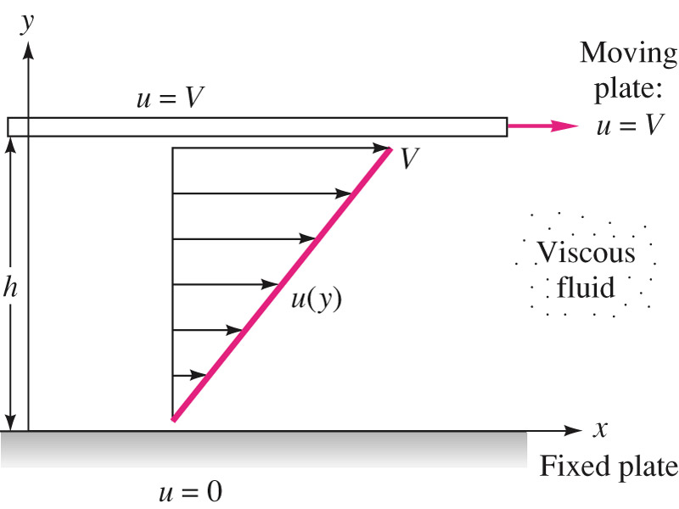
With zero acceleration and assuming no pressure variation in the flow direction, one can write a force balance on a small fluid element that leads to the result that the shear stress is constant throughout the fluid:
$$\frac{du}{dy}=\frac{τ}{μ}=const.$$
After integration:
$$u=a+by$$
the velocity distribution is linear, as shown in the figure and the constants can be found using boundary consitions (no-slip velocity at lower and upper plates):
$$u=\left\{\begin{matrix}0=a+b\left(0\right) & at y=0 \\ V=a+b\left(h\right) & at y=h\end{matrix}\right.$$
The velocity becomes:
$$u=V\frac{y}{h}$$

Surface tension
A liquid, being unable to expand freely, will form an interface with a second liquid or gas.
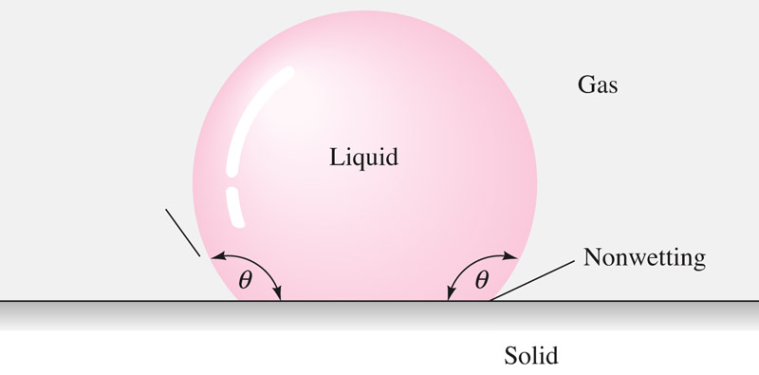
Fig. 7: Surface tension, liquid-gas-solid interface.
The cohesive forces between liquid molecules are responsible for the phenomenon known as surface tension. The molecules at the surface do not have other like molecules on all sides of them and consequently they cohere more strongly to those directly associated with them on the surface.
Surface tension $Υ$ (pronounced upsilon) has the dimension of force per unit length (N/m) or of energy per unit area (J/m²).
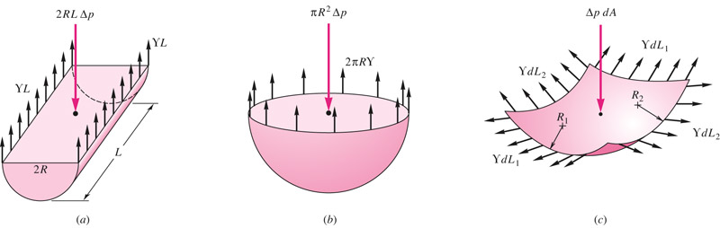
Fig. 8: Pressure drop across curved interfaces due to surface tension.
Pressure increase in the interior of a liquid half-cylinder droplet of length L and radius R is, Fig.8-a:
$$2RLΔp=2ΥL or ∆p=\frac{Υ}{R}$$
Pressure droplet in the interior of a liquid half-sphere droplet of radius R is, Fig.8-b:
$$πR^{2}Δp=2πRΥ or ∆p=\frac{2Υ}{R}$$
For a full sphere droplet, e.g. soap bubble, which has two interfaces with air, the pressure increase will be twice:
$$Δp_{bubble}≈2Δp_{droplet}=\frac{4Υ}{R}$$
Pressure droplet in the interior of an arbitrarily curved interface of principal radii R1 and R2, Fig.8-c:
$$Δp=Υ\left(\frac{1}{R_{1}}+\frac{1}{R_{2}}\right)$$
This is a more general relationship and yields both cylindrical ($R_{1}=R and R_{2}→∞$ ) and spherical $R_{1}=R_{2}=R$.
Contact angle$θ$: appears when a liquid interface intersects with a solid surface.
$$θ=\left\{\begin{matrix}\begin{matrix} \\ <90°\end{matrix} & wetting liquid \\ >90° & nonwetting liquid\end{matrix}\right.$$
The contact angle is sensitive to actual physiochemical condition of the solid-liquid interface. Water is extremely wetting to a clean glass surface with$θ≈0$. For a clean mercury-air-glass interface, $θ≈130°$.

Vapor pressure and cavitation
Vapor pressure is the pressure at which a liquid boils and is in equilibrium with its own vapor. When the liquid pressure is dropped below the vapor pressure due to a flow phenomenon, we call the process cavitation. The dimensionless parameter describing flow-induced boiling is called cavitation number:
$$Ca=\frac{p_{a}-p_{v}}{0.5ρV^{2}}$$
where, p_{a} is ambient pressure, p_{v} is vapor pressure and V is the fluid velocity.
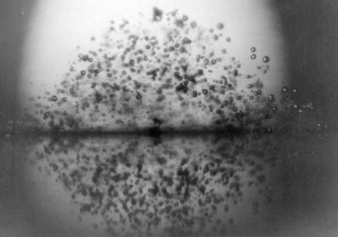
Fig. 9: Cavitation bubbles.
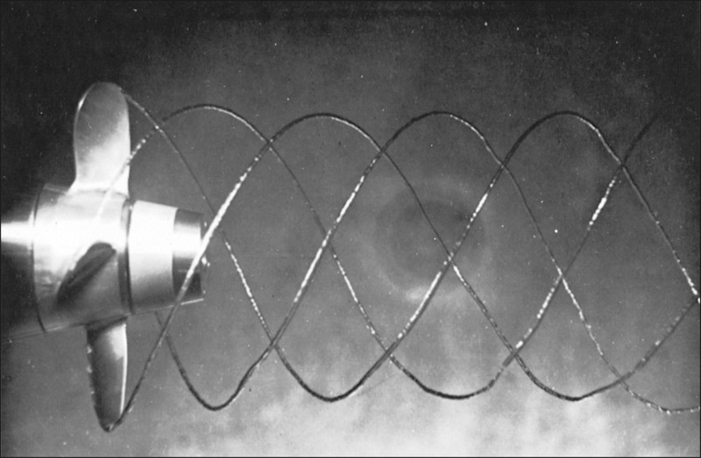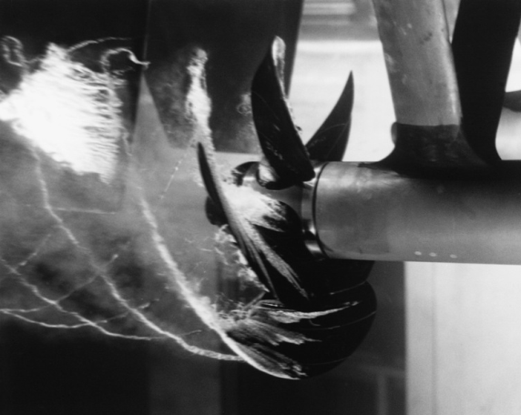
Fig. 10: Spiral bubbles form from the surface of a marine propeller. When water is accelerated, its pressure drops, this can cause cavitation. The cavitation bubbles being formed on a low-pressure surface of a marine propeller move into a higher-pressure region and collapse, creating a beautiful image.
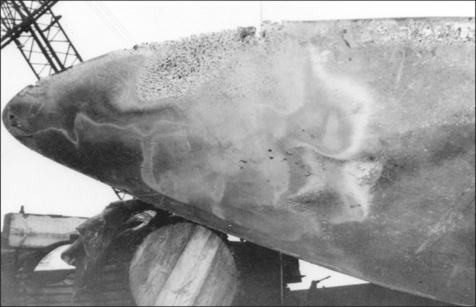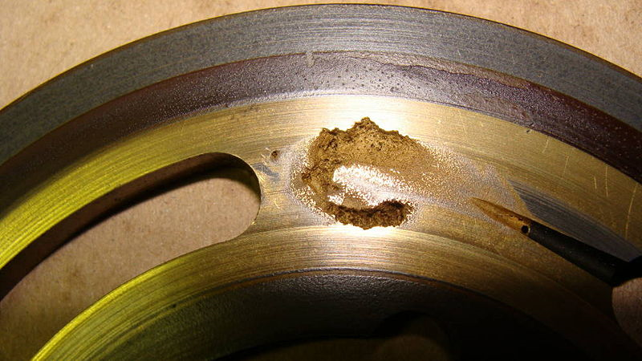
Fig. 11: Bubble collapse is a particularly important subject because of the noise and material damage that can be caused by the high velocities, pressures, and temperatures that may result from that collapse. The figure shows the damaging erosion effects of collapsing cavitation bubbles on a propeller surface (LHS) and on a valve plate (RHS).

No-slip and no-temperature-jump condition
When a fluid flow is bounded by a surface, molecular interactions cause the fluid in contact with the surface to seek momentum and energy equilibrium with the surface. Except for rarefied gas flows, we shall assume:
$V_{fluid}=V_{wall}$ no-slip condition
$T_{fluid}=T_{wall}$ no-temperature-jump condition
They serve as boundary conditions for analysis of fluid flow past a solid surface.

Velocity profile, laminar flow
Velocity profile, Turbulent flow
Laminar flow
Turbulent flow
Thin fixed plate
Fig. 12: no-slip condition in water flow past a thin fixed plate. the upper flow is turbulent, the lower is laminar. The velocity profile is made visible using a line of hydrogen bubbles.

Speed of sound and compressibility effects
When the flow velocity reaches a considerable fraction of the speed of sound of a fluid, the compressibility effects can be important in gas flow due to significant density changes caused by the high velocity flow.
Speed of sound: is the rate of propagation of small disturbance pressure pulses (sound waves) through the fluid:
$$a^{2}=k{\left(\frac{∂p}{∂ρ}\right)}_{T}, k=\frac{c_{p}}{c_{v}}$$
For an ideal gas, one finds:
$$a_{ideal gas}=\sqrt{kRT}$$
R is the gas constant, and T is the absolute temperature (Kelvin), for air at 20C, a = 343 m/s.
Mach number is the ratio of the flow to the speed of sound:
$$Ma=\frac{V}{a}$$
Compressibility effects are normally neglected for $Ma<0.3$, i.e., for air flow velocity up to 100 m/s.

Flow pattern
Streamline: is a line everywhere tangent to the velocity vector at a given instant.
Pathline: is the actual path traversed by a given fluid particle.
Streakline: is the locus of particles that have earlier passed through a prescribed point.
Timeline: is a set of fluid particles that form a line at a given instant.
Note: in steady flows, streamlines, pathlines, and streaklines are identical.
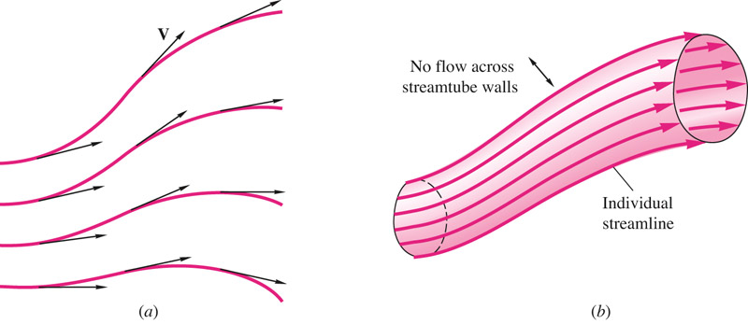
Fig. 13: a) streamlines are tangent to the local velocity vector, b) a streamtube is formed by a closed collection of streamlines. By definition the fluid within the streamtube is confined there because it cannot cross the streamline; thus the streamtube walls need not be solid but may be fluid surface.
If the elemental arc length dr of a streamline is to be parallel to V, their respective components must be in proportion:
Streamline: $\frac{dx}{u}=\frac{dy}{v}=\frac{dz}{w}=\frac{dr}{V}$
Thus, if velocities (u, v, w) are known functions of position and time, we can integrate the above equation and find the streamline passing through the initial point (x₀, y₀,z₀).

