Unit: ImMATHgration

Subject/Grade: Grade 9 Data Analysis
I mainly made this a Grade 9 Unit Plan for Data Analysis, but I think that it can be easily manipulated for a Grade 8 Unit to Review/Learn Fractions. This is not a full unit plan and does not outline all activities, problems, and/or forms of assessment; however, I have included main concepts that would allow for students to build their understanding of both migrant justice and Data Analysis.

Math concepts explored:
Key concepts and PLOs:
- Grade 9: Data Analysis
  - D1: Describe the effect of bias, use of language, ethics, cost, time and timing, privacy, cultural sensitivity on the collection of data
  - D2: Select and defend the choice of using either a population or a sample of a population to answer a question
  - D3: Search for data, collect data in an appropriate manner, and draw conclusions to answer questions

- If for Grade 8: Fractions and percents
  - Demonstrate an understanding of percents greater than or equal to 0%
  - Fractions

Sequence of lessons (Each lesson may take multiple classes)
1st Lesson: Canada is an immigrant nation
- Write: “Canada is an immigrant nation”
  - Have students discuss this statement in small groups. What does this statement mean to you? What does this make you think about?
  - Students can complete a KWL table (formative assessment). This can be useful to assess what are some key concepts that may require more or less time in the upcoming lessons.
- Make a class pie chart outlining the class immigrant composition.
  - Generate the pie chart on your computer and project it so students can see. If you cannot do this, write on the board. You want the pie chart to show How many students in your class (or families) have come to Canada in the past year, 2 years, 5 years, 10 years, 25 years, 50 years, 100s)
- A pie chart for Canada?
  - Have students make their own pie charts for the makeup of Canada. After knowing the makeup of their class, what do they think is the makeup of Canada?
    - Themes that can come up are French and British colonization, European settlement and migration, other migration patters (Chinese migration to help with railroad, South Asian migration to work in logging, Latinx migration to work in Agriculture, Filipino migration as caregivers, etc.)
- Reveal an actual pie chart (or other graphs/visual representations used to look at immigration system) for Canada.
  - May show a number of different ones:
    - Migrants by region
    - Percentages of 1st, 2nd, 3rd generation Canadians
    - Immigrant makeup per province/sector

2nd Lesson: What is a migrant?
- (https://www.youtube.com/watch?v=NX6u0D4HnbA)
- Word match/definitions
  - Cut out strips of paper with the following words typed on them: refugee, immigrant, migrant, citizen, undocumented, temporary foreign worker, permanent economic immigrant, permanent resident
  - Cut out strips of paper with definitions of each of these things typed on them.
  - In groups students have to match up the definition with the definition.
  - Verify as a class
  - Questions? (Elaborate/discuss as needed)
- Number match: Now that students know what all of those terms mean, give students numbers!! Students have to guess which number corresponds to the number of people living in Canada under that classification. (I.e. Students are given the number 20,000. Does that correspond to the number of Refugees or the number of Foreign Workers?)
  - Verify and discuss as a class. Are students surprised? Why or why not?
  - How would students display this data? Ask students to find some way to visually represent this data. (summative or formative assessment)
  - May want to brainstorm as a class:
    - What are some good ways to show data?
    - What are some different kinds of graphs?
- Have students pick a “community.” This could be their school, a community centre, a workplace, a supermarket, a café etc.—essentially any place where they feel that they can quantify the number of people. Based on what we know now about the immigration status of people in Canada, what fraction of this “community” is made up of undocumented people, citizens, permanent residents, refugees, etc.?

Lesson 3: Myth or Reality: Immigrants take Canadian Jobs
- Canadian Pacific Railway (Cross-curricular applications Social Studies):
  - Have students explore immigration and labour as a result of building the CPR. http://www.roadtojustice.ca/laws/chinese-head-tax
  - Have students do the following problem (which I found off twitter: https://twitter.com/aliciagunnteach/status/603629464052989953)
    - The Head Tax on Chinese immigrants to Canada was a form of government-approved racism used to limit immigration. Many families were seperated and dislocated as a result of racist attitudes and exclusion. The head tax caused a great financial burden for many Chinese living in Canada. The chart shoes the amount of various head taxes shown in 1914 dollars and the cost in 2015 dollars calculated using the Bank of Canada Inflation Calculator. A) Calculate the cost to bring different sized families to Canada in 1914 and 2015 dollars. B) Compare the dollar values, C) Can you think of an equation to represent the relationship.
Year | Cost of Head Tax (1914 dollars) | Cost Head Tax (2015 dollars)
1885 | $50 | $1053
1900 | $100 | $2105
1903 | $500 | 10525
  - Discussion/Reflection/Post-problem activity
- Temporary Foreign Workers
  - Connect this to Chinese Head Tax by talking about how workers are able to come to Canada under the Temporary Foreign Worker Program (TFWP), but are unable to bring their families or to use the time they spend in Canada towards gaining immigration status.
  - Have students read this article: http://geo-mexico.com/?p=5682
  - Using the facts and figures in the article, determine how much tax revenue the Canadian government is making from the migrant workers in Leamington Ontario.
    - Problem to assign for homework (summative): Many workers have a fraction of their pay check go towards social services. This helps support the Canadian Pension Plan, Canada’s health care system, and other national services. Agricultural Temporary Foreign Workers pay into these as well. In 2006, there were 4000 Temporary Workers in Leamington, Ontario. How much money is being generated from Leamington, Ontario and contributing to Canada’s national budget? How much from all Temporary Foreign Workers (not just agricultural)? Information from the article can be used for this question.

Lesson 4: Immigrants and Canadian spending?*
- Have students discuss the following statement: Immigrants use up all the available money that Canadians put into taxes.
- Debate: Have the class debate and research the following statements.
  - Divide the class into two groups. Half the class will be exploring Refugee Health Care and the other half will be looking at Immigration Detention. Within each group there will be a “yes” side and a “no” side. Each side will have to defend their position (i.e. Yes, indeed refugees do exploit the Health Care System, etc.)
    - Indefinite Immigration Detention
      - Canada is the only country in the Western world that puts immigrants in jail for an undetermined amount of time. Debate: This is an effective use of Canadian tax dollars as it reduces crime and illegal immigration to Canada.
      - Resources: http://endimmigrationdetention.com/about-the-strike/ (Numbers and figures in the background section)
      - Research, show your math, and visually represent your findings to prove your “side:”
    - In the past few years, the Canadian government has made drastic changes to its Refugee Health Care system. Debate: Refugees putting stress on Canada’s Health Care system. Research, show your math, and visually represent your findings to prove your “side:”
      - For Follow up: 59 Cent Campaign https://www.youtube.com/watch?v=TQiSe00HOec&feature=youtu.be
      - The cost of healthcare for refugees and refugee claimants amounts to just 10% of that of other Canadians. (http://ccrweb.ca/sites/ccrweb.ca/files/ifhreporten.pdf)
- Closing: Juice Rap News Video on Immigration. (https://www.youtube.com/watch?v=pUkW0kWb1x0) It has been translated into a number of different languages. I used to do their Spanish translations, but I am in school, so I haven’t been able to do as much with them.

Challenges with this unit.
Issues of immigration in Canada can be complex. There are many terms such as “non-status” and “undocumented” that may be ambiguous or difficult to define. The way in which it is discussed in the social sector and newspapers may refer to concepts with which students are unfamiliar. Terms such as “the system” or “CPP” and “foreign worker,” come up—none of which are terms that come up in the every teenager’s daily life. That being said, I think we can talk about these issues in high school as long as we sift out unnecessary information, and clearly define important information and terms.
Also, never having been a math teacher, I am unfamiliar with how much ‘non-math’ material can be incorporated into the classroom. That being said, I think that these lessons can show students that understanding math can be useful outside of the classroom. In other words, we are not limiting the mathematic learning to the classroom and [hopefully] encouraging students to see math in other parts of their lives such as the media.
Some of these issues can be very emotionally draining and personal for some students. Other topics may be controversial. I think this requires sensitivity and astute facilitation on the part of the teacher. I do not necessarily think that the PDP provides students teachers with skills to facilitate controversial topics; however, teachers need to learn sometime. More importantly, teachers should be preparing students for life beyond our classrooms. In that life, otherwise often referred to as “the real world,” students have to deal with complex issues and controversy. We may as well be equipping our students with the patience and vocabulary to deal with them.
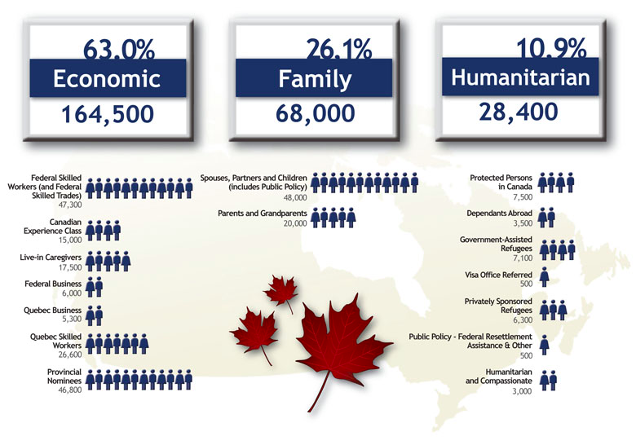
http://www.cic.gc.ca/english/department/media/notices/2013-11-01.asp
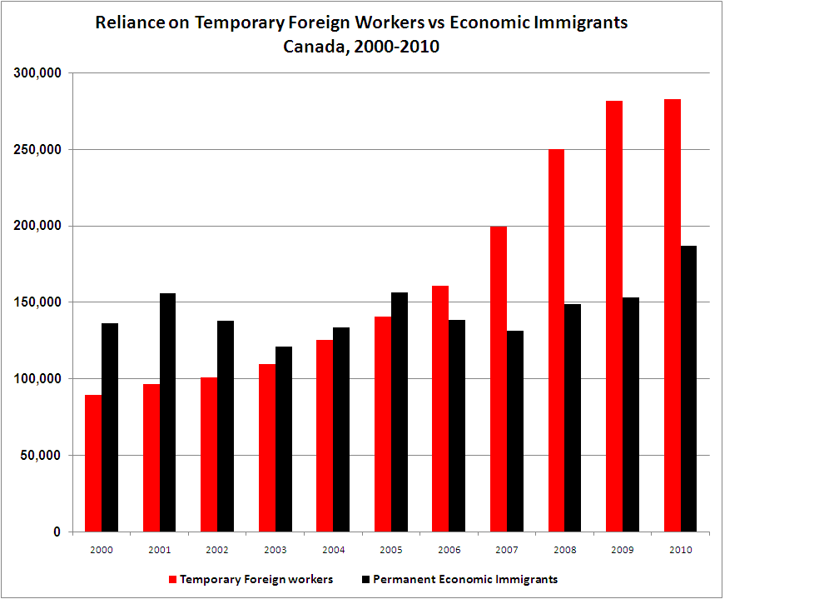
http://www.progressive-economics.ca/2011/02/18/canadas-immigration-policy-whos-on-the-guest-list/
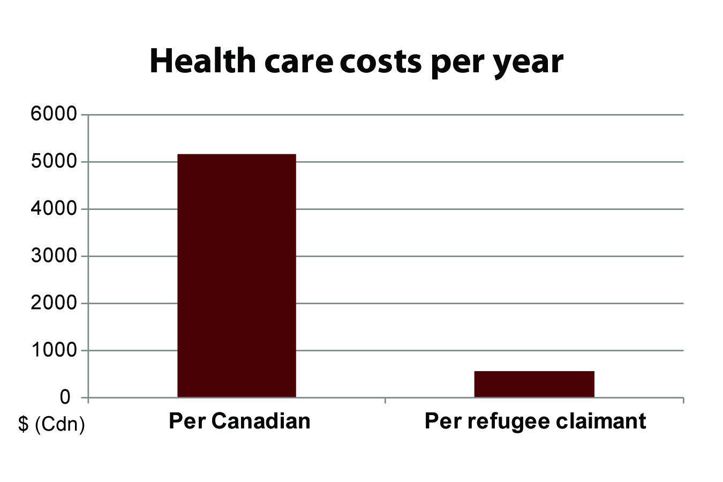
http://ccrweb.ca/sites/ccrweb.ca/files/ifhreporten.pdf

