Project 1 Milestone
Group 7
Tianchi Bi 301137581 tbi@sfu.ca
Joanna Long 301183087 yitingl@sfu.ca
Nancy Lu 301231772 wla92@sfu.ca
Xuan Wang 301149193 xwa59@sfu.ca

Topic of project: Video player remote. Users are able to change sound value by rotating, stop or play the video by pressing, and the player itself are able to change its brightness according to the room lighting environment.
Physical Installation
- Planned: Light sensor, rotation sensor and touch sensor, one LED needs to be connected to breadboard, and breadboard is connected to Arduino. Light sensor connects to A0, rotation sensor connects to A1, touch sensor connects to A2, and LED connects to digital pin 13. All these hardware are put in a plastic container which connects to the computer.
- Current progress: Physical installation of light sensor, rotation sensor, and touch sensor are done separately. All tests with Arduino have done separately and succeeded. Plastic container with reserved place for each sensors and LED has made.
- Sketches and circuit: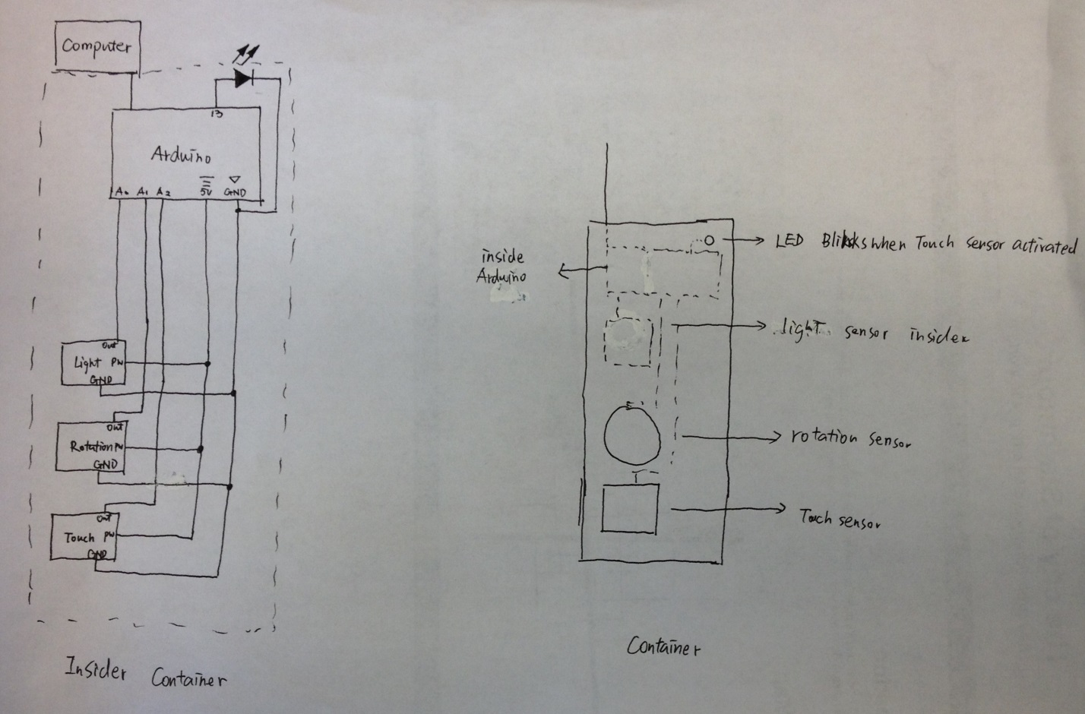
Processing Application
- This processing application needs to be able to let users make choice on which short video clip they want to play, and play it.
- It needs to be able to communicate with Arduino serially so it can receive data from Arduino and change parameters correspondingly. For example, it should read the degree that is sent by the rotation sensor through Arduino, and map the value into range from 0 to 100, and adjust the volume to which users’ desire.
- Once the video clip has gone to the end, it needs to be able to let users to choose if they want to play another or end the application.
Challenges:
- Physical setup: It is really difficult to fit all the sensors, one LED and Arduino into one small container.
- Possible solutions (yellow is applied):
  - Minimize the number of wires and let them all connect to one power and ground.
  - Use a larger container
  - Use wireless connection
  - Make Arduino outside the container
  - Make Breadboard outside the container
- Code: It is fairly complicate to make processing to play videos.
- Possible solutions:
  - Tutorials on Processing.org
  - Video tutorials on YouTube
  - Existing similar code or project online
- Sensor communication to Processing: It is really easy to confuse with different data that passed from Arduino. For instance, treating the light sensor data as a rotation sensor data.
- Possible solutions:
  - Using meaningful variable name
Deviations from the original project idea and task distribution
- Deviation from the project idea: We were planning to add another screen capture function using the touch sensor, but we changed to play or stop the video. We did not plan to have a LED in the design, but we think it is easier for users to tell whether they made a valid instruction or not.
- Deviation from the task distribution: Joanna needs to change the function of touch sensor from screen capture to play or stop. Xuan needs to add a task of adding LED into the circuit.

