Human Computer Interaction(HCI): psychology + design
Informed Craft development:
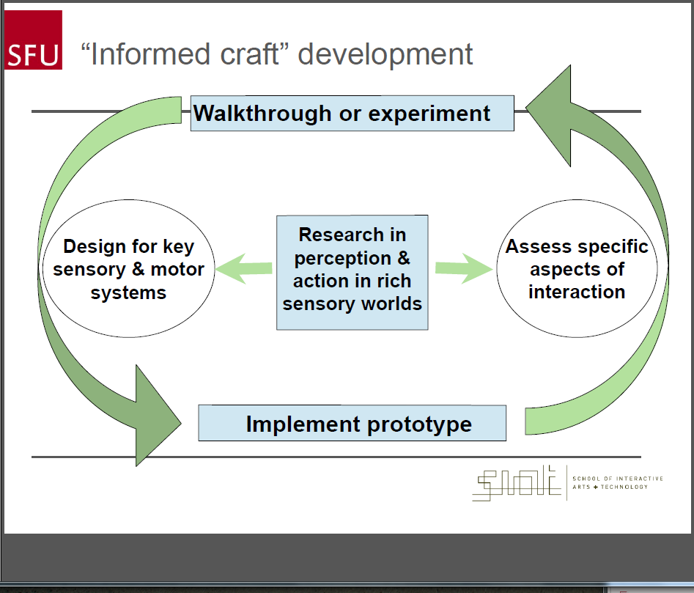

User Center Design(UCD) by Norman
1. Use both knowledge in the world and in the head*
2. Simplify the structure of tasks*
3. Make things visible*
4. Get the mappings right*
5. Exploit the powers of constraints-Natural & Artificial*
6. Design for Error
7. When all else fails, standardize
Usability Principles by Nielsen
• Visibility of system status
• Match between system and the real world
• User control and freedom
• Consistency and standards
• Help users recognize, diagnose and recover from
errors
• Error prevention
• Recognition rather than recall
• Flexibility and efficiency of use
• Aesthetic and minimalist design
• Help and documentation
3 Perspective:
- Johnson: focus on user interface design consistent with science
- HCI design Guidelines:
- Shneiderman:
  - strive for consistency
  - cater to universal usability
  - offer informative feedback
  - design task-flows to yield closure
  - prevent errors
  - permit easy reversal of actions
- Nielsen & Molich:
  - visibility of system status
  - match between system & real world
  - user control & freedom
  - consistency & standards
  - error prevention
  - recognition rather than recall
  - flexibility & efficiency of use
  - aesthetic & minimalist design
  - help users recognize, diagnose & recover from errors
  - provide online documentation & help
- Stone:
  - visibility: first step to goal should be clear
  - affordance: control suggests how to use it
  - feedback: should be clear what happened or is happening
  - simplicity: as simple as possible & task-focused
  - structure: content organized sensibly
  - consistency: similarity for predictability
  - tolerance: prevent errors, help recovery
  - accessibility: usable by all intended users
b. Applying Guidelines
- UI guidelines are based on how people perceive, think, learn, act
- UI designers want reasons for rules
- UI guidelines are not rote recipes
- Applying them effectively requires understnading their scientific basis
- Determining rule applicability & precedence
- Balancing trade-offs between competing rules
c. Facts about Human Perception & Cognition
- we perceive what we expect
- our vision is optimized to see structure
- we seek and use visual structure
- reading is unnatural
- our color vision is limited
- our peripheral vision is poor
- our attention is limited, our memory is imperfect
- limits on attention shape our thought & action
- recognition is easy, recall is hard
- learning from experience & performing learned actions are easy, problem-solving & calculation are hard
- many factors affect learning
- we have real-time requirements
- we perceive what we expect, our perceptions is based on our experience, the context, and our goals
- our perception & attention focuses almost totally on our goals
- tend not to notice things unrelated to goal

- Stakeholder-Center design: satisfy different people
  - identifying the stakeholder:
    - interact directly with the product
    - manage direct users
    - receive output from the product
    - make the purchasing decision
    - use competitors products
  - three categories of user by Eason
    - Primary: frequent hands-on
    - Secondary:occasional or via someone else
    - tertiary: affected by its introduction, or will influence its purchase
- Design/Science:design increasingly complex interactive displays that can be perceived and understood by users, value, individual differences, application goals are usually cognitive, social, experiential
Metacognitive Gap
- intuitions are good at thoughts, goals and plans, and it’s about how people see, hear, remember
- lack of awareness of the limits of intuition is Metacognitive Gap
Design & science methods
- Karl Popper, Imer Lakatos’s theory of natural science
  - bold predictions in the form of tastable hypothesis
  - design experiments that falsify the predictions
  - scientists build protective belt around their theories to avoid being falsified
- Avi Soudack’s theory of design evaluation
  - design hypothesis
  - predict user behaviours, and making such predictions explicit focuses on usability reviews, test the design, not the users
- Wason’s confirmation bias: naive subjects test hypothesis by generating positive example
- Popper’s seek to disconfirm hypotheses: falsify theory
- Models: can be evocative and misleading
  - conceptual models describe a phenomenon metaphorically
  - computational models make predictions based on algorithm
- Theories:
  - Computational theories: a program that simulate real-world causal relationship
    - Newell’s SOAR: use mechanisms of chunking and procedural learning, means-ends analysis
    - Anderson’s ACT-R: attempts to build subprograms for each aspect of the structure of mental processing
  - Other theories: mathematical, conceptual
  - Theory in science: build to directly address events in the world
    - falsifiable prediction
    - well-supported by many independent strands of evidence
    - consistent with pre-existing theories
    - adaptable and modifiable for new evidence
  - Levels of description of theory
    - bottom-up: sensation -? perception -> cognition -> action
    - top-down: gestalt
    - middle-ground: Rock’s logic of perception
Mental Representation
- Norman’s seven-stage model
  - establishing the goal to be achieved
  - forming the intention for action to achieve goal
  - specifying the action sequence corresponding to the intention
  - executing the action sequence
  - perceiving the system state
  - interpreting the perceived system state
  - evaluating the system state with respect to the goal and the intentions
Mental Model in design (HIP)
- cognitive model in design
  - design system so users understand them
  - assist user to build useful mental models
    - user’s own activity leads to mental model
    - explanatory theory developed by users
    - often used to predict future behavior of the system
    - done by the user, not the designer
  - system model builds on lower-level abstractions, actual detail may be hidden from implementers
  - user’s mental model is what they think they see, match mental model to system model, or rely on user illusion - a performance model
- runnable models:
  - dynamic models, simple, includes a notion of causality
  - used for explanation, part of Norman’s model of behavior (interpretation)
  - used for prediction, part of Norman’s model (intention)
- common form of mental models
  - state transition models: changes in state need to be visible (telephone)
  - object-action models: users think in terms of concrete or abstract objects, system supports action on the objects (Unix mv)
  - mapping model: users learn a sequence of actions to accomplish tasks (calculator)
  - analogies: new system closely resembles old system
- Errors result from inadequate mental models (to solve, hide system complexity)
  - failure to appreciate the system’s state during interpresentation of perception
  - failure to select to the appropriate action during map intention to action
  - inadequate evaluation of the resulting state during evaluating interpretation
  - lack of intention to take recovery action during form intention
- Cognitive walkthrough(evaluation)
  - enable debug mental models
  - emphasizes user's mental model at each stage of interaction, system image in support of the mental model, changes in the mental model that occur during interaction
Mental Model in design (Ecological)
- interfaces are virtual and may not have affordances
- Norman’s interface is not real affordance, instead is perceived affordance
  - learned conventions of arbitrary mappings between actions and effect at the interface
Human Information Processing Psychology
Vision:
- Marr’s 2 ½ D sketch (visual intelligence)
  - computational theory: objects are important, and edges help design them
  - algorithm to find edges in the image: Rock’s ‘zero crossings’
  - mechanisms: early brain cells seem to be sensitive to zero crossings
- Marr’s levels of theories of vision
  - computational: what is it for?
  - algorithm: how is information processsed?
  - neural mechanism: how is it implemented
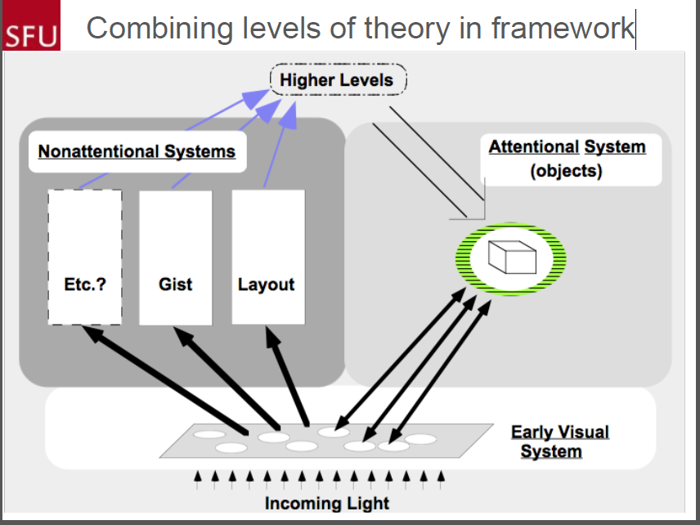
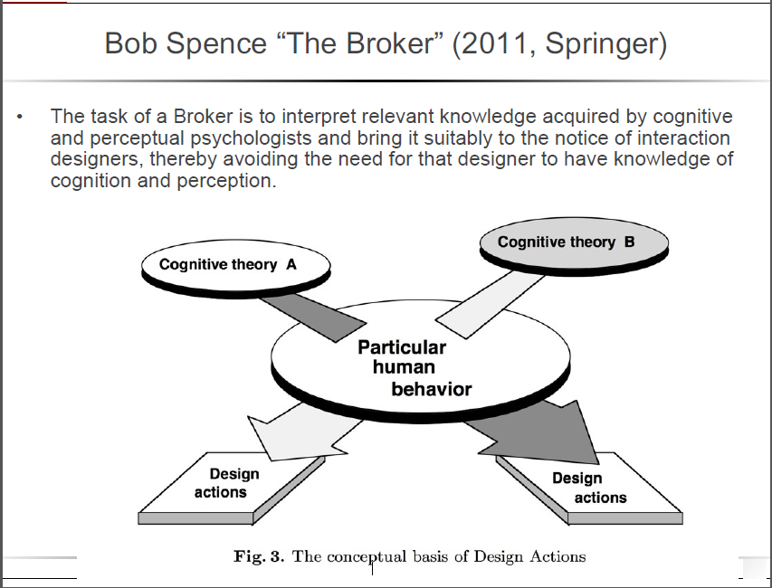
- Early Color perception
- Light is an information source
  - short wavelength = high frequency & bluish color, long wavelength = low frequency & reddish color
  - great amplitude = bright colors, small amplitude = dull colors
- Detecting & focusing light
  - Rods: need lots of light to see, low light sensitivity
  - Cones: need less light to see, high light sensitivity
- From light to neural signals(transduction)
- Processing neural data
  - Helmholz’s Trichromacy theory
    - 3 photopigments: short, medium, long wave cones
    - short wave is sensitive to blue & violet
    - medium wave is sensitive to green
    - long wave is sensitive to red
    - supported by primary colors, red-green deficiency, color blindness
  - Hering’s opponent color
    - accounts for complementary colors, color aftereffects
- Modern Color Perception
  - bottom-up information drives pattern building
  - top-down attentional processes reinforce relevant information
  - cones in the fovea where are no rods, and they are sensitive to three wavelengths that are colored blue, green and read
  - Jameson & Hurvich’s personal equation
    - color theory ought to be predictable, it is true for the unique yellow individuals
  - Munsell color system: 3 color dimensions that are perceptually uniform and independent dimensions (hue, brightness, saturation)

- Pylyshyn’s Cognitive impenetrability: the inability of observes to use semantic information to influence the operation of the input stage
Attention (selective):
Hearing
- we have a limited capacity so we select what we process, and perceptually rich environments can overload higher processes
- Overt orienting: moving body to pick up more information (notice)
- Covert orienting: concentrating on important event, ignoring distractions (move and look at it)
  - early selection on attention to events:
    - external simulus -> sensory register(may forgetting through decay) -> attention -> short-term memory -(rehearsal and coding)->long-term memory
- Endogenous attentions: covert orienting to a task on purpose (willed attention)
  - reduces errors. increase performance
  - enhances perception, e.g. the ‘zoom lens’ of visual attention
- Exogenous attention: attention that is captured by a sensory event
- Attention tokens: FINSTs are hot links between mental processes and things perceived in the environment
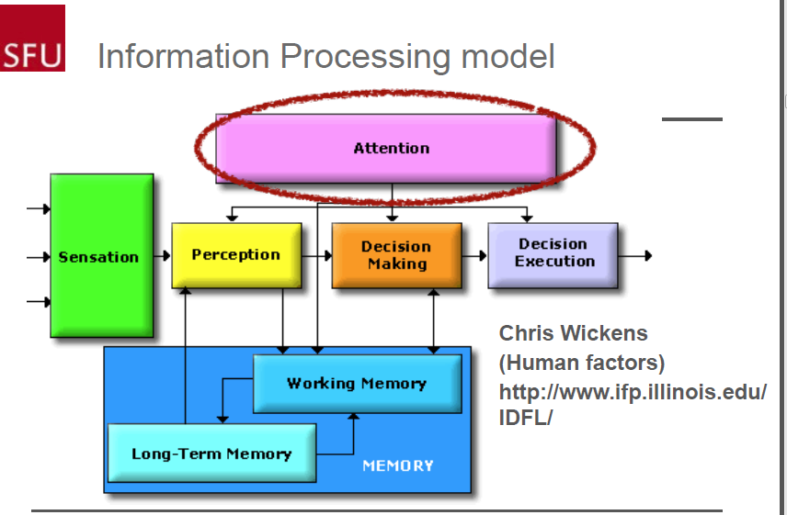
- Broadbent model
  - hearing: 3 digits were presented to one ear, and another 3 to the other ear
  - senses can process multiple objects at the same time, but too much can overload cognitive process
  - a filter allows attended source to pass, but stores other source in a buffer
  - cognitive processes only have access to filtered data
  - attention creates a bottleneck to prevent overloading
- Treisman
  - hearing: sound break through filter, cognitive processes override the filter
  - sensory information moves from physics to semantics in a IP pathway
  - if there’s not enough processing capacity, analysis stops
  - there is a threshold of consciousness that has to be reached before information can move to the next stage
- Deutsch and Deutsch
  - all information is analyzed for meaning
  - selection happens at the level of consciousness, we are aware of only a few items
Visual(top-down)
- Location based attention
  - Posner: attention is a spotlight that illuminates an area so items are clearer
    - covert attention
    - focus eyes on central point, when fixation point changes, try to detect new object
  - Eriksen: Attention is a zoom lens that can be focused for maximum power, or expanded to over more space with less power
- Attention and visual objects (bridging theories)
  - Treisman: attention is a glue used for feature integration (predict search time)
    - attention ties visual features together
    - Parallel search:we search for a unique target on any feature dimension, but not a unique combination of features
    - Serial search: combining features of an object takes attention and must be done one at a time. slower
    - creates an object file, failure leads to illusory conjunctions
  - Pylyshyn: attention tokens FINSTs monitor (predict performance)
    - small number visual objects are indexed for enhanced processing, and the rest receive limited processing
    - Perception: hotlink tokens, drawn to salient events, object-centred, visual routines, finite numbers
    - Cognition: maintain object history, implicit memory of object associations, sparse cognitive representation, just-in-time delivery information, atom of intentionality
Mental Representation
- memory of sensory events(perception)
  - buffers: iconic(visual), echoic(auditory), haptic(touch)
  - limited processing ‘logic of perception’, sensory learning
  - passes into short-term memory by attention filtering
- working memory (cognition)
  - faster access, rapid decay
  - central executive coordinates the process
    - visual-spatial sketchpad:working memory for event in visual and visuomotor space
- Kosslyn: mental images are largely the same as perceptual images (elephant study: distance matters)
- Pylyshyn: that’s only how they appear, not how they are stored (map study: visual representation does not support thinking)
    - articulatory loop: working memory for sounds
    - could take place on LTM stores
  - limited capacity (scratch-pad): 7 +/- 2
    - chunking extend A/P loop STM :4 +/- 1 chunks
  - flush when finished with a task, or move into long-term memory via rehearsal
  - Memory methods
    - Method of Loci: memory palace, images for digits
    - Study methods: Roediger’s testing effect
    - Chase & Simon
      - expertise allows chunking of silent information to promote memory, they organize knowledge differently.
      - experts see structural similarities, so they have low cognitive load, novices see surface similarity, so their cognitive load is high
      - 10k hrs of deliberate practice
- long-term memory: procedures, experiences, facts, environments (cognition)
  - Semantic memory
    - virtually unlimited capacity, recall is the bottleneck
    - Anderson’s associative memory: memories are stored as linked concepts, and more links support faster retrieval
    - the paradox of the expert
  - Episodic memory
    - autobiographical, focus on specific event, personal meaning
    - Flashbulb memories
    - debatable accuracy
  - Procedural memories
    - memory of a sequence of operations
    - learning through practice, can become automatic
    - John’s Cognitive Perceptual Motor GOMS
- parallel processing
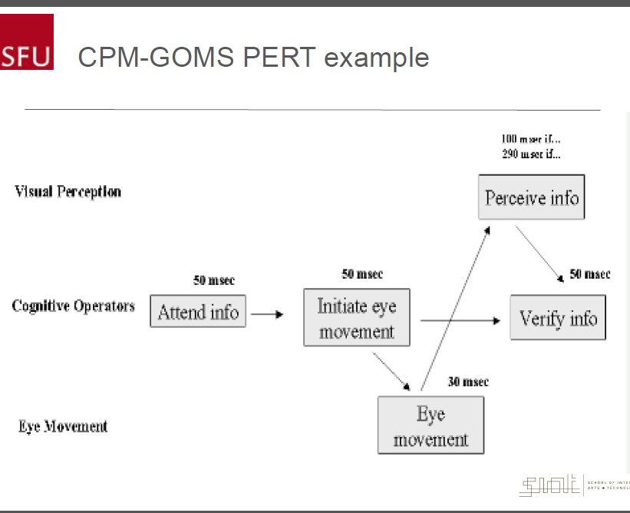
    - Card’s Keystroke Level Model (KLM)
- observable events and single stream of sequential operators
- provide crude task execution times
- limitations: procedural knowledge, routine cognitive skills, top-level tasks and user goal knowledge
    - Card, Moran & Newell’s GOMS: predict how long operation takes, and compare different candidate methods
        - goals: user is trying to reach (often hierarchical)
        - operators: primitive operations that are assembled to find a solution
        - methods: sequences of operators, grouped together to reach a goal
        - selection: decide which method when several are applicable
- hierarchical KLM
- more accurate execution times, better view of the task structure
- tasks are organized as a series of goals and subgoals
- operator are organized into subroutines called methods
- can model with SOAR/ACT-R cognitive architecture
- needs to take parallel processing into account

- Motor memory: skilled performance, chunking, sensory procedural expertise (motor)
  - motor programs/perception-action loops
  - Explicit knowledge: can be recalled at will
  - Tacit knowledge can’t be described in detail, but everyone has it
  - Flynn effect causes: improved visual intelligence
  - The Trivium: grammar, logic, rhetoric
Ecological Psychology
Vision:
- Gestalt
  - Gestalt theory: seek qualitative explanations for human performance
  - Wertheimer’s Gestalt principle: observations about the kinds of stimuli that lead to a specific perceptual inference
    - law of proximity: automatic classification and categorization
    - law of similarity
    - law of continuity
    - law of symmetry
    - law of closure
    - law of common fate
    - part-whole relationship
    - connectedness
    - relative size
  - Escher prints is a top-down visual illusion
  - Biederman’s Geon theory
- Color perception
  - Lythgoes’s vision
  - animal’s visual capabilities are adapted to their environment
  - culture affects color perception
- Biosemiotics approach:
  - Thompson, Palacios & Varela’s way of coloring: colors are properties of the world that result from animal-environment codetermination
  - patterns are a function of behaviour, rather than the objective world
  - colors are determined by interaction of organism and environment
Attention:
- where thoughts and sense inputs meet
- Neisser ‘We attend to objects & events not sense daya’
Mental models:
- Affordance: an attribute of an object that is readily available to perception that suggests actions
Distributed Cognition
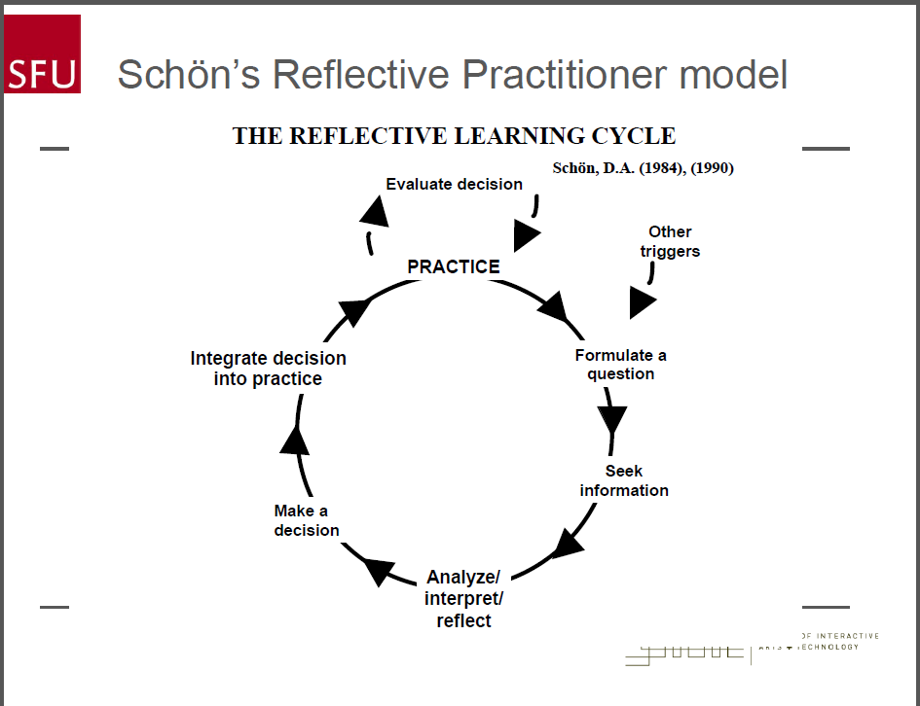
- D-cog vs HIP
  - relationship is oppositional. seek a paradigm shift
  - develop reflective design practice
  - Perry scheme
    - level 1: duality
    - level 2: multiplicity
    - level 3: relativism
    - level 4: commitment to relativism
- D-cog vs ecological
  - ecological is a precursor to enactive D-cog: smart-seeing
  - d-cog includes smart-seeing, projecting, close-coupling
- internal representation: facts, experiences, procedures
  - HIP combines internal representation with sensory perception
  - Not stable
- external representation
  - limits to memory, mental models, but we prefer ext-rep
  - materiality: constraints and affordances, creating serially and evaluate as you go
- Milliseconds matters: changes in response time, can shift problem-solving strategies
- Mind in the world, instead of world in the mind
- Biederman’s mental math study: how sensory information interacti with mental representations
  - predictions from reduction in uncertainty
  - preview operation faster than control
  - preview numbers slower than control
  - display sequence changed task from math to memory search
  - bottom-up selection
- Extended D-cog
  - interacting with external representations is a part of thinking, part of the overall process
  - Free Body Diagram (FBD): a sketch of a mechanical system cut free of its surroundings. It shows all the external forces acting on the systems, and requires disengaging each gear.
  - visual thinking including: concept driven perceptual routines, perceptual and conceptual projection of possible futures
- Engelbart’s concept
  - augmenting human intellect ‘collective IQ’
  - improvement infrastructure
  - co-evolution of artifacts with socio-cultural language practices
  - goal: advanced outposts staffed by knowledge workers and subject experts to explore future modes of working
  - augmented support structures for organizational improvement
  - raising the competence of the designers, implementers
Smart-Seeing & Projection (think with objects)
- actively looking at external representations, and projecting onto them makes us more powerful thinker
- offload working memory, deeper and wider cognitive activity
- visual proof: convince self by recreating the move yourself so you partly ignore what is there
- perception: seeing what is there, purely dependent on external stimulus
- imagination: internal representation, pure fabrication of what is not
- projection: a way of seeing something extra in the thing present, what could be the case
  - perception is concerned with seeing what is present, projection is concerned with seeing what is not present but might be
  - becomes most powerful when coupled with materialization as in project structure -> materialize project -> project next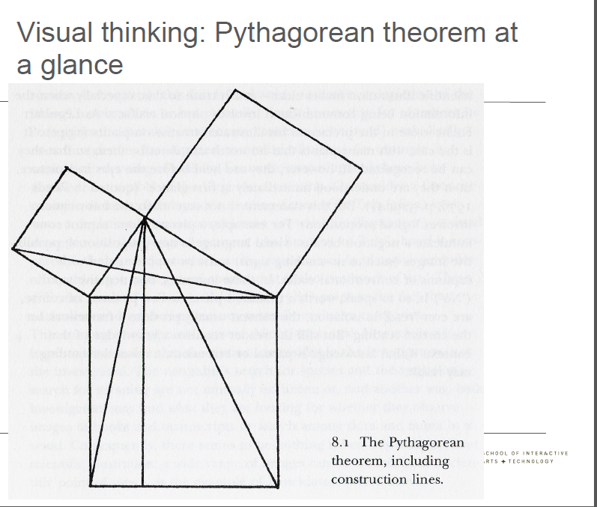
- thinking with objects
  - costs and benefits to each process (internal, external)
  - mental simulation is fallible, does not scale well
  - rearrangement makes it easier to notice key attributes
  - interactive version is infallible: complete semantic guarantee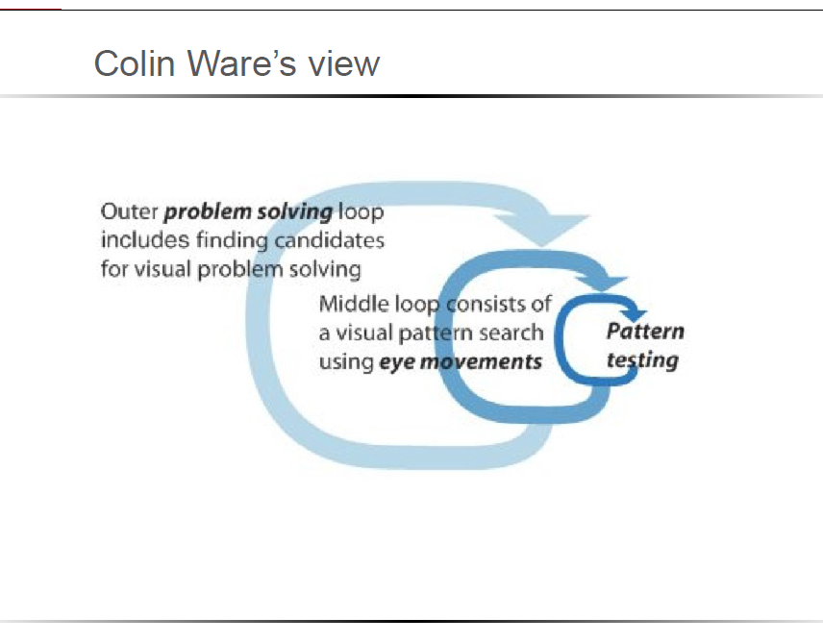
  - Three cost structure
- Digital support can lower cost operator outside
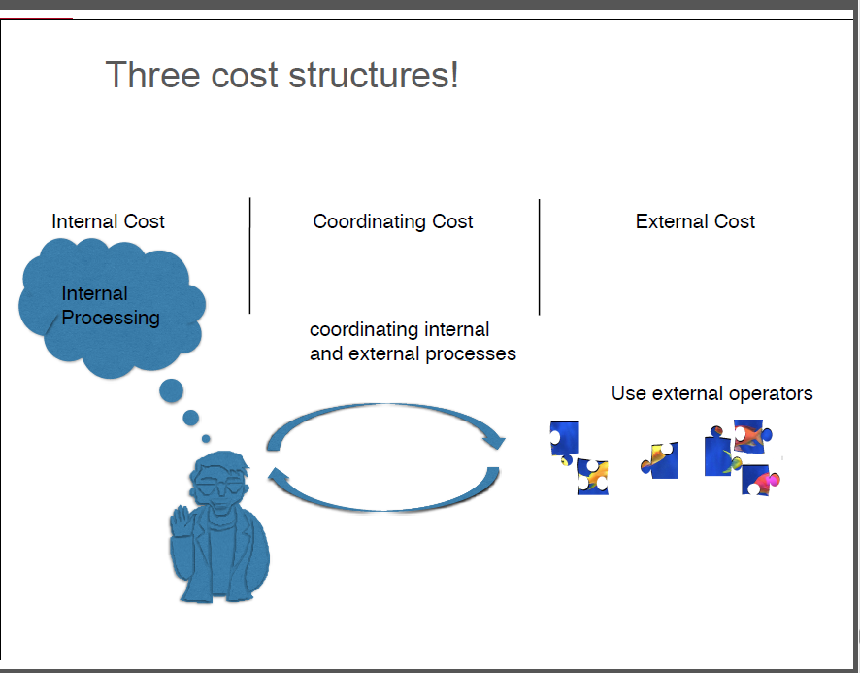
- Projecting -> create -> project
Close-Coupling
- Agent and artifact form a tight cognitive coupling, tighter coupling, lower cost.
- Principle of embeddedness: cognition flows to wherever costs are lower
  - in closely coupled system, process and structure migrates to wherever costs are lowest: both epistemic and pragmatic costs (computational and physical)
  - Jiang, Norman’s old view on distribute representation
    - process is not just representational
    - we use non representational operations
    - adapt to cost structure
    - we create new structure
  - good artifacts afford cheap and fast interaction and cognitive process
Social D-Cognition
- thinking about people
  - mentalism: people use mental representations for social phenomena
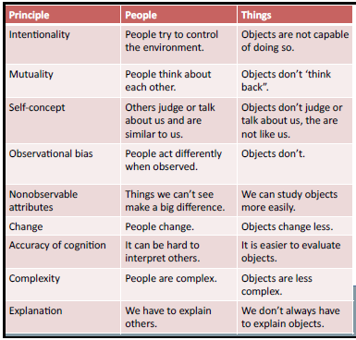
  - mental representations and cognitive processes develop, operate and change over time
  - Hutchins: boundaries in the unit of analysis of cognition, and the range of mechanisms (cognitive artifacts)
  - Wimmer & Perner, Siegal & Varney’s theory of mind
    - the ability to understand others’ mental states: beliefs, desires, intentions
    - we use our mutual knowledge, mutual beliefs, mutual expectations, mutual assumptions to ground out interactions
    - basis for interaction, but it doesn’t mean we are always right about interpretations
    - face-to-face conversation uses a lot redundant tacit cues to ground and repair interpretations
    - we have mental models of what others think
  - Fosterling’s attribution
    - factors that affecting attributions: fundamental attribution error. self-serving bias. belief in a just world
    - internal attribution & external attribution
  - stereotypes
    - schemas about people, could be positive, negative or neutral
    - stereotypes helps organize and understand people, but we can be wrong
    - we forget or ignore information that doesn’t fit the stereotype
  - ingroups & outgroups
    - ingroup favoritism: more diversity, attractive, socially acceptable, and nicer
    - outgroup favoritism: more similarity
- thinking with people
  - functionalism: social cognitive process serves a purpose, explores the settings, goals, and activities of social cognition
  - embodied & distributed, the success of the system depends on more than one individual or module
  - joint attention: the ideal solution to a coordination problem among two or more agents with respect to their current common ground
  - common ground(shared basis):
    - every member of community has information that bases holds
    - basis indicates to every member of community that every member has information that basis holds
    - basis indicates to members of that common ground
    - shared common ground helps us identify the fundamental mechanisms that underlie coordination. The concepts give observational power
  - distributed cognition
    - culture
- across time with products of earlier events -> cultural additions -> nature of later events
- knowledge is built into tools, environment design, representations, procedures and instruments
    - inner and outer process (close-coupling)
- brain-body-stuff: between brain/mind processes and material tools in the environment. Using interactive tools to help people to improve their internal and external process performance
    - group:
- collectivist thinking: cognition can be distributed across members of a social group either co-present or over a distance
- group intelligences: public and private goals, roles, timing, sharing information, transform information, emergent organizational structure
- the unit are coordinated because of their roles, their timely responses, their common understanding, and various tools or coordinating representations
- cognition models
  - embodied cognition I (EC-I): cognitive processes are partially dependent upon extracranial bodily processes
  - Embodied Cognition II (EC-II): cognitive processes are partially constituted by extracranial bodily process
  - Embedded Cognition (EMC): cognitive processes are partially dependent upon extrabodily processes
  - Extended Cognition (EXC): cognitive processes are partially constituted by extrabodily processes
  - Enacted Cognition (ENC): cognition is the relational process of sense-making that takes place between an autonomous system and its environment
- cognitive system:
  - scripts: sequence of tasks in which individual specific roles are trained
  - artifacts that support the task
  - communication protocols and channels for coordination
  - the ship:
    - the necessary knowledge and cognition to operate doesn’t exist in one or few’s head, each people has a partial view
    - mind in this case is the ship that distributed over people, procedure & things.Intelligence implies cognition and is displayed in how robust, resilient, adaptable the system is in solving hard problems
    - system as a whole
- can correct errors
- supports dynamic reconfiguration
- can be analyzed at multiple levels and loci
    - computational subunits(person/task/artifact)
- encapsulate information needed for operation
- be at the correct location
- act at the correct time so as to coordinate with other actors and events on the ship and in the environment
- communication information when needed
- the starbuck system
  - humans in heavily enculturated system, and procedures have optimized for the machines, and machines are optimized for humans
  - design challenge: minimize costs, prevent errors
  - changes cognitive efficiency, and minimizes costs in most areas
  - reduces errors, robust to interruption, tolerated breakdown, supports multi-tasking, order complexity goes up
  - units and levels of cognition
    - culture
    - group of employees
    - layout of the service area and machine
    - use of cognitive artifacts that support cognitive processing between individuals
- Music Making
  - shared tacit knowledge (enculturation, practice)
  - we need concepts that help us identify and label those tacit processes: music making. The context also structures the kinds of things musician will attend to and make decisions about. Context provide cues for common ground
  - musicians attend in ways that changes their performance to suit the context, and they know how the others are attending to the same thing (CG shared)
  - coordination: the understanding of one’s public and private goals and roles. Timing, sharing information among group, transform information into one’s understanding, emergent organizational structure within the group
  - Polanyi’s structure of tacit knowledge
    - functional aspect: attending from particulars to the whole
    - phenomenal aspect: aware of the particulars in the appearance of the whole
    - semantic aspect: the particular become meaningful by their relation to the whole
    - ontological aspect: what the tacit knowing is a knowledge of

