Final Report
SECTION ONE - INTRODUCTION:
- Game Name: Space War
- Game Type: 2D, Side scrolling
- Background store: You are the planner of the Saving Earth program. You will be driving a space ship to fight for energy diamond. You need to complete three levels to get the diamond.
- Design style: The object images were all created by myself. The game used a doodling style to present the objects. This style makes the game interface funny, unique and attractive. The sound effects of game match the style, and it makes the game more lifelike.
- Keywords: Doodle, Funny, Cute, Simple, Lifelike, Exciting.
- Reference for sound effects:
AudioPlayer shoot http://freesound.org/people/fumiya112/sounds/144320/
AudioPlayer bosshit http://freesound.org/people/fins/sounds/146730/
AudioPlayer collisionstone http://freesound.org/people/dkmedic/sounds/104439/
AudioPlayer collisionenemy http://freesound.org/people/dkmedic/sounds/104447/
AudioPlayer hit http://freesound.org/people/jorickhoofd/sounds/160045/
AudioPlayer bonusbmusic http://freesound.org/people/fins/sounds/171671/
AudioPlayer bonusemusic http://freesound.org/people/fins/sounds/171670/
AudioPlayer winner http://www.freesound.org/people/jivatma07/sounds/122255/
AudioPlayer levelup http://www.freesound.org/people/jivatma07/sounds/76234/
AudioPlayer gameover http://www.freesound.org/people/notchfilter/sounds/43696/

SECTION TWO – FEATURES:
There are total 7 scenes for the game, include: introduction, three difference levels, interim, failing and success. Player can move around and shoot different enemies to complete three levels and get the diamond. During the game, Player can get bonus for HP and scores.
Crashing stone or enemies will decrease player’s HP. In the level three, a boss will move vertically and shoot.
For the movement of the game, the background is in the space where have some little stars move from right to the left; the color of background will be deeper when level up. At the same times, there are sound effects for animation of object.

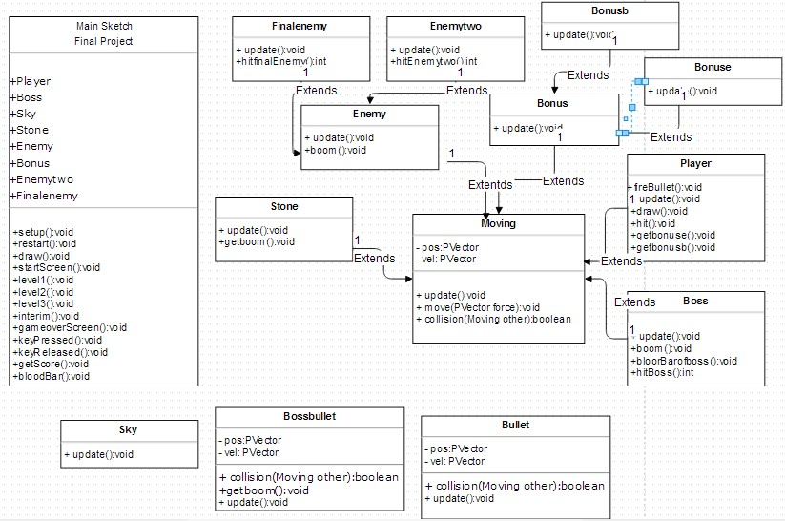
SECTION THREE – FINAL UML:

SECTION FOUR – DETAILED CLASSES SUMMARY: (Example: Class ‘Player’)
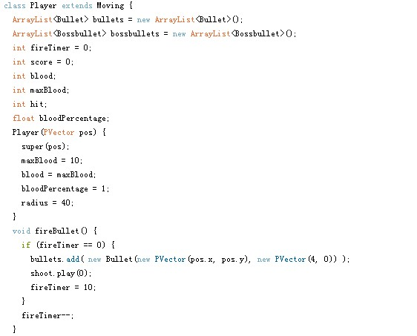
1 of 3
The sub class ‘Player’ extends class ‘Moving’.
Define variables which will be used in this sub class.

Use super (pos) to get date from ‘Moving’.

Method for fire. (Control fire time, fire location and sound effects).

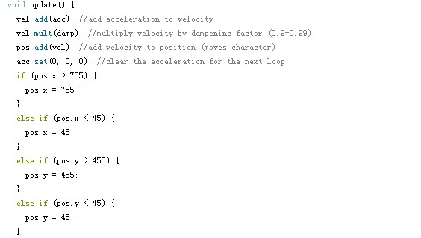

In the update();
Add one vector to the other and move the object

Use ‘if’ loop to make sure the player stay in-screen.

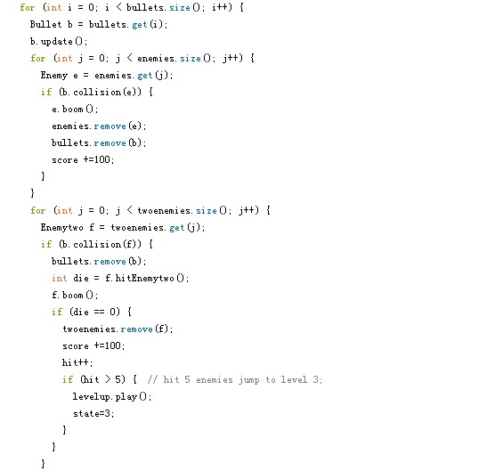

In the update():void,
Check the collide between player’s bullet and other objects which extend in the moving class.

If bullet collision with enemies, call the image of bomb and remove the bullet or enemy from arraylist respectively. Receive 100 for score.

If bullet collision with level 2 enemies, time of hit plus one; minus half HP of enemy; call the image of bomb and remove the bullet. Enemy removed from arraylist when the hit equals to 2,
Kill at least 5 level 2 enemies will let player go to the next level.

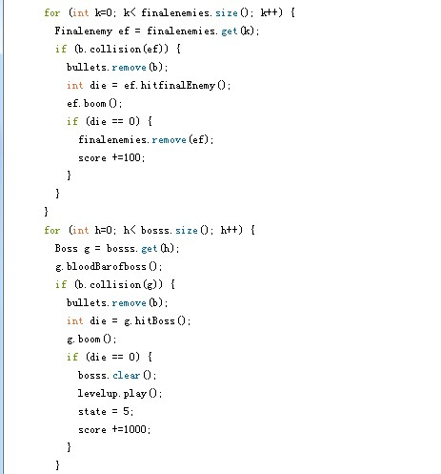
If bullet collide with level 3 enemies, time of hit plus one; minus 1/3 HP of the enemy; call the image of bomb and remove the bullet. Enemy remove from arraylist when the hit equals to 3 (die equal to 0). Receive 100 for score.

If bullet collision with boss, time of hit plus one; Clear the arraylist of when hit equal to 20 (die equal to 0). Call the image of bomb and remove the bullet. Receive 1000 for score and switch to state 5(interim screen)

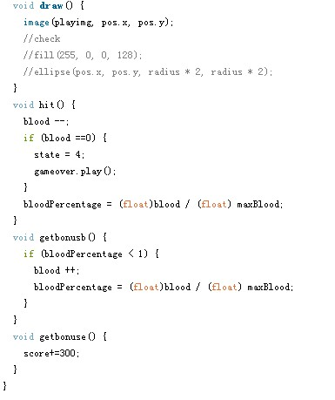
In method draw():void, loading image of player.

hit():void control and check player’s HP. If player collide with other object,
player’s HP is decreased. Screen switch to game over screen when player’s HP equals to 0.

getbonus method: player collide with ‘bonus’ will get extra HP or score respectively

SECTION FIVE – MAIN APPLICATION:
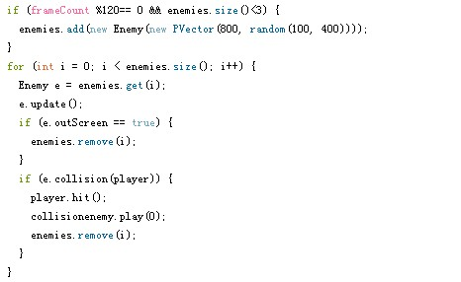
Example:
Created, stored, destroyed and iterated

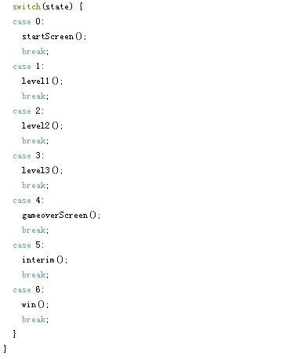

Example: 7 states in the game

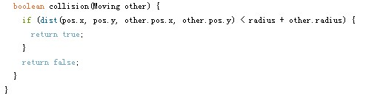
Example: Interactive between objects (Radial Collsions)
(Setting the radius of each objects and returns the value of boolean)

SECTION SIX – MEETING REQUIRMENTS:
- Inheritance : see class ‘Moving’, ‘Bullet’, ‘Bossbullet’
- Polymorphism via Overriding: see sub class extends class ‘Moving’
- Method Overloading: see sub class extends class Moving
- Objects as Parameters to Methods: see collsions():void in class Moving or ‘Bullet’
- Objects Declared Within Objects: see sub sub class ‘Finalememy’ in sub class ‘Enemy’

SECTION SEVEN – SUMMARY:
Illustration of game:
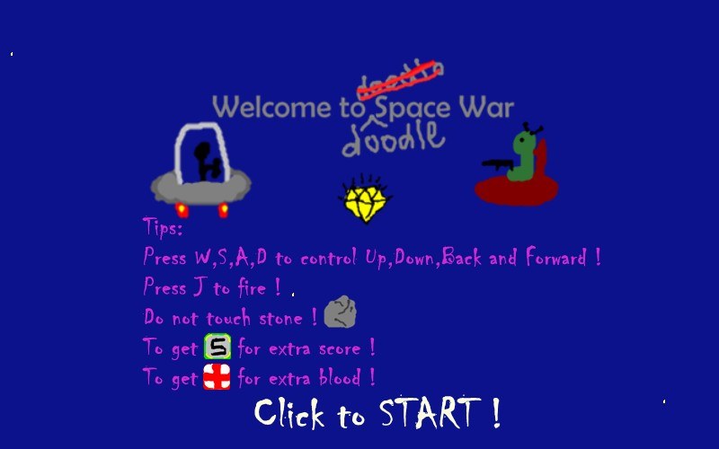

Introduction
The screen includes title of the game, use game image and words to explain the game and rules.
This basically shows the style, funny, simple, of the game. In introduction scene, user need click to get start. (Jump to level 1)

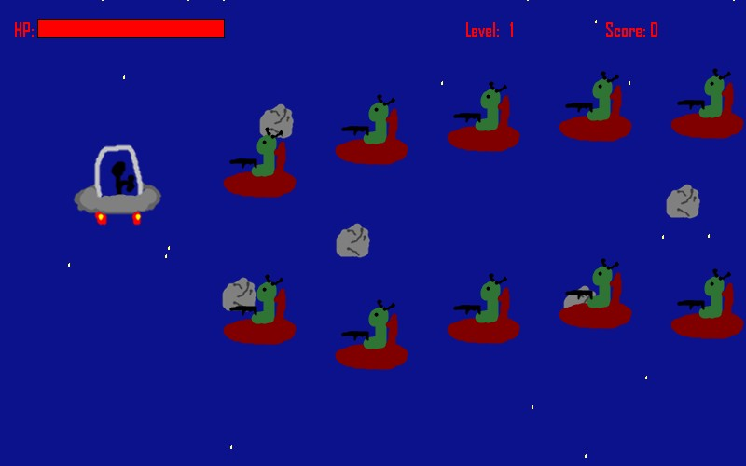
In the game interface, the top displays player’s HP, Level, and Score. Player set at the left in the beginning, and fire to the right. The enemies, stone, bonus all come from right and move to left.
Player should avoid the stone and enemies, any collision with them would decrease the HP of player and stone and enemies would disappear.
‘S’ bonus is displayed when score is dividable by 800. If player get ‘S’ bonus, player get extra 300 points of score. ‘Red Cross’ sign is displayed when score is dividable by 1000, player get extra 10 points of HP. To kill one enemy can get 100 point score. Player can jump to level 2 when score above 1300 point score.
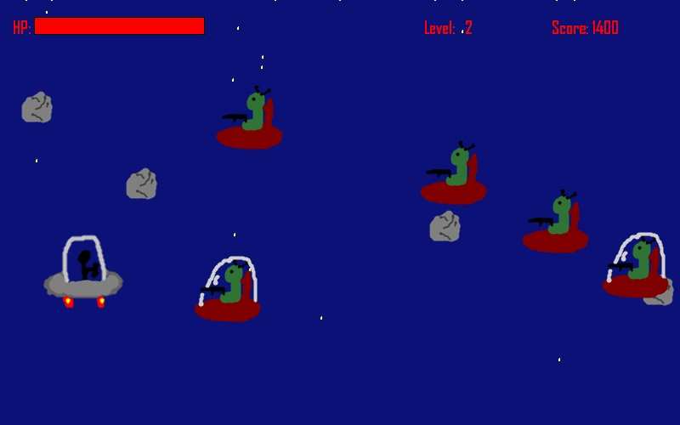

In level 2, a new type of enemy is displayed. Player should hit them twice to kill the enemy.
Player needs to kill at least five new enemies to jump to level 3.

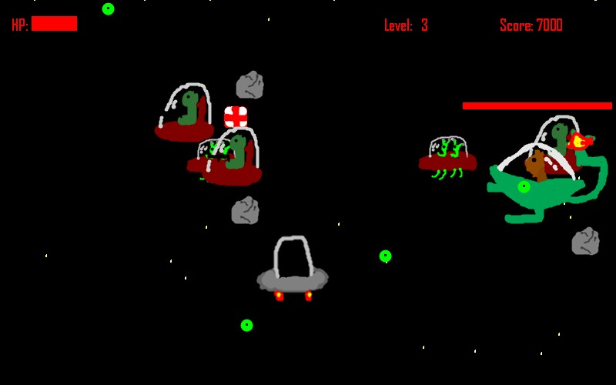
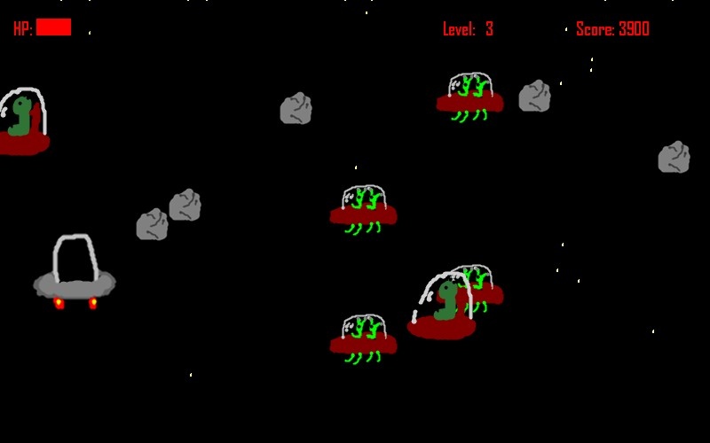
In level 3, a new type of enemy is displayed. Player should hit those three times to kill them. Player needs to kill at least ten enemies to call the boss out.
After kill boss, player will jump to the interim scene.

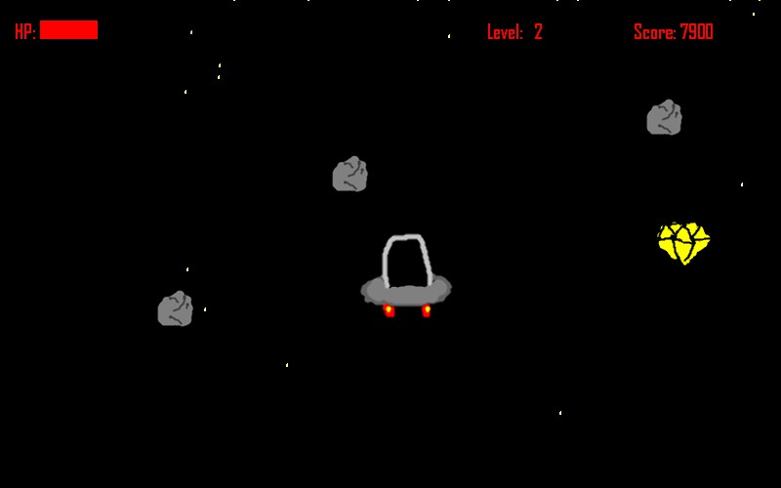
In the interim screen, an ‘energy’ diamond is displayed and all enemies are clear.
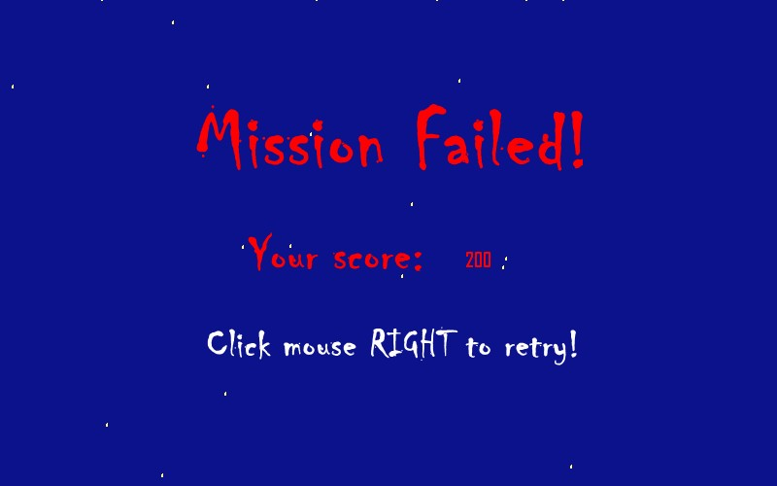
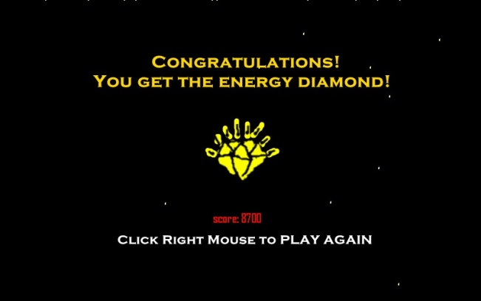
Player needs to get the diamond to complete the mission, then the success scene will be displayed.

During in the game, player will jump to the fail scene when player’s HP value equals to zero.

According the Illustration of game, the game is complete and compliable. I am happy and proud with my own game. I believe that client will happy with that. This is because the interface is simple, clear and funny. Besides, player is easy to control, the game is easy to play, and the sound effects and animation are lifelike. If there is some things that needs to be improved, I will do more about the variety of fire.

