Properties of Pure Substances

Pure Substance
A substance that has a fixed chemical composition throughout is called a pure substance such as water, air, and nitrogen.
A pure substance does not have to be of a single element or compound. A mixture of two or more phases of a pure substance is still a pure substance as long as the chemical composition of all phases is the same.

Phases of a Pure Substance
A pure substance may exist in different phases. There are three principal phases solid, liquid, and gas.
A phase: is defined as having a distinct molecular arrangement that is homogenous throughout and separated from others (if any) by easily identifiable boundary surfaces.
A substance may have several phases within a principal phase, each with a different molecular structure. For example, carbon may exist as graphite or diamond in the solid phase, and ice may exist in seven different phases at high pressure.
Molecular bonds are the strongest in solids and the weakest in gases.
Solid: the molecules are arranged in a three-dimensional pattern (lattice) throughout the solid. The molecules cannot move relative to each other; however, they continually oscillate about their equilibrium position.
Liquid: the molecular spacing in liquid phase is not much different from that of the solid phase (generally slightly higher), except the molecules are no longer at fixed positions relative to each other.
Gas: the molecules are far apart from each other, and a molecular order does not exist. Gas molecules move randomly, and continually collide with each other and the walls of the container they are in.
Molecules in the gas phase are at a considerably higher energy level than they are in liquids or solid phases.

Phase-Change Processes of Pure Substances
Consider a process where a pure substance starts as a solid and is heated up at constant pressure until it all becomes gas. Depending on the prevailing pressure, the matter will pass through various phase transformations. At P₀:
1. Solid
2. Mixed phase of liquid and solid
3. Sub-cooled or compressed liquid (means it is not about to vaporize)
4. Wet vapor or saturated liquid-vapor mixture, the temperature will stop rising until the liquid is completely vaporized.
5. Superheated vapor (a vapor that is not about to condense).
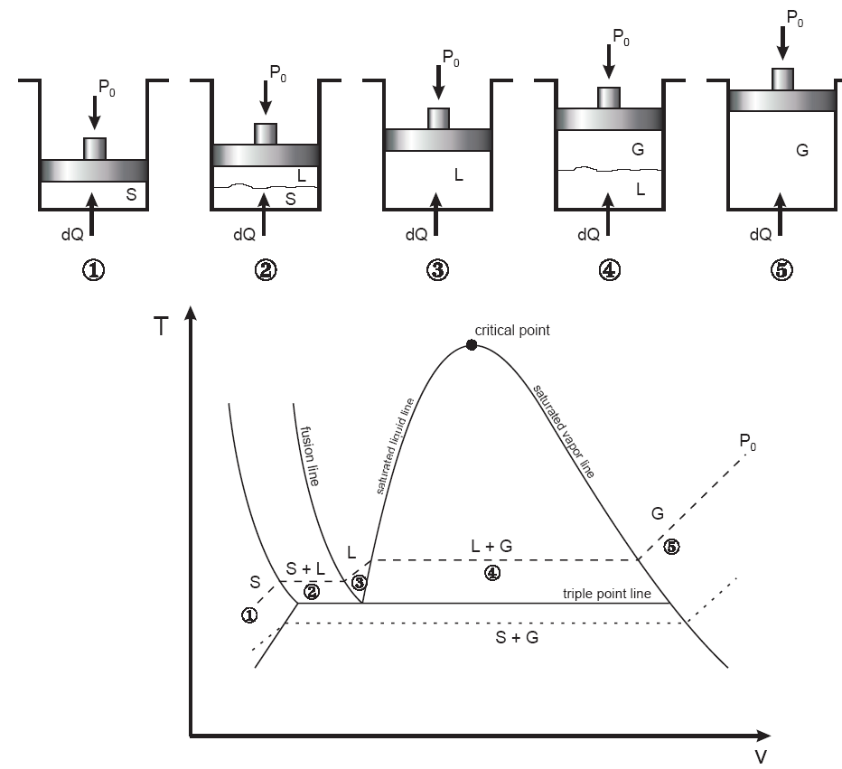
Fig. 1: T-v diagram for the heating process of a pure substance.
- At a given pressure, the temperature at which a pure substance starts boiling is called the saturation temperature, T_{sat}.
- Likewise, at a given temperature, the pressure at which a pure substance starts boiling is called the saturation pressure, P_{sat}.
- During a phase-change process, pressure and temperature are dependent properties, T_{sat} = f (P_{sat}).
- The critical point is the point at which the liquid and vapor phases are not distinguishable
- The “triple point” is the point at which the liquid, solid, and vapor phases can exist together. On P-v or T-v diagrams, these triple-phase states form a line called the triple line.
Table 1: Critical and triple point for water and oxygen.
 | Critical Point |  | Triple Point
 | P (atm) | T (K /°C) | P (atm) | T (K /°C)
H₂O | 218 | 647.30/(374.14) | 0.006 | 273.17 (0.01)
O₂ | 50.136 | 154.80/(−118.36) | 0.0015 | 54.16/(−219)

Vapor Dome
The general shape of a P-v diagram for a pure substance is very similar to that of a T-v diagram.
critical point
P
sat. vapor line
sat. liquid line
SUPERHEATED VAPOR REGION
COMPRESSED
LIQUID
REGION
SATURATED LIQUID-VAPOR REGION
v
T₂ = const. >T₁
T₁ = const
Fig. 2: P-v diagram of a pure substance.

The P-T or Phase Change Diagram
This is called phase diagram since all three phases are separated from each other by three lines. Most pure substances exhibit the same behavior.
- One exception is water. Water expands upon freezing.

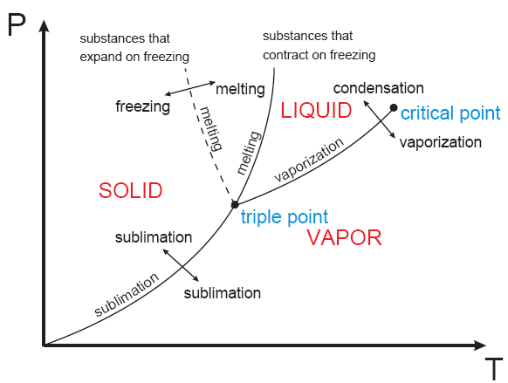
Fig. 3: phase diagram of pure substances.
There are two ways that a substance can pass from solid phase to vapor phase i) it melts first into a liquid and subsequently evaporates, ii) it evaporates directly without melting (sublimation).
- the sublimation line separates the solid and the vapor.
- the vaporization line separates the liquid and vapor regions
- the melting or fusion line separates the solid and liquid.
- these three lines meet at the triple point.
    - if P<P_{TP} , the solid phase can change directly to a vapor phase
    - at P<P_{TP} the pure substance cannot exist in the liquid phase. Normally (P>P_{TP} ) the substance melts into a liquid and then evaporates.
    - matter (like CO₂) which has a triple point above 1 atm sublimate under atmospheric conditions (dry ice)
    - for water (as the most common working fluid) we are mainly interested in the liquid and vapor regions. Hence, we are mostly interested in boiling and condensation.

Property Tables
For most substances, the relationships among thermodynamic properties are too complex to be expressed by simple equations. Thus, properties are frequently presented in the form of tables, see Table A-4.
The subscript “f” is used to denote properties of a saturated liquid and “g” for saturated vapor. Another subscript, “fg”, denotes the difference between the saturated vapor and saturated liquid values of the same property.
For example:
v_{f} = specific volume of saturated liquid
v_{g} = specific volume of saturated vapor
v_{fg} = difference between v_{g} and v_{f} ( v_{fg} = v_{g} – v_{f})
Enthalpy: is a property defined as H = U + PV (kJ) or h = u + Pv (kJ/kg) (per mass unit).
Enthalpy of vaporization (or latent heat): represents the amount of energy needed to vaporize a unit mass of saturated liquid at a given temperature or pressure. It decreases as the temperature or pressure increase, and becomes zero at the critical point.

1- Saturated Liquid-Vapor Mixture
During vaporization, a mixture of part liquid part vapor exists. To analyze this mixture, we need to know the proportions of the liquid and vapor in the mixture. The ratio of the mass of vapor to the mass of the total mixture is called quality, x:
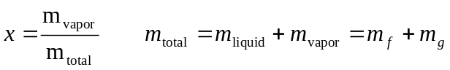
Saturated liquid-vapor mixture is treated as a combination of two sub-systems (two phases). The properties of the “mixture” are the average properties of the saturated liquid-vapor mixture.
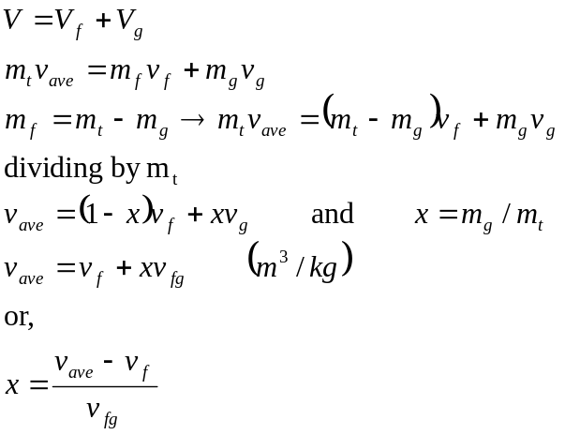
critical point
sat.
liquid
states
sat.
vapor
states
sat. vapor

sat. liquid
P or T
v
Fig. 4: The relative amounts of liquid and vapor phases (quality x) are used to calculate the mixture properties.
Similarly,
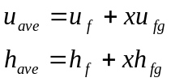
Or in general, it can be summarized as y_{ave} = y_{f} +x.y_{fg}. Note that:
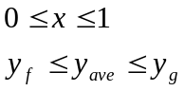
Note: pressure and temperature are dependent in the saturated mixture region.
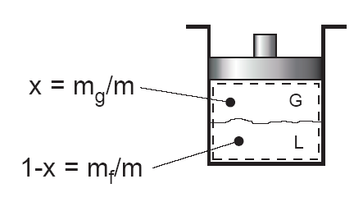
Fig. 5: Quality defined only for saturated liquid-vapor mixture.

Example 1: Saturated liquid-vapor mixture
A closed, rigid container of volume 0.5 m³ is placed on a hot plate. Initially the container holds a two-phase mixture of saturated liquid water and saturated water vapor at P₁= 1 bar with a quality of 0.5. After heating, the pressure in the container is P₂=1.5 bar. Indicate the initial and final states on a T-v diagram, and determine:
a) the temperature, in °C, at each state.
b) the mass of vapor present at each state, in kg.
c) if heating continues, determine the pressure, in bar, when the container holds only saturated vapor.
Solution:
Assumptions:
- Water in the container is a closed system.
- States 1, 2, and 3 are equilibrium states.
- The volume of container remains constant.
Two independent properties are required to fix state 1 and 2. At the initial state, the pressure and quality are known. Thus state 1 is known, as mentioned in the problem. The specific volume at state 1 is found using the given quality:
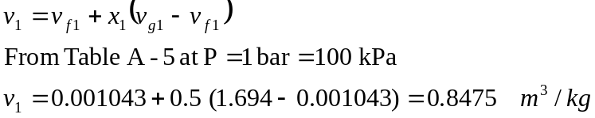
At state 2, the pressure is known. Volume and mass remain constant during the heating process within the container, so v₂=v₁. For P₂= 0.15 MPa, Table A-5 gives v_{f2}= 0.001053 and v_{g2}=1.1593 m³/kg. Since
v_{f2} < v₂ < v_{g2}
State 2 must be in the two-phase region as well. Since state 1 and 2 are in the two-phase liquid-vapor region, the temperatures correspond to the saturation temperatures for the given. Table A-5:
T₁ = 99.63 °C and T₂ = 111.4 °C
To find the mass of water vapor present, we first find the total mass, m.
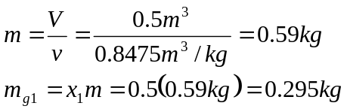
v
P₂ = 1.5 bar
P₁ = 1 bar
3
1
2
T
The mass of vapor at state 2 is found similarly using quality x₂. From Table A-5, for P₂ = 1.5 bar, we have:
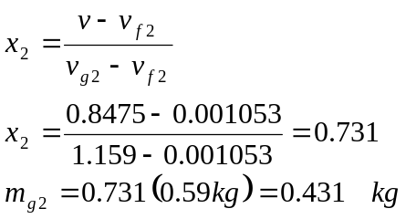
If heating continued, state 3 would be on the saturated vapor line, as shown in on the T-v diagram above. Thus, the pressure would be the corresponding saturation pressure. Interpolating in Table A-5 at v_{g} = 0.8475 m³ /kg, we get P₃ = 2.11 bar.

2- Superheated Vapor
Superheated region is a single phase region (vapor only), temperature and pressure are no longer dependent. See Table A-6 for superheated vapor properties.
If T>> T_{critical} or P<<P_{critical}, then the vapor can be approximated as an “ideal gas”.

3- Compressed (or Sub-cooled) Liquid
The properties of a liquid are relatively independent of pressure (incompressible).
A general approximation is to treat compressed liquid as saturated liquid at the given saturation temperature.
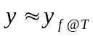
The property most affected by pressure is enthalpy. For enthalpy use the following approximation:
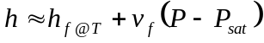

The Ideal-Gas Equation of State
Any equation that relates the pressure, temperature, and specific volume of a substance is called an equation of state.
The simplest and best known equation of state for substances in the gas phase is the ideal-gas equation of state.
Gas and vapor are often used as synonymous words. The vapor phase of a substance is called a gas when it is above the critical temperature. Vapor usually implies a gas that is not far from a state of condensation.
It is experimentally observed that at a low pressure the volume of a gas is proportional to its temperature:
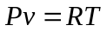
Where R is the gas constant. The above equation is called the ideal-gas equation of state (ideal gas relation). Since R is a constant for a gas, one can write:
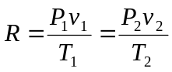
where 1 and 2 denote two states of an ideal gas. The constant R is different for each gas; see Table 2-3 in Cengel book.
R_{u} = 8.314 kJ / (kmol. K) is the universal gas constant, R = R_{u} /M.
The molar mass, M (kg/kmol): is defined as the mass of one mole of a substance. The mass of a system is equal to the product of its molar mass M and the mole number N:
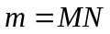 (kg)
See Table A-1 for R and M for several substances. An ideal gas is an imaginary substance that obeys the relation Pv = RT. It is experimentally observed that the ideal gas closely approximate the P-v-T behavior of real gases at low densities.
- In the range of practical interest, many familiar gases such as air, nitrogen, oxygen, hydrogen, helium, argon, neon, and CO₂ can be treated as ideal gases with negligible error.
- Water vapor (in general see Fig. 4-49 Cengel book), refrigerant vapor in refrigerators should not be treated as ideal gases.
- Water vapor at pressures below 10 kPa can be treated as an ideal gas, regardless of temperature.

Compressibility Factor
The assumption of ideal gas relation implies that:
- the gas particles take up negligible volume
- the intermolecular potential energy between particles is small
- particles act independent of one another
However, real gases deviate from ideal gas behavior. This deviation at given temperature and pressure can be accurately accounted for by introduction of a correction factor called the compressibility factor Z.
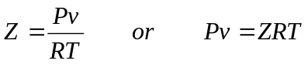
or Z = v_{actual} / v_{ideal}. Obviously, Z=1 for ideal gases.
Gases behave very much the same at temperatures and pressures normalized with respect to their critical temperatures and pressures.
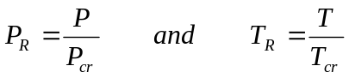
Here P_{R} and T_{R} are called the reduced pressure and temperature, respectively.
By curve-fitting all the data, the general compressibility chart is obtained which can be used for all gases.
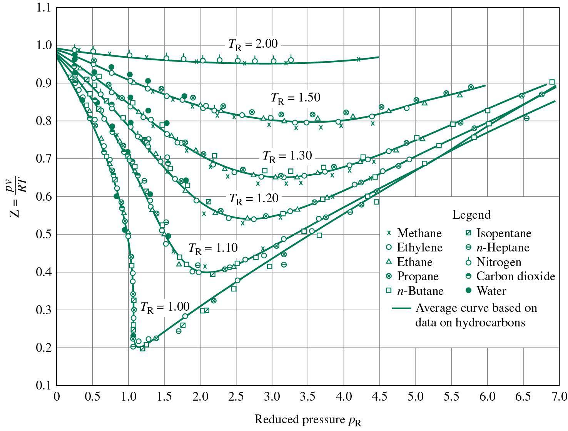
Fig. 6: Z factor, general compressibility chart.
From the Z chart, one can conclude:
- at very low pressure (P_{R} <<1), the gases behave as an ideal gas regardless of temperature
- at high temperatures (T_{R}>2), ideal gas behavior can be assumed.
- the deviation is highest in the vicinity of the critical point.
Example 2: Ideal Gas
Determine the specific volume of R-134a at 1 MPa and 50°C, using (a) ideal gas equation (b) the generalized compressibility chart. Compare the values obtained with the actual value of 0.02171 m³/kg.
Solution:
From Table A-1, for R-134a, R = 0.0815 kPa.m³/(kg.K), P_{cr} = 4.067 MPa, and T_{cr} = 374.3 K
(a) Ideal gas equation of state
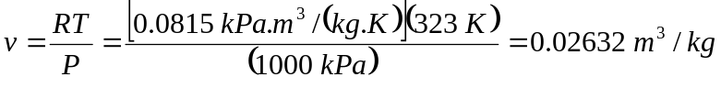
Comparing with the tabulated value, using ideal gas equation one would get an error of (0.02632-0.02171)/0.02171=0.212 or 21.2%.
(b) To determine the correction factor Z,
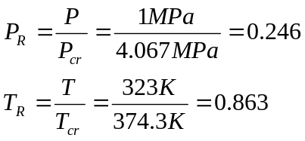
From Fig. A-28, Z= 0.84. Thus,
v = Z v_{ideal} = 0.84 (0.02632 m³/kg) =0.02211 m³/kg
The error is less than 2%.
Therefore, in the absence of exact tabulated data, the generalized compressibility chart can be used with confidence.

