Community Structure

- One of the most hotly debated and confusing topics in ecology is that involved with defining and describing what are commonly referred to as communities. Ecologists have many definitions for what defines a community.

Examples:

- an evolved, organized interdependent ecological unit (discrete boundaries)
-referred to as a superorganism or holistic model
- a coincident group of species that occur in the same place, who can tolerate the local physical and biological conditions (boundaries subjective)
-referred to as an individualistic model

- Individualistic versus holistic concept of communities

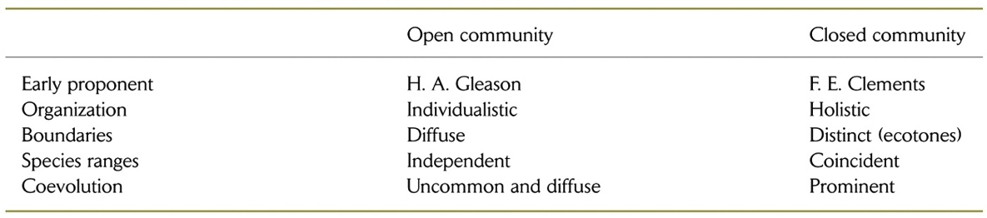

- Related to the debate about individualistic versus holistic (or super organism) communities is the question about whether communities are ‘open’ or ‘closed’.

Closed communities describe associations where the species are tightly tied to one another and that the ecological limits of a given species coincide strongly with the limits of all the other species in the community.
Open communities are composed of species whose distributions are somewhat independent of all the other species in the community. Thus certain species may span several species associations.

The concept of ecotone refers to locations where environmental gradients are steep, and thus, species composition changes abruptly.

The continuum concept posits that within broad categories of habitat (e.g., deciduous forest), species replace themselves continuously along gradients of physical conditions.

- Most of the early concepts of communities are derived from the patterns of dominant plant species found in a certain habitats (e.g. biomes, ecoregions, biogeographic regions)

- Food webs are a complementary way to characterize communities.

  - diagrams that show who eats whom in a community

  - derived from an interest in understanding how energy moves through the organisms in an ecosystem.

- Food webs can show a variety of different characteristics about the feeding relationships in communities. Examples:

- Connectedness webs

- Energy flow webs

- Functional (or interaction) webs

- The idea of the Keystone species (coined by R.T. Paine) developed out of interaction/function food webs.

Are all species equally important at determining the key characteristics (diversity, productivity, species composition) of communities?

Examples of keystone species from diverse habitats:

- Starfish (Pisaster) in rocky intertidal areas

- Many fishes in lakes (example: Alosa)

- Wolves and bears in the western US

How does the current distribution of terrestrial carnivores in N. America differ from their historical distributions? What might this mean for the structure of terrestrial communities throughout N. America?

- What is a trophic level? (e.g., producers, primary consumers, secondary consumers,)?

- Omnivory – where species obtain energy by feeding on organisms from more than one trophic level

  - adds complexity to food webs
  - assumed for a long time that omnivory was rare because it made simple mathematical models very unstable (population crashes). However, omnivory is rampant in nature and is prevalent in most food webs.

- Trophic organization of communities is affected by both top-down (predation) and bottom-up (production processes). There has been substantial debate about which of these two processes is more important in determining the structure of communities. The best answer is probably that both are important, in general, but that certain processes might be especially important in certain situations compared to others.

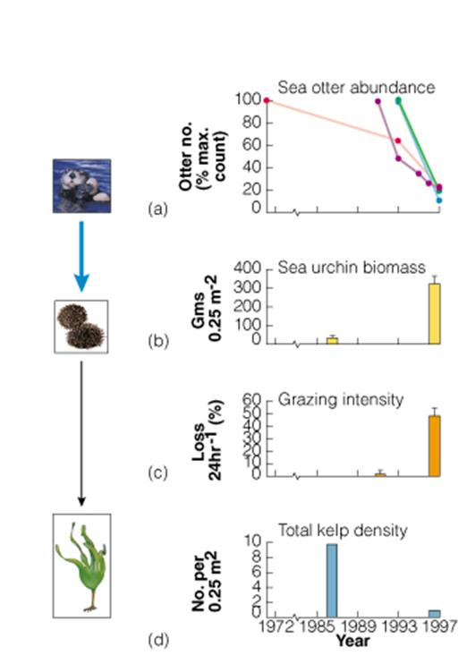
Trophic cascades refer to the phenomenon whereby a top predator can affect the entire trophic structure (and productivity) of a community through its top-down effects. These do not refer to bottom-up interactions.

- How abundant is a typical species?
  - most species are rare, dominant species are usually represented by only a handful of taxa.
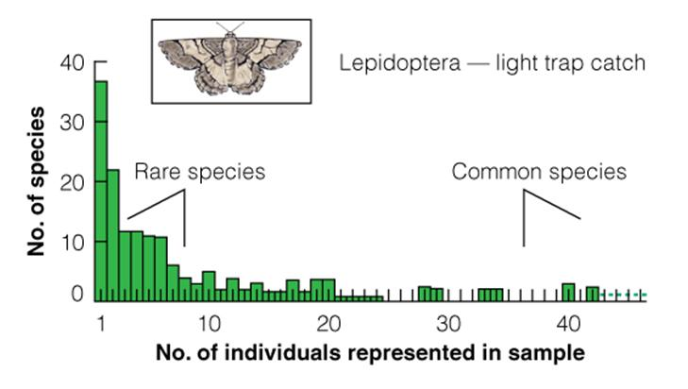

O) What is the difference between species richness and species diversity?

