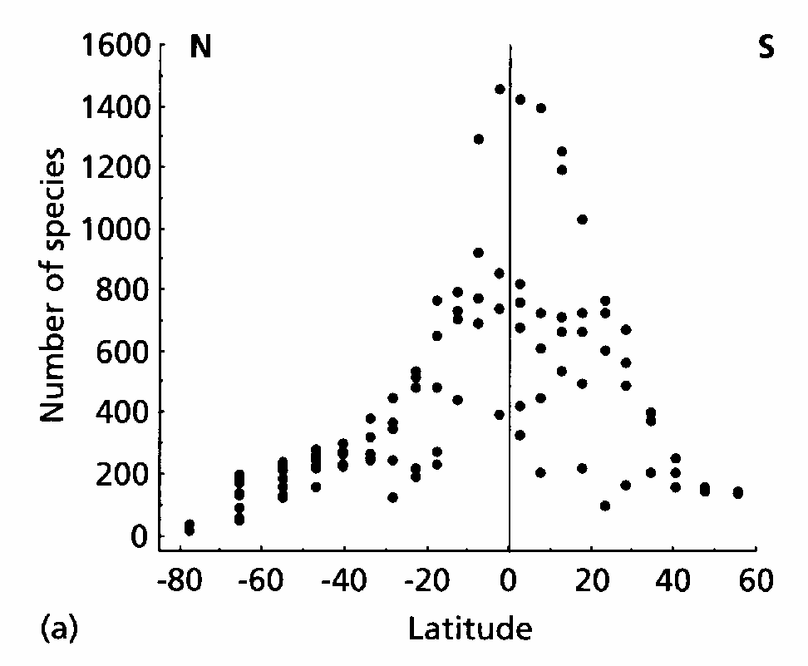
Patterns of Species Diversity and Reserve Design
Birds
- Latitudinal gradients in species diversity

Higher species richness at low latitudes (closer to the equator). Why?

Some proposed hypotheses...

a) Time- since glaciation/major disturbance, species accumulation

b) Area- tropical habitats dominate terrestrial landmasses

c) Energy- constant climate, highest solar radiation flux, greatest rates of plant production

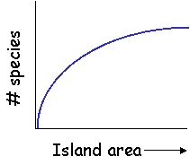
- Islands as a special case
(also other “island-like” habitats: mountaintops, lakes, forest fragments, etc.)

a) Island area predicts species diversity

“Species-Area curve”

S = c *A^{z}

Why might large islands have more species than small islands?

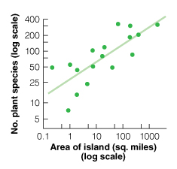

b) Island isolation predicts species diversity
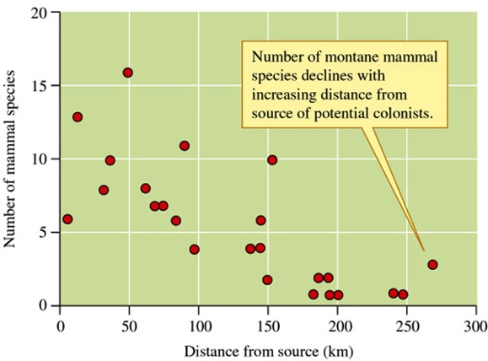
Islands near sources of potential colonists have higher species diversity.

c) Equilibrium view of island species diversity
Theory of island biogeography

Species diversity balanced between arrival of new colonists and extinction of existing species (RATES, #spp/time)

a) SIZE: Large islands have more species than small-lower chance of extinction

Affects extinction rate

b) ISOLATION: Islands far from others have lower chance of colonization

Affects colonization rate

c) COMBINATIONS?

*Simberloff and Wilson’s experiment on mangrove islands demonstrated this theory quite well. What did they find?

- Metapopulations: modern extension of Island Biogeography, applied to single species population dynamics.

  - Classic (Levins’ formulation):

A collection of smaller “sub-populations”, each with independent dynamics, linked by movement among subpopulations.

Predicts change in proportion of patches occupied per unit time = colonization rate (rate at which extinct patches are recolonized) - extinction rate (rate at which occupied patches go extinct)
Classic:
All subpopulations have equal and independent colonization and extinction probabilities

*How is predicting single species “colonization” and “extinction” of habitat patches different from Island biogeography?

Assumes:
1. All populations have independent dynamics
2. All patches of equal quality

Lessons for conservation & management:

1. Unoccupied patches or disappearing subpopulations can be rescued by immigration (Rescue Effect)

2. Unoccupied patches are necessary for metapopulation persistence

  - Two other forms

    - Mainland-Island

Larger subpopulations or patches remain indefinitely, exporting individuals to smaller subpopulations with a tendency to go extinct

Mainland-island: Colonists from large subpopulation maintain smaller subpopulations

    - Source-Sink

Some subpopulations have r > 0. These supply immigrants to subpopulations with r < 0. Incorporates differences in patch quality.

Source-sink: Some subpopulations occur in better habitat (r > 0; black) than others (r < 0; grey)

* How would this approach influence your choices for habitat protection for particular species?

