- Ecologists and environmental scientists are focusing much of their attention on trying to understand the ecological processes that regulate the global ecosystem of the Earth. Most of the impetus for this interest is to try and reduce the degradation of the global ecosystem by human activities, or to plan for the consequences of our continuing poor treatment of our home.

- Humans are affecting essentially every process and ecosystem that we have already discussed in this course. The magnitude and nature of these effects vary widely depending on the ecosystem in question and the type of human activities focused in any given area.

- There is a subset of human activities that are affecting the Earth’s ecosystems at a global scale. These are described briefly here.

- Background extinction rates are ~1000X higher than historic rates

- Exploitation of top predators. Humans have reduced the densities and prevalence of top predators in many of the world’s ecosystems. Consider what the effects on food webs and communities is because of the loss of top predators.

There has been a tendency to remove top predators in the order of their profitability to humans – which often scales with their body sizes. This is referred to as serial depletion of top predators. Example from whale exploitation:
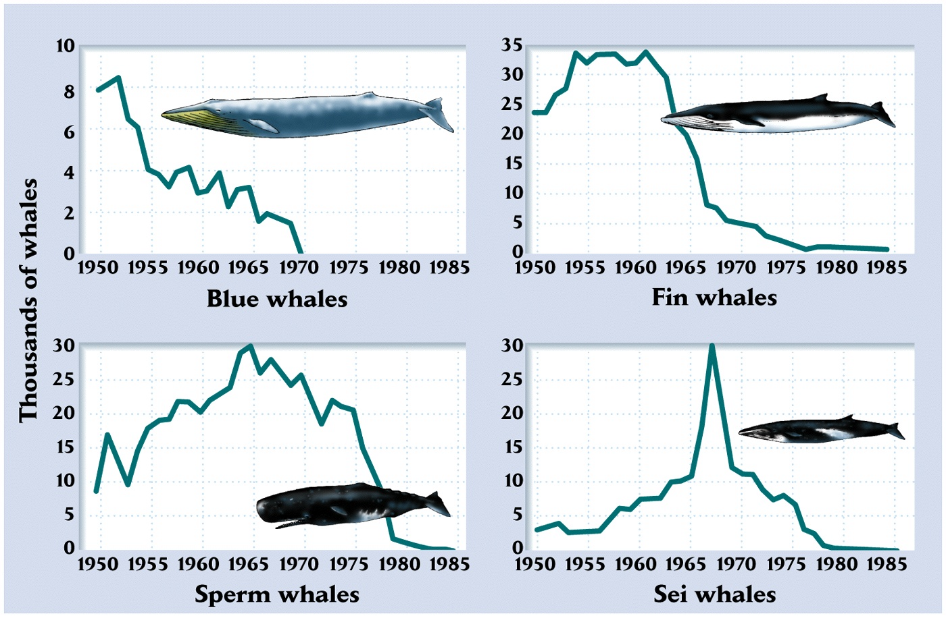

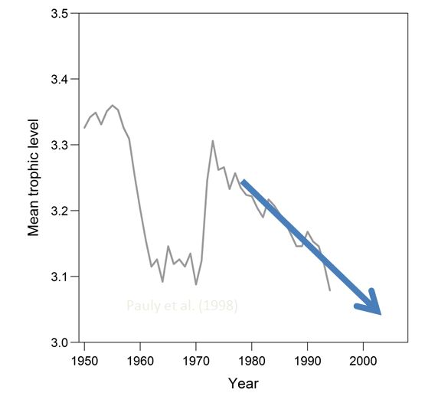

We’ve discussed this before as a ‘fishing down’ of marine and freshwater food webs.

- Invasive species. Development of a global economy has been associated with rapid movement of species beyond their natural ranges. These exotic and invasive species often do not establish in new places where they are moved by humans, but in cases where they do (~<10%?), they can outcompete or prey on native species and even cause extinctions. In many cases, invasive are causing tens of millions of dollars of damage to human economies (e.g., fisheries, agriculture). There are lots of unanswered questions about the ecology of invasive species such as:

Why do some of their populations take over their invaded habitats while they remain relatively rare or common in their native habitats?

How do they move around and how can human behavior change to reduce movement of invasives?

How do invasives change local communities and the ecosystem processes they perform?

- Land-use change. Humans are transforming most continental regions of the Earth through forestry, agriculture, urban development and a large variety of industrial processes. These transformations result in loss of habitat for lots of species and changes in global nutrient, hydrological and energy cycles. In many cases, land-use changes are reducing the overall productivity of terrestrial ecosystems because of increased erosion that degrades the quality and quantities of top soil.

- Appropriation of freshwater. Although every human only needs a few liters of water per day to survive, many of us use thousands of liters every day to meet the needs of consumptive lifestyles. Much of this overuse of water is associated with industrial scale agriculture (often in deserts!), many industrial uses, and leaky water pipes in cities. Current estimates suggest that humans use about half of all the freshwater that is available at the global scale. That doesn’t leave a lot left over for freshwater ecosystems.

- Nutrient pollution. Intensive fertilizer use, poor sewage treatment, and land-use changes are moving increasing amounts of nitrogen and phosphorus into freshwater ecosystems. Rivers are transporting many of these nutrients to nearshore oceans. Increases in nutrient concentrations are causing excessive growth of algae and bacterial consumption of organic matter. This collection of responses are generically referred to as eutrophication, which increases the primary productivity of ecosystems, but degrades their abilities to support higher trophic levels. In some cases, eutrophication is associated with blooms of toxic algae which are harmful to humans and wildlife.

Two of the most dramatic examples of eutrophication are the development of dead zones in the Gulf of Mexico and the Chesapeake Bay:
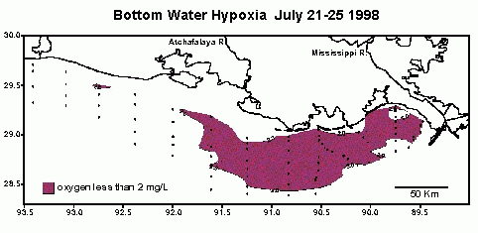

- Contaminant pollution Humans have either mobilized many natural contaminants (such as heavy metals) or have synthesized many new contaminants (such as pesticides) that have accumulated in the biosphere. Many of these cause major human and wildlife health problems. The passing of the US Clean Water Act and the Clean Air Act have actually improved contaminant concentrations throughout most of North America and Western Europe (e.g., use of DDT). However, contaminant pollution has become more of a global problem lately because of continued heavy use in developing countries where there are often only very limited environmental restrictions on industrial activities. Some of the contaminants that are used in developing countries are actually transported globally via the atmosphere. For example, some populations of lake trout in northern Canada are thousands of kilometers from the nearest source of pesticides, yet the concentrations of pesticides in these fish is often too high for safe human consumption. The source of these pesticides is from Asia and Eastern Europe and are transported in via the atmosphere.

The grasshopper effect results in increasing concentrations of volatile contaminants at higher latitudes.
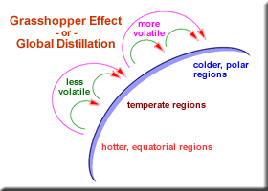

- Stratospheric ozone depletion.

Ozone in the upper atmosphere serves an important role to the biosphere because it blocks out much of the biologically damaging UV radiation before it reaches the biosphere. Production of CFCs and their transport to the upper atmosphere has caused massive ‘holes’ to develop in the ozone layer because these compounds are very stable yet catalyze the degradation of ozone. Thinning of the ozone layer has resulted in increased UV radiation flux to the Earth’s surface. Except for a few notable cases, the biological effects of increased UVR remain undescribed.

The Montreal Protocol is an international treaty designed to reduce the use of CFCs at a global scale. It has been only marginally effective.

