The global climate is changing faster now than it has in the last several million years. It appears that most of this change is a result of the greenhouse effect that is produced through fossil fuel burning and deforestation.

Several visualizations of complex global atmospheric data are now available that make the contributions of different natural and human caused factors more apparent. Explore them for yourself here:
https://www.bloomberg.com/graphics/2015-whats-warming-the-world/

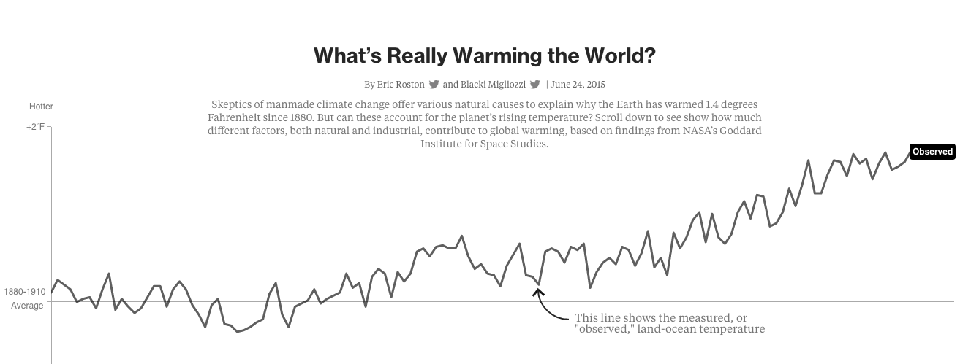

A variety of human-produced gases contribute to the greenhouse effect. While most attention has focused on carbon dioxide, gases such as methane and nitrous oxide are much more potent greenhouse gases (on a molecule basis). One molecule of methane is about 25 times more potent, and nitrous oxide is about 310 times more potent than a molecule of carbon dioxide. Major sources of methane and nitrous oxide are industrial scale agriculture.

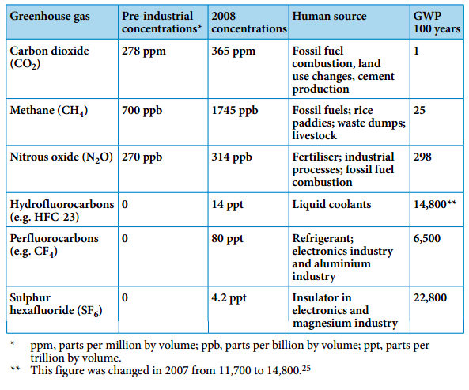

The Kyoto Protocol was signed in 1997 by most countries of the world to reduce the amount of greenhouse gas emissions to the atmosphere on a country basis. This international treaty has led to lots of ‘green innovation’ to reduce greenhouse gases (e.g., trading ‘carbon credits’, replanting forests, etc.). Reducing our dependency on fossil fuels is the obvious thing to do. In 2015, the Paris Climate agreement was negotiated by196 countries to control global temperature increases to less than 2* C compared to pre-industrial levels. This voluntary international agreement is unprecedented in scope and commitment. To date 170 of the countries have ratified the agreement, including Canada. The agreement is non-binding and acknowledges that different countries have different capacities and levels of responsibility for climate action.

There is accumulating evidence (lots of it!) that shows that many ecological systems are responding to climate warming in the last century. These examples include range shifts of many species towards the poles, changes in spring and fall phenology of organisms in seasonal environments, loss of some species from the equatorial components of their ranges.

- Advance of spring events
- Pole-ward range shifts
- Observed changes linked to local or regional climate change
- Species respond differently
- Shifts in species are resulting in changes to human disease dynamics
- Range restricted species will experience severe declines
- Evolution can’t ‘keep-up’ with climate-induced changes

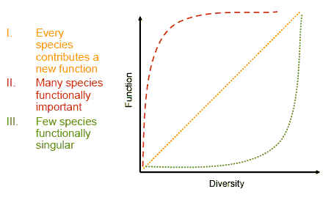

Biodiversity is now being lost at unprecedented rates at a global scale.

In fact, most of the world’s species have not been described yet, but are being wiped out by a combination of the factors listed above. Biodiversity loss is of particular concern because humans derive many products and services (called “ecosystem services”) from the Earth’s other species, and the ecosystems we rely on function because of the processes carried out by the species in them (clean water, clean air, productive soils, etc.). We have seen how changes in the abundance of keystone species can dramatically change communities and their ecosystems. Beyond this, there are many competing theories regarding exactly how dependent natural ecosystems are on maintaining diverse species assemblages. We know in general that without many interacting species, ecosystems and the services we derive from them can be eroded, but the scientific evidence is weak. Nevertheless, the conservation of natural species assemblages is a major global priority and an important first step toward maintaining the integrity of the Earth’s ecosystems.

