Dynamics of Predation

- Several general questions concern studies of predator-prey interactions, and their subsequent effects on population dynamics and community structure:

Do predators or consumers reduce the densities of prey populations below the level defined by their own resources (i.e., carrying capacity)?

Do predator-prey interactions cause populations to oscillate in time and space?

- Predators often reduce prey below their carrying capacity. See example of mite populations on strawberry plants
However, the severity of this predator control of prey varies widely among taxa, ecosystems, and through time.

C) Predator-prey systems sometimes cycle. The most well-known example was documented by Charles Elton in the early 1900s—fur records of lynx and hares from the boreal forest from the Hudson’s Bay Company’s records

*There are many other examples of predator-prey cycles in rodents, fishes, insects, plankton, bacteria, and a variety of other taxa.

- causes of these cycles are not always entirely clear

- but often occur when there is a strong single predator-single prey interaction

D) Predator-prey interactions can be modeled with simple math. The simplest and best understood model is referred to as the Lotka-Volterra predator-prey model

**similar to the equations we learned about simple population dynamics for continuously reproducing populations (exponential and logistic)

Prey equation (R) | dR/dt = rR – cRP  where: r is the prey growth rate, c is the capture efficiency of the predator
Predator equation (P) | dP/dt = acRP - dP  where: a is the predator conversion efficiency, c is the capture efficiency of the predator, and d is the predator death rate

Although these models are mathematically very simple, they produce complicated dynamics, some of which resemble real predator-prey cycles observed in nature and in experiments.

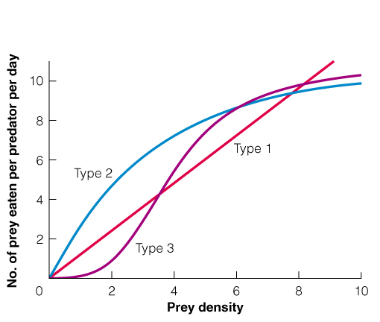
E) The Functional Response

describes the shape of the relationship between the predator feeding rate and the prey density.

**Note in the simple L-V model, the predator feeding rate is modeled as a linear function of prey density (feeding rate = cR).

This means that a plot of predator feeding rate versus prey density (R) is a straight line with positive slope c (referred to as a Type-1 functional response).

Assumes that the feeding rate of the predator continues to increase linearly as the number of prey it encounters in nature increases.

However, there are good reasons to believe that the functional response is a non-linear function (Type 2 and Type 3). To understand the mechanisms that might determine these non-linear functions, it is convenient to think about the predation process as a series of discrete processes:

1) searching for prey, 2) attacking prey, and 3) handling and digesting prey

-time required for searching for prey is negatively related to prey density (the more prey out there, the less time is required to find one to attack)

-time required for attacking prey often small part of the predation process (most predators very well adapted for attacking their prey)

*Exceptions include situations where small predators are attempting to capture a very large prey (e.g., wolves hunting moose).

-time required for handling prey is a very important component of the predation process because it determines how many prey a predator can actually consume at any given prey density

**Could you eat 30 BigMac’s in an hour? Probably not – because there is a discrete amount of time required for handling each Big Mac (unwrapping and chewing it) and for digesting it (or not!). Handling time often constrains the functional response at high prey densities.

What happens in a Type-3 functional response?
- refuges
- predator switching
- other reasons?

