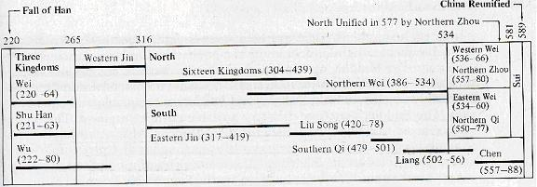I. Introduction

A. Themes in the North
1. Conversion of nomads into farmers
2. Centralizing, state-building tendencies
3. Military expansionism

B. Themes in the South
1. Assimilation of aboriginals
2. Rivarly between old and new colonists
3. Colonial feel

II. The Three Kingdoms (AD 220–280)
1. Wèi 魏,
2. Shǔ 蜀
3. Wú 吳
End of the Three Kingdoms and the [Western] Jìn 晉 Dynasty (265 – 316)

III. Retreat to the South: The Six Dynasties
[1. Kingdom of Wu]
2. Eastern Jin Dynasty
3. Song Dynasty
4. Qi Dynasty
5. Liang Dynasty
6. Chen Dynasty

IV. “Barbarians” in the North: The Sixteen Kingdoms
Han Zhao, Later Zhao, Cheng Han, Former Liang, Later Liang, Northern Liang, Western Liang, Southern Liang, Former Yan, Later Yan, Northern Yan, Southern Yan, Former Qin, Later Qin and Western Qin and Xia

V. From “Barbarian” to “Chinese”: The Northern Wei
Xiānbēi 鮮卑

Timeline from Conrad Schirokauer, A Brief History of Chinese Civilization (1991): 79.

