It's a Small World after All:
The Wider World in Historians' Peripheral Vision

Nicholas Guyatt and Luke Clossey

1. The problem
The metrics of comparing peoples’ relative worth are murky and grim. The human-trafficking market offers one kind of answer: Today a Thai sex slave sells for around the same price as forty forced laborers in Africa. The Philadelphia Convention of 1787 estimated that, for the purposes of federal representation, five slaves might carry the weight of three freedmen. In 1973, during the American wars in southeast Asia, the satirist Russell Baker extrapolated that, in terms of the bombing that would be needed to save their hearts and minds, an Italian would cost 3.3 times as much as a Cambodian. (“Expensive perhaps, but who would say it is not worth it to save Venice for the free world?”) A journalist weighing the value of possible stories might rely on an apocryphal but revealing dictum: one dead in Brooklyn equates to five dead Londoners, or fifty dead Arabs, or five hundred dead Africans. These calculations are unpleasant, but are perhaps unavoidable until the day slave-owners’ money, American congressional districts, bombs, and news-hour airtime become infinite.

The specific question of how news media value different regions, their Global Attention Profiles (GAP), has been studied by Ethan Zuckerman at the Berkman Center for Internet and Society at Harvard. Trawling through years of international news websites, his research shows the number of stories in various regions correlates not with the size of countries’ population but with the size of their economies. The outlet most at odds with this pattern is the BBC, probably saved by its history, as even the poor countries in the Commonwealth receive substantial coverage. For the most part, journalists point us towards countries that are wealthy.

How directly are these media priorities internalized? What does the world look like to a college freshman? One way to test this is to ask a group of new undergraduates to list the ten most populous countries. Nearly everyone knows that China, India and the United States come first, second and third. Most students will put Brazil, Russia and Japan in the top ten, though not necessarily in the right order. A far smaller number will correctly identify the other four countries: Indonesia (4), Pakistan (6), Nigeria (7), and Bangladesh (8). Instead, they’re likely to promote a European nation (Germany (15) or France (21), perhaps), an Anglophone ex-colony like Australia (52), or a country that has attracted the attention of the United States military. (Iraq (39) and Afghanistan (38), usually.) You can see this pattern even more clearly if you ask students to estimate population in absolute rather than relative terms: countries like Egypt, Iran, the Philippines, Turkey and Ethiopia will score consistently lower than smaller western nations like Canada, Italy or Spain. In the imagination of our students, the biggest countries tend to be white, wealthy or war-torn.

Our guinea pigs here are first-semester students, which means that their professors have several years to encourage them towards a more cosmopolitan outlook. Your authors teach history at universities, and have come to understand how badly we serve our students on this count. Professors are no more immune than students to CNN; rather than counterbalance our students’ GAP we replicate it. In fact, because military history is unfashionable, we historians tend to skip the war-torn Iraq and Afghanistan to even more narrowly focus our teaching and research on the West. Universities pride themselves on their global outlook: they recruit students and staff from around the world, they form international networks and collaborations, and they trumpet ‘world-leading’ research as their most prized achievement. But in a subject like history, most students and staff know that North America and Europe still dominate in the classroom and in research output.

The historical profession has a checkered record of bringing the world’s pasts to young people. The origins of modern historical practice were closely bound to the rise of nationalism in the eighteenth and nineteenth centuries. For many of its most passionate advocates during this period, history mattered because it reinforced national affinities. Even today, US historians defend their interests in Washington by presenting themselves as guardians of the national story; in the UK, meanwhile, scholars meet government targets for ‘research impact’ by emphasizing the contribution of their work to the heritage industry. Whether history is presented as civics lesson or tourist magnet, it’s clear that there are entrenched reasons to value one’s own past over the history of far-flung places.

When historians have made the case for a broader view, they haven’t always proved able to explore the rest of the world on its own terms. The proponents of ‘universal history’ in the medieval and early modern periods insisted that humanity shared a common past and future, but placed this ‘universal’ experience within the frame of their particular religious belief. For Christian philosophers and historians, world history was the story of how God made, peopled and redeemed the world. In the nineteenth and early twentieth centuries, scholars of European expansion produced imperial histories that swept distant places into a narrative of civilization and progress: again, this story told us more about ourselves than about the peoples we claimed to have conquered. After World War II, the study of the non-western world was complicated by the concerns of the present: historians of Russia, China, Southeast Asia and other regions discovered that new sources of funding came with new pressures for usable knowledge in the Cold War.

It’s our contention, though, that historians can and should do more to encourage wider-world history. Our discipline has limitless potential to educate young people about the world in its entirety: historians work on every conceivable time period and geographical region, after all. But we’ve long suspected that the range of teaching and research in our major universities is wildly skewed towards Europe and North America. To assess the scale of the problem, we decided to look more carefully at how our leading history departments covered the planet’s myriad pasts. Here we share our results, and argue for a major shift in the range of history that we offer to our students.

2. Methods
Although we were trained in the United States, we’ve each taught within and outside the US – in Canada and the UK, in particular. It seemed like a good idea, then, to examine the geographical range of historical research across these three major Anglophone countries. Our first question was simple: does anyone in Britain, Canada or the United States keep track of the range of work that professional historians actually do? To the best of our knowledge, the answer for the UK and Canada is ‘no.’ The American Historical Association, on the other hand, combs its directory of US-based history departments every five years to offer a breakdown of regional expertise. The data is gratifyingly beefy: in 2010, the AHA survey included 16,016 names from more than 800 departments across the United States. Even better, they’ve been doing this since 1975, giving us an idea of how the profession is changing. (Or not, in the case of some historical fields.) We’ll come back to the AHA survey later, but we decided that we’d do something both more and less ambitious. We wanted to survey historians in Britain and Canada as well as the US, to see if the picture looked very different outside the American system. And we wanted a sample that was small enough to allow a really careful consideration of what historians were actually doing.

In the spring and summer of 2011, we examined nearly sixty history departments from the US, Canada and the UK, comprising almost 2400 historians in total. We picked our departments on the basis of size – each needed at least fifteen historians to make the cut – and on their performance in the league tables produced by US News and World Report, Macleans (for Canada), and the British government (in the gloriously batty ‘Research Assessment Exercise’). Anyone who works in higher education can tell you how unreliable these indices are, so we’re not claiming to present data for the twenty ‘top’ departments in each of our three countries. But we believe that we’ve surveyed a reasonably broad range of ‘elite’ and middle-ranking institutions: the largest and best-resourced Canadian, British and American universities show up in our sample.

As we worked through departmental websites and faculty pages, some historians were easy to categorize; we became particularly fond of those who’d written a dozen articles and books on sixteenth-century France, for example. Others were trickier: does a scholar working on British officials in nineteenth century India count as an historian of India? What if she doesn’t have any local languages, and focuses principally on colonists rather than non-white people? What about a historian who claims on their webpage to be doing “international history” or “world history,” when they publish solely on American foreign policy – using American sources, and concentrating principally on American actors?

Instead of relying on self-descriptions, we decided to allocate historians to particular categories by closely examining the work they’d actually published. In the website that supports this essay, we provide more information about our methods, and how we dealt with the small but not insignificant number of historians who were particularly difficult to characterize. (This number was around 20% of the total sample.) To achieve greater precision we treated cross-regional historians fractionally: we might divide one person into, say, 0.4 Africa and 0.6 Southeast Asia. (Not unlike the Counter Reformation church dividing up a saint’s relics among globally scattered devotees.) This produces odd combinations in some cases, and plenty of non-integers when we work with the figures, but we hope it captures geographical emphases more honestly.

3. Overall findings
We began by combining the data from all three countries (UK, US, Canada) to produce an overall picture. The results confirmed our suspicions that historical work is skewed strongly towards a few areas, though we were surprised by the extent of the imbalance. Figure 1 demonstrates that Europe, the UK, the US and Canada are the subject of more than three-quarters of all historical research in Britain and North America:

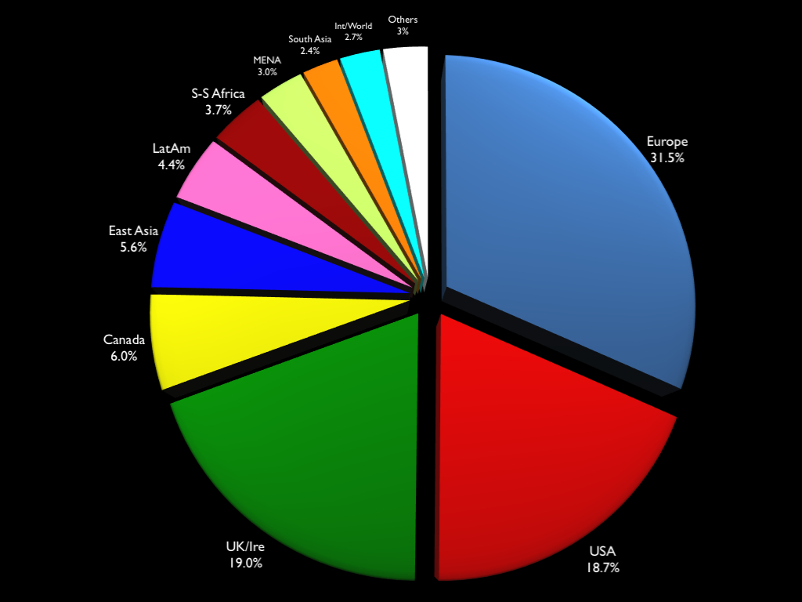

Figure 1: What historians study

We can get a clearer sense of the problem from figure 2. Historical research maps poorly onto regional population. Europe, the US, the UK and Canada are greatly overrepresented; the non-western world is greatly underrepresented. (Anatolia is the only exception to the western/non-western pattern; it’s slightly over-represented, buoyed partly by classical scholars and partly by a wave of recent PhDs that began to swell when the European Union agreed to negotiate the accession of Turkey.) For a number of reasons, we might reject the idea that population should precisely determine our historical curiosity. But to the extent that the number of people ought to count for something, we can identify patterns in the current distribution of historical research. Europe attracts three times as many historians as the raw population numbers would merit; for the United Kingdom and Ireland, the level of interest from historians is around twenty times the figure that population would suggest. (This makes the United States – which is over-represented by a factor of four – seem bashful.) Conversely, historians of East Asia comprise only around a quarter of the numbers we’d expect from the population data. The situation is worse for historians of South and Southeast Asia: they only manage to reach a tenth of the number that their population would demand, if history were a truly democratic enterprise.

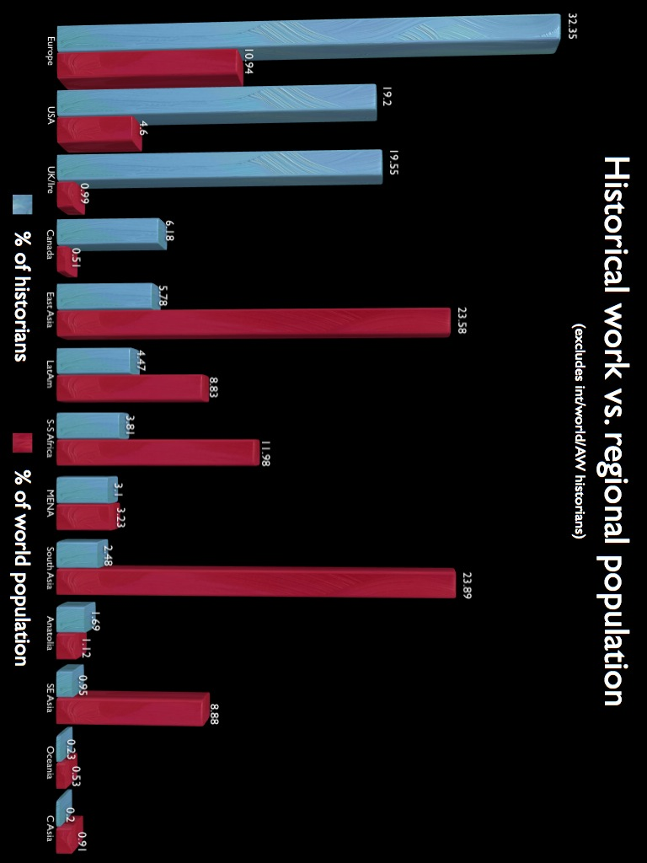

Figure 2: Historical research vs. regional population

Assuming that population doesn’t determine the distribution of historians to particular regions, are there other indicators that might explain how the profession has reached this point? Gross domestic product works quite well for Europe, the United States and South Asia, but it makes poor sense of East Asia, Southeast Asia and the United Kingdom. GDP per capita comes closer to capturing the contours of our research, as figure 3 demonstrates. This suggests that historians’ interests track not wealth but rather wealthy people; East Asians, individually poor, cannot pool their money to attract our attention.

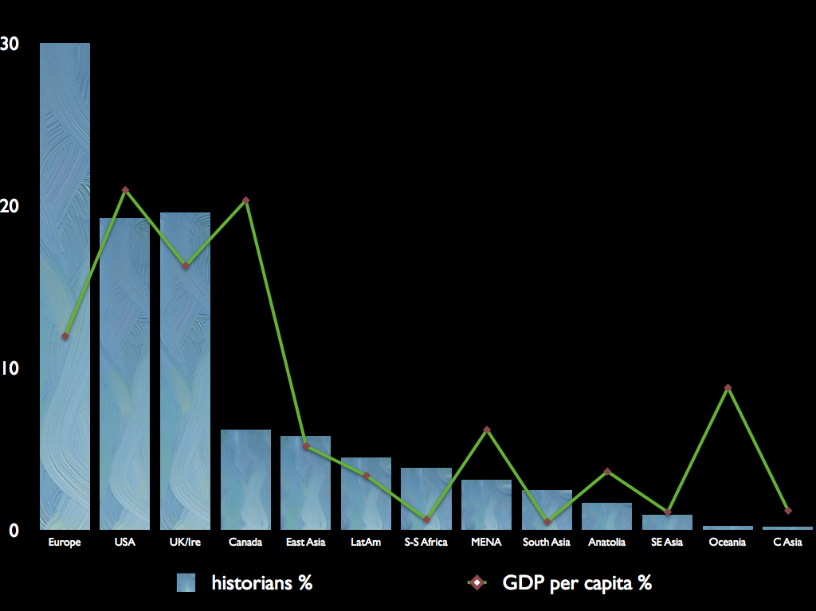

Figure 3: Historical fields and GDP per capita

Universities are, depending on your point of view, famously or notoriously liberal places. The rise of social history since the 1970s has reclaimed a vital past for the poor and middling sorts who were previously marginalized by political and intellectual historians. And yet the widespread enthusiasm for ‘history from below’ hasn’t extended to the fate of people living beneath twenty-five degrees latitude (north). It would be crude to argue that academics merely follow the money, though our findings would support that conclusion. More likely, our collective vice is solipsism: we’re interested in ourselves and, relatively speaking, we’re a lot richer than people in other parts of the world.

4. Local variations
When looking in more detail at the results within the three countries we examined, a clear pattern emerges: the United States does the best job of covering the history of the wider world, and the United Kingdom does worst. Figure 4 shows the respective strengths of American, British and Canadian history departments in different areas of world history.

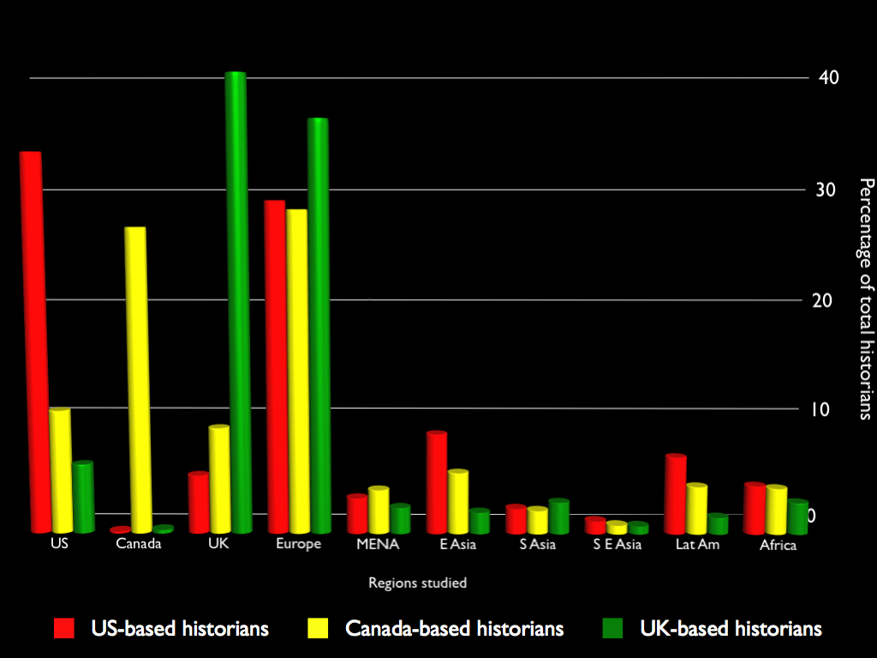

Figure 4: percentage of historians in US/UK/Canada studying world regions

One immediate point of comparison is the number of historians who work on their own country. Unsurprisingly, the country with the largest number of UK historians is the United Kingdom; the same preference for ‘home’ history is true in the US and Canada. British history departments, though, do much more ‘home’ history than Canadian ones: 27% of historians based in Canada do Canadian history, whereas 41% of UK-based historians study the UK and Ireland. If British historians want to make the case that the UK has a bigger historical footprint than Canada, they have to contend with the fact that the United States – hardly the most inconspicuous nation in world history – has only around a third of its total historians working on the homeland.

The deep roots of British history probably explain some of this. A considerable number of UK-based historians work on the medieval period, whereas only a tiny fraction of US-based historians work on the indigenous societies of North America before 1600. But the UK preference for the domestic is accompanied by a secondary preference for Europe, which doubly crowds out the wider world: around 36% of the historians in UK departments work on European history, compared to only 29% in North American departments. Adding the UK/Ireland to the figure for European history, more than three-quarters of all historians working in the UK study Britain and Europe. If we consider the history of the West in aggregate – the history of the UK, Europe, the US and Canada – we can see why Britain does so badly at telling stories from further afield: the combined figure for western history among US-based historians is 68%, for Canada-based historians it’s 75%, and in the UK it’s 84%. Whereas history departments in the United States devote nearly a third of their faculty appointments to the world beyond Europe and North America, fewer than one in six UK historians covers the wider-world beat.

While they look respectable in comparison with the UK, neither the US nor Canada has cause for satisfaction in the absolute sense. A quarter of the US departments we sampled had no South Asian history whatever; for Southeast Asia, the figure was closer to 50%. (From a purely neighbourly point of view, Canadians might lament the fact that nearly 80% of US departments had no Canadian historians on their books.) Some American departments have begun hiring in world or global history, though ironically British and Canadian departments were more likely to have at least one world historian: around two-thirds of the US departments lacked a tenure-track employee in this emerging field.

Do history departments outside Europe and North America do a better job of covering the world? We examined the faculty listings for Australian National University, Peking University, the University of Cape Town, and the National Autonomous University of Mexico. In these institutions, the vast majority of historians are studying their own countries: Peking (62% working on domestic history) made even the UK (41%) look cosmopolitan, and the other departments were more extreme: ANU (64%), UCT (83%), UNAM (96%). The parochialism of the periphery thus mitigates the lack of attention we pay to the wider world; as teachers, they restrict their students’ horizons even more than we do. Or perhaps they feel that, if they don’t do their own histories, no one else will.

5. Are things getting better?
Before we assess the prospects for real change in the direction of historical research, it’s worth asking whether the ground has already begun to shift. In the United States, at least, there are modest grounds for optimism. The American Historical Association’s survey for 2010 (figure 5) suggests that Ph.D. students over the past thirty years have moved slowly away from European history towards the history of the wider world.
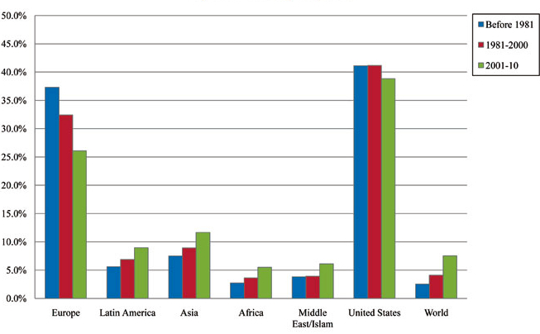
Figure 5: Faculty members and fields by year of degree, taken from AHA 2010 survey

Some of the numbers here are eye-catching: the proportion of faculty trained in European history has dropped by almost a third over the span of the survey, freeing up spaces for historians trained in African, Asian and world history in particular. Two caveats about these figures: first, the relative balance of US departments is still massively tilted towards the US and Europe. Even if these trends continue, it will be many years before Asian history creeps towards a respectable level of coverage. (According to these figures, 12% of faculty who received PhDs between 2001 and 2010 specialized in Asian history; Asian countries comprise nearly 60% of the world’s population.) Second, the commitment of American history departments to US history has held steady at around 40%. Unless this changes, there is unlikely to be more room to expand the history of the wider world.

Our own survey bears out some of the findings of the AHA, while confirming the problems facing UK history departments in particular. Instead of determining the year in which a particular faculty member received their Ph.D., we opted for the simpler method of noting whether a historian was an assistant, associate or full professor. (UK universities have a different system of ranking, but we adapted this to fit the North American conventions.) Then we looked at the number of historians working on the ‘wider world’ at each level of seniority (with ‘wider world’ meaning everything beyond Europe and North America). The results are in figure 6. To the extent that full professors are generally older than assistant professors, this should allow us to see changes over time – offering a point of comparison with the AHA data.
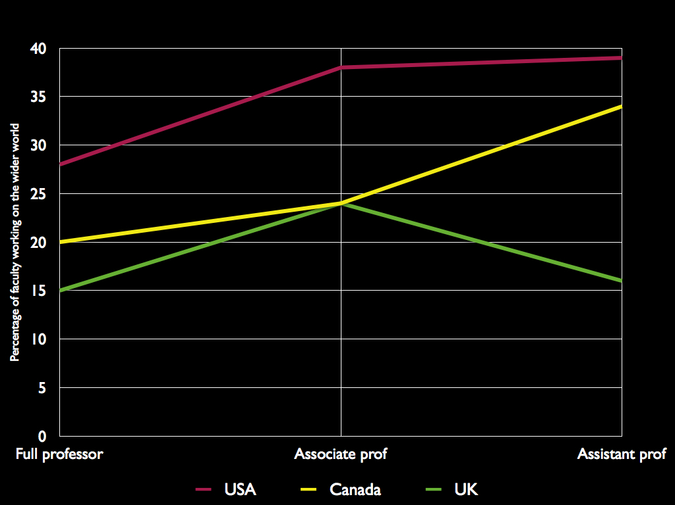

Figure 6: Percentage of wider-world history by seniority of faculty

The American story here is similar to the one told in the AHA survey: a significant gain for wider-world history among more junior faculty, though the increase tails off from the associate to the assistant level. (There’s a hint here that the rebalancing may already be slowing.) In Canada, the trend towards wider world history takes longer to get started, but it’s pronounced among assistant professors. The UK figures are extraordinary: they suggest that the British historical profession made a shift towards wider world history, but that the latest influx of junior staff have largely given up the gains made by their predecessors. We examine these results in more detail in the online version of this article, but they offer a clear warning to anyone who imagines that the shift towards wider-world history is ongoing and inexorable. An acquaintance of ours who teaches British history in the UK recently sniffed that world history was a “fad” that should not determine hiring priorities; our findings for UK universities suggest that, on the first part at least, he may have been right.

6. Obstacles and challenges
Why don’t history departments hire more people to work on the wider world? From our experience, and from anecdotal evidence gathered by our friends and colleagues, we can identify a number of obstacles that deter appointments in non-western history.

Professional inertia
There’s an obvious way to diversify the profession: whenever a senior historian of the UK, North America or Europe retires, a department should consider replacing her/him with a historian of the non-western world. In practice, things aren’t as simple. Faculty typically keep their jobs for decades, and one of their key tasks is to train graduate students in their field. An historian of France or the UK has a duty to produce more historians of France and the UK, which only increases the pressure to create more jobs in western history. It’s possible to break the cycle: the emerging discipline of world history owes a great deal to European historians who encouraged their students to pursue stories and sources far beyond the traditional bounds of their field. But the dynamics of professional history aren’t friendly to a major shift in geographical focus. The transition that we advocate in this essay would require a deliberate and coordinated effort from department chairs and senior faculty.

(Perceived) apathy among students
One familiar response to calls for more wider-world history is that students don’t want to study these unfamiliar stories. Even if this hypothesis were true, to our eyes it would suggest urgency rather than surrender. But absent any convincing evidence for student apathy, it’s hard to concede its influence. Britain, Canada and the United States are diverse societies with a global reach: the history of all three nations has been made and remade by their interaction with the wider world, and by immigrant populations with African, Asian or Latin American roots. These days, teachers of US or British history are much more attentive to the histories of race and immigration in their own work, which provides a solid foundation for the teaching of non-western history on its own terms. Given the imperial history of the UK in particular, it seems strange that so many British history departments offer no teaching in African, East Asian or Middle Eastern history.

Moreover, our undergraduates are painfully aware of the difficulties they’ll face on the job market when they graduate. There are plenty of reasons to regret the intrusion of material realities on the college experience: it would be better if students could graduate without debt and pursue their studies without the need to calculate professional advantage. But changes in the political and economic makeup of the world can only increase the importance of knowing more about countries and regions beyond Europe and North America. Surveys of our students reveal that international possibilities, skills, and awareness not only attract them to history programs but also are among the dividends most valued by alumni in the contemporary workplace. Our departments’ current regional foci, meanwhile, excellently prepare students for the nineteenth century – to be ambassadors to the Congress of Vienna, perhaps, or citizens and administrators of a world order that has already passed.

Time, languages and resources
Wider-world history brings a particular set of challenges for graduate students and young faculty: you’ll need languages that you haven’t had a chance to study before college; you’ll need money to get to distant archives, and time to consolidate your skills and write up your findings. Given the current funding problems in North American and British academia these obstacles may seem insurmountable, especially if university departments remain reluctant to create new posts in wider-world history. Even the very best students at top graduate schools are hardly guaranteed a job – let alone a good job – when they complete their doctorate. Will young scholars in the UK dedicate the time and resources to studying the history of China or Latin America when the prospect of a permanent job is so small? The pressure to publish immediately creates another hardship for wider-world historians, as does the proliferation of short-term adjunct teaching as a stepping-stone to a permanent position. These pressures affect everyone coming into the profession, of course, but they are particularly damaging to the prospects of those who undertake the long apprenticeship required by non-western history.

Limited resources may work against non-western history in other ways. A fresh faculty member in a completely new field may need significant support from library staff who are working on a strained budget. He or she may struggle to recruit advanced undergraduates and graduate students if their university makes no provision for training in a particular language. Department chairs may seek to leverage the existing research strength of a department, especially in the context of encouraging bids for research grants from funding bodies; this can lead colleagues to promote additional hiring in their own fields. Again, the pressure to produce more work in familiar geographical regions is considerable.

The West versus the Rest
Although it’s hardly the only reason why we do so much western history – and it may not even be the most important one – we can’t ignore the fact that our geographical biases reflect a preference for westerners over resterners, to borrow Niall Ferguson’s term. This preference isn’t always manifested with the Grand Guignol of Ferguson’s work (“I’m sure the Apache and the Navajo had all sorts of admirable traits…”), but it has surely played a role in limiting our historical curiosity to our own nations and to Europe. Our collective parochialism may be inadvertent or unconscious; sometimes it may even be clothed in concern for a new hire who may not ‘fit in’ with a department’s existing profile. A friend of ours who teaches history at a major university told us about a recent department meeting to discuss hiring priorities: when our friend advocated a new hire in African or East Asian history, since her department had no representation at all in those fields, she was told that a scholar of non-western history might feel ‘isolated’ as the only person working on their region. (Historians of US residential segregation might roll their eyes at this.) The quiet assumption that the West has played a much more important role in the shaping of world history than the Rest presents a powerful challenge to a rebalancing of our geographical focus.

Sometimes the assumptions are not so quiet. Debates about the teaching of history have often flared up in the United States; most notoriously, perhaps, in the mid 1990s, when Lynne Cheney led the fight to stop world history from crowding out “the ways in which the American system has uniquely nurtured justice and right.” Canada’s patriotism is considerably less aggressive; one Canadian-history textbook is called A Nation Nourished on Self-Doubt. But Stephen Harper’s Conservative government has recently begun a new drive to promote domestic history, oriented around the unlikely axis of the military, the monarchy and the Arctic. (The Harper government’s unexpectedly lavish commemoration of the War of 1812 covers two of those bases.) In the UK, meanwhile, education secretary Michael Gove was appalled last year to discover that most sixteen-year-olds studying history are learning about Nazi Germany and the 19th century American West rather than “the linear narrative of British history, Britain’s impact on the world, and the world’s impact on Britain.” Gove was particularly indignant at a survey revealing that British students were unsure about whether Lord Nelson or the Duke of Wellington was the British commander at the Battle of Waterloo. (A handful named Napoleon.) Beyond cheap politics, there are genuine challenges in constructing a curriculum that both protects the role of history and gives students a clear and manageable understanding of the past, especially in the fervid setting of high-school education. But it is odd to see nationalism still shaping our research priorities given that the world had such a long history before its rise, and has changed so much since its zenith.

Certainly western students should be aware of their national histories and the history of western civilization. And yet “our western heritage” is becoming increasingly global – as the “our” becomes more diverse, as historians reveal the “western” to have always been more dependent on and more interlaced with the wider world, as “heritage” seems increasingly bounded by a circular argument: students are western because they have received a western-civilization education, which was promoted at the expense of the wider world because these students are in fact western. Why restrict ourselves to a corner of the planet when we could be heirs to a history and civilization that is in fact global?

The deepest obstacle is our own psychology. To consider wider-world history as less important than western history, is, perhaps, reasonable; we are mostly “westerners” teaching mostly “western” students who will live their lives in mostly “western” societies. To consider wider-world history not nearly as important is another matter. In word and deed, we often imply that history can manage quite well without the wider world. When a book is called Dance in the Sixteenth Century, it’s usually about dance in sixteenth-century Europe rather than dance in sixteenth-century Africa or Asia: the West is an assumed default in how we title our work. In one of the grand bookstores of Oxford we found the titles, so few, on African history not amongst the vast gallery of history books, but in the basement with the African books. A friend of ours trained in European and Chinese history applied for an early-modern teaching position at a flagship university in Europe; during the interview, his offers to teach Abul Fazl alongside Machiavelli or to lecture in Chinese history—which would have made him the only historian teaching China anywhere in that country—were politely refused. Europe suffices. What does Chinese history, or African history, have to do with history?

7. How to sell the world: A manifesto for wider world history
It is hard to find arguments to convince someone prima facie unimpressed with the history of five-sixths of humanity. We might appeal to scale: to the longevity and continuity of the China's dynastic history, or to the volume and depth of China's historical record. We might appeal to urgency: to the records of pre-colonial India which are slowly losing people who can read them, or to the decaying medieval manuscripts of Mali and the dozens of non-western archives endangered by our unwitting negligence. We might most profitably appeal to pragmatism and presentism. Could our debates on government austerity and fossil-fuel dependence benefit from knowledge of the streamlined stateless societies of pre-conquest Africa, or the successful response of the Tokugawa Japanese to their own energy crisis? Do we have anything to discuss with the Inca Titu Cusi, so afraid of globalization that during his reign he executed only one Spaniard, the one who informed him of his realm’s gold mines? Or we could pose the question simply in terms of good manners: are we more likely to persuade Brazilian and Chinese officials to bail out the Euro if we know even a scintilla of their history?

The current weighting of historical work poorly serves our students, and we need to find ways to value the experience of other peoples and places. In spite of the ‘internationalization’ rhetoric of our leading universities, it would be futile to expect a revolution in geographical emphasis any time soon. The history departments of Harvard, Toronto and Oxford are unlikely to fall to a coalition of Asianists, and domestic history will retain its outsized influence within the profession. But it might be possible to rally historians around a more modest set of priorities that would have a huge impact on both historical research and the teaching of history to undergraduates. On the basis of our findings, we make three suggestions:

1. Departments should ensure that every major world region has representation on the faculty.
Even a single ‘isolated’ faculty member in a particular region provides opportunities for undergraduates to learn about that part of the world, and minimal coverage is better than none at all. History departments in the United States have made progress in this area, and the goal of a faculty member for each major region is very much within reach for larger departments. These pioneers need not labour in isolation: as historians widen their interests, they are finding academic connections that transcend geography and enrich both western and non-western fields. But these connections depend on our collective willingness to hire non-western historians and to foster conversations between historians across geographical boundaries.

2. UK historians should initiate a crash program to encourage more teaching and research in wider-world history.
The UK lags far behind the US and Canada in its provision of non-western history; worse, the evidence from our study suggests that it has lost even more ground in recent years. The gap between the UK and the US/Canada can only be closed with a concerted effort on the part of department chairs and university officials to hire in non-western fields. In particular, UK departments have a dire need to provide expertise in the histories of East, Southeast, and South Asia. If UK historians admit that their domestic history demands no more weight than the Americans give theirs – that there may be equilibrium between the Anglo-Saxons’ settling of Britain twelve centuries before America, and the United States having twelve times as many active nuclear warheads as the United Kingdom – British history departments might aspire to US levels of parochialism: a shift from 16% to 32% wider-world history.

3. Historians should identify a desirable balance of geographical expertise, and work to ensure that their faculty hiring decisions deliver and sustain this balance.
On the basis of the US experience, it seems plausible to imagine that the commitment to domestic and European/‘western’ history might be pegged to around 60% of a history department’s faculty roster. In the United States, a reallocation of 4% from Europe/the UK and from US history would still leave the US and Europe as comfortably the biggest fields in American departments, with 30% of faculty in each. But it would free up a huge number of new positions for historians of East Asia, Africa, the Middle East and – especially – South Asia. Our results suggest that all history departments should be moving south and east with all possible speed; we have a long way to go before there's any danger that we’ve gone too far.

OPTIONAL QUESTIONS FOR OUR BETA TESTERS

Would non-historians care? Should we pitch this towards history-profession-specific journals or towards the broader audiences of the LRB and NYRB? Can you think of other venues where this would capture an audience?

How can we make it shorter? It’s nearly 6000 words; needs to be closer to 5000, maybe fewer. Are any sections especially tangential/preachy/redundant?

Do the anti-UK conclusions here seem to let the US and Canada off the hook?

Should we include a ranked table of all 57 departments? (Currently on the website.)

Too scientific, too many charts? Not scientific enough, MORE CHARTS?

Is the methods section too long? Should we put nearly all of this on the website, and rush to the findings immediately after the intro?

Too maniacal, too much frothing at the mouth?

Better project name than “History and the World”?

Neither Dr. G. or Prof. C are much happy with the other's version of the paragraph that begins “The deepest obstacle is our own psychology.” My point was that evidence such as (1) bookstores not putting wider-world history in the history section and (2) writing books like Dance in the Sixteenth Century that never bother to look outside of Europe implies that on some level We think wider-world history is not history. This I (Prof. C) consider a far more serious problem than anything else we've ranted about. I think Dr G thinks it's unfair or too pointed; the current version is his, which I don't think makes the same point. If the point is worth making (and I may be making too much out of mere semantics, out of practical issues of book marketing and shelving), is there a graceful way to do it?

There's also maps of the scene in 1890s and 2011 on the website, at
http://web.me.com/nsguyatt/History_and_the_world/Home.html
http://web.me.com/nsguyatt/History_and_the_world/Contact.html
Unfair?

? The ‘others’ category comprises Anatolia, Central Asia, Southeast Asia and Oceania. The ‘international/world’ category includes international/world history and ‘Atlantic history’ (a relatively well-defined field since the 1970s). ‘MENA’ stands for Middle East and North Africa (as opposed to sub-Saharan Africa).
? The inclusion of a catch-all ‘Asian’ category may also mask the particularly weak commitment to South Asian history among US history departments, a phenomenon that we noted in our survey.
? Our crude conversion system for the UK hierarchy: ‘Lecturer’ equals assistant prof; ‘Senior Lecturer’ and ‘Reader’ equals associate prof; ‘Professor’ equals full prof.
? Lynne V. Cheney, Telling the Truth: Why Our Culture and Our Country Have Stopped Making Sense – And What We Can Do About It (New York: Touchstone, 1996), 30.
? <http://news.nationalpost.com/2011/12/30/downsized-cbc-remains-key-goal-for-tories-in-2012-heritage-minister-james-moore/>
? <http://www.guardian.co.uk/education/2011/nov/24/michael-gove-british-history-neglected?INTCMP=ILCNETTXT3487

